DOMINICAN COLLEGE OF TARLAC, INC.

OOTDLY : A MOBILE APP FOR ORGANIZING WARDROBE

A Capstone Proposal presented to the
Faculty of the College of Computer Studies,
Dominican College of Tarlac, Inc.

In Partial Fulfillment
of the Requirements for the Degree of
Bachelor of Science in Information Technology

by:

Baluyut, Lucilla M.
Ningala, Vim Aurem
Pasia, John Paul S.
Romero, John Adams S.
Sembria, Marlon R.
Tangonan, Armand Robin I.

Victor C. Yu
Capstone Adviser

October 2025

DOMINICAN COLLEGE OF TARLAC, INC.

ADVISER’S RECOMMENDATION SHEET

This Capstone Proposal entitled

OOTDLY : A MOBILE APP FOR ORGANIZING WARDROBE

by:

Baluyut, Lucilla M.
Ningala, Vim Aurem
Pasia, John Paul S.
Romero, John Adams S.
Sembria, Marlon R.
Tangonan, Armand Robin I.

And submitted in partial fulfillment of the requirements of the
Bachelor of Science in Information Technology degree has been examined
and is recommended for acceptance and approval

Victor C. Yu
Adviser

October 2025

DOMINICAN COLLEGE OF TARLAC, INC.

DEAN’S ACCEPTANCE SHEET

This Capstone Proposal entitled

OOTDLY : A MOBILE APP FOR ORGANIZING WARDROBE

After having been recommended and approved is hereby accepted
by the College of Computer Studies Department
of Dominican College of Tarlac, Inc.

Rossano C. Samson, L.P.T
Dean

October 2025
DOMINICAN COLLEGE OF TARLAC, INC.

PANEL’S APPROVAL SHEET

This Capstone Proposal entitled

OOTDLY : A MOBILE APP FOR ORGANIZING WARDROBE

developed by:

Baluyut, Lucilla M.
Ningala, Vim Aurem
Pasia, John Paul S.
Romero, John Adams S.
Sembria, Marlon R.
Tangonan, Armand Robin I.

after having been presented is hereby approved
by the following members of the panel

Jan Nicole B. Apostol Gerald B. Tolentino
Panelist Panelist

Rachel Anne D. Capiz
Lead Panelist

October 2025
Acknowledgement

This achievement was made possible through the collaboration and dedication of many individuals, primarily the proponents who gave their precious time, effort, and hard-work. They sincerely extend their gratitude to everyone else who contributed to the completion of this project.
The proponents express their appreciation to College of Computer Studies (CCS) department at Dominican College of Tarlac for providing the necessary support and resources that facilitated the study. The guidance and encouragement received throughout the process played a significant role in shaping the project's success. The proponents are also thankful for the unwavering support from their families, who encouraged and helped them both financially and emotionally for the completion of this project. Above all, the proponents acknowledge the divine guidance of the Lord that provided strength and wisdom throughout the journey. This project stands as a testament to collective effort and hard-work.
To God be all the glory!

Abstract
This project aims to help physical wardrobe owners to create a digital copy of their wardrobe items to their mobile devices. The project includes several menus and modules with different functionalities. Physical wardrobe owners are the expected users of the project, and they need to sign-in using their Google account for Android devices, and Google or Apple account for iOS devices to access the features of the project.
The project has four tabs: Home, Wardrobe, Schedules, and Profile. The Home Tab includes the information about the total number of added wardrobe items, total number of lent items, total number of generated outfits, colors module for managing and viewing colors, and models module for viewing and managing image-based models. The Wardrobe Tab includes several modules for viewing and managing the digital copy of physical wardrobe items. It includes the Wardrobe Module for managing items, Preview Outfit Module for creating outfit based on item combinations, Lent Records Module for tracking lent items or outfits, Favorites Module for managing favorite items or outfits, Wardrobe Gallery Module for displaying all items and all generated outfits, and Location Current Temperature Module for displaying the current temperature of a city or location and the suggested outfits to wear based on the temperature. The Schedules Tab includes a module for scheduling item or outfit on a specific date. The Profile Tab includes modules for viewing the currently logged in user, viewing the terms and conditions, privacy policy, tips, and log out module.

Table of Contents
- Introduction 1-1
1.1 Project Context 1-1
1.2 Objectives 1-2
1.2.1 General Objective 1-2
1.2.2 Specific Objectives 1-2
1.3 Scope and Limitations 1-16
1.3.1 Scope 1-16
1.3.2 Limitations 1-68

- Review of Related Literature 2-1
2.1 Related Theories 2-1
A. Virtual Wardrobe 2-1
B. Image Background Removal 2-1
C. Camera Quality 2-2
2.2 Related Projects 2-2
A. Clozzie - Your Digital Closet 2-2
B. XZ (Closet) 2-7
C. Fits – Outfit Planner & Closet 2-10

- Technical Background 3-1
3.1 Development 3-1
3.1.1 Hardware 3-1
3.1.2 Software 3-2
3.1.3 Peopleware 3-4
3.2 Implementation 3-6
3.2.1 Hardware 3-6
3.2.2 Software 3-8
3.2.3 Peopleware 3-8
3.2.4 Network 3-8

- Methodology 4-1
4.1 Prototype Model 4-1
4.1.1 Phases in Prototype Model 4-2
4.1.1 Initial Requirements 4-2
4.1.2 Design 4-2
4.1.3 Prototyping / Building Prototype 4-2
4.1.4 Customer / User Evaluation 4-2
4.1.5 Review and Updation 4-2
4.1.6 Development 4-3
4.1.4 Testing 4-2
4.1.5 Maintain 4-2

4.2 Requirement Specification 4-4
4.2.1 Operational Feasibility 4-4
A. Fishbone Diagram 4-4
B. Functional Decomposition 4-5
Diagram
4.2.2 Technical Feasibility 4-14
A. Relevance of Technology 4-15
4.2.3 Schedule Feasibility 4-15
A. Gantt Chart 4-15
4.2.4 Economic Feasibility 4-22
A. Cost and Benefit Analysis 4-22
B. Cost Recovery Scheme 4-22
4.2.5 Requirements Modeling 4-23
A. Use Case Diagram 4-23
B. Sequence Diagram 4-34
C. Activity Diagram 4-44
4.2.6 Risk Assessment / Analysis 4-46
4.3 Design 4-46
4.3.1 Output and User-interface Design Forms 4-46
4.3.2 Application Logo 4-48
4.3.3 Data Design 4-49
A. Entity Relationship Diagram 4-49
B. Data Dictionary 4-50
4.3.3 System Architecture 4-55
A. Network Model 4-55
B. Security 4-79
B.1 Account Implementation 4-98
4.4.4 Program Specification 4-99
4.4.5 Test Plan 4-112
4.4.6 Programming Environment 4-145
4.5 Verification, Validation, Testing 4-145
4.5.1 Unit Testing 4-145
4.5.2 Integration Testing 4-181
A. Compatibility Testing 4-181
4.5.3 Performance Testing 4-192
A. Load Testing 4-192
A.1 Pacing Time 4-193
A.2 Response Time 4-195
A.3 Stress Testing 4-198
A.4 Concurrent Testing 4-201
A.5 Load Testing 4-204
4.5.4 Acceptance Testing 4-207
A. Alpha Testing 4-207
B. Beta Testing 4-208
B.1 Survey 4-208
4.6 Implementation Plan 4-210
4.6.1 Physical Environment 4-210
4.6.2 Interface 4-211
4.6.3 Functionality 4-211
4.6.4 Data 4-211
4.6.5 Security 4-211
4.7 Installation Process 4-212
4.7.1 Installing OOTDLY on Android Devices 4-212
4.7.2 Installing OOTDLY on iOS Devices 4-212
5.0 Conclusion and Recommendation 4-213
5.1 Conclusion 4-213
5.2 Recommendations 4-213
A. Device Compatibility 4-213
B. Enhanced User Guidance 4-213
C. Expand Wardrobe Features 4-213
D. Advance Calendar Integration 4-213
E. Improved Security and Backup 4-214
F. Personalization and AI Integration 4-214
G. User Interface and Experience 4-214

LIST OF APPENDICES
Appendix A Work Assignment A-1
Appendix B Definition of Terms B-1
Appendix C Screen Design C-1
Appendix D Transcript of Interview D-1
Appendix E Curriculum Vitae E-1

LIST OF TABLES

Table No. 1 Month of January of 2025 4-15
Table No. 2 Month of February of 2025 4-16
Table No. 3 Month of March of 2025 4-16
Table No. 4 Month of April of 2025 4-18
Table No. 5 Month of May of 2025 4-18
Table No. 6 Month of June of 2025 4-19
Table No. 7 Month of July of 2025 4-20
Table No. 8 Month of August of 2025 4-20
Table No. 9 Month of September of 2025 4-21
Table No. 10 Month of October of 2025 4-21
Table No. 11 Cost and Benefit Analysis 4-22
Table No. 12 Models 4-50
Table No. 13 Colors 4-51
Table No. 14 Wardrobe Items 4-51
Table No. 15 Wardrobe Item Colors 4-51
Table No. 16 Scheduled Items 4-51
Table No. 17 Favorites Item 4-52
Table No. 18 Lent Items 4-52
Table No. 19 Generated Outfits 4-53
Table No. 20 Lent Outfits 4-53
Table No. 21 Preview Outfit Projects 4-53
Table No. 22 Project Canvas Items 4-54
Table No. 23 Scheduled Outfits 4-54
Table No. 24 Favorites Outfits 4-54

LIST OF FIGURES

Figure No. 1 New Item Module 2-3
Figure No. 2 Take a Photo Module 2-3
Figure No. 3 Captured Photo Module 2-4
Figure No. 4 Background Remove Module 2-4
Figure No. 5 Closet Module 2-5
Figure No. 6 New Outfit Module 2-5
Figure No. 7 Selecting Items Module 2-6
Figure No. 8 Edit Outfit Module 2-6
Figure No. 9 Location Module 2-8
Figure No. 10 Suggested Outfit in Location Temperature Module 2-8
Figure No. 11 Outfit Suggested Module 2-9
Figure No. 12 Add Outfit Schedule Module 2-10
Figure No. 13 Select Schedule Module 2-11
Figure No. 14 Choose Outfit Module 2-11
Figure No. 15 Select Occasion Module 2-12
Figure No. 16 Saved Outfit Schedule Module 2-12
Figure No. 17 Prototype Model 4-1
Figure No. 18 Fishbone Diagram 4-4
Figure No. 19 Online Home Tab FDD 4-5
Figure No. 20 Online Wardrobe Tab FDD 4-6
Figure No. 21 Online Wardrobe Tab FDD 4-7
Figure No. 22 Online Calendar Tab FDD 4-8
Figure No. 23 Online Profile Tab FDD 4-9
Figure No. 24 Offline Home Tab FDD 4-10
Figure No. 25 Offline Home Tab FDD 4-11
Figure No. 26 Offline Wardrobe Tab FDD 4-12
Figure No. 27 Offline Calendar Tab FDD 4-13
Figure No. 28 Offline Application Manual Tab FDD 4-14
Figure No. 29 Use Case Diagram – Login Module 4-23
Figure No. 30 Use Case Diagram – Online Home Tab 4-24

Figure No. 31 Use Case Diagram – Online My Wardrobe 1 4-25
Figure No. 32 Use Case Diagram – Online My Wardrobe 2 4-26
Figure No. 33 Use Case Diagram – Online Preview Outfit 4-27
Figure No. 34 Use Case Diagram – Online Lent Items /
Outfits, Favorites, and Wardrobe Gallery 4-28
Figure No. 35 Use Case Diagram – Online Generated
Outfits and Location Temperature 4-29
Figure No. 36 Use Case Diagram – Online Calendar Tab 4-30
Figure No. 37 Use Case Diagram – Online Profile Tab 4-31
Figure No. 38 Use Case Diagram– Offline Home Tab 4-32
Figure No. 39 Use Case Diagram – Offline My Wardrobe Tab 4-33
Figure No. 40 Use Case Diagram – Offline Preview Outfit 4-34
Figure No. 41 Use Case Diagram – Offline Lent Items /
Outfits, Favorites, and Wardrobe Gallery 4-35
Figure No. 42 Use Case Diagram – Offline Generated Outfits
and Location Temperature 4-36
Figure No. 43 Use Case Diagram – Offline Calendar Tab 4-37
Figure No. 44 Use Case Diagram – Offline Profile Tab 4-38
Figure No. 45 User Log In 4-39
Figure No. 46 Models Module 4-40
Figure No. 47 Colors Module 4-41
Figure No. 48 My Wardrobes Module 1 4-42
Figure No. 49 My Wardrobe Module 2 4-43
Figure No. 50 My Wardrobe Module 3 4-44
Figure No. 51 Preview Outfit Project CRUD 4-45
Figure No. 52 Preview Outfit Project Module 1 4-46
Figure No. 53 Preview Outfit Project Module 2 4-47
Figure No. 54 Favorites Module 4-48
Figure No. 55 Lent Items / Outfits Module 4-49
Figure No. 56 Lent Items / Outfits 4-50
Figure No. 57 Wardrobe Gallery Items Module 4-51
Figure No. 58 Generated Outfits Module 4-52
Figure No. 59 Location Temperature Module 4-53
Figure No. 60 Calendar Tab Module 4-54
Figure No. 61 Profile Tab Module 4-55
Figure No. 62 Activity Diagram – Login Module 4-56
Figure No. 63 Activity Diagram – Models Module 4-57
Figure No. 64 Activity Diagram – Colors Module 4-58
Figure No. 65 Activity Diagram – My Wardrobe Module 4-59
Figure No. 66 Activity Diagram – Preview Outfit Module 4-60
Figure No. 67 Activity Diagram – Favorites Module 4-61
Figure No. 68 Activity Diagram – Add New Project Module 1 4-62
Figure No. 69 Activity Diagram – Add New Project Module 2 4-63
Figure No. 70 Activity Diagram – Wardrobe Gallery Module 4-64
Figure No. 71 Activity Diagram – Lent Record Module 4-65
Figure No. 72 Activity Diagram – Generated Outfits Module 4-66
Figure No. 73 Activity Diagram – Location Temperature Module 4-67
Figure No. 74 Activity Diagram – Calendar Tab Module 4-68
Figure No. 75 Activity Diagram – Profile Tab Module 4-69
Figure No. 76 Color Palettes 4-71
Figure No. 77 Imprima Font 4-71
Figure No. 78 Roboto Font 4-71
Figure No. 79 Application Logo 4-72
Figure No. 80 Entity Relationship Diagram 4-73
Figure No. 81 Entity Relationship Diagram 4-73
Figure No. 82 Network Model 4-79

1.0 Introduction
1.1 Project Context
A physical wardrobe is the home of the clothing items or outfits of an individual, and it includes storage areas for item storage. Physical wardrobes are made of durable materials and varies in sizes and design, ranging from simple small clothes to bigger ones that includes additional areas for personalized item storage.
Looking through a physical wardrobe to find a specific outfit or clothing item involves patience, energy, and physical presence to the physical wardrobe. Individuals with walking closet who wants to find the right item or outfit needs more energy and patience, especially when their closet is disorganized. The scenario of finding a clothing item or outfit on a disorganized physical wardrobe is stressful and leads to delays. Individuals who are in a hurry because of important events like business meetings might end up wearing inappropriate outfit, resulting in unprofessional appearance and increased stress level.
Another problem is when physical wardrobe owners are unable to view clothing items on mobile devices. When an individual is not at their house, they have no way to know what items are already in their physical wardrobe. This lack of remote view hinders the opportunity to creatively generate outfit based on matching wardrobe items, as the individual is unsure of what they already own. Inability to remotely view physical wardrobe items also leads to unnecessary purchases of extra items, resulting in money being wasted, extra space, and clutter. According to Bang and Su [1], there is a need for digital wardrobe to enhance clothing management and solve difficulties in outfit planning.
When individuals lend their clothes to others, they might forget to get them back because they have no reminder. When the lent item or outfit is valuable or important, not getting it back can cause stress. Individuals will also have fewer options especially when they rely on the lent item to complete an outfit for special occasion or everyday wear. An article entitled “Friendship Fallout and Bailout Backlash: The Psychology of Borrowing and Lending” [5] indicates that lending without proper tracking can lead to negative emotions and damaged relationships. The article highlights the importance of having effective management solutions, which applies to wardrobe lent items or outfits tracking to implement return monitoring.
Outfit planning in advance for special occasions or important events is another problem. Physical wardrobes cannot provide a way to schedule an outfit for specific date and notify the owner beforehand. When an individual is away from their house and needs to plan outfit for an important or unexpected event, they will not able to plan properly because they are unsure of what items are available on their physical wardrobe. An individual may rush to pick an outfit and might end up wearing inappropriate one that looks unprofessional. An article entitled “I Plan All My Outfits at the Beginning of the Week—Here’s Why You Should Too” [2] notes that without planning outfits ahead of time, mornings can be stressful.
To address these problems, the proponents developed a digital wardrobe organizer application that let the users view their physical wardrobe items on their mobile devices. The project provided a way for users to store a copy of physical wardrobe items on mobile devices and on the internet, generate outfits based on the items on digital wardrobe, track lent items or outfits, and schedule an item or outfit for a specific date. These approaches delivered ways to help users plan, track, and schedule using only their mobile devices.
1.2 Objectives
1.2.1 General Objective
The general objective of the study was to develop an application called OOTDLY that let the users have a digital view of their physical wardrobe items. Users were able to organize and manage the digital wardrobe items.
1.2.2 Specific Objectives
A. Online Mode
A.1 Developed a module that allows users to sign up or sign in using their Google account or Apple account.
This module allows users to sign up or sign in to an online account using their Google or Apple account. Users must agree to the Terms and Conditions and Privacy Policy to create an account. If users already have an existing account, they can sign in using their Google or Apple account. Upon successful sign-up or sign-in, users are redirected to the online Home screen where they can access the available features. All data and changes made by users in this online mode are saved and uploaded, and are only visible when the user is in online mode.
A.2 Home Tab
A.2.1 Developed a module that allows users to view the total number of user-added models, total colors, total wardrobe items, total generated outfits, and total lent items/outfits.
A.2.1.1 Total Added Models Module
A.2.1.1.1 Developed a module that allows users to view the two default image-based models and manage the user-added image-based models.
This module displays two default image-based, full-body standing models — one male and one female. Users could upload their own standing pictures, remove the background, enter a name, and select a gender to create a new model. They could then choose a model to generate an outfit. Users also had the option to update or delete their added models, but default models cannot be modified or deleted.
A.2.1.2 Total Added Colors Module
A.2.1.2.1 Developed a module that allows users to view the 12 default colors and manage the user-added colors.
This module displays the 12 default colors from the color wheel. Users could also add a color and put a name to it. This module also allow users to view the possible color combinations of the 12 default colors from the color wheel. Only the default 12 colors had color combination suggestions.
A.2.1.3 Total Wardrobe Items Module
A.2.1.3.1 Developed a module that allows users to view the total number of added wardrobe items.
This module displays the total number of the added wardrobe items by the user in numeric format.
A.2.1.4 Total Generated Outfits Module
A.2.1.4.1 Developed a module that allows users to view the total number of added generated outfits.
This module displays the total number of generated outfits in numeric format.
A.2.1.5 Total Lent Items Module
A.2.1.5.1 Developed a module that allows users to view the total number of added lent items and outfits.
This module displays the total number of lent items and outfits in numeric format.
A.3 Wardrobe Tab
A.3.1 Developed a module that allows users to select wardrobe feature options.
This module displays seven (7) feature options available on the Wardrobe tab screen, each accompanied by its respective icon. The options are: My Wardrobe, Preview Outfit, Favorites, Wardrobe Gallery, Lent Records, Generated Outfits, and Location Current Temperature. Users can select one feature at a time and switch to another by clicking the back button to return to the Wardrobe tab screen.

A.3.2 My Wardrobe Module
A.3.2.1 Developed a module that allows users to view the content of “My Wardrobe”
This module displays ten (10) default categories: Formal, Casual, Work, Sports, Seasonal, Classic, Travel, Party, Street Style, and Date. Users can browse these categories by scrolling up or down on the screen. The module also allows users to add new online wardrobe item categories. To add a category, users must upload a category image—either from the gallery or by taking a photo—choose whether to enable automatic background removal, enter a category name consisting of letters and numbers, and click the “Save” button. Additionally, users can search for a category by entering its name into the search input. Only user-added categories can be updated or deleted.
A.3.2.2 Developed a module that allows users to add and view wardrobe items based on the selected categories. Each category had default sample items to provide an insight on the selected category.
This module allows users to add wardrobe items under a selected category. Users can choose an image from the gallery or take a photo using the camera, enable or disable automatic background removal, and enter the item's name, color, and an optional note before clicking the “Save” button. The module also allows users to search for specific wardrobe items by entering the item name, color, or note. Items can be updated, deleted, or marked as favorites by tapping the heart icon.
A.3.3 Preview Outfit Module
A.3.3.1 Developed a module that allows users to add and view the online preview outfit projects.
This module allows users to add a preview outfit project. Users need to enter the project name in letter and number format and select between “Plain Canvas” and “With Model” canvas types. By creating a project, users could use “Lock Scroll” to easily place the selected wardrobe items onto the canvas. These items can be moved, scaled, and rotated by the users to the desired position. Users could delete an individual item by double-clicking it, and the search box can be used to find specific items to add to the project. Users could use the “Clear Canvas” button to remove all the selected wardrobe items on the canvas at once. They could save the project by clicking “Save Project” to add it to the preview outfit. A project could also be saved as an outfit and added to the Generated Outfit by clicking the “Save Outfit” button. Users could also update and delete a project by clicking the edit icon above. Finally, this module displays the preview outfit projects, and users could browse the projects by scrolling up or down on the screen or search for a specific project by entering the project name.
A.3.4 Favorites Module
A.3.4.1 Developed a module that allows the users to view the wardrobe items set as favorites.
This module allows users to view the wardrobe items and generated outfits set as favorites. Favorite wardrobe items and outfits could also be removed by the users by clicking the remove button.
A.3.5 Wardrobe Gallery Module
A.3.5.1 Developed a module that allows users to view all wardrobe items and generated outfits.
This module allows users to browse all the wardrobe items and generated outfits by scrolling up or down on the Wardrobe Gallery interface.
A.3.6 Lent Records Module
A.3.6.1 Developed a module that allows users to record lent wardrobe items or outfits in calendar format.
This module allows users to add records of the lent wardrobe items or outfits by selecting the date when the users lent the item, clicking the add button below, and entering the borrower’s name. The same date could be used multiple times, so users could add notes on the record if necessary. When a wardrobe item or outfit is returned, users can click the Returned button to save the changes. Records could be updated and deleted by clicking the item; only the name, notes, and return status of the lent items are editable. If there are multiple records on the same date, the users could use the search box to specifically find the record.
A.3.7 Generated Outfits Module
A.3.7.1 Developed a module that allows users to view the online generated outfit categories.
This module displays ten (10) default categories: Formal, Casual, Work, Sports, Seasonal, Classic, Travel, Party, Street Style, and Date. Users can browse these categories by scrolling up or down on the screen.
In addition to the default categories, users can add new online wardrobe item categories. To do this, they upload a category image—either from the gallery or by taking a photo using the camera—enable or disable automatic background removal, enter a category name using letters and numbers, and click the Save button to add the new category. Users can also search for an existing category by entering its name into the search input. Only user-added categories can be updated or deleted.
Generated outfits are created using combinations of items from the Preview Outfit Module. These generated outfits can also be marked as favorites by clicking the heart icon.
A.3.8 Location Current Temperature Module
A.3.8.1 Developed a module that allows users to search a location and view the current temperature and possible outfits to wear.
This module allows users to enter a location within the Philippines to view the current temperature. Alternatively, users can enable device location and grant permission to automatically retrieve the temperature. Based on the current temperature, the module suggests possible outfits to wear.
A.4 Schedules Tab
A.4.1 Developed a module that allows users to schedule outfits for upcoming events.
This module allows users to schedule an item or outfit for a specific date. To schedule, users select an item or outfit and add a note. Adding a note is required to help identify the outfit when multiple outfits are scheduled on the same date. The same date can be used for multiple scheduled outfits, and the calendar displays the total number of outfits scheduled on each date. Past dates cannot be selected for scheduling.
Users can navigate between months in the calendar by clicking the right arrow (to go to the next month) or the left arrow (to view previous months), allowing them to see both past and upcoming scheduled outfits. Scheduled outfits can be updated or deleted. Users can also find a specific outfit scheduled on the same date by entering the note associated with it.

A.5 Profile Tab
A.5.1 Developed a module that allows users to view the account information.
This module displays the user's first name, last name, account email, and a label indicating "Online Account." Under the Profile tab, several options are available:
- Tips – Provides guidance on how to take a good photo.
- Privacy Policy – Displays the privacy policy implemented in the application.
- Terms and Conditions – Shows the terms and conditions that apply to the use of the application.
- Delete Account – Provides warnings about what happens when an account is deleted. Users must confirm multiple prompts before proceeding.
- Contact Us – Displays the developers' contact details in email format.
- Log Out – Allows users to log out of their online account.
A.5.2 Developed a module that automatically logs users out when their account is signed in on another device or deleted.
This module automatically logs users out of the application when their account is signed in on another device or deleted. Users must sign in again or sign up to access the online mode features.
B. Offline Mode
B.1 Developed a module that allows users to use the application when offline.
This module displays four navigation tabs—Home, Wardrobe, Schedules, and Profile—at the bottom of the application screen upon opening the app. Users can select one tab at a time and switch between tabs by clicking the desired option.
B.2 Home Tab
B.2.1 Developed a module that allows users to see the total number of user-added models, total colors, total wardrobe items, total generated outfits, and total lent items/outfits.
B.2.1.1 Total Added Models Module
B.2.1.1.1 Developed a module that allows users to view the two default image-based models and manage the user-added image-based models.
This module displays two default image-based, full-body standing models: male and female. Users can upload their own standing pictures, remove the background, enter a name, and select a gender to create a new model. Users can choose a model to generate an outfit. They also have the option to update or delete added models, while default models cannot be modified or deleted.
B.2.1.2 Total Added Colors Module
B.2.1.2.1 Developed a module that allows users to view the 12 default colors and manage the user-added colors.
This module displays the 12 default colors from the color wheel. Users can also add a color and assign a name to it. Additionally, the module shows possible color combinations for the 12 default colors. Only these default colors have color combination suggestions.
B.2.1.3 Total Wardrobe Items Module
A.2.1.3.1 Developed a module that allows users to see the total number of added wardrobe items.
This module displays the total number of the added wardrobe items by the user in numeric format.
B.2.1.4 Total Generated Outfits Module
A.2.1.4.1 Developed a module that allows users to view the total number of added generated outfits.
This module displays the total number of generated outfits in numeric format.
B.2.1.5 Total Lent Items Module
A.2.1.5.1 Developed a module that allows users to view the total number of added lent items and outfits.
This module displays the total number of lent items and outfits in numeric format.

B.3 Wardrobe Tab
B.3.1 Developed a module that allows users to select wardrobe feature options.
This module displays seven (7) feature options on the wardrobe tab screen, each accompanied by its display icon. The options are: My Wardrobe, Preview Outfit, Favorites, Wardrobe Gallery, Lent Records, Generated Outfits, and Location Current Temperature. Users can select one option at a time and switch between features by using the back button to return to the wardrobe tab screen.
B.3.2 My Wardrobe Module
B.3.2.1 Developed a module that allows users to view the content of “My Wardrobe”
This module displays ten (10) default categories: Formal, Casual, Work, Sports, Seasonal, Classic, Travel, Party, Street Style, and Date. Users can browse these categories by scrolling up or down on the screen. The module also allows users to add new online wardrobe item categories by uploading a category image—from the gallery or by taking a photo—enabling or disabling automatic background removal, entering a category name using letters and numbers, and clicking the “Save” button. Users can search for categories by entering the category name into the search input. Only user-added categories can be updated or deleted.
B.3.2.2 Developed a module that allows users to add and view wardrobe items based on selected categories. Each category includes default sample items to provide insight into that category.
This module allows users to add a wardrobe item under the selected category. Users can pick an image from the gallery or take a photo using the camera, enable or disable automatic background removal, provide the item name, color, and note, and click the “Save” button to add the wardrobe item. Users can also search for a wardrobe item by entering the item name, color, or note. Wardrobe items can be updated, deleted, or added to Favorites by clicking the heart button.
B.3.3 Preview Outfit Module
B.3.3.1 Developed a module that allows users to add and view the online preview outfit projects.
This module allows users to create a preview outfit project. To start, users enter a project name using letters and numbers, and select a canvas type—either “Plain Canvas” or “With Model.” Once the project is created, users can enable “Lock Scroll” to conveniently place wardrobe items onto the canvas. Items can be moved, scaled, and rotated to the desired position. Individual items can be deleted by double-clicking them, and the search box can be used to find specific items.
Users can clear all items from the canvas by clicking the “Clear Canvas” button. Projects can be saved by clicking “Save Project,” and can also be saved as outfits and added to the Generated Outfit section using the “Save Outfit” button. Projects can be updated or deleted via the edit icon.
Finally, the module displays all preview outfit projects, which users can browse by scrolling up or down, or search by entering the project name.
B.3.4 Favorites Module
B.3.4.1 Developed a module that allows users to view the wardrobe items set as favorites.
This module allows users to view wardrobe items and generated outfits marked as favorites. Users can also remove favorite items or outfits by clicking the Remove button.
B.3.5 Wardrobe Gallery Module
B.3.5.1 Developed a module that allows users to view all wardrobe items and generated outfits.
This module allows users to browse all wardrobe items and generated outfits by scrolling up or down on the Wardrobe Gallery interface.
B.3.6 Lent Records Module
B.3.6.1 Developed a module that allows users to record lent wardrobe items or outfits in calendar format.
This module allows users to add records of lent wardrobe items or outfits by selecting the lending date, clicking the Add button, and entering the borrower's name. The same date can be used for multiple records, and users can add notes to distinguish between them if necessary. When an item is returned, users can click the Returned button to save the update.
Records can be updated or deleted by clicking the item. Only the borrower’s name, notes, and return status are modifiable. If multiple records exist on the same date, users can use the search box to find a specific record.
B.3.7 Generated Outfits Module
B.3.7.1 Developed a module that allows users to view the online generated outfit categories.
This module displays ten (10) default categories: Formal, Casual, Work, Sports, Seasonal, Classic, Travel, Party, Street Style, and Date. Users can browse these categories by scrolling up or down on the screen.
The module allows users to add new online wardrobe item categories. To do so, users can upload a category image—either from the gallery or by taking a photo using the camera—enable or disable automatic background removal, enter a category name using letters and numbers, and click the “Save” button.
Additionally, users can search for a specific category by entering its name in the search input. Only user-added categories can be updated or deleted.
Generated outfits are created from combinations of items in the “Preview Outfit Module.” These outfits can also be marked as favorites by clicking the heart button.
B.3.8 Location Current Temperature Module
B.3.8.1 Developed a module that allows users to search a location and view the current temperature and possible outfits to wear.
This module allows users to view static temperature ranges and see suggested outfits based on these predefined ranges.
B.4 Schedules Tab
B.4.1 Developed a module that allows users to schedule outfits for upcoming events.
This module allows users to schedule an item or outfit for a specific date. To schedule, users select an item or outfit and add a note. Adding a note is required to help identify the outfit when multiple outfits are scheduled on the same date. The same date can be used for multiple schedules, and the calendar displays how many outfits are scheduled for that date. Past dates cannot be used for scheduling.
Users can navigate between calendar months by clicking the right arrow (to move forward) or the left arrow (to view previous months), allowing them to see both past and upcoming scheduled outfits. Scheduled outfits can be updated or deleted, and users can find a specific outfit scheduled on the same date by entering the note in the search box.
B.5 Profile Tab
B.5.1. Developed a module that allows users to view tips.
This module allows users to see tips on how to take a good photo for the application.
1.3 Scope and Limitations
1.3.1 Scope
A. Online Mode
A.1 Loading Screen.
This module allows the user to view the application logo, application name, and attributions for the illustrations and default images used in the app. These attributions ensure proper usage rights and help avoid copyright issues.
The module also checks if an account is already logged in, preventing repetitive login prompts each time the user opens the application. During this process, users must wait until the account check is completed. The speed of this check depends on the device’s performance and internet connection.
A.2 Google Account or Apple Account Registration.
This module displayed when the application detects that the device had a working internet connection and if the user did not have a logged-in account. This module allows users to register or create an online account using either a Google or Apple account. Users do not need to enter a password or verification code to verify the account.
A.3 Google Account or Apple Account Log In.
This module displayed when the application detects that the device has a working internet connection and the user is not logged-in. This module allows users to log in to an existing account using either a Google or Apple account. Once logged in, the registration and login screen does not appear the next time the application detects a working internet connection.
A.4 Navigation Tabs.
This module displayed four navigation tabs: Home, Wardrobe, Schedules, and Profile at the bottom of the application screen after successful sign-up or sign-in. Users could select one tab at a time and switch between tabs by clicking the desired tab.
A.5 Home Tab
A.5.1 Total Model Images Display.
This module displayed images of a standing male and female image-based model, together with the text “Total Model Images” and the total number of user-added image-based models, excluding the two default models.
A.5.2 View models.
This module displayed a button with the text “View Models” and an arrow icon pointing to the right. This module allowed the user to view the two default image-based models and user-added image-based models when the button was clicked.
A.5.2.1 Information note.
This module displayed an information note that the two default models could not be updated or deleted, and a note that the users could add more models.
A.5.2.2 Browse models.
This module allows users to browse the two default image-based models and user-added image-based models, together with the model name and model sex, by scrolling up or down the screen.
A.5.2.3 Search model.
This module allows users to enter a model name into the search model input to find a specific model.
A.5.2.4 Add new model.
This module allows users to add a new model.
A.5.2.4.1 Upload model image.
This module allows users to select one image of the model from two image sources: camera and gallery. Users have to enable camera permission to successfully take a model photo and file storage permission to select a model photo.
A.5.2.4.2 Deselect Model Image
When there was an already selected model image, a circle button with an “X” indicator allowed the users to deselect the image and select a model image again.
A.5.2.4.3 Auto Background Remove.
This module allows users to turn on or turn off automatic background removal for the model image. When there was an already selected image, the automatic background removal option was disabled. The user had to turn on or turn off automatic background removal for the model image before selecting or taking an image of the model.

A.5.2.4.4 Assign Model Name.
This module allows users to enter a name for the model using letters and numbers.
A.5.2.4.5 Assign Model Sex.
This module allows users to assign a sex to the model by choosing between the male and female options in the dropdown input.
A.5.2.4.6 Save Model.
This module allows users to save the model image, together with the model name and model sex to online by clicking the “Save” button.
A.5.2.4.7 Update Model.
This module allows users to click a model image to display the update information interface. Users could update a model name and sex by changing the name in the name input, selecting a different sex in the sex dropdown input, and clicking the “Save” button to apply the changes. The model image could not be changed.
A.5.2.4.8 Delete Model.
This module allows users to click a model to display the delete button. Users have to click the “Delete” button and then click “OK” on the delete confirmation to successfully delete the model. Users can not delete a model if it was used in any preview outfit project.

A.5.3 Total Color Display.
This module displayed an illustration of colors in image format and showed the text “Total Colors” along with the total number of user-added colors, excluding the 12 default colors from the color wheel.
A.5.4 View Colors.
This module displayed a button with the text “View Colors” and an arrow icon pointing to the right. This module allowed the user to view the 12 default colors from the color wheel and the user-added colors when the button was clicked.
A.5.4.1 Information note.
This module displayed an information note that the 12 default colors were from the color wheel and that the colors would be used to add color to a wardrobe item.
A.5.4.2 Browse colors.
This module allows users to browse the 12 default colors and user-added colors, together with the color names and HEX values, by scrolling up or down the screen.
A.5.4.3 Search color.
This module allows users to search for a color by entering the color name in the search input.
A.5.4.4 Add new color.
This module allows users to add a new color.
A.5.4.4.1 Select color.
This module displayed a clickable text, “Click here to pick color.” Upon clicking, it allows users to select a color from the color selection, and the HEX value of the selected color was automatically applied to the HEX value input.
A.5.4.4.2 Assign color name.
This module allows users to enter a name for the color using letters and numbers.
A.5.4.4.3 Set color HEX value.
This module allows users to set the HEX value instead of picking a color from the color selection. Users had to enter the value into the HEX value input.
A.5.4.4.4 Save color.
This module allows users to save the color, together with the color name and HEX value to online by clicking the “Save” button.
A.5.4.4.4 Update color.
This module allows users to click a color to display the update information screen. Users could update the color, color name, and HEX value. By clicking the “Save” button, the changes made were applied. Users can not update a color if it was linked to a wardrobe item or outfit.
A.5.4.4.4 Delete color.
This module allows users to click a color to display the delete button. Users have to click the “Delete” button and then click “OK” on the delete confirmation to successfully delete the color. Users can not delete a color if it was linked to a wardrobe item or outfit.
A.5.4.5 Color Combination Suggestions.
This module allows users to view the possible color combinations of the 12 default colors from the color wheel. Only the default 12 colors had color combination suggestions.
A.5.5 Total Wardrobe Items Display.
This module displayed only the text “Total Wardrobe Items” and the total number of user-added wardrobe items.
A.5.6 Total Generated Outfits Display.
This module displayed only the text “Total Generated Outfits” and the total number of generated outfits.
A.5.7 Total Lent Items and Outfits Display.
This module displayed only the text “Total Lent Items and Outfits” and the total number of lent items and outfits.

A.6 Wardrobe Tab
A.6.1 Wardrobe Tab Option Features.
This module displays seven feature options in the wardrobe tab screen, each with a display icon. The options are: My Wardrobe, Preview Outfit, Favorites, Wardrobe Gallery, Lent Records, Generated Outfits, and Location Current Temperature. Users could select one option at a time and switch to another by clicking the back button to return to the wardrobe tab screen.
A.6.1.1 My Wardrobe Option
A.6.1.1.1 My Wardrobe Content.
This module displayed the text “My Wardrobe” and a wardrobe icon on the Wardrobe Tab screen. Users have to click the icon or the text to navigate to the My Wardrobe screen to see the contents.
A.6.1.1.1.1 Online or Offline Wardrobe Item Categories Browsing.
This module displays ten default categories—Formal, Casual, Work, Sports, Seasonal, Classic, Travel, Party, Street, and Date—along with any user-added categories, each with its display image. Users could choose between online and offline categories by selecting the corresponding category tab.
A.6.1.1.1.2 Search Online or Offline Wardrobe Item Category.
This module allows users to search an online or offline category by entering the category name in the search input. Users have to select first either online or offline categories tab before searching.
A.6.1.1.1.3 Add New Online or Offline Wardrobe Item Category.
This module allows users to add a new online or offline wardrobe item category. Users have to first select either online or offline categories tab, then click the “Add Category” button, upload a category image from the gallery or take a photo using the camera, turn on or off the automatic background removal for the image, enter a category name using letters and numbers, and click the “Save” button to add the new category.
A.6.1.1.1.4 Update Online or Offline Wardrobe Item Category.
This module allows users to update an online or offline wardrobe item category name and category image. Users have to first select either online or offline categories tab, then click a category and click the pencil icon in the upper right corner to navigate to the update screen, and then enter the updated category name in the name input, turn on or off the automatic background removal, choose a new category image from the gallery or take a photo using the camera, and finally click the “Save” button to save the changes.
A.6.1.1.1.5 Delete Online or Offline Wardrobe Item Category.
This module allows users to delete an online or offline wardrobe item category. Users have to select first either the online or offline categories tab, then click a category and tap the pencil icon in the upper right corner to navigate to the update page. The “Delete” button was available on this page, and users have to click it and confirm the deletion to successfully delete the wardrobe item category.
A.6.1.1.1.6 View Wardrobe Items based on Selected Category.
This module allows users to view the wardrobe items under the selected category. Users have to click the category name or category image of any of the online or offline default categories or user-added categories to view the wardrobe items.
A.6.1.1.1.7 Browse Wardrobe Items based on Selected Category.
This module allows users to browse the wardrobe items under the selected category by scrolling up or down the screen.
A.6.1.1.1.8 Search Wardrobe Item based on Selected Category.
This module allows users to search for a wardrobe item under the selected category. Users have to enter the wardrobe item name, color, or note to find a specific wardrobe item.
A.6.1.1.1.9 Set a Wardrobe Item as Favorite.
This module let the users click the heart button to add a wardrobe item to Favorites. When the heart button has only a stroke, it indicated the item was not in favorites. When the heart button was filled with red, it indicated the item had been added to Favorites. Users can click the heart button again to remove the item from favorites, returning it to the stroke-only state.
A.6.1.1.1.10 Add New Wardrobe Item.
This module allows users to add a new wardrobe item under the selected category.
A.6.1.1.1.10.1 Upload a Wardrobe Item.
Users have to pick an image from the gallery or take a photo using the camera. For the gallery option, users have to allow file storage access to successfully choose and upload an image. For the camera option, users have to allow camera access to successfully take and upload an image. The allowed image file types are .jpg, .jpeg, .png, and .heic. The application automatically kept 85% of the image quality to reduce the file size while maintaining the identical image view.
A.6.1.1.1.10.2 Deselect Image
When there was an already selected image, a circle button with an “X” indicator enabled the users to deselect the image and select a wardrobe item image again.
A.6.1.1.1.10.3 Wardrobe Item Image Auto Background Removal.
This module allows users to turn on or turn off automatic background removal for the wardrobe item image. Turning it on meant that the image would automatically remove the background, and turning it off meant that no background removal would occur. When there is a selected image, the automatic background removal option is disabled.
A.6.1.1.1.10.4 Wardrobe Item Name.
This module allows users to enter a wardrobe item name made of letters and numbers.
A.6.1.1.1.10.5 Wardrobe Item Color.
This module allows users to assign one color to the wardrobe item by choosing from the color dropdown input.
A.6.1.1.1.10.6 Wardrobe Item Note.
This module allows users to enter a wardrobe item note made of letters, numbers, and special characters.
A.6.1.1.1.10.7 Save Wardrobe Item.
This module allows users to click the “Save” button to add the wardrobe item.
A.6.1.1.1.11 Update a wardrobe item.
This module allows users to update a wardrobe item’s name, color, and note under the selected category. Users have to enter the updated information into the desired input and click the “Save” button to save the changes. Users can not change the wardrobe item image.
A.6.1.1.1.12 Delete a wardrobe item.
This module allows users to delete a wardrobe item under the selected category. Users have to tap the wardrobe item, click the “Delete” button, and confirm the deletion to successfully delete the wardrobe item.
A.6.1.1.1.13 Sample Category Items.
This module allows users to view sample wardrobe items based on the selected online or offline category. Suggested items were only available in the ten (10) default categories. User-added categories did not have suggested items.
A.6.1.2 Preview Outfit Option
A.6.1.2.1 View Online Preview Outfit Projects.
This module allows users to view the online preview outfit projects when the Preview Outfit option was clicked.
A.6.1.2.2 Browse Online Preview Outfit Projects.
This module displayed the online preview outfit projects, and users could browse the projects by scrolling up or down on the screen.
A.6.1.2.3 Search Online Preview Outfit Project.
This module allows users to search a specific online project by entering the project name in the search input.
A.6.1.2.4 Add a New Online Preview Outfit Project.
This module allows users to add a new online preview outfit project. Users have to enter the project name in letter and number format, select between “Plain Canvas” and “With Model” canvas type, and click the “Create Project” button to successfully add the project.
A.6.1.2.5 View the “plain canvas” preview outfit project.
This module allowes users to see the plain canvas with a light gray background color.
A.6.1.2.6 View the “with model” preview outfit project.
This module allows users to see the canvas with a model. The canvas had a gray background with the default male model shown at the center.
A.6.1.2.7 Change model on “With Model” Project.
This module allows users to change the model shown at the center of the canvas. Users could click the “Change Model” button and choose between the default models or user-added models. Users could also search for a model by name.
A.6.1.2.8 Browse the wardrobe items that can be put to the “Plain Canvas” and “With Model” canvas.
This module displays all wardrobe items at the bottom part of the screen and allows users to scroll horizontally to view other wardrobe items that could be placed on the plain or with-model canvas.
A.6.1.2.9 Search a wardrobe item that can put to the “Plain Canvas” and “With Model” canvas.
This module allows users to enter a wardrobe item name in the search input to view the specific wardrobe item at the bottom part of the screen. Users could scroll horizontally to see additional wardrobe items if there were many results.
A.6.1.2.10 Put a wardrobe item to the “Plain Canvas” or “With Model” canvas.
This module allows users to click the desired wardrobe item to place it on the plain or with-model canvas. Users can combine different wardrobe items and see the resulting outfit, with a maximum of five items allowed on the canvas at any time.
A.6.1.2.11 Move, scale, rotate, and delete the wardrobe items in the “Plain Canvas” and “With Model” canvas.
This module allows users to move wardrobe items on the plain or with-model canvas by holding the item with one finger and dragging it to the desired area. Users could also resize an item by pinching outward with two fingers to increase the size or pinching inward to decrease it. Additionally, users could rotate an item by holding it with two fingers and rotating them to the desired direction. When a wardrobe item was double-tapped, it was deleted from the canvas.
A.6.1.2.12 Clear the wardrobe items on the plain and with model canvas.
This module allows users to remove all the wardrobe items on the plain or with-model canvas at once by clicking the “Clear” button.
A.6.1.2.13 Save preview outfit project.
This module allows users to save the preview outfit project together with the positions of the wardrobe items on the plain or with-model canvas.
A.6.1.2.14 Save the combined wardrobe items as outfit.
This module allows users to save the combined wardrobe items on the plain or with-model canvas project as an outfit.
A.6.1.2.14.1 Choose Outfit Category.
This module allows users to select a category for the outfit.
A.6.1.2.14.2 Outfit Name.
This module allows users to enter an outfit name using letters and numbers.
A.6.1.2.14.3 Outfit Color.
This module allows users to assign one color to the outfit by selecting it from the color dropdown input.
A.6.1.2.14.4 Outfit Note.
This module allows users to enter an outfit note composed of letters, numbers, and special characters.
A.6.1.2.14.5 Save Outfit.
This module allows users to click the “Save” button to save the outfit to the generated outfits.
A.6.1.2.15 Update Project.
This module allows users to update the project name and the canvas type of the preview outfit project.
A.6.1.2.16 Delete Project.
This module allows users to delete an online preview outfit project. Users have to confirm the deletion to successfully remove the project.
A.6.1.3 Favorites Option
A.6.1.3.1 View the Wardrobe Items set as Favorite.
This module allows users to view the wardrobe items set as favorite.
A.6.1.3.2 Remove Wardrobe Items to Favorite.
This module allows users to remove wardrobe items to the favorites by clicking the “Added to Favorites” button with green background below the wardrobe item name.
A.6.1.3.3 View the Outfits set as Favorite.
This module allows users to view the generated outfits set as favorite.
A.6.1.3.4 Remove Outfits to Favorite.
This module allows users to remove generated outfits to the favorites by clicking the Remove button with red background below the wardrobe item name.
A.6.1.4 Wardrobe Gallery Option
A.6.1.4.1 View all wardrobe items.
This module allows users to see all the wardrobe items.
A.6.1.4.2 Browse all wardrobe items.
This module allows users to browse all the wardrobe items by scrolling up or scrolling down to the wardrobe gallery screen.
A.6.1.4.3 View all Generated Outfits.
This module allows users to see all the generated outfits.
A.6.1.4.4 Browse all Generated Outfits.
This module allows users to browse all the Generated Outfits by scrolling up or scrolling down to the wardrobe gallery screen.
A.6.1.5 Lent Items and Outfits Records Option
A.6.1.5.1 View Online or Offline Lent Wardrobe Items and Lent Generated Outfits.
This module allows users to see the offline lent wardrobe items and lent generated outfits, and the online lent wardrobe items and lent generated outfits.
A.6.1.5.2 Browse online or offline lent wardrobe items and lent generated outfits records.
This module allows users to browse the online or offline lent wardrobe items and lent generated outfits records by scrolling up or scrolling down to the screen.
A.6.1.5.3 Search a lent wardrobe item or lent generated outfit records.
This module allows users to enter a wardrobe item name, note, or borrower name to the search input to search a specific lent wardrobe item. Users can also able to enter generated outfit name, note, or borrower name to search a specific lent generated outfit.
A.6.1.5.4 Filter online or offline lent wardrobe items or lent generated outfits based on selected date.
This module allows users to select a specific date to filter the result of the online or offline lent wardrobe items or lent generated outfits.
A.6.1.5.5 Add a New Online or Offline Lent Item or Outfit.
This module allows users to add a new online or offline lent item or outfit record.
A.6.1.5.5.1 Select Wardrobe Item or Outfit.
This module allows users to choose an existing wardrobe item or outfit.
A.6.1.5.5.2 Borrower name.
This module allows users to enter the borrower name in letter only.
A.6.1.5.5.3 Lent Note.
This module allows users to enter a lent item or outfit note in letter, number, or special characters.
A.6.1.5.5.4 Save Lent Item or Outfit Record.
This module allows users to save the lent item or outfit record. Users need to click the “Save” button to successfully save the record.
A.6.1.5.6 Update an online or offline lent item or outfit information.
This module allows users to update the name of the borrower, note, and return status of the lent item. Users need to click the “Save” button to save the changes.
A.6.1.5.7 Delete an online or offline lent item or outfit.
This module allows users to delete a lent item or outfit record. Users need to click the “Delete” button and confirm the deletion to successfully delete a lent item or outfit record.
A.6.1.5.8 View online or offline total number of lent wardrobe items and generated outfits records in calendar format.
This module allows users to see the records of online or offline wardrobe items or generated outfits, if the same date is use for lending, the total numbers of lent item shows below the date.
A.6.1.5.9 Delete an online or offline item or outfit record.
This module allows users to delete a returned item or outfit record. Users need to confirm the deletion to successfully delete the record of the lent item or outfit.
A.6.1.6 Generated Outfits Option
A.6.1.6.1 View the online or offline generated outfits categories.
This module displayed online and offline ten (10) default categories: Formal, Casual, Work, Sports, Seasonal, Classical, Travel, Party, Street, Date and the user-added categories together with the category display image.
A.6.1.6.2 Browse the online or offline generated outfits categories.
This module allows users to browse the online or offline default ten categories and the user-added categories by scrolling up or scrolling down to the screen.
A.6.1.6.3 Search an online or offline generated outfit category.
This module allows users to enter a category name on the search input to search an online or offline specific category.
A.6.1.6.4 Add a new online or offline generated outfit category.
This module allows users to add a new online or offline generated outfit category. Users need to upload a category image either from the gallery of take a photo from the camera, turn on or turn off the automatic background removal for the image, enter a category name made of letters and numbers, and click the “Save” button to add the new category.
A.6.1.6.5 Update an online or offline generated outfit category.
This module allows users to change the category image and category name of an online or offline generated outfit category.
A.6.1.6.6 Delete an online or offline generated outfit category.
This module allows users to delete an online or offline generated outfit category. Users need to confirm the deletion to successfully delete the category.
A.6.1.6.7 Set an online generated outfit as favorite.
This module allows users to set a generated outfit as favorite.
A.6.1.6.8 Edit the name, color, and note of a generated outfit.
This module allows users to change the name, color, and note of the generated outfit. Users need to click the “Save” button to save the changes.
A.6.1.6.9 Delete a generated outfit under the selected online or offline category.
This module allows users to delete a generated outfit. Users need to confirm the deletion to successfully delete a generated outfit.
A.6.1.6.10 View suggested outfits based on the selected online or offline generated outfit category.
This module allows users to view suggested outfits based on the selected online or offline category. Suggested outfits are only available on the ten (10) default categories. User-added categories do not have suggested items.
A.6.1.7 Location Current Temperature Option
A.6.1.7.1 Search a location and view the current temperature and possible outfits to wear.
This module allows users to enter a location and see the current temperature on the entered location. Users can able to see the possible outfits to wear based on the current temperature as well.
A.6.1.7.2 Turn on device location and view the current temperature and possible outfits to wear.
This module allows users to use the device location and see the current temperature based on the device location. Users can able to see the possible outfits to wear based on the current temperature as well. Users need to click the location icon in the right side of the search bar and allow location service permission. The location icon turns green color when the location access is successful.
A.7 Schedules Tab
A.7.1 View a calendar with the scheduled items and outfits.
This module allows users to see a calendar with the images of the scheduled items or outfits.
A.7.2 Browse the calendar with the scheduled items and outfits.
This module allows users to navigate to other months of the calendar by clicking the right arrow near the month name and year to navigate to the next month, and the left arrow to navigate to the previous month.
A.7.3 View upcoming online or offline scheduled items and outfits on a specific date.
This module allows users to see the upcoming online or offline scheduled items or outfits on a specific date. Users need to click a day of the month on the screen.
A.7.4 Browse upcoming online or offline scheduled items and outfits on a specific date.
This module allows users to browse the online or offline scheduled items or outfits in calendar format.
A.7.5 Search upcoming scheduled item or outfit based on a specific date.
This module allows users to enter a schedule note to search a specific online or offline scheduled item or outfit.
A.7.6 Add a new upcoming online or offline scheduled item or outfits based on a specific date.
This module allows users to schedule an item or outfit to a specific date in online or offline. Users need to select an item or outfit, add note, and save.
A.7.7 Update the information of an upcoming online or offline scheduled item or outfit on a specific date.
This module allows users to change the online or offline scheduled wardrobe item or outfit, and note.
A.7.8 Delete an upcoming online of offline scheduled item or outfit on a specific date.
This module allows users to delete a scheduled online or offline item or outfit on a specific date.
A.7.9 View completed online or offline scheduled items and outfits on a specific date.
This module allows users to see the records of the completed online or offline scheduled items and outfits. Completed ones are the scheduled item or outfit that successfully happened.
A.7.10 Search a completed online or offline scheduled item or outfit on a specific date.
This module allows users to search a completed online or offline scheduled item or outfit by entering note to find the specific item or outfit.
A.7.11 Delete a completed online or offline scheduled item or outfit record on a specific date.
This module allows users to delete a completed scheduled item or outfit record.
A.8 Profile Tab
A.8.1 View the account information.
This module allows users to see the account first name and last name, account email, and “Online Account” text.
A.8.2 View options under Profile Tab.
This module allows users to view six (6) options under the Profile Tab which are: Tips, Privacy Policy, Terms and Conditions, Delete Account, Contact Us, and Log Out.
A.8.3 View tips on how to take a good photo.
This module allows users to see the topics on how to properly take a good photo of your wardrobe item.
A.8.4 View the Privacy Policy.
This module allows users to see the privacy policy that was be implemented on the application.
A.8.5 View the Terms and Condition.
This module allows users to see the terms and conditions that was be implemented on the application.
A.8.6 View details when deleting account.
This module provides warnings about what happens when an account is deleted. Users must confirm multiple prompts before proceeding. All the data that is uploaded and saved using that account is permanently deleted, while only the data that was saved offline remains.
A.8.7 View the contact details of the developers under the Contact option.
This module allows users to see the contact details of the developers in email format.
A.8.9 Log out or sign out to their online account.
This module allows users to log out to their online account to the application.
B. Offline Mode
B.1 Loading Screen.
This module allows users to see the application logo, application name, and attribution for the illustrations and default images used in the application. The attribution ensures that the illustrations and images can be used without any rights-related issues.
B.2 Navigation Tabs.
This module displays four navigation tabs: Home, Wardrobe, Schedules, and Profile on the bottom part of application screen after the loading screen. Users can be able to select one navigation tab at a time and switch between navigation tabs by clicking the desired tab.
B.3 Home Tab
B.3.1 Total Model Images Display.
This module displayed images of a standing male and female image-based model, together with the text “Total Model Images” and the total number of user-added image-based models, excluding the two default models.
B.3.2 View models.
This module displayed a button with the text “View Models” and an arrow icon pointing to the right. This module allowed the user to view the two default image-based models and user-added image-based models when the button was clicked.
B.3.2.1 Information note.
This module displayed an information note that the two default models could not be updated or deleted, and a note that the users could add more models.
B.3.2.2 Browse models.
This module allows users to browse the two default image-based models and user-added image-based models, together with the model name and model sex, by scrolling up or down the screen.
B.3.2.3 Search model.
This module allows users to enter a model name into the search model input to find a specific model.
B.3.2.4 Add new model.
This module allows users to add a new model.
B.3.2.4.1 Upload model image.
This module allows users to select one image of the model from two image sources: camera and gallery. Users have to enable camera permission to successfully take a model photo and file storage permission to select a model photo.
B.3.2.4.2 Deselect Model Image
When there was an already selected model image, a circle button with an “X” indicator allowed the users to deselect the image and select a model image again.
B.3.2.4.3 Auto Background Remove.
This module allows users to turn on or turn off automatic background removal for the model image. When there was an already selected image, the automatic background removal option was disabled. The user had to turn on or turn off automatic background removal for the model image before selecting or taking an image of the model.
B.3.2.4.4 Assign model name.
This module allows users to enter a name for the model using letters and numbers.

B.3.2.4.5 Assign Model sex.
This module allows users to assign a sex to the model by choosing between the male and female options in the dropdown input.
B.3.2.4.6 Save Model.
This module allows the users to save the model image together with the model name and model sex to local storage by clicking the “Save” button.
B.3.2.4.6 Update Model.
This module allows users to click a model image to display the update information interface. Users could update a model name and sex by changing the name in the name input, selecting a different sex in the sex dropdown input, and clicking the “Save” button to apply the changes. The model image could not be changed.
B.3.2.4.7 Delete Model.
This module allows users to click a model to display the delete button. Users have to click the “Delete” button and then click “OK” on the delete confirmation to successfully delete the model. Users can not delete a model if it was used in any preview outfit project.
B.3.3 Total Color Display
This module displayed an illustration of colors in image format and showed the text “Total Colors” along with the total number of user-added colors, excluding the 12 default colors from the color wheel.
B.3.4 View Colors.
This module displayed a button with the text “View Colors” and an arrow icon pointing to the right. This module allowed the user to view the 12 default colors from the color wheel and the user-added colors when the button was clicked.
B.3.4.1 Information note.
This module displayed an information note that the 12 default colors were from the color wheel and that the colors would be used to add color to a wardrobe item.
B.3.4.2 Browse colors.
This module allows users to browse the 12 default colors and user-added colors, together with the color names and HEX values, by scrolling up or down the screen.
B.3.4.3 Search color.
This module allows users to search for a color by entering the color name in the search input.
B.3.4.4 Add new color.
This module allows users to add a new color.
B.3.4.4.1 Select color.
This module displayed a clickable text, “Click here to pick color.” Upon clicking, it allows users to select a color from the color selection, and the HEX value of the selected color was automatically applied to the HEX value input.
B.3.4.4.2 Assign color name.
This module allows users to enter a name for the color using letters and numbers.
B.3.4.4.3 Set color HEX value.
This module allows users to set the HEX value instead of picking a color from the color selection. Users had to enter the value into the HEX value input.
B.3.4.4.4 Save color.
This module allows users to save the color, together with the color name and HEX value to online by clicking the “Save” button.
B.3.4.4.5 Update color.
This module allows users to click a color to display the update information screen. Users could update the color, color name, and HEX value. By clicking the “Save” button, the changes made were applied. Users can not update a color if it was linked to a wardrobe item or outfit.
B.3.4.4.6 Delete color.
This module allows users to click a color to display the delete button. Users have to click the “Delete” button and then click “OK” on the delete confirmation to successfully delete the color. Users can not delete a color if it was linked to a wardrobe item or outfit.
B.3.4.5 Color Combination Suggestions.
This module allows users to view the possible color combinations of the 12 default colors from the color wheel. Only the default 12 colors had color combination suggestions.
B.3.5 Total Wardrobe Items Display.
This module displayed only the text “Total Wardrobe Items” and the total number of user-added wardrobe items.
B.3.6 Total Generated Outfits Display.
This module displayed only the text “Total Generated Outfits” and the total number of generated outfits.
B.3.7 Total Lent Items and Outfits Display.
This module displayed only the text “Total Lent Items and Outfits” and the total number of lent items and outfits.
B.4 Wardrobe Tab
B.4.1 Wardrobe Tab Option Features.
This module displays seven feature options in the wardrobe tab screen, each with a display icon. The options are: My Wardrobe, Preview Outfit, Favorites, Wardrobe Gallery, Lent Records, Generated Outfits, and Location Current Temperature. Users could select one option at a time and switch to another by clicking the back button to return to the wardrobe tab screen.
B.4.1.1 My Wardrobe Option
B.4.1.1.1 My Wardrobe Content.
This module displayed the text “My Wardrobe” and a wardrobe icon on the Wardrobe Tab screen. Users have to click the icon or the text to navigate to the My Wardrobe screen to see the contents.
B.4.1.1.1.1 Wardrobe Item Categories Browsing.
This module displays ten default categories—Formal, Casual, Work, Sports, Seasonal, Classic, Travel, Party, Street, and Date—along with any user-added categories, each with its display image. Users could choose between online and offline categories by selecting the corresponding category tab.
B.4.1.1.1.2 Search Wardrobe Item Category.
This module allows users to search category by entering the category name in the search input
B.4.1.1.1.3 Add New Wardrobe Item Category.
This module allows users to add a new wardrobe item category. Users have to click the “Add Category” button, upload a category image from the gallery or take a photo using the camera, turn on or off the automatic background removal for the image, enter a category name using letters and numbers, and click the “Save” button to add the new category.
B.4.1.1.1.4 Update Wardrobe Item Category.
This module allows users to update a wardrobe item category name and category image. Users need to enter the updated category name on the name input, turn on or turn off the automatic background remove for the category image, and choose new category image either from the gallery or take a photo using the camera, and finally click the “Save” button to save the changes.
B.4.1.1.1.5 Delete Wardrobe Item Category.
This module allows users to delete a wardrobe item category. Users need to tap the pencil icon on the upper part of the wardrobe item screen, then click the “Delete Category” button and confirm the deletion to successfully delete the wardrobe item category.
B.4.1.1.1.6 View Wardrobe Items based on Selected Category.
This module allows users to view the wardrobe items under the selected category. Users need to click the category name or category image of any of the ten default categories or user-added categories to view the wardrobe items.
B.4.1.1.1.7 Browse Wardrobe Items based on Selected Category.
This module allows users to browse the wardrobe items under the selected category by scrolling upward or downward to the screen.
B.4.1.1.1.8 Search Wardrobe Item based on Selected Category.
This module allows users to search a wardrobe item under the selected category. Users need to enter the wardrobe item name, color, or note to search a specific wardrobe item.
B.4.1.1.1.9 Set a Wardrobe Item as Favorite.
This module let the users click the heart button to add a wardrobe item to Favorites. When the heart button has only a stroke, it indicated the item was not in favorites. When the heart button was filled with red, it indicated the item had been added to Favorites. Users can click the heart button again to remove the item from favorites, returning it to the stroke-only state.
B.4.1.1.1.10 Add New Wardrobe Item.
This module allows users to add a new wardrobe item under the selected category.
B.4.1.1.1.10.1 Upload a Wardrobe Item.
Users have to pick an image from the gallery or take a photo using the camera. For the gallery option, users have to allow file storage access to successfully choose and upload an image. For the camera option, users have to allow camera access to successfully take and upload an image. The allowed image file types are .jpg, .jpeg, .png, and .heic. The application automatically kept 85% of the image quality to reduce the file size while maintaining the identical image view.
B.4.1.1.1.10.2 Deselect Image
When there was an already selected image, a circle button with an “X” indicator enabled the users to deselect the image and select a wardrobe item image again.
B.4.1.1.1.10.3 Wardrobe Item Image Auto Background Removal.
This module allows users to turn on or turn off automatic background removal for the wardrobe item image. Turning it on meant that the image would automatically remove the background, and turning it off meant that no background removal would occur. When there is a selected image, the automatic background removal option is disabled.
B.4.1.1.1.10.4 Wardrobe Item Name.
This module allows users to enter a wardrobe item name made of letters and numbers.
B.4.1.1.1.10.5 Wardrobe Item Color.
This module allows users to assign a one color to the wardrobe item by choosing on the color dropdown input.

B.4.1.1.1.10.6 Wardrobe Item Note.
This module allows users to enter wardrobe item note made with letters, numbers, and special characters.
B.4.1.1.1.10.7 Wardrobe Item Note
This module allows users to enter wardrobe item note made with letters, numbers, and special characters.

B.4.1.1.1.10.8 Save Wardrobe Item.
This module allows users to click the “Save” button to add the wardrobe item.
B.4.1.1.1.9 Update a wardrobe item.
This module allows users to update a wardrobe item name, color, and note under the selected category. Users need to enter the updated information to the desired input and click the “Save” button to save the changes. Users cannot change the wardrobe item image.
B.4.1.1.1.10 Delete a wardrobe item.
This module allows users to delete a wardrobe item under the selected category. Users need to tap the wardrobe item, click the “Delete Item” button and confirm the deletion to successfully delete the wardrobe item.
B.4.1.1.1.11 Sample Category Items.
This module allows users to view suggested wardrobe items based on the selected category. Sample items are only available on the ten (10) default categories. User-added categories does not have suggested items.

B.4.1.2 Preview Outfit Option
B.4.1.2.1 View Preview Outfit Projects.
This module allows users to view the preview outfit projects when the preview outfit option was clicked.
B.4.1.2.2 Browse Preview Outfit Projects.
This module displayed preview outfit projects and users can browse the projects by scrolling up or down to the screen.
B.4.1.2.3 Search Preview Outfit Project.
This module allows users to search a specific project by entering the project name on the search input.
B.4.1.2.4 Add a New Preview Outfit Project.
This module allows users to add a new preview outfit project. Users need to enter the project name in letter and number format and select between “Plain Canvas” and “With Model” canvas type.
B.4.1.2.5 View the plain canvas preview outfit project.
This module allows users to see the plain canvas with a light gray background color.
B.4.1.2.6 View the with model canvas preview outfit project.
This module allows users to see the canvas with model. The canvas has a gray background with the default male model shown on the center of the canvas.
B.4.1.2.7 Change model on “With Model” Canvas Preview Outfit Project.
This module allows users to change the model shown in the center of the canvas. User can select between the default models or user-added models.
B.4.1.2.8 Browse the wardrobe items that can be put to the “Plain Canvas” and “With Model” canvas project.
This module displays all the wardrobe items in the bottom part of the screen and allows users to scroll horizontally to see the other wardrobe items that can be put to the plain and with model canvas.
B.4.1.2.9 Search a wardrobe item category to display the category items that can put to the “Plain Canvas” and “With Model” canvas projects.
This module allows users to enter a category name to the search input to see all the wardrobe items under the category in the bottom part of the screen. Users can be able to scroll horizontally to see the other wardrobe items if there are many results.
B.4.1.2.10 Search a wardrobe item that can put to the “Plain Canvas” and “With Model” canvas projects.
This module allows users to enter a wardrobe item name, color, or note to the search input to see the specific wardrobe item in the bottom part of the screen. Users can able to scroll horizontally to see the other wardrobe items if there are many results.
B.4.1.2.11 Put a wardrobe item to the “Plain Canvas” or “With Model” canvas project.
This module allows users to click the desired wardrobe item to put it in the plain or with model canvas. This module allows users to combine different wardrobe items and see the output of combination.
B.4.1.2.12 Move, scale, and rotate the wardrobe items in the “Plain Canvas” and “With Model” canvas projects.
This module allows users to move wardrobe items on the plain or with-model canvas by holding the item with one finger and dragging it to the desired area. Users could also resize an item by pinching outward with two fingers to increase the size or pinching inward to decrease it. Additionally, users could rotate an item by holding it with two fingers and rotating them to the desired direction. When a wardrobe item was double-tapped, it was deleted from the canvas.
B.4.1.2.13 Clear the wardrobe items on the plain and with model canvas project.
This module allows users to remove all the wardrobe items on the plain or with-model canvas at once by clicking the “Clear” button.
B.4.1.2.14 Save preview outfit project.
This module allows users to save the preview outfit project together with the positions of the wardrobe items on the plain or with-model canvas.
B.4.1.2.15 Save the combined wardrobe items as outfit on the project.
This module allows users to save the combined wardrobe items on the plain or with-model canvas project as an outfit.
B.4.1.2.15.1 Choose Outfit Category.
This module allows users to select a category for the outfit.
B.4.1.2.15.2 Outfit Name.
This module allows users to enter an outfit name using letters and numbers.
B.4.1.2.15.3 Outfit Color.
This module allows users to assign one color to the outfit by selecting it from the color dropdown input.
B.4.1.2.15.4 Outfit Note.
This module allows users to enter an outfit note composed of letters, numbers, and special characters.
B.4.1.2.15.5 Save Outfit.
This module allows users to click the “Save” button to save the outfit to the generated outfits.
B.4.1.2.16 Update Project.
This module allows users to update the project name and the canvas type of the preview outfit project.
B.4.1.2.17 Delete project.
16 Delete Project.
This module allows users to delete an online preview outfit project. Users have to confirm the deletion to successfully remove the project.
B.4.1.3 Favorites Option
B.4.1.3.1 View the Wardrobe Items set as Favorite.
This module allows users to view the wardrobe items set as favorite.
B.4.1.3.2 Remove Wardrobe Items to Favorite.
This module allows users to remove wardrobe items to the favorites by clicking the Remove button with red background below the wardrobe item name.
B.4.1.3.3 View the Outfits set as Favorite.
This module allows users to view the generated outfits set as favorite.
B.4.1.3.4 Remove Outfits to Favorite.
This module allows users to remove generated outfits to the favorites by clicking the remove button with red background below the wardrobe item name.
B.4.1.4 Wardrobe Gallery Option
B.4.1.4.1 View all wardrobe items.
This module allows users to see all the wardrobe items.
B.4.1.4.2 Browse all wardrobe items.
This module allows users to browse all the wardrobe items by scrolling up or scrolling down to the wardrobe gallery screen.
B.4.1.4.3 View all Generated Outfits.
This module allows users to see all the generated outfits.
B.4.1.4.4 Browse all Generated Outfits.
This module allows users to browse all the Generated Outfits by scrolling up or scrolling down to the wardrobe gallery screen.
B.4.1.5 Lent Items and Outfits Option
B.4.1.5.1 View Lent Wardrobe Items and Lent Generated Outfits.
This module allows users to see the lent wardrobe items and lent generated outfits.
B.4.1.5.2 Browse lent wardrobe items and lent generated outfits.
This module allows users to browse the lent wardrobe items and lent generated outfits by scrolling up or scrolling down to the screen.
B.4.1.5.3 Search lent wardrobe item or lent generated outfit.
This module allows users to enter a wardrobe item name, note, or borrower name to the search input to search a specific lent wardrobe item. Users also able to enter generated outfit name, note, or borrower name to search a specific lent generated outfit.
B.4.1.5.4 Add a New Lent Item or Outfit.
This module allows users to add a new online or offline lent item or outfit record.
B.4.1.5.5.1 Select Wardrobe Item or Outfit.
This module allows users to choose an existing wardrobe item or outfit.
B.4.1.5.5.2 Borrower name.
This module allows users to enter the borrower name in letter only.
B.4.1.5.5.3 Lent Note.
This module allows users to enter a lent item or outfit note in letter, number, or special characters.
B.4.1.5.5.4 Save Lent Item or Outfit Record.
This module allows users to save the lent item or outfit record. Users need to click the “Save” button to successfully save the record.
B.4.1.5.6 Update lent item or outfit information.
This module allows users to update the name of the borrower, the note, and the return status of the lent item
B.4.1.5.7 Delete lent item or outfit.
This module allows users to delete a lent item or outfit record. Users need to click the “Delete” button and confirm the deletion to successfully delete a lent item or outfit record.
B.4.1.5.8 View returned wardrobe items and returned generated outfits.
This module allows users to see the returned wardrobe items or generated outfits.
B.4.1.5.9 Browse returned wardrobe items and generated outfits.
This module allows users to browse the returned wardrobe items and returned generated outfits by scrolling up or scrolling down to the screen.
B.4.1.5.10 Search returned wardrobe item or returned generated outfit.
This module allows users to enter a returned wardrobe item name, note, or borrower name to search a specific returned wardrobe item. Users can also able to enter generated outfit name, note, or borrower name to search a specific returned generated outfit.
B.4.1.5.11 Delete a returned item or outfit.
This module allows users to delete a returned item or outfit record. Users need to confirm the deletion to successfully delete the record of returned item or outfit.
B.4.1.6 Generated Outfits Option
B.4.1.6.1 View the generated outfits categories.
This module displays ten (10) default categories: Formal, Casual, Work, Sports, Seasonal, Classical, Travel, Party, Street, Date and the user-added categories together with the category display image.
B.4.1.6.2 Browse the generated outfits categories.
This module allows users to browse the default ten categories and the user-added categories by scrolling up or scrolling down to the screen.
B.4.1.6.3 Search a generated outfit category.
This module allows users to enter a category name on the search input to search a specific category.
B.4.1.6.4 Add a new generated outfit category.
This module allows users to add a new generated outfit category. Users need to upload a category image either from the gallery of take a photo from the camera, turn on or turn off the automatic background removal for the image, enter a category name made of letters and numbers, and click the “Save” button to add the new category.
B.4.1.6.5 Update an online or offline generated outfit category.
This module allows users to change the category image and category name of a generated outfit category.
B.4.1.6.6 Delete a generated outfit category.
This module allows users to delete a generated outfit category. Users need to confirm the deletion to successfully delete the category.
B.4.1.6.7 Set a generated outfit as favorite.
This module allows users to set a generated outfit as favorite.

B.4.1.6.8 Edit the name, color, and note of a generated outfit.
This module allows users to change the name, color, and note of the generated outfit. Users need to click the “Save” button to save the changes.
B.4.1.6.9 Delete a generated outfit under the selected online or offline category.
This module allows users to delete a generated outfit. Users need to confirm the deletion to successfully delete a generated outfit.
B.4.1.6.10 View suggested outfits based on the selected generated outfit category.
This module allows users to view suggested outfits based on the selected category. Suggested outfits are only available on the ten (10) default categories. User-added categories do not have suggested items.
B.4.1.7 Location Current Temperature Option
B.4.1.7.1 View static temperatures and possible outfits to wear.
This module allows users view static temperatures and see the possible outfits to wear based on temperatures.
B.5 Schedules Tab
B.5.1 View a calendar with the scheduled items and outfits.
This module allows users to see a calendar with the images of the scheduled items or outfits.
B.5.2 Browse the calendar with the scheduled items and outfits.
This module allows users to navigate to other months of the calendar by clicking the right arrow near the month name and year to navigate to the next month, and the left arrow to navigate to the previous month.
B.5.3 View upcoming scheduled items and outfits on a specific date.
This module allows user to see the upcoming scheduled items or outfits on a specific date.
B.5.4 Browse upcoming scheduled items and outfits on a specific date.
This module allows users to browse the scheduled items or outfits by scrolling up or scrolling down to the screen.
B.5.5 Search upcoming scheduled item or outfit based on a specific date.
This module allows users to enter a schedule note to search a specific scheduled item or outfit.
B.5.6 Add a new upcoming scheduled item or outfits based on a specific date.
This module allows users to schedule an item or outfit to a specific date and time. Users need to select an item or outfit, and add a note.
B.5.7 Update the information of a scheduled item or outfit on a specific date.
This module allows users to change the scheduled wardrobe item or outfit, and the note.
B.5.8 Delete an upcoming scheduled item or outfit on a specific date.
This module allows users to delete a scheduled item or outfit on a specific date.
B.5.9 View completed scheduled items and outfits on a specific date.
This module allows users to see the records of the completed scheduled items and outfits. Completed ones are the scheduled item or outfit that successfully happened.
B.5.10 Browse the completed scheduled items and outfits on a specific date.
This module allows users to browse the completed scheduled items or outfits by scrolling up or scrolling down to the screen.
B.5.11 Search a completed scheduled item or outfit on a specific date.
This module allows users to search a completed scheduled item or outfit by entering the note to find the specific item or outfit.
B.5.12 Delete a completed scheduled item or outfit record on a specific date.
This module allows users to delete a completed scheduled item or outfit record.
B.6 Tips Tab
B.6.1 View the topics on how to take a good photo.
This module allows users to see tips on how to properly take a photo of your wardrobe item.

1.3.2 Limitations
1.3.2.1 Device Limitations
      - The user must allow camera access to use the camera.
      - The user must allow storage access to be able to upload images.
      - The application cannot detect if the photo uploaded by users is not an outfit.
      - The application cannot enhance the quality of uploaded images from the gallery and captured images from the camera.
      - The image file type that can only be uploaded are .jpg and .png.
      - The device location current temperature cannot be used if the location service in the phone is disabled.
      - When an item is deleted, it cannot be restored.
      - The image file requirement to upload is 2 MB below.
      - The application is supported for Android and iOS phones only.
      - The user must ensure the camera is clear before capturing an image.
      - When downloading the OOTDLY app and uploading an image, Android and iOS phone devices must have at least 2GB of available internal storage.
      - Only one (1) image of model and wardrobe item is allowed per new model or new wardrobe item.
1.3.2.2 Online Mode
      - Online mode can only be used with an internet connection.
      - Users can only use a Google account to register or log in.
      - There is no forgot password on the online account.
      - In the online mode, user-added colors cannot be synced in the offline mode.
      - In the online mode, user-added models cannot be synced in the offline mode.
      - In online mode, wardrobe items categories cannot be saved in offline mode.
      - Users cannot update or delete the default models.
      - Users cannot update or delete the default colors.
      - Users cannot update or delete the default wardrobe sample items.
      - Users cannot update or delete the default wardrobe items and generated outfit categories.
1.3.2.3 Offline Mode
      - In the offline mode, user-added models cannot be synced in the online mode.
      - In the offline mode, user-added colors cannot be synced in the online mode.
      - In the offline mode, users cannot view the online mode wardrobe items.
      - In the offline mode, users cannot view the online mode scheduled and completed outfits.
      - In the offline mode, users cannot view the online mode lent items or outfits.
      - In the offline mode, users cannot view the online mode generated outfits.
      - Users cannot update or delete the default models.
      - Users cannot update or delete the default colors.
      - Users cannot update or delete the default wardrobe stock items.
      - Users cannot update or delete the default wardrobe item categories.
      - Users cannot update or delete the default wardrobe items category and default generated outfit.
2.0 REVIEW OF RELATED LITERATURE
2.1 RELATED THEORIES
A. Virtual Wardrobe
Virtual wardrobe is s digital tool aims to assist users to plan, organize, and visualize their closets. Users are able to digitally store their closet, combine match outfits, and get recommendations depending on different conditions such as weather or fashion trends. Also, users who are interested in fashion or who need assistance with daily dressing issues could find virtual wardrobes very useful.
Choosing and organizing clothes take a lot of time, especially for users with big physical closets. However, the procedure has gotten more convenient and effective with the rise of virtual wardrobes driven by digital platforms and smartphone applications.
According to Haeun Bang and Jin Su, people are more likely to use virtual wardrobe technology if they are more involved in fashion, innovative, and environmentally sensitive. These users value the ability of being able to manage their fashion. [1]
B. Image Background Removal
The process of removing an image background from its main subject is known as background removal. Applications for this technology include photography, where users can be positioned against multiple backgrounds, and commerce, where objects are positioned against numerous backgrounds to better showcase them.
Historically, background removal from images required manual editing, which was time consuming. However, deep learning, a type of artificial intelligence that copies how the human brain works, made this process faster and more automatic.
In the research experiment by Ahmed and Singh in INTI International University, the deep learning models were trained to identify and segregate foreground objects from their backgrounds. Such models learn on large image databases, picking out patterns and characteristics that differentiate between the subject matter and the background. As the result, the system could be able to automatically identify and remove backgrounds away from new pictures. [6]

C. Camera Quality
Camera Quality in smartphones are convenient for a range of activities, such as taking photos and using apps that need high-quality images. Expert previously assessed camera quality by analyzing the actual photos. But since smartphones became better, a faster and more precise way of measuring camera performance was needed. A system called “deep learning” automatically check the quality of pictures. It looks at things like sharpness, color, and brightness without needing a person to do it. This system can quickly spot problems like blurry pictures or incorrect colors, which helps ensure that smartphone cameras are up to standard. [7]
2.2 Related Projects
A. Clozzie - Your Digital Closet
Developer: Romaen Sale
Date Published: November 07, 2023
Source: Google Play Store
Clozzie is an online and free lifestyle application. It helps users to view their wardrobe and enable them to organize, their outfit. The app allows users to upload and catalog their clothing items, which can then be easily mixed and matched to design personalized outfits.

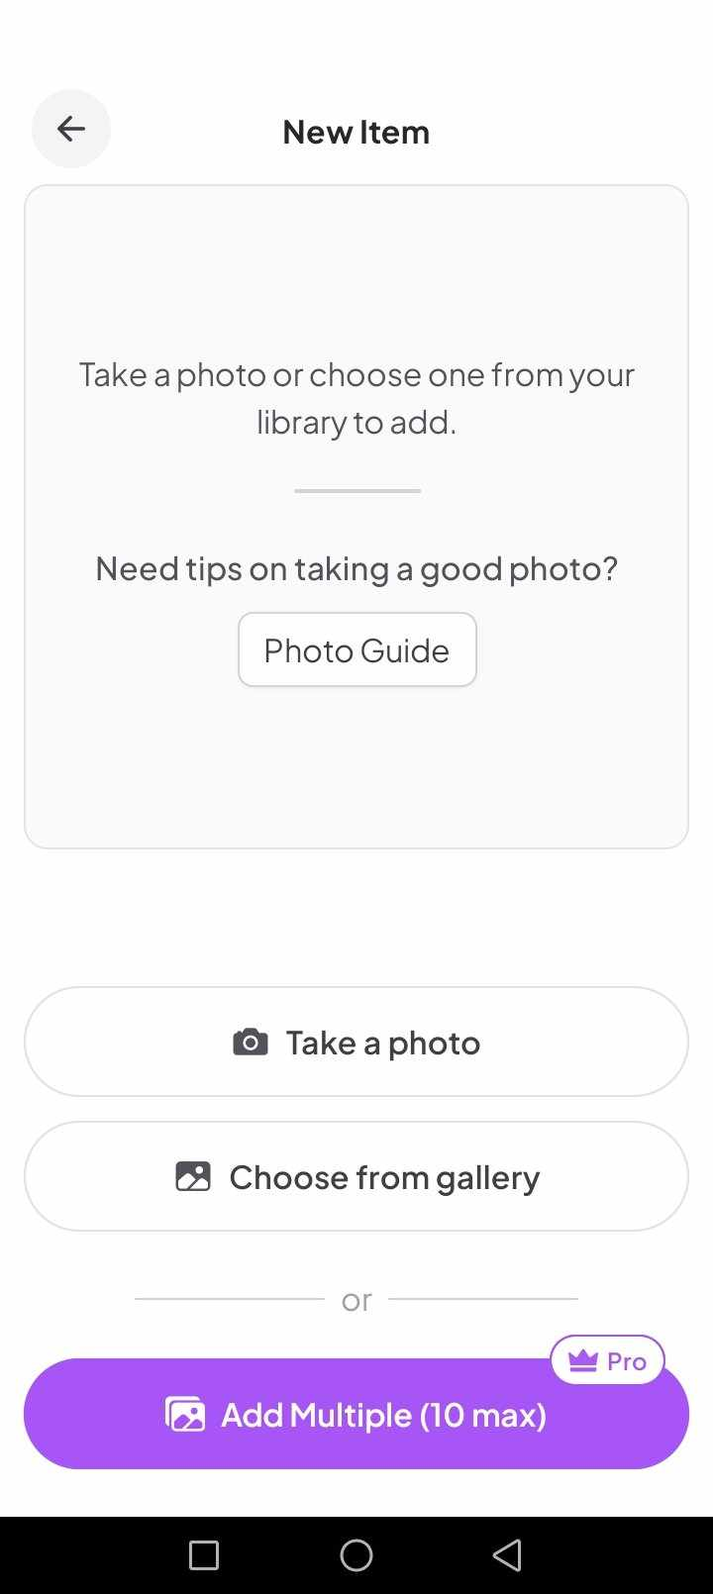

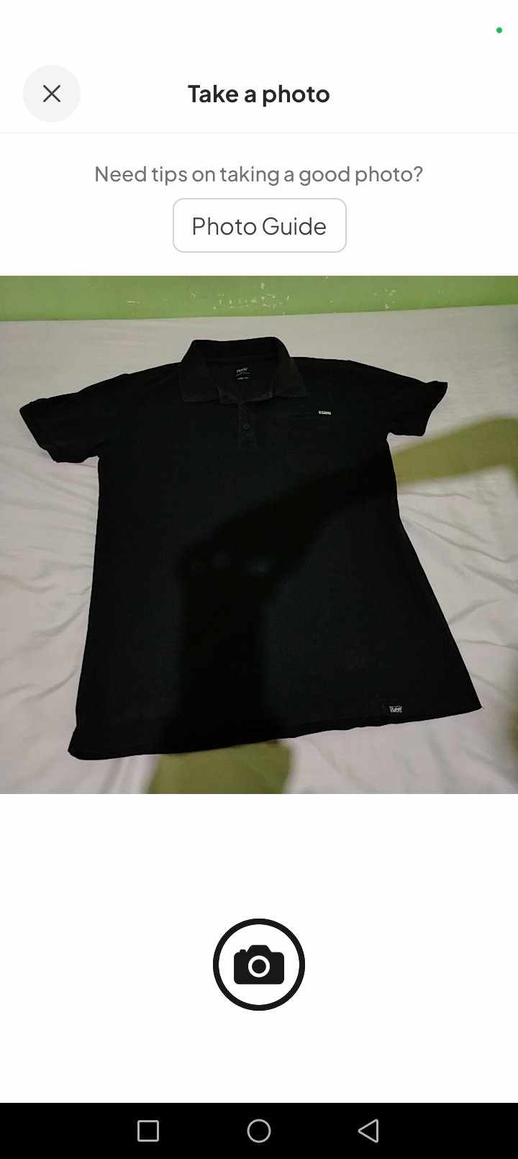
Figure No. 1: New Item Module

Figure No. 2: Take a Photo Module

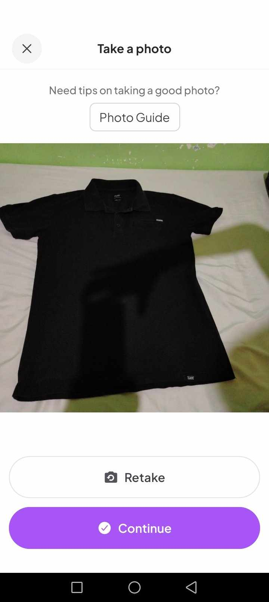

Figure No. 3: Captured Photo Module
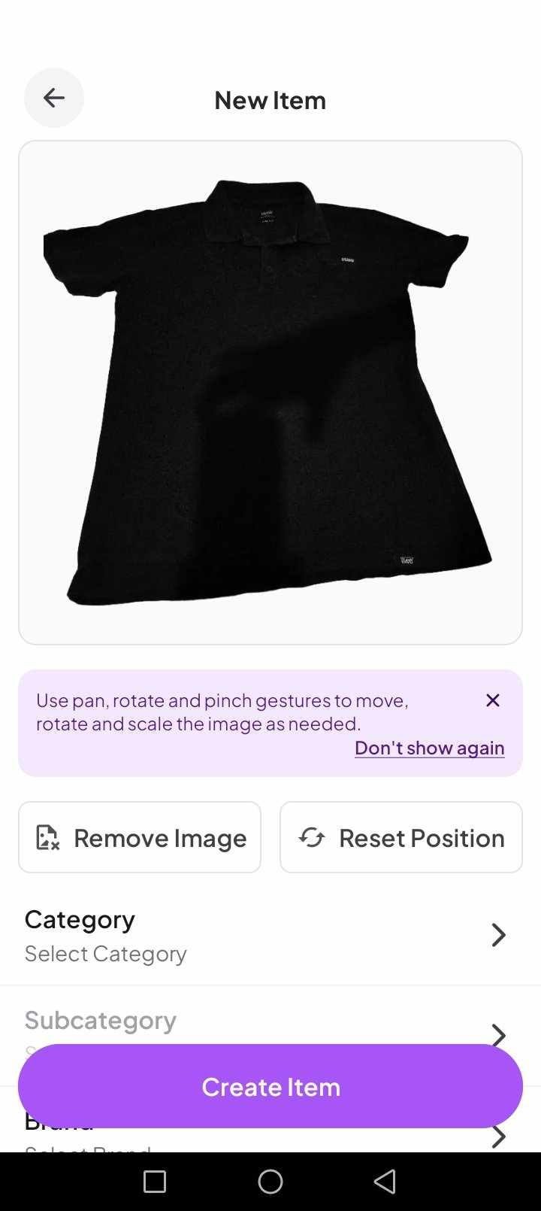

Figure No. 4: Background Remove Module
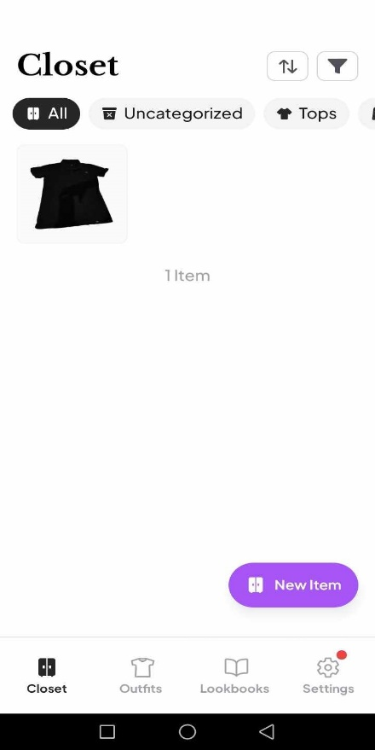
Figure No. 5: Closet Module
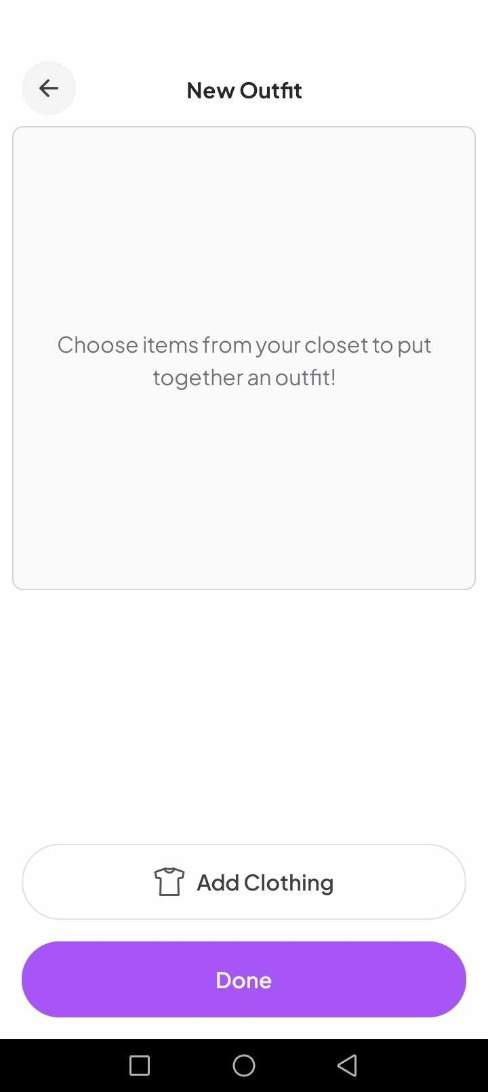
Figure No. 6: New Outfit Module
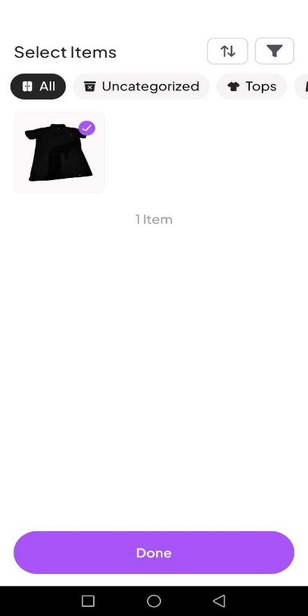
Figure No. 7: Selecting Items Module
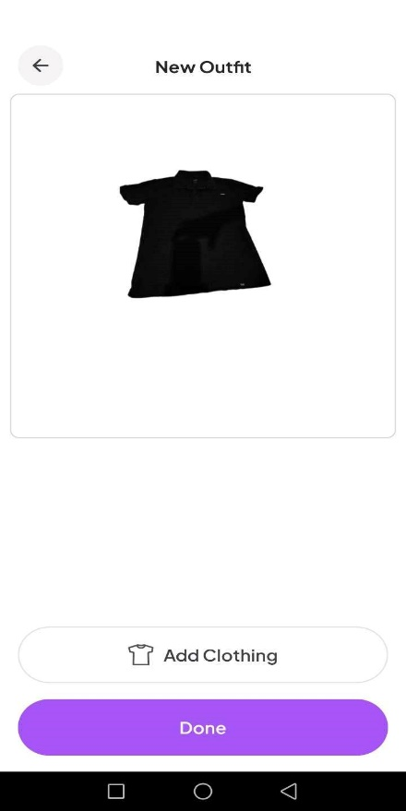
Figure No. 8: Edit Outfit Module

A.1 Similarities between OOTDLY and Clozzie
OOTDLY and Clozzie both assist users to manage and digitize their wardrobes, allowing them to plan and create outfits from their clothing items.
A.2 Difference between OOTDLY and Clozzie
OOTDLY provides calendar for scheduling outfits on specific dates, lent clothes tracker, 2D model image for outfit preview, location-based temperature information to suggest possible clothes to wear, and an offline mode so users can plan without an internet connection. Clozzie required an internet connection to fully function.
B. XZ(Closet)
Offered by: standing ovation inc
Date Published: August 24, 2024
Source: Google Play Store
XZ(Closet) is a free fashion app designed to help users improve their style by organizing their wardrobe and providing daily outfit suggestions.

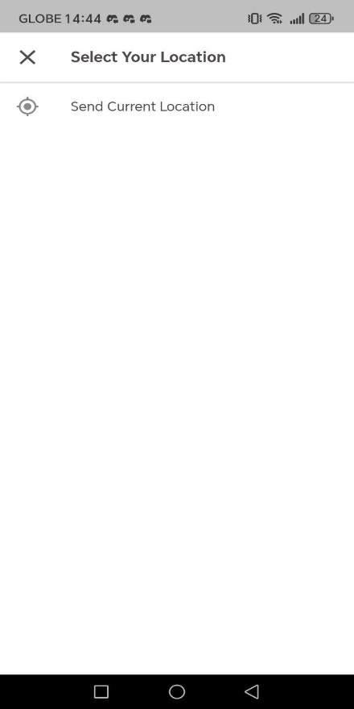

Figure No. 9: Location Module
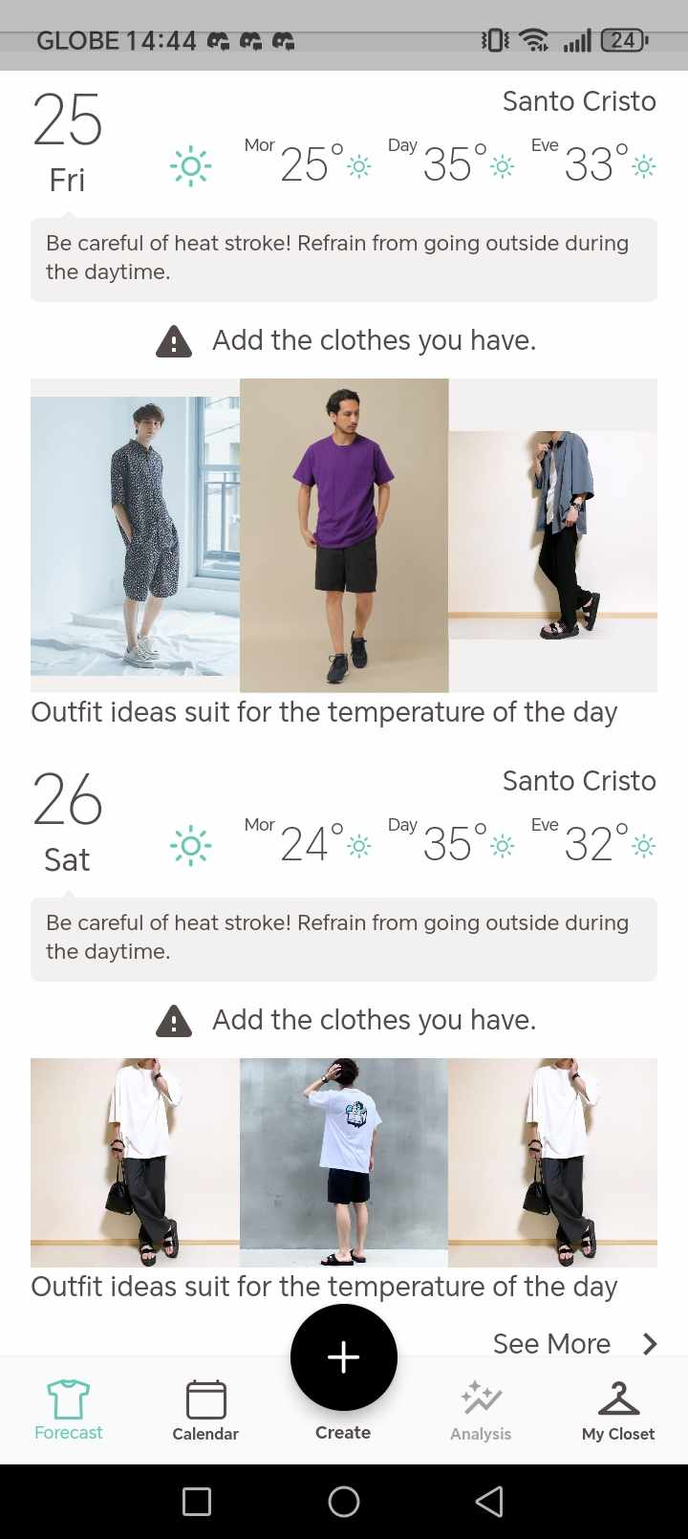

Figure No. 10: Suggested Outfit in Location Temperature Module
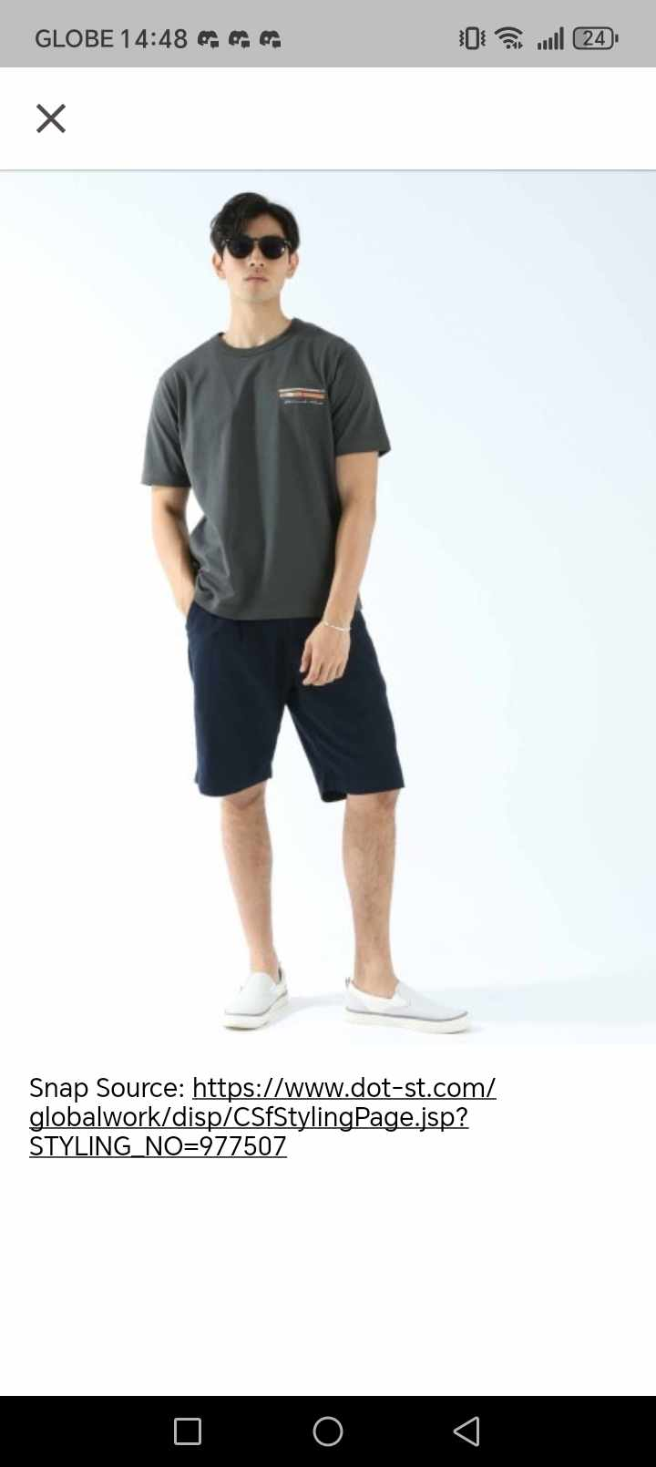
Figure No. 11: Outfit Suggested Module

B.1 Similarities between OOTDLY and XZ (Closet)
XZ(Closet) and OOTDLY have several similarities in helping users manage their wardrobe and plan stylish outfits. Additionally, the OOTYDY have temperature base outfit recommendation and XZ(Closet) have a weather base outfit recommendation base on the temperature. This feature helps user to dress clothes depends on the current temperature location.
B.2 Differences between OOTDLY and XZ (Closet)
OOTDLY provides lent clothes tracker, 2D model to preview looks, location-based temperature alerts to suggest what to wear, and an offline mode so users can plan without an internet connection. While, XZ (Closet) use a weather base outfit recommendation base on the temperature. Additionally, it cannot be run if the user does not have internet connection.

C. Fits – Outfit Planner & Closet
Developer: L. & J. Henne UG
Date Published: 27 Jan 2025
Source: Apple App Store
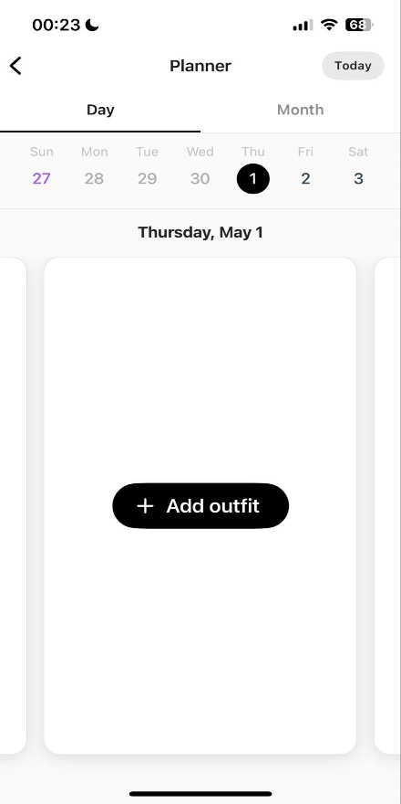
Fits is a free iOS app designed to help users organize their wardrobe and plan outfits. It allows users to digitize their closet by uploading photos of their clothing items and tagging them for easy organization.

Figure No.12: Add Outfit Schedule Module

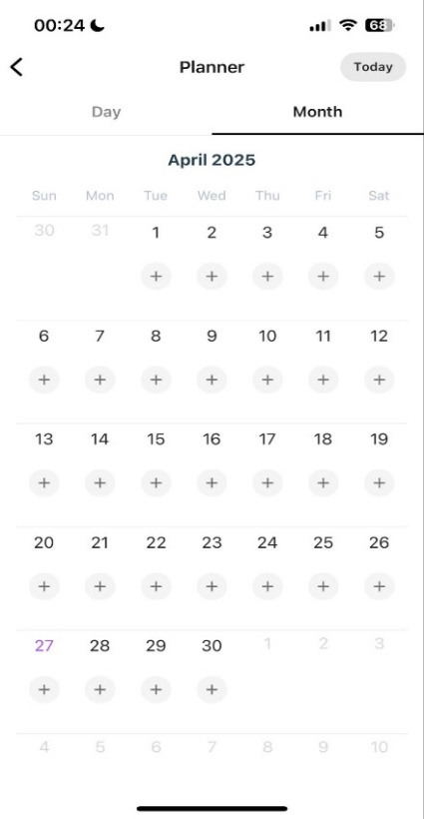

Figure No. 13: Select Schedule Module
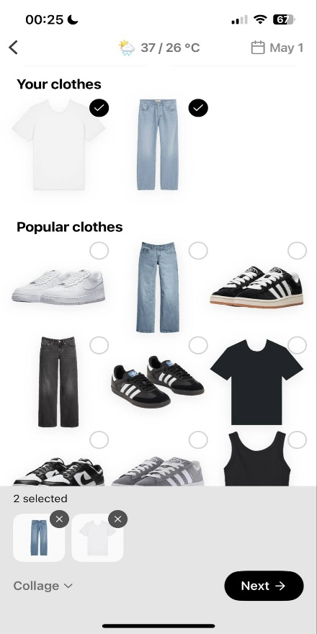

Figure No. 14: Choose Outfit Module
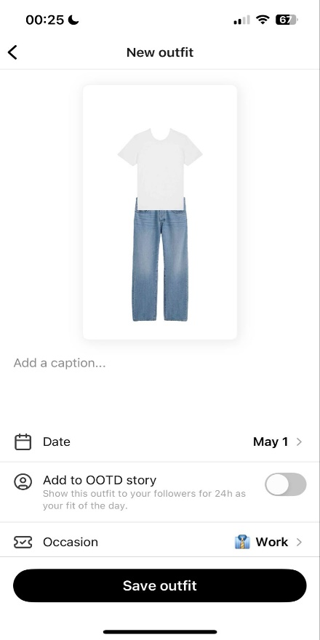

Figure No. 15: Select Occasion Module
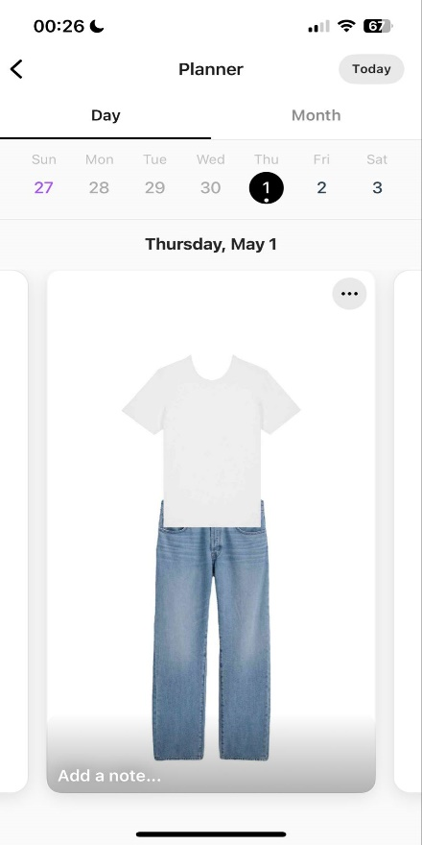

Figure No. 16: Saved Outfit Schedule Module
C.1 Similarities between OOTDLY and Fits
OOTDLY and Fits both help users organize their wardrobe by allowing them to upload photos of their clothes and create outfits. They both have a calendar feature where users can plan what to wear on different days.
C.2 Differences between OOTDLY and Fits
OOTDLY provides lent clothes tracker, 2D model to preview looks, and an offline mode so users can plan without an internet connection. While, Fits provides AI outfit suggestions and allows users to share the outfits they created with others. Additionally, it cannot be run if the user does not have internet connection.

3.0 Technical Background
3.1 Development
3.1.1 Hardware
A. Laptop
The proponents used a laptop in order to access, download, install, and execute the tools needed to debug and develop the android version of the application.
Specifications:
- Operating System: Windows 11 Home
- Processor: Intel® Core™ i5-12500H
- Dedicated Graphics: NVIDIA® GeForce RTX™ 3060 Laptop GPU (6 GB GDDR6)
- Integrated Graphics: Intel® Iris® Xe Graphics
- Storage: SK Hynix 512 GB PCIe® Gen4 NVMe™ TLC M.2 SSD
- RAM: 16GB DDR5 4800 MHz
- Display: 40.9 cm (16.1") diagonal, FHD (1920 x 1080), IPS, micro-edge, anti-glare, 250 nits, 100% sRGB, 144Hz

B. MacBook Air
The proponents used a MacBook Air in order to access, download, install, and execute the tools needed to debug and develop the iOS version of the application.
Specifications:
- Operating System: macOS Sequoia 15.5
- Processor: Apple M2 chip with 8-core CPU (4 performance cores + 4 efficiency cores)
- Integrated Graphics: Apple 8-core GPU
- Storage: 256 GB SSD (PCIe-based)
- RAM: 16 GB unified memory
- Display: 33.78 cm (13.3") diagonal, Retina display (2560 x 1600), IPS, True Tone technology, 400 nits brightness

C. Android Phone
The proponents used android phone to perform debugging while developing the application to see the behavior of the application on a real android phone.
Minimum Requirements:
- Android Version: Android 10 (API Level 29) or higher
- Processor (CPU): Quad-core (4 cores) at 1.8 GHz or faster
- GPU (Graphics Processor): Adreno 506 or newer, or Mali-T830 MP2 or newer
- RAM: 4 GB RAM or higher
- Available Internal Storage: 2 GB free storage or higher
- Camera Specifications:
  - Rear Camera: 12 Megapixels with autofocus or higher
  - Front Camera: 5 Megapixels or higher
- Screen Size: Minimum 5.0 inches, Maximum 6.9 inches
- Battery: 3000mAh or higher
D. iOS iPhone
The proponents used android phone to perform debugging while developing the application to see the behavior of the application on a real android phone.

Minimum Requirements (iPhone):
        - iOS Version: iOS 15 or higher
        - Processor (CPU): Apple A10 Fusion or newer
        - GPU (Graphics Processor):
          - Apple-designed GPU in A10 Fusion chip or newer
          - (PowerVR Series7XT Plus or newer equivalent)
        - RAM: 3 GB RAM or higher
        - Available Internal Storage: 2 GB free storage or higher
        - Camera Specifications:
          - Rear Camera: 8 Megapixels with autofocus or higher
          - Front Camera: 5 Megapixels or higher
        - Screen Size: Minimum 4.7 inches, Maximum 6.7 inches
        - Internet Connection: Wi-Fi or 4G LTE
        - Battery: 1960mAh or higher

3.1.2 Software
A. Android Studio
Android studio is an Integrated Development Environment (IDE) that supports the development of application for both Android and iOS mobile phones. The proponents used Android Studio to develop the Android and iOS version of the application.
B. Flutter
Flutter was made by Google and it lets the developers to create cross-platform applications, for both Android and iOS using only a single code. The proponents used Flutter to develop the application for Android and iOS mobile phones.
C. Dart
Dart is the programming language used by Flutter for application development. The proponents used the Dart programming language to write the functionality and algorithms of the application.
D. Web Browser
The proponents used web browser to search for good color combinations and fonts for user interface design. The proponents used web browser to access Figma, an online design tool for creating user interface designs. The proponents used the web browser to search for application bug fixes during the application development.
E. Figma
The proponents used Figma to create the user interface design of the application. Figma is an online design tool that offers user-friendly interface and real-time collaboration.
F. Draw.io
Draw.io is a free online tool used for creating diagrams such as activity diagram, sequence diagram, and entity-relationship diagram. The proponents used Draw.io to create the diagrams related to the application flow.
G. Git
The proponents used Git to track the development of the application. It is a free, open-source, distributed version control system that allows project collaboration.
H. GitHub
The proponents used GitHub for cloud-based version control. It can be used alongside with Git and it could allow the proponents to track their development progress online.
I. Firebase
Firebase is a backend service provided by Google. It is loaded with different tools such as NoSQL database, cloud storage, authentication and real-time update feature. The proponents used Firebase as their main online backend.
J. SQLite
SQLite is an offline relational database. The proponents used SQLite for the application to operate offline.

K. DB Browser
DB Browser is a tool used to access and modify SQLite database schema. The proponents used DB Browser to perform database creation and modification when necessary.
L. Weather API
Weather API is a free weather update provider. The proponents used the API to get the current temperature on a location.
M. Camera API
The proponents used the Camera API to access device camera.
3.1.3 Peopleware
A. The Proponents
“Proponents” refers to a group of individuals collaborating together to develop the OOTDLY application. Each single proponent has specific roles, tasks, and responsibilities, contributing their skills and expertise. Their combined efforts could ensure that OOTDLY application succeed.
B. Capstone Adviser
Mr. Victor C. Yu, a professional application developer, is the Capstone Adviser of the proponents. He plays a key part in guiding the group through the project development process. His knowledge and expertise help the group for the success of the project.
C. Resource Persons
C.1 Trisha Joy G. Tañedo
Trisha Joy G. Tañedo, 16 years old, used to not get ready for parties, such as Trisha’s friend's debut with a "starry night" theme, because Trisha didn’t know Trisha was invited and wasn’t prepared. Although Trisha’s clothes are organized within the cabinet, picking what to wear remains a struggle, especially for school or casual outings. Outfits are chosen based on the occasion, typically opting for plain and comfortable clothes. For evening events, a simple yet classy look that is comfortable is preferred. An app for planning clothes and recommending outfits would be extremely helpful, given the difficulty in deciding what to wear most of the time. If Trisha’s clothes could be reorganized, they would be categorized, separating house clothes from going-out clothes.
C.2 Jeffrey Galang Bais
Jeffrey Galang Bais, aged 28, said that he experienced lack of preparation when choosing what to wear for an event, especially when the event takes place suddenly or unexpectedly. Jeffrey's physical wardrobe items are sorted in a physical cabinet, with shirts separated from shorts. Most of the time, Jeffrey finds it hard to select clothes for an occasion or when going out, as there are times when the clothes he wears are inappropriate for the occasion. In Jeffrey’s opinion, there should be a way to choose outfits based on occasion or weather, and a mobile application that can help users choose outfits would be helpful.

C.3 Leonila Luis
Leonila Luis, at the age of 61, shared that she felt unprepared when it comes to selecting clothes to wear, especially when invited to serve as a godmother at a wedding. Leonila's attire is stored in a physical cabinet, with some clothes hung and others folded neatly. Leonila mentioned that at times, it is hard for her to decide on an outfit, particularly for special occasions like weddings or christenings. Leonila does not have a particular way of choosing outfits based on color, occasion, or season. Leonila feels that an app on her mobile phone that helps organize clothes and recommend outfits would be helpful in managing the process of choosing outfits for occasions with multiple events lined up. If Leonila had the opportunity, she would want her clothes to be sorted by color and style.
D. Wardrobe Owners
Individuals who are 13 years old and above and owns storage for their clothing items could be the main users of the application. These individuals give the proponents useful insights to develop the application with user-friendly interface and functionalities.
3.2 Implementation
3.2.1 Hardware
A. Android Phone
The users need an Android phone to download and use the Android version of the application.
B.1 Minimum Requirements:
- Android Version: Android 10 (API Level 29) or higher
- Processor (CPU): Quad-core (4 cores) at 1.8 GHz or faster
- GPU (Graphics Processor): Adreno 506 or newer, or Mali-T830 MP2 or newer
- RAM: 4 GB RAM or higher
- Available Internal Storage: 2 GB free storage or higher
- Camera Specifications:
  - Rear Camera: 12 Megapixels with autofocus or higher
  - Front Camera: 5 Megapixels or higher
- Screen Size: Minimum 5.0 inches, Maximum 6.9 inches
- Battery: 3000mAh or higher
Example Android Phones:
- Samsung Galaxy A21s
- Xiaomi Redmi Note 9
- realme 5 Pro
- Motorola Moto G9 Play
- Samsung Galaxy M21
B. iOS Phone
The users need an iOS phone to download and use the iOS version of the application.
B.1 Minimum Requirements:
        - iOS Version: iOS 15 or higher
        - Processor (CPU): Apple A10 Fusion or newer
        - GPU (Graphics Processor):
          - Apple-designed GPU in A10 Fusion chip or newer
          - (PowerVR Series7XT Plus or newer equivalent)
        - RAM: 3 GB RAM or higher
        - Available Internal Storage: 2 GB free storage or higher
        - Camera Specifications:
          - Rear Camera: 8 Megapixels with autofocus or higher
          - Front Camera: 5 Megapixels or higher
        - Screen Size: Minimum 4.7 inches, Maximum 6.7 inches
        - Internet Connection: Wi-Fi or 4G LTE
        - Battery: 1960mAh or higher

Example iOS Phones:
- iPhone 7 Plus
- iPhone 8 Plus
- iPhone X
- iPhone XR
- iPhone 11
- iPhone 13

3.2.2 Software
A. Google Play Store
The Google Play Store is a trusted platform for Android users to access and download a wide range of applications. The OOTDLY application was uploaded to the Google Play Store, where it is securely available to all Android phone users.
B. Apple App Store
The Apple App Store is a trusted platform for iOS users to access and download a wide range of applications. The OOTDLY application was uploaded to the Apple App Store, where it is securely available to all iOS iPhone users.
C. Android OS
Android OS is the most widely used mobile operating system worldwide. It is an open-source platform developed by Google and commonly utilized in daily activities. The OOTDLY application can be used on Android devices, as many people rely on Android OS for their smartphones. To install and run the application, users are required to have Android version 10 (API Level 29) or higher.
D. iOS
iOS is a widely used mobile operating system developed by Apple, exclusively designed for iPhone devices. It is recognized as a secure and trusted platform commonly utilized in daily activities by millions of users worldwide. The OOTDLY application can be used on iOS devices, with installation and usage requiring iOS version 15 or higher.

3.2.3 Peopleware
A. Wardrobe Owners
Individuals who are 13 years old and above and owns storage for their clothing items are the main users of the application. They are the individuals who used the app to view their physical clothing items on their mobile devices.
3.2.4 Network
A. Wifi / Data Connection
In order to use the online mode of the application, users need to register or log in using Google account or Apple account. This authentication required them to have a working internet connection.

4.0 Methodology
4.1 Prototype Model
The Prototype Methodology was a step-by-step process for software development that focused on creating a version of the system beforehand, called a prototype. The prototype provided a preview of how the final system would function. The development team gathered reviews and feedback, made improvements, and repeated the process until a final acceptable prototype was achieved. This approach helped identify problems early, resulting in reduced development risk.
The proponents used the Prototype Methodology for OOTDLY application. It enables the proponents to create a prototype first, and when a final acceptable prototype was achieved, the proponents start the development. This approach lay the foundation to develop a user-friendly and functional application.
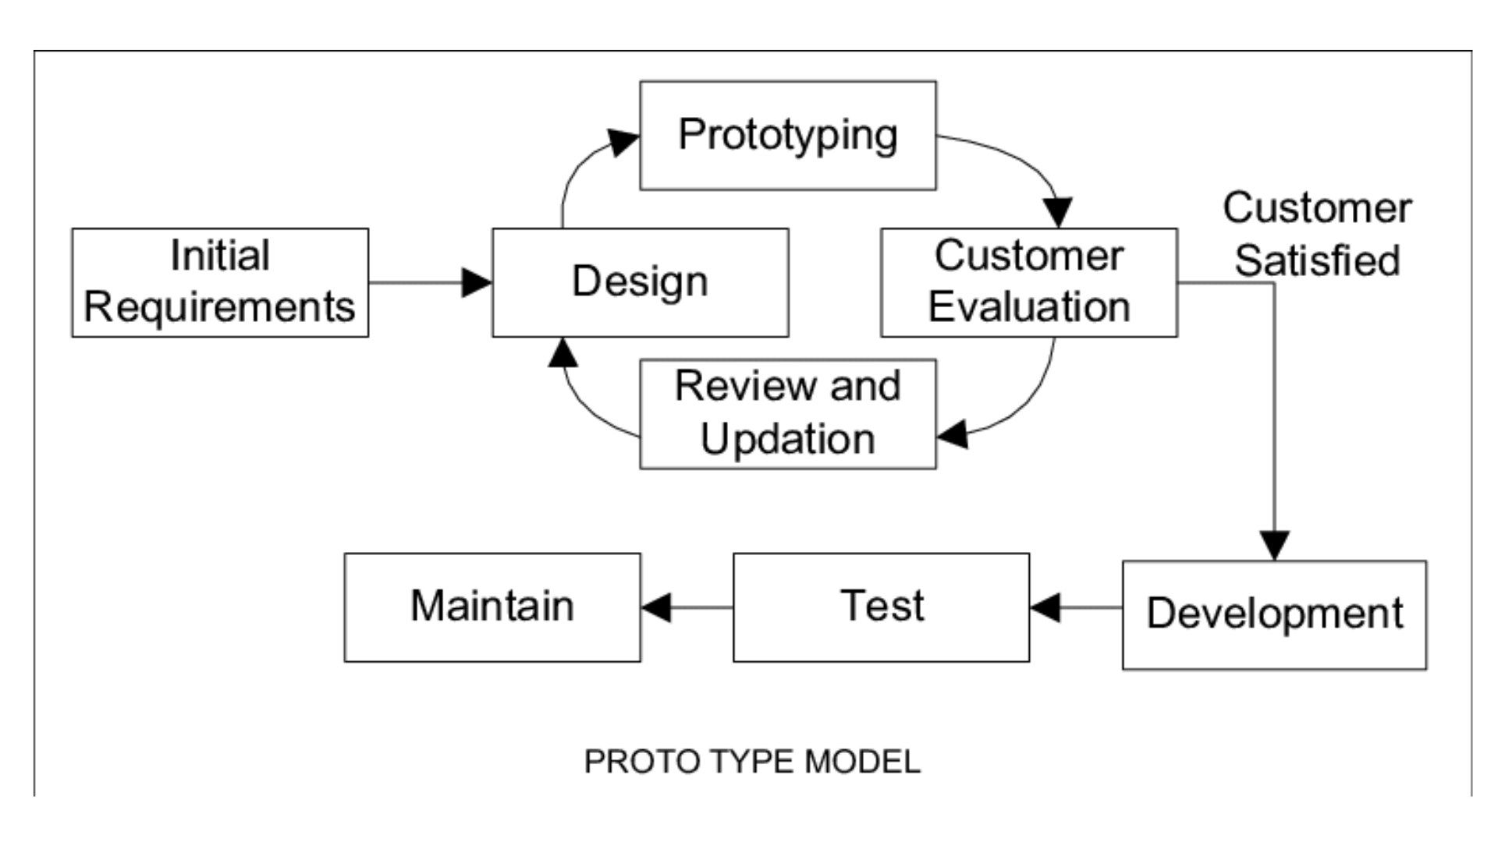

Figure No. 17: Prototyping Model

4.1.1 Phases in Prototype Model
A. Initial Requirements
In this stage, the proponents gathered essential information related to outfit planning, wardrobe organization, and fashion trends. To better understand the needs and expectations of potential users, the proponents conducted a survey that collected insights about user fashion habits, common challenges in choosing outfits in physical wardrobe, and desired features in a wardrobe management app. Also, the proponents researched existing applications and design inspirations to explore different user interface styles, layouts, and features.
B. Design
After gathering the necessary information, the proponents created an initial design for the application interface.
C. Prototyping / Building Prototype
Using the initial design, the proponents develop a prototype of OOTDLY. The prototype include navigation features such as navigating to other page when a button was clicked.
D. Customer / User Evaluation
Once the prototype is ready, users be invited to test it and share their experiences. User feedback be gathered to identify which aspects of the application needs improvements or adjustments to enhance usability and functionality.
E. Review and Updation
Based on user evaluations, the proponents review the prototype results and update the prototype accordingly. Modifications enhance the design, improve feature performance, fix identified issues, and optimize the app usability.

F. Development
After the prototype was refined and approved based on user feedback, the proponents move into the actual development phase. During development phase, the proponent conduct the actual coding and application debugging.
G. Testing
In this stage, the proponents conduct functionality testing, usability testing, and compatibility testing across various devices to ensure that OOTDLY is stable, user-friendly, and ready for launch.
H. Maintain
In this stage, the proponents deployed the OOTDLY application to the Google Play Store and Apple App Store and continue to maintain the application presence on Google Play Store and App Store.

4.2 Requirement Specification
4.2.1 Operational Feasibility
A. Fishbone Diagram
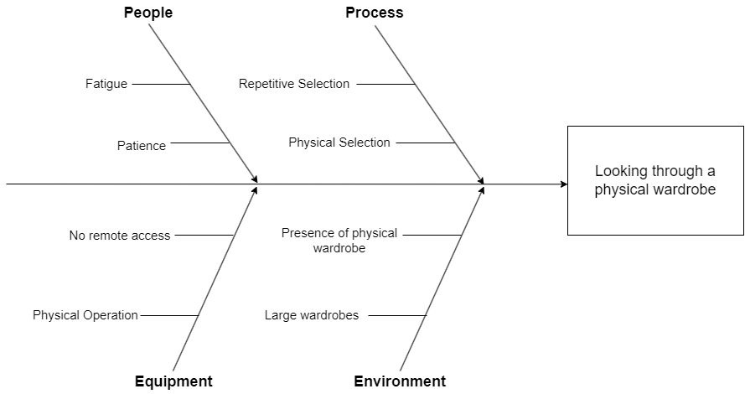

Figure No. 18: Fishbone Diagram

B. Functional Decomposition Diagram
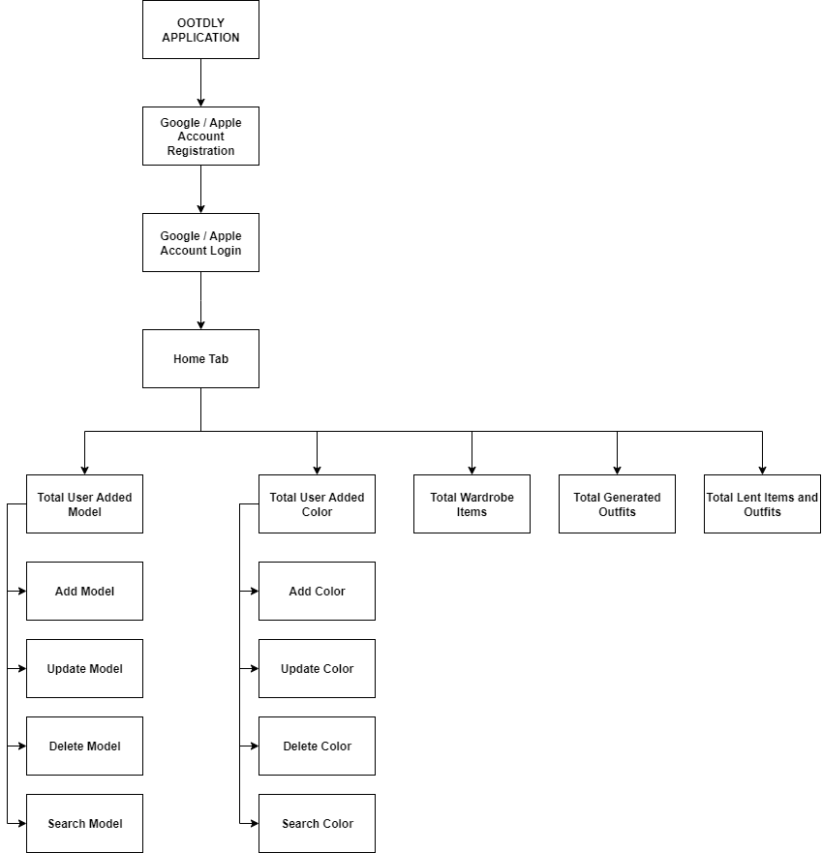

Figure No. 19: Online Home Tab FDD

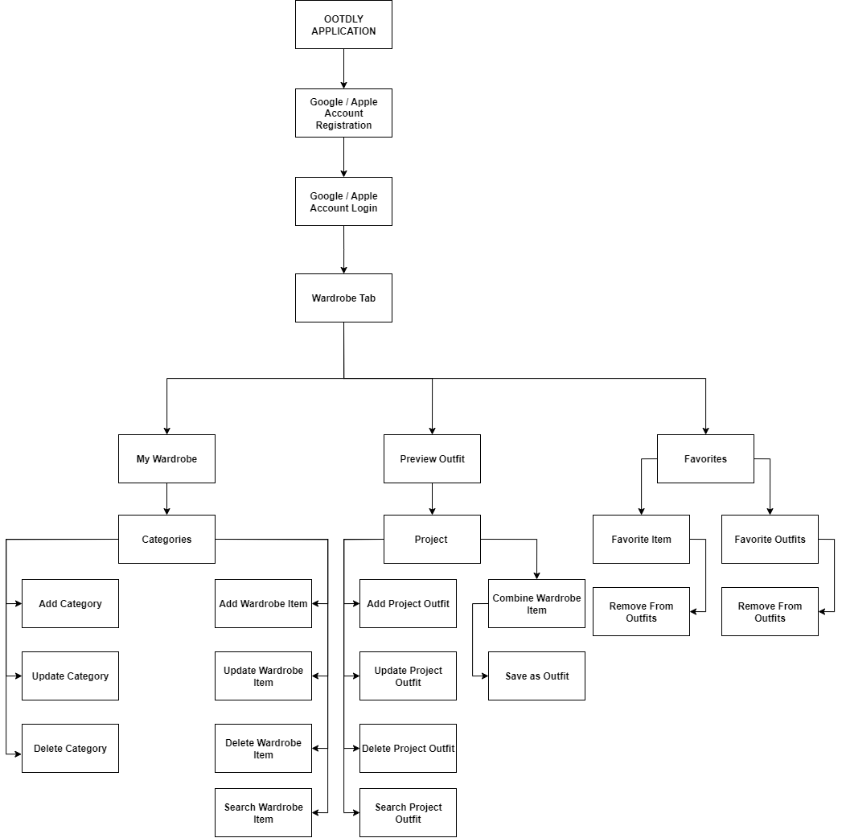

Figure No. 20: Online Wardrobe Tab FDD

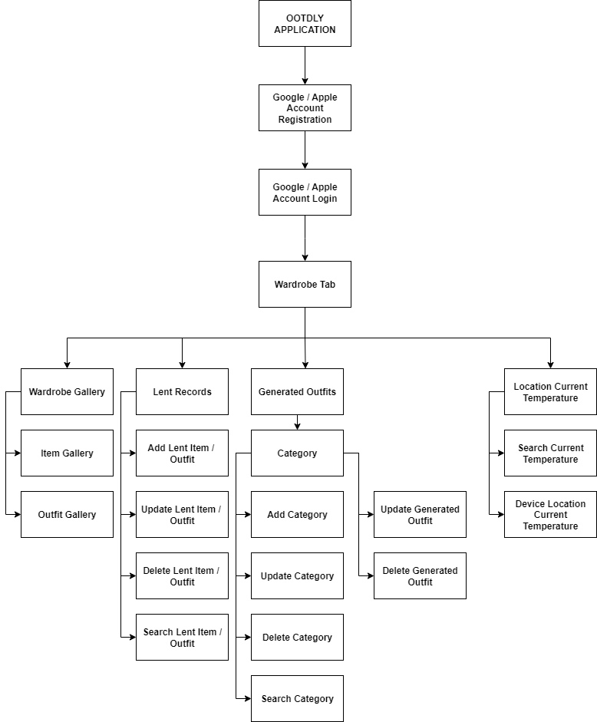

Figure No.21: Online Wardrobe Tab FDD

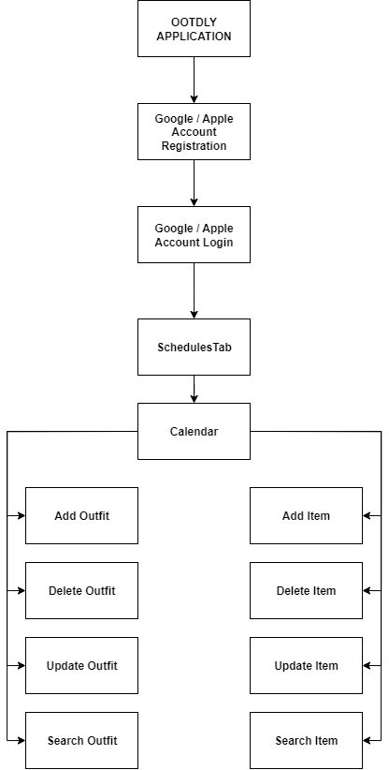
Figure No. 22: Online Calendar Tab FDD
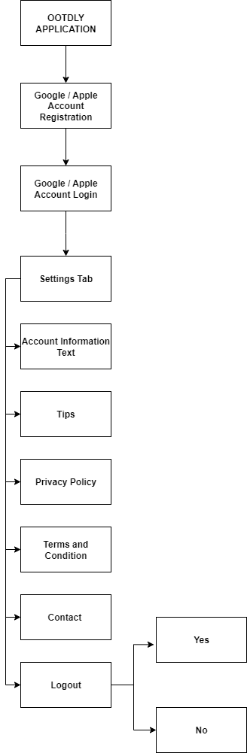

Figure No. 23: Online Profile Tab FDD
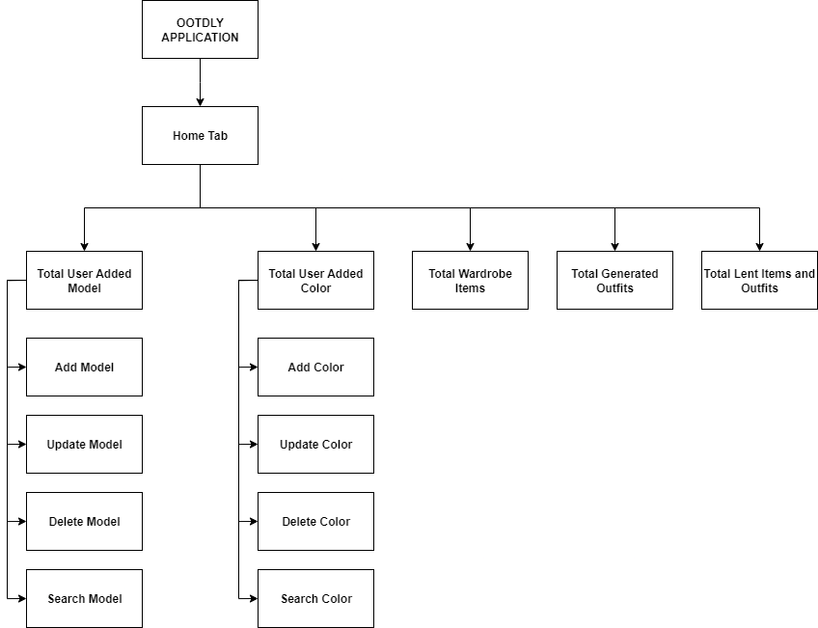
Figure No. 24: Offline Home Tab FDD

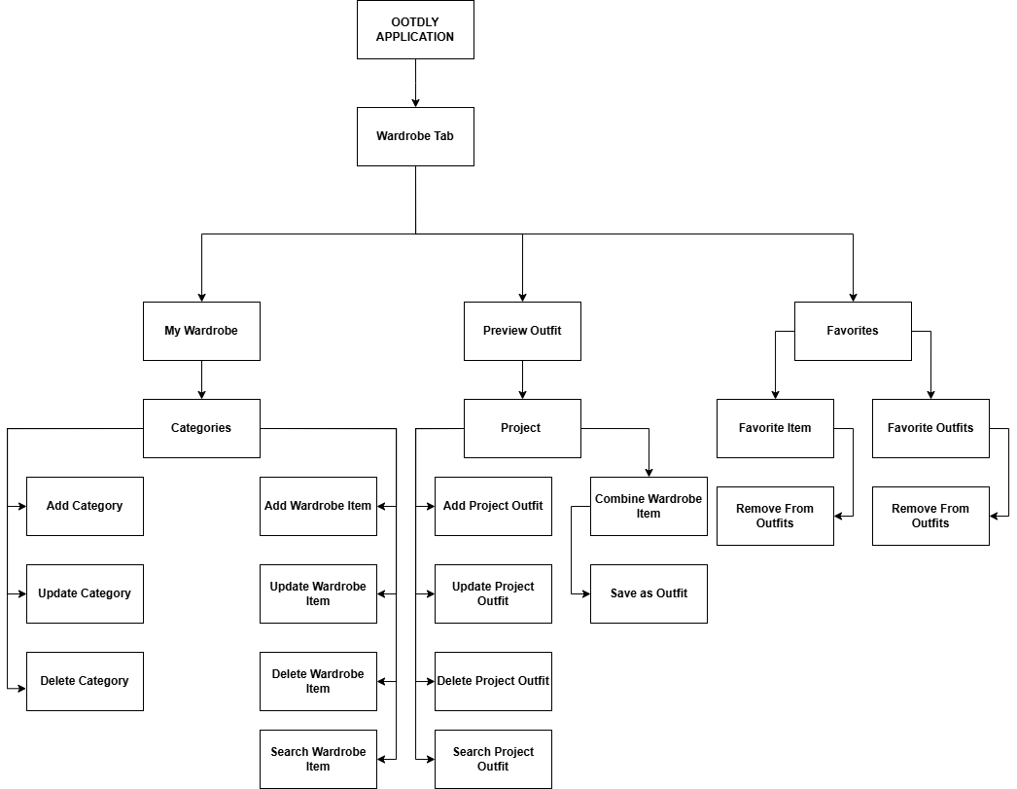
Figure No. 25: Offline Home Tab FDD

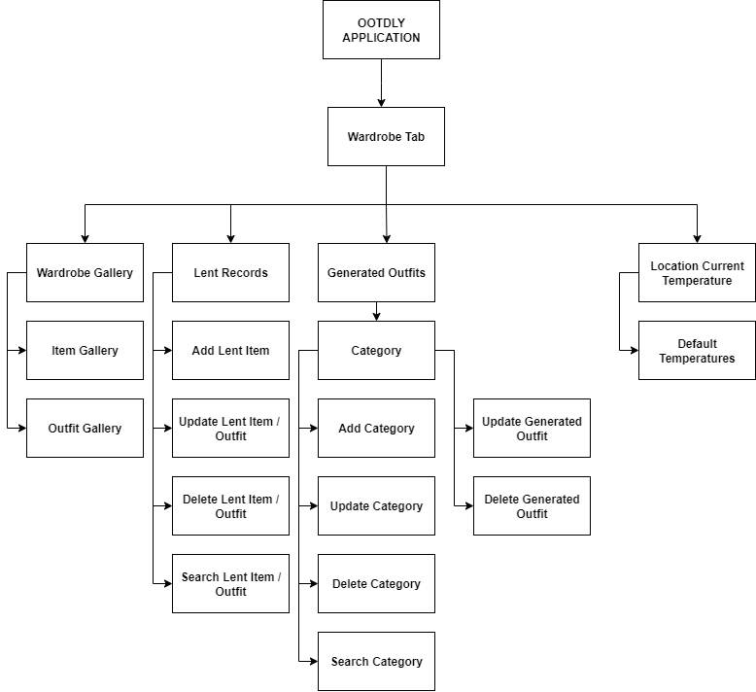

Figure No. 26: Offline Wardrobe Tab FDD

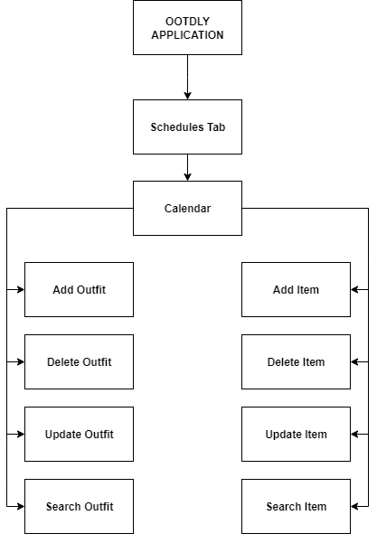

Figure No. 27: Offline Calendar Tab FDD

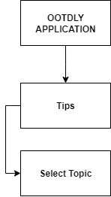

Figure No. 28: Offline Application Manual Tab FDD

4.2.2 Technical Feasibility
Technology is continuously making the daily life of humans easier, ranging from simple digital communication technologies to rising trend of digitization and digitalization of physical belongings. As technology is evolving, various tools for application development are actively growing, unlocking the potential to create applications that can help the daily life of humans. The proponents have considered the hardware and software compatibility to develop the OOTDLY application. The selected hardware, which is a laptop, is compatible with the required software tools, including Android Studio, Flutter, Firebase, and SQLite. The compatibility of hardware and software technologies enable the proponents to achieve fully developed OOTDLY application.
A. Relevance of the Technology
The integration of technology into human life has unlocked new ways to live with ease. With the use of mobile devices, individuals can now keep track of their wardrobe. OOTDLY helps users to manage their clothing by allowing them to view their wardrobe items, combine different wardrobe items to create outfits, and schedule items or outfits for specific dates. Users can experience convenience in planning what to wear without going to their physical closet or wardrobe every time.
4.2.3 Schedule Feasibility
A. Gantt Chart
Table No. 1: Month of January of 2025
Activities | Week 1 | Week 2 | Week 3 | Week 4
Initial Requirements
Brainstorming
Online Research
Online Meeting
Tittle Defense
Selecting Adviser

Table No. 2: Month of February of 2025
Activities | Week 1 | Week 2 | Week 3 | Week 4
Brainstorming
Online Research
Online Meeting
Creating Documentation (Chapter 1)
Creating Documentation (Chapter 2)
Creating Documentation (Chapter 3)
Creating Documentation (Chapter 4)
Adviser checking of documentation (Chapter 1 – 4)

Table No. 3: Month of March of 2025
Activities | Week 1 | Week 2 | Week 3 | Week 4
Revision of document (chapter 1 - 4)
Initial submission of document for Plagiarism and AI checking
Online Meeting
Meeting and checking of document with Adviser
Revision of document (Chapter 1 to 4)
Submission of document for Plagiarism and Ai Checking
Design
Research about what colors, fonts, buttons, functions, API, and inputs implement
Brainstorming with team
Creating User Interface

Table No. 4: Month of April of 2025
Activities | Week 1 | Week 2 | Week 3 | Week 4
Preparation for Oral Defense
Oral Defense
Prototyping
Create prototype using figma

Table No. 5: Month of May of 2025
Activities | Week 1 | Week 2 | Week 3 | Week 4
Customer / User Evaluation
Presentation and testing of prototype to the target users
Review and Updation
Gather, organize, and review the feedback from the target users
Design
Online Research about the suggestion of the target users
Add and removal of features on the user interface base on the gathered feedback form the target users
Prototyping
Modification of prototype on figma to include the suggestion from the gathered feedback form the target users

Table No. 6: Month of June of 2025
Activities | Week 1 | Week 2 | Week 3 | Week 4
Customer / User evaluation
Presentation and Testing of prototype to the target users
Development
Setting Firebase Project for online functionality of the mobile app
Setting Flutter on Android Studio and integrating SQLite for offline functionality

Table No. 7: Month of July of 2025
Activities | Week 1 | Week 2 | Week 3 | Week 4
Developing loading screens, Online and Offline log in, registration, and forgot password modules
Developing Home Tab
Developing of Wardrobe Tab

Table No. 8: Month of August of 2025
Activities | Week 1 |  | Week 2 | Week 3 | Week 4
Developing Wardrobe Tab
Developing of Calendar Tab and Profile Tab
Building the application for Android and iOS Google Play Store and Apple App Store registration

Table No. 9: Month of September of 2025
Activities | Week 1 | Week 2 | Week 3 | Week 4
Testing
Functionality testing, usability testing, and compatibility testing for target users.
Maintain
Deployment of the application to Play Store and App Store

Table No. 10: Month of October of 2025
Activities | Week 1 | Week 2 | Week 3 | Week 4
Deployment of the application to Play Store and App Store
Preparation for Final Defense
Final defense

4.2.4 Economic Feasibility
A. Cost and Benefit Analysis
The project was hosted on two well-known application providers: Google Play Store for Android devices and Apple App Store for iOS devices. It required ₱1,438 for Play Store registration and ₱5,750 for App Store registration. The project also used Firebase for the online backend. It utilized the free tier offered by Firebase, but additional costs could apply if the limits were exceeded. Therefore, the initial estimated cost was ₱7,188, with possible additional charges depending on Firebase usage.

Table No. 11: Cost and Benefit Analysis
Item | Cost | Benefits
Registration  (Google Play Store) | ₱ 1,438 | To made the application available to safely download for Android users.
Registration  (Apple App Store) | ₱ 5, 750 | To made the application available to safely download for iOS users.
Total Estimated Cost | ₱ 7, 188

B. Cost Recovery Scheme
The project will utilize an ad-based cost recovery model. There is no limit of uploading in the online mode but ads will pop up anytime while using the application in online mode. This approach will ensure that the core functionality of the application remains free while allowing the project to sustain itself through ad revenue from users.

4.2.5 Requirements Modeling
4.2.5.1 Object Modeling
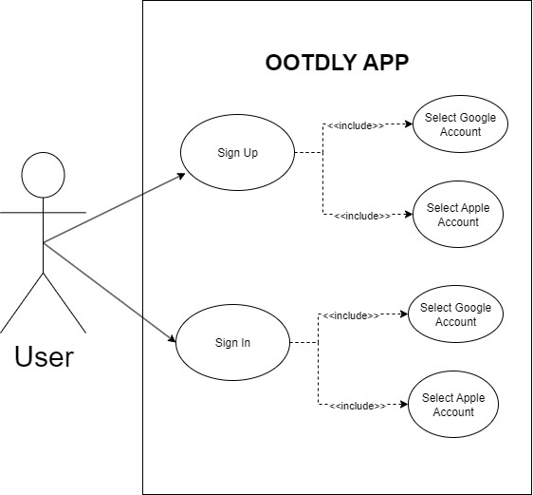
- Use Case Diagram

Figure No. 29: Use Case Diagram – Login Module

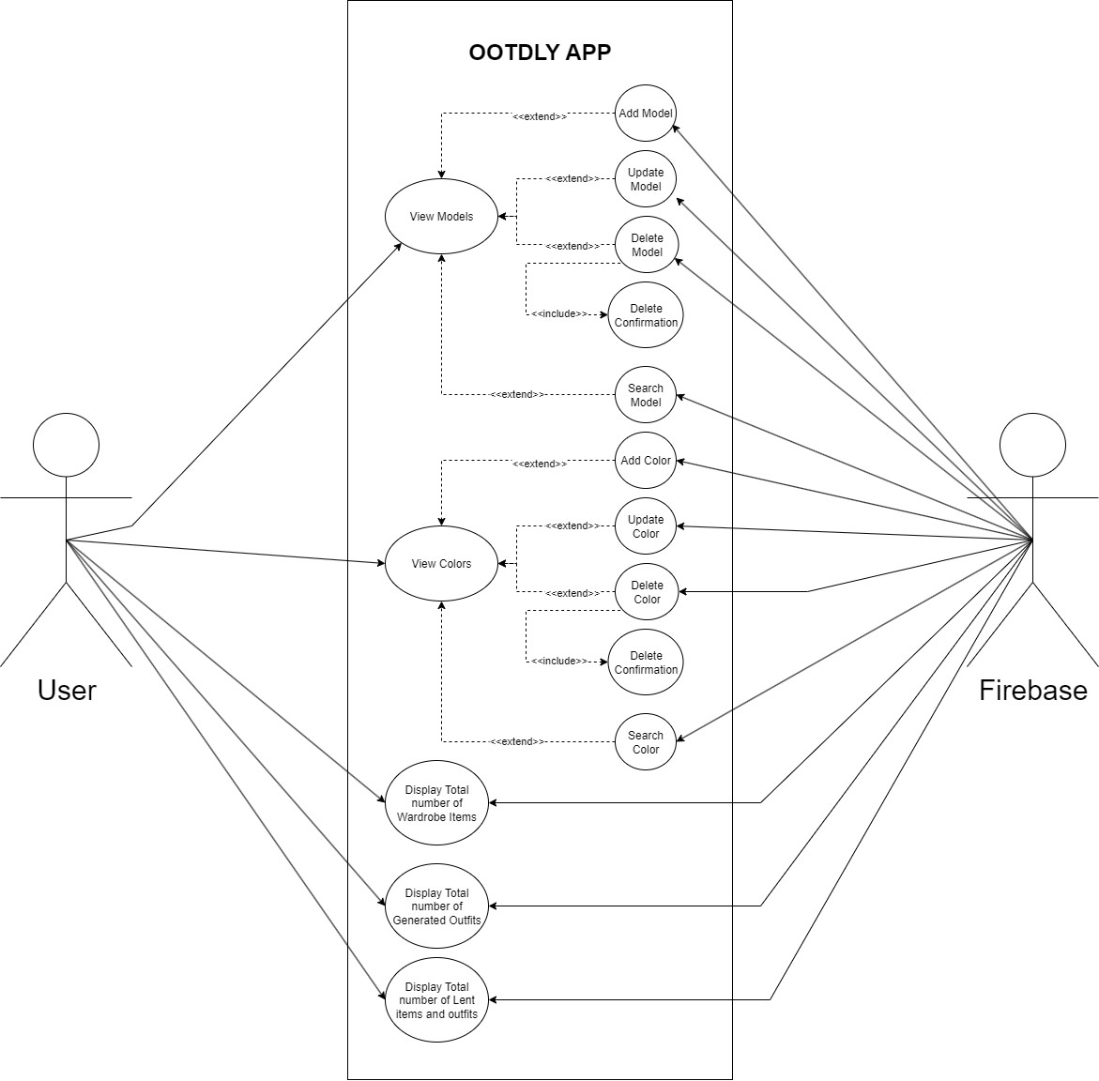

Figure No. 30: Use Case Diagram – Online Home Tab

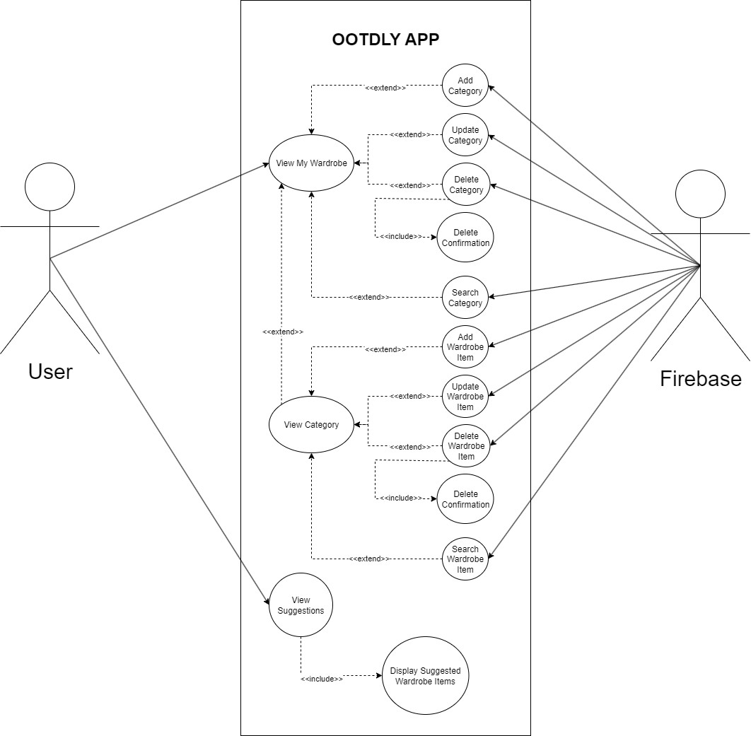

Figure No. 31: Use Case Diagram – Online My Wardrobe 1

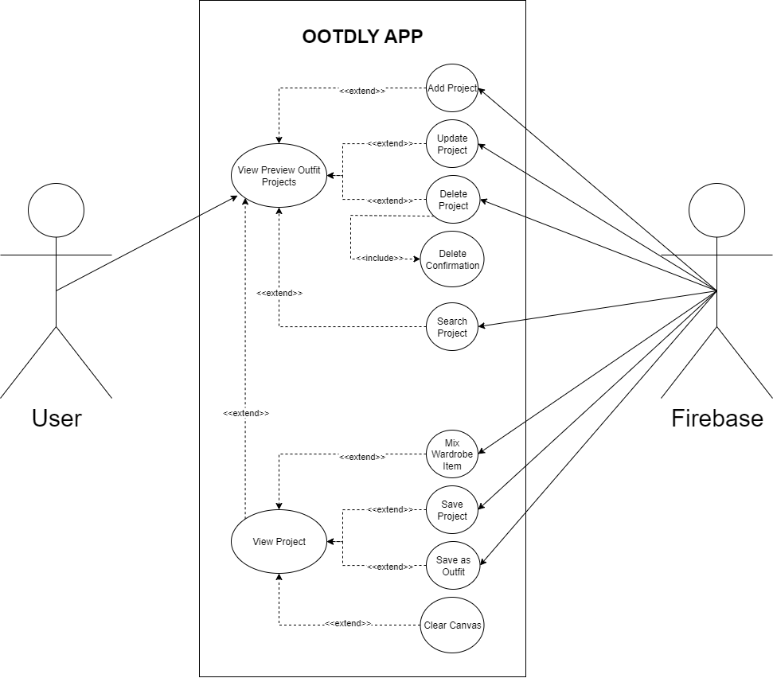

Figure No. 33: Use Case Diagram – Online Preview Outfit
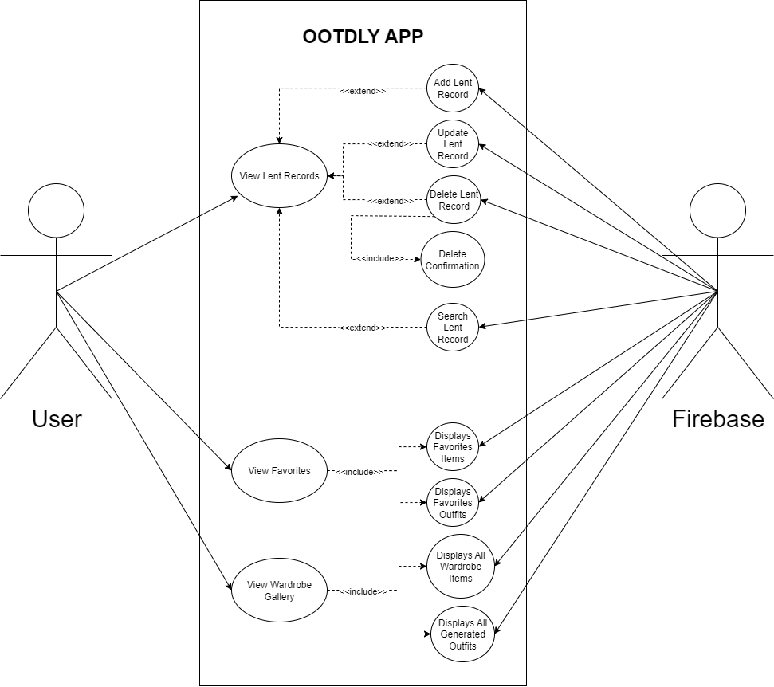

Figure No. 34: Use Case Diagram – Online Lent Items / Outfits, Favorites, and Wardrobe Gallery

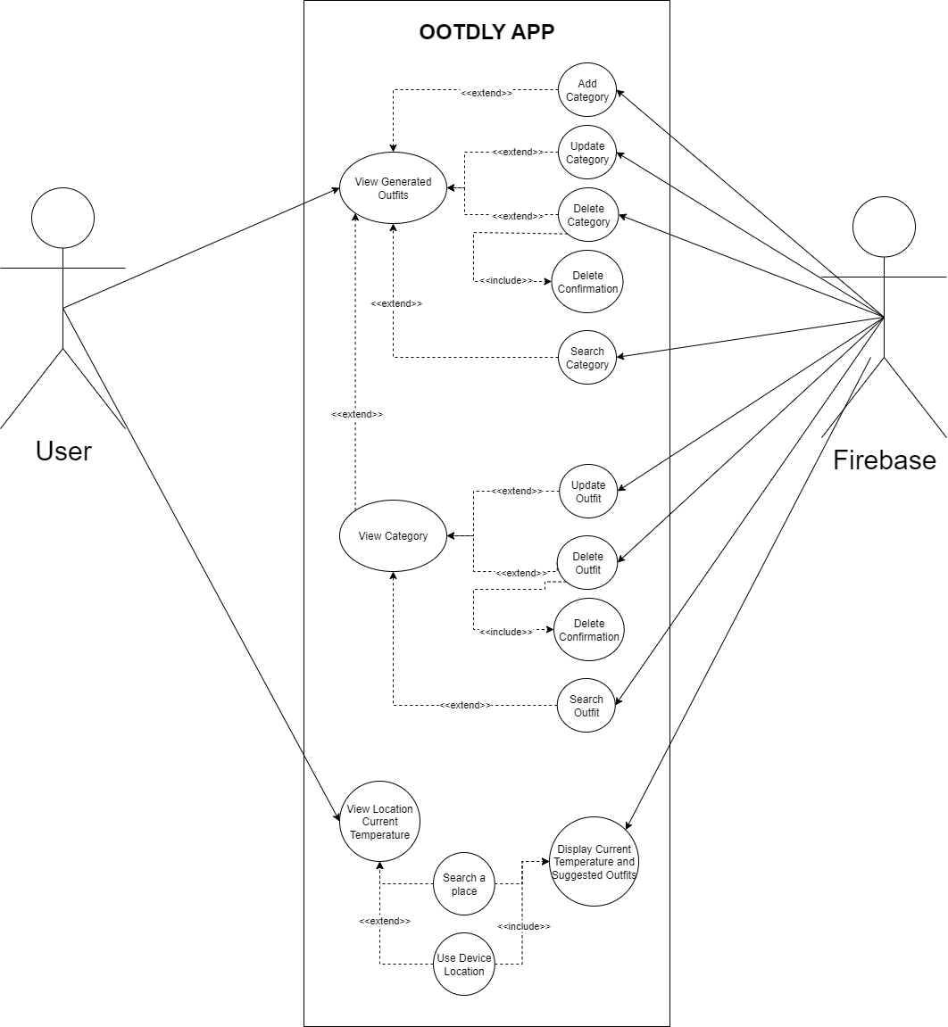

Figure No. 35: Use Case Diagram – Online Generated Outfits and Location Temperature

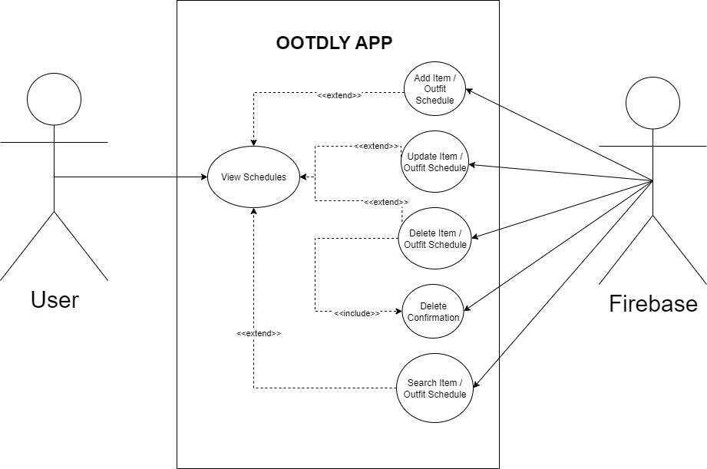

Figure No. 36: Use Case Diagram – Online Calendar Tab

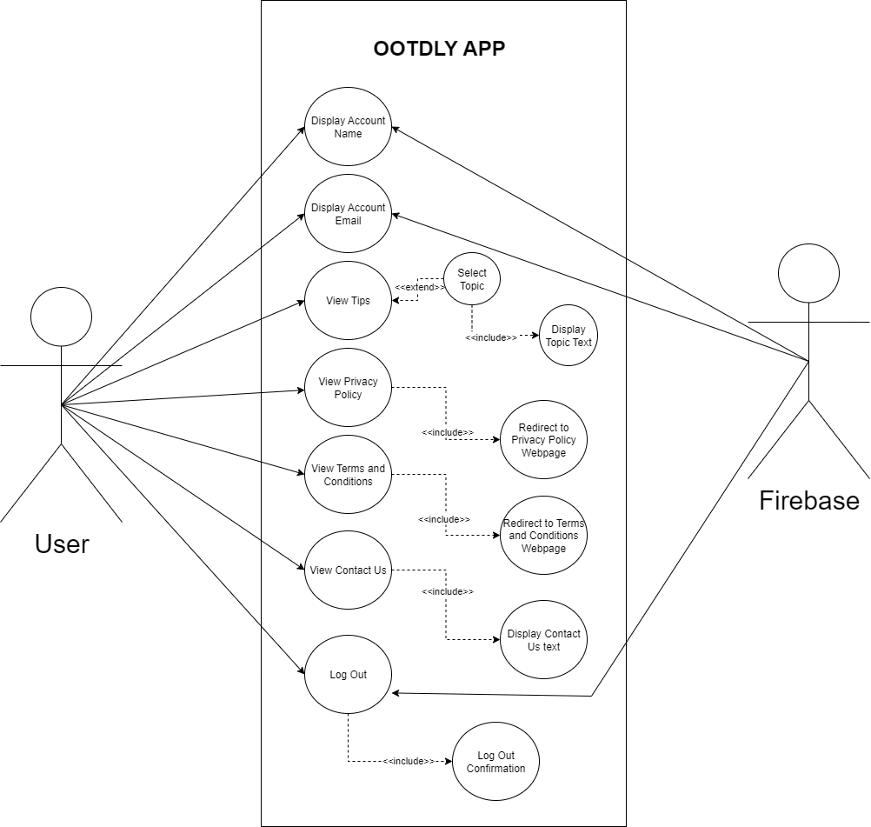

Figure No. 37: Use Case Diagram – Online Profile Tab

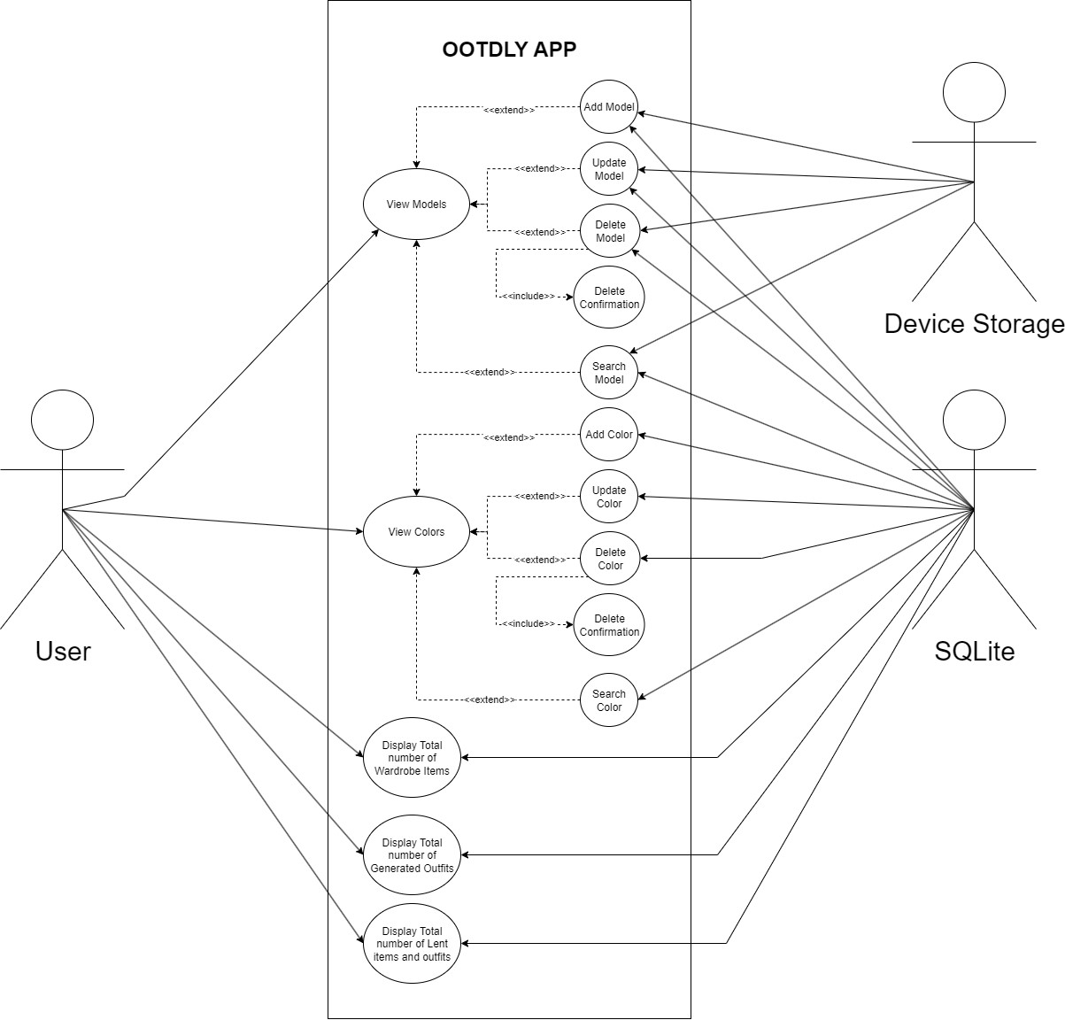

Figure No. 38: Use Case Diagram– Offline Home Tab

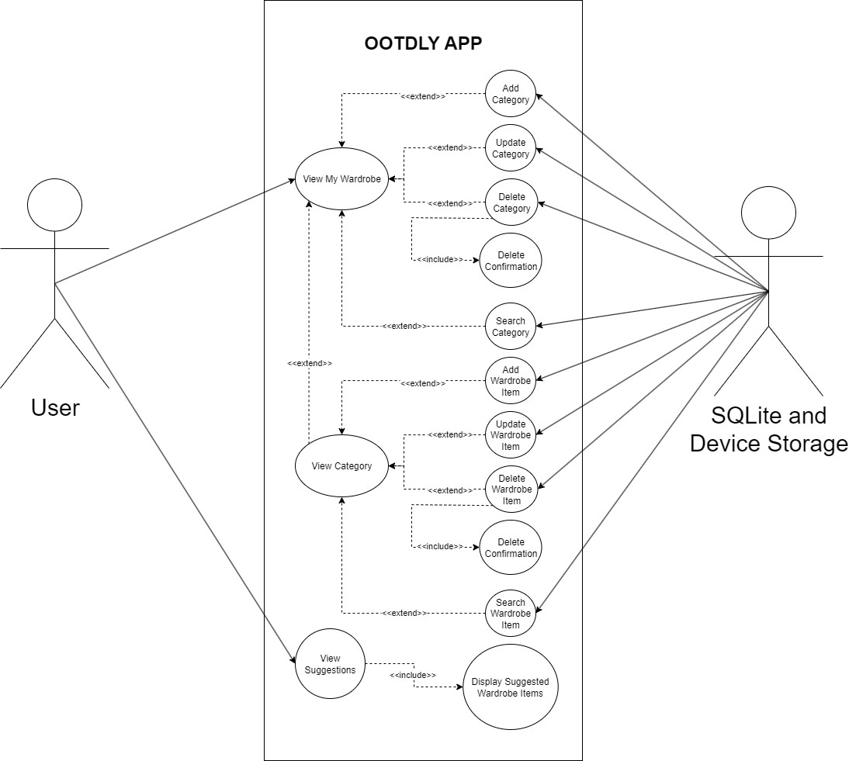
Figure No. 39: Use Case Diagram – Offline My Wardrobe Tab

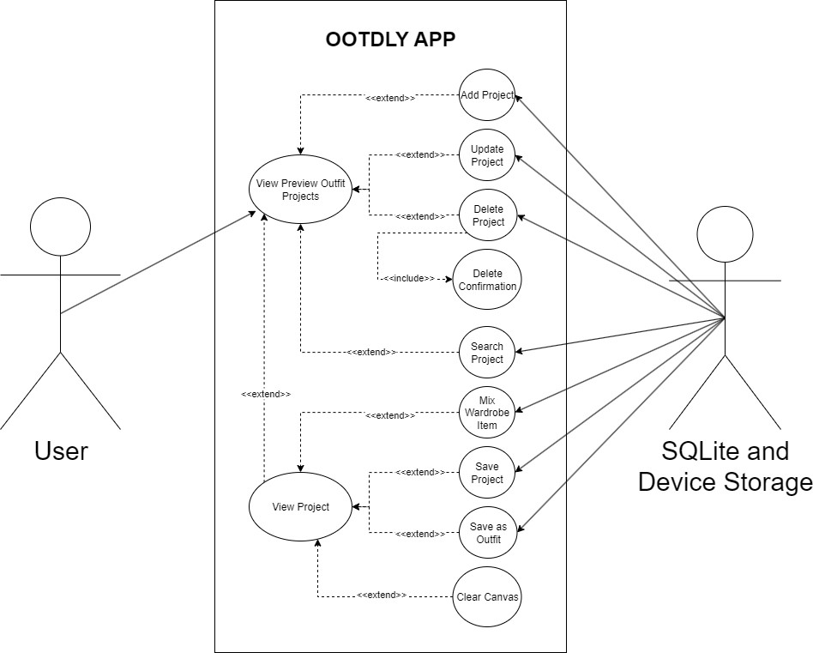

Figure No. 40: Use Case Diagram – Offline Preview Outfit

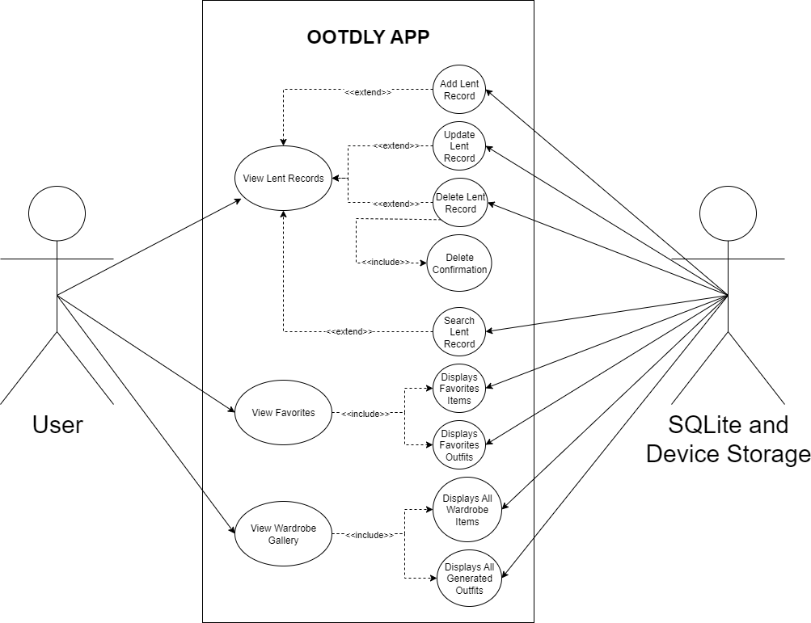

Figure No. 41: Use Case Diagram – Offline Lent Items / Outfits, Favorites, and Wardrobe Gallery

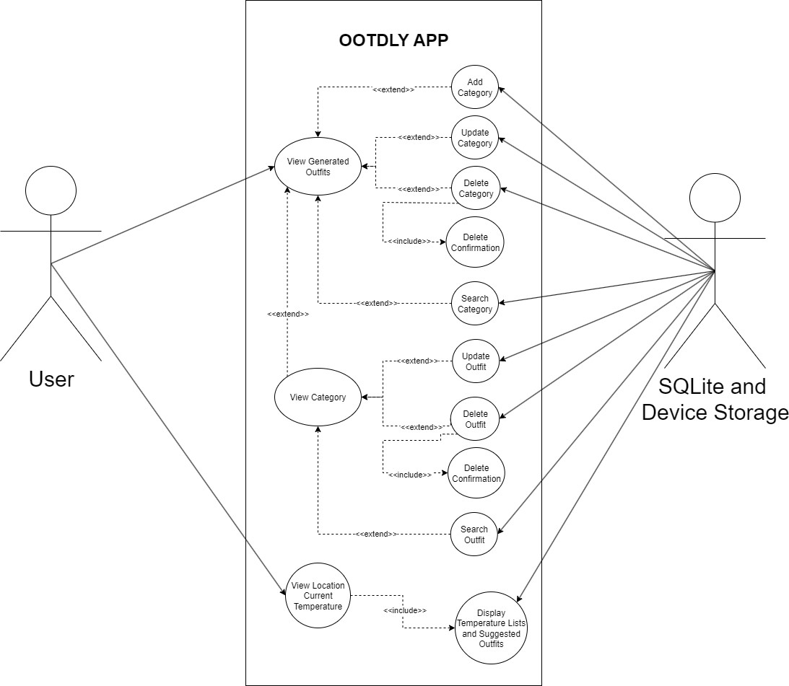
Figure No. 42: Use Case Diagram – Offline Generated Outfits and Location Temperature

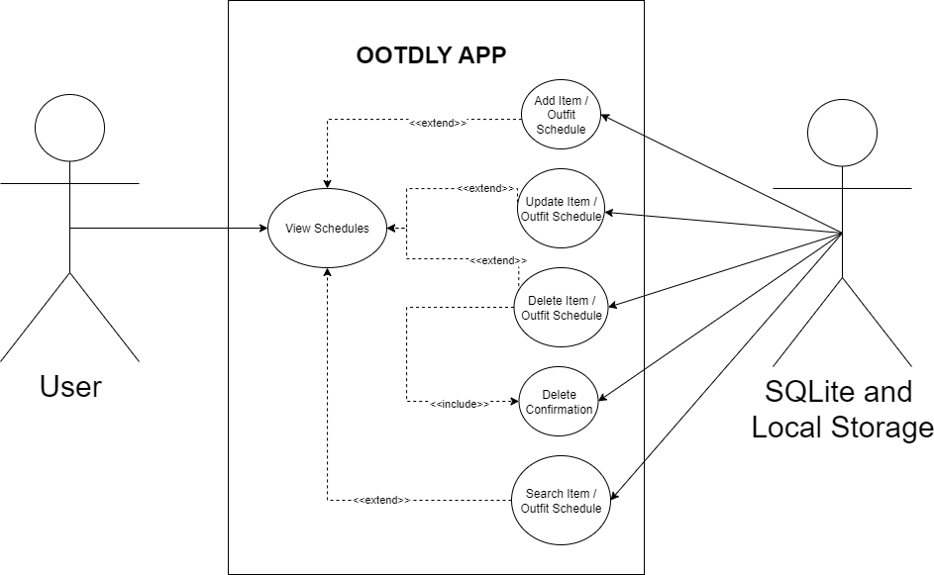
Figure No. 43: Use Case Diagram – Offline Calendar Tab

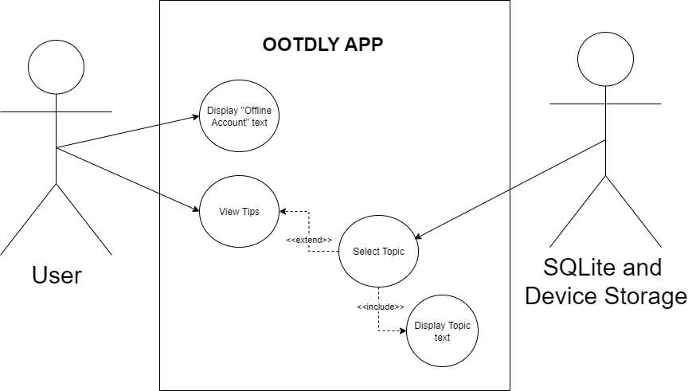
Figure No. 44: Use Case Diagram – Offline Profile Tab

- Sequence Diagram

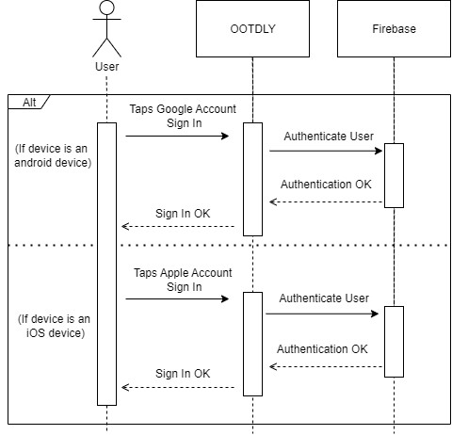

Figure No. 45: User Log In

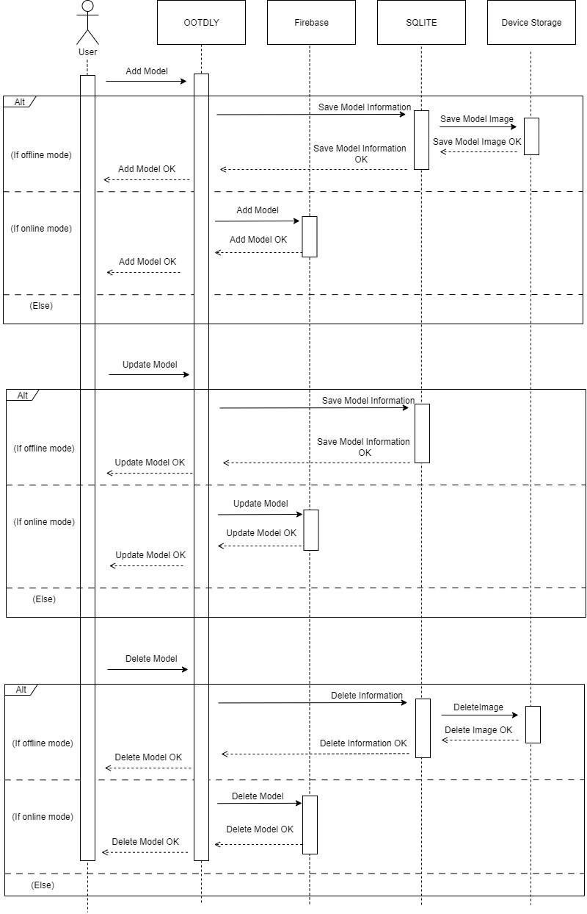
Figure No 46. Models Module
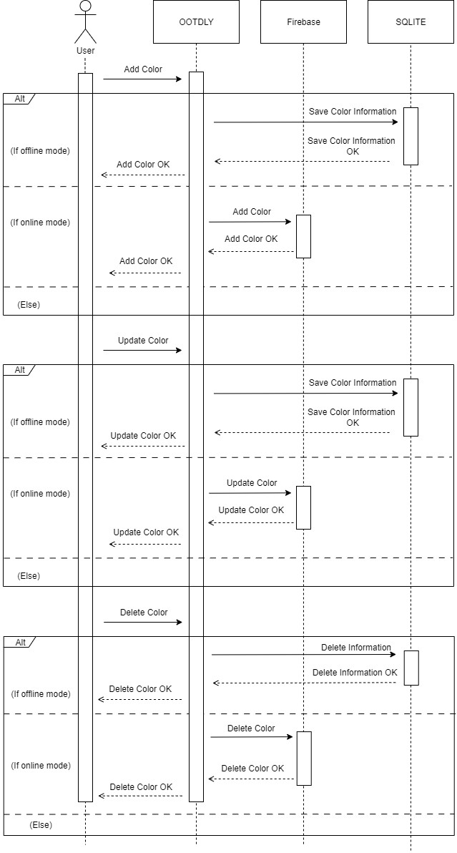

Figure No. 47: Colors Module
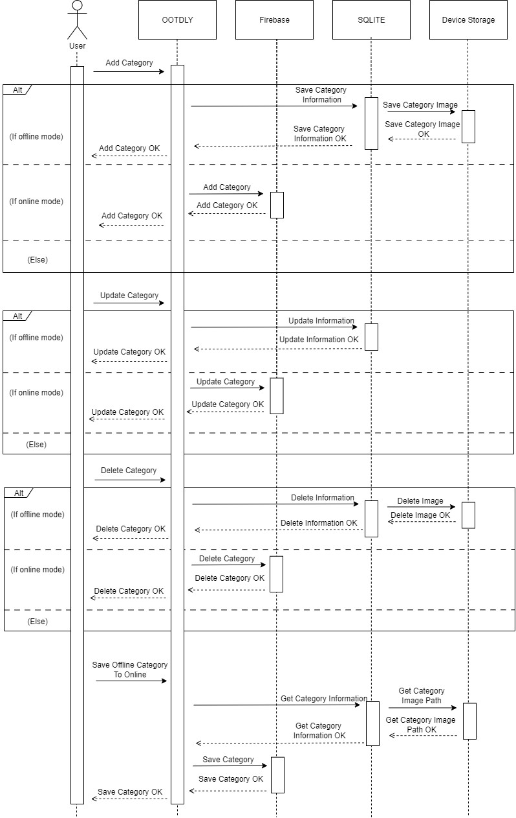

Figure No. 48: My Wardrobes Module 1
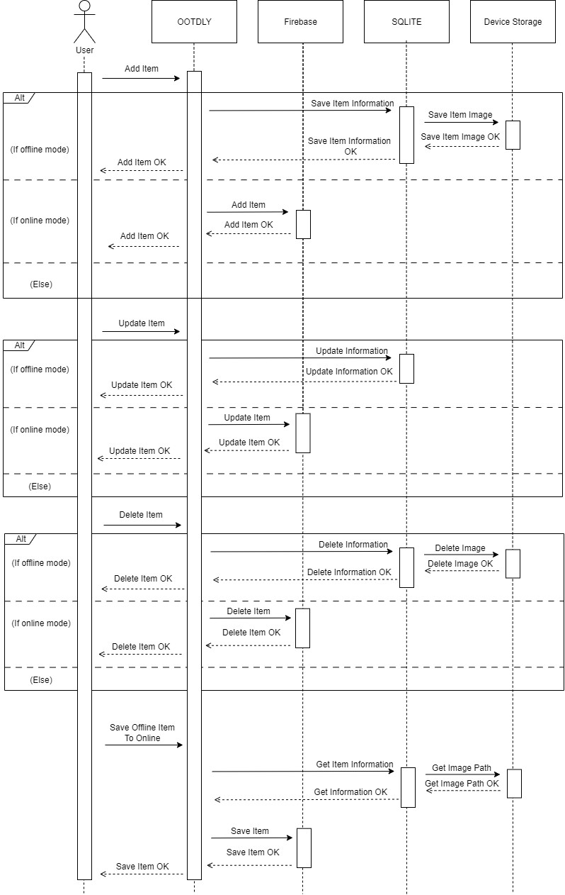
Figure No. 49: My Wardrobe Module 2
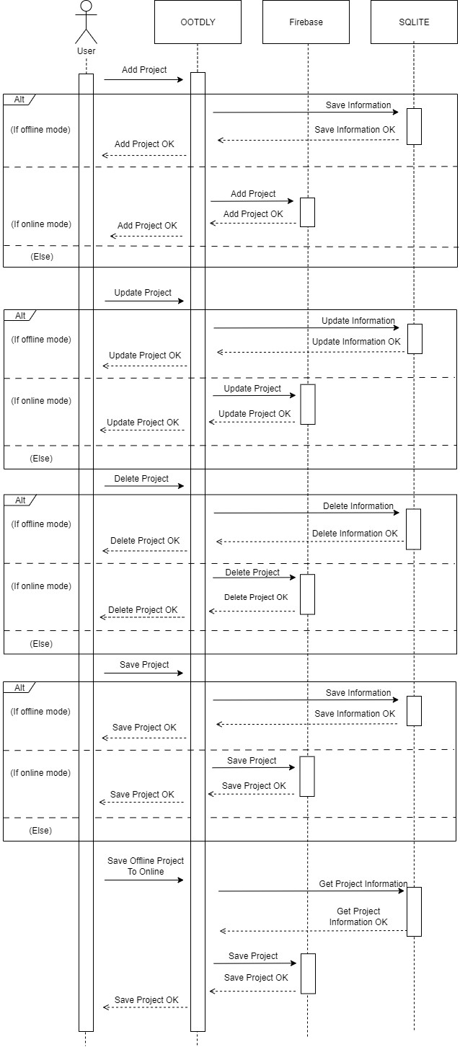

Figure No. 50: My Wardrobe Module 3



Figure No. 51: Preview Outfit Project CRUD
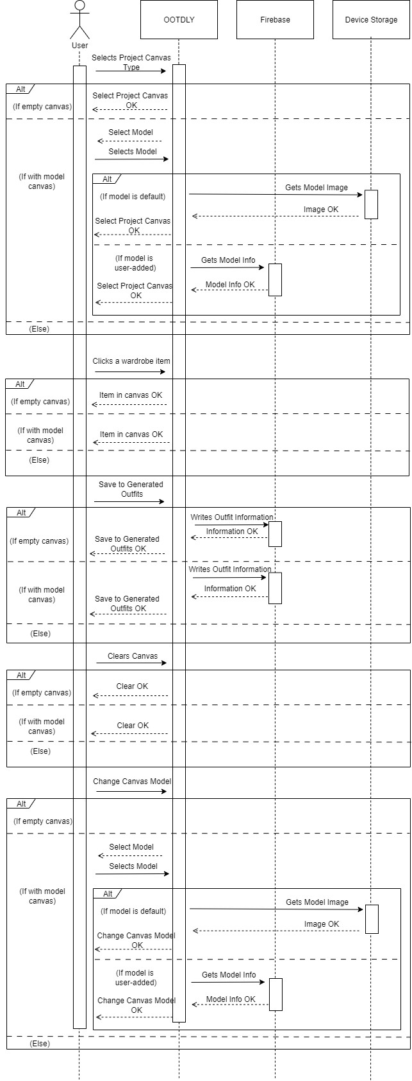
Figure No. 52: Preview Outfit Project Module 1

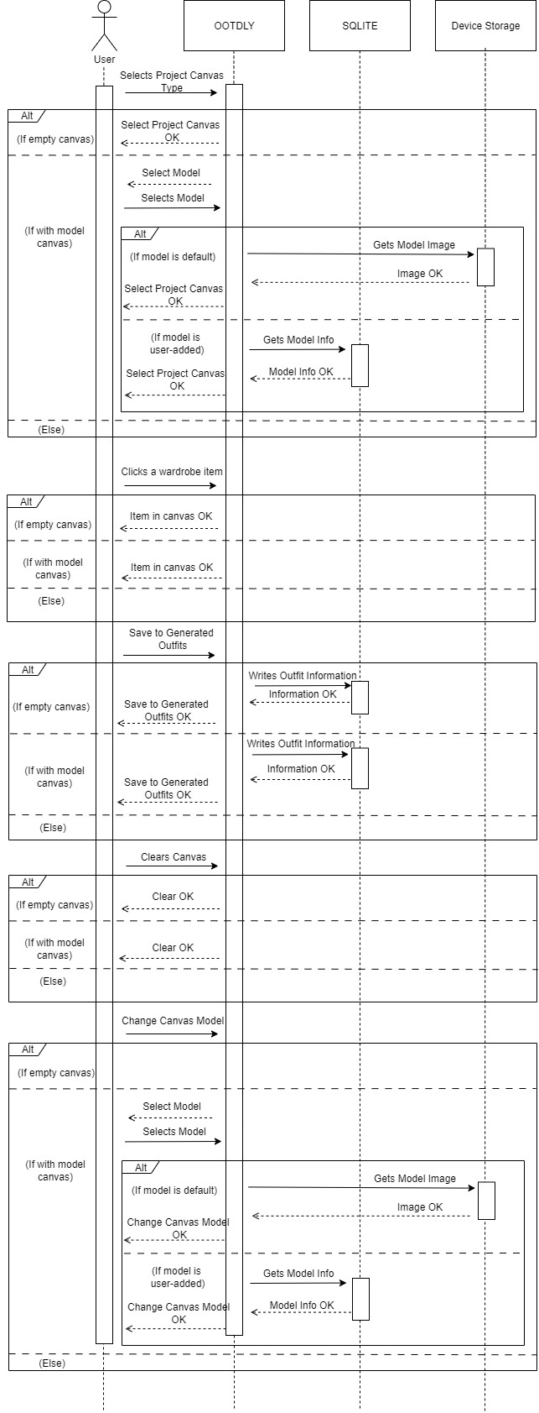

Figure No. 53: Preview Outfit Project Module 2

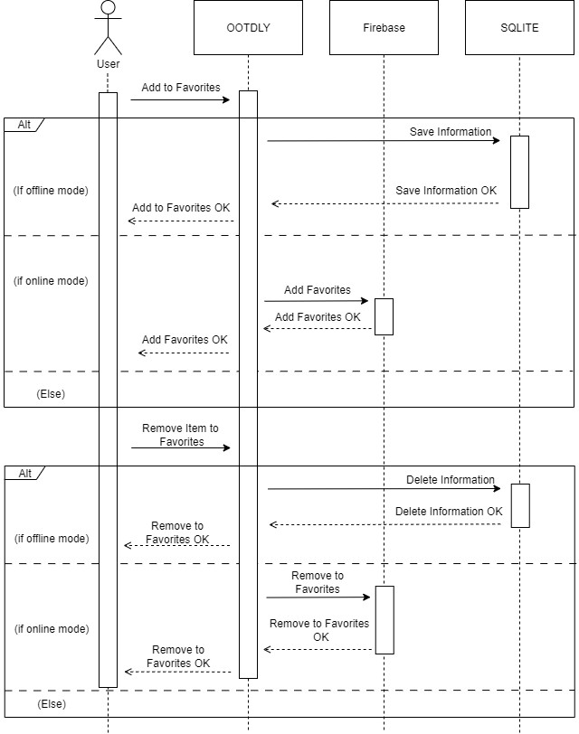

Figure No. 54: Favorites Module
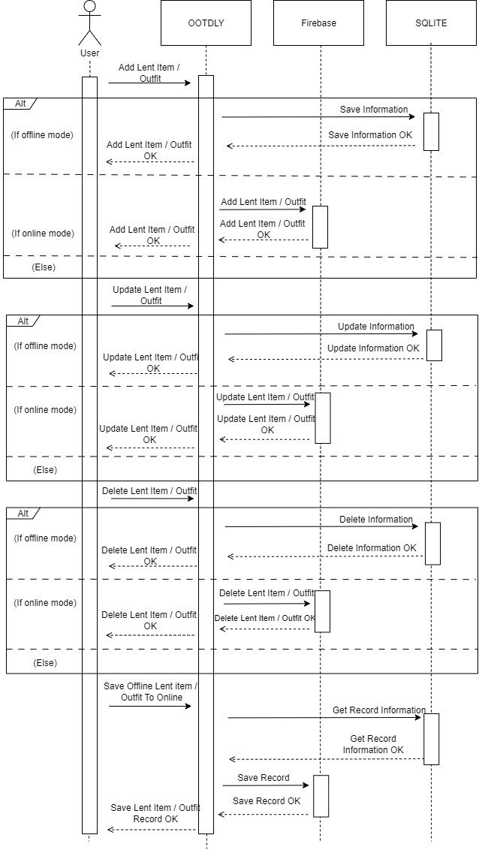
Figure No. 55: Lent Items / Outfits Module


Figure No. 56: Lent Items / Outfits

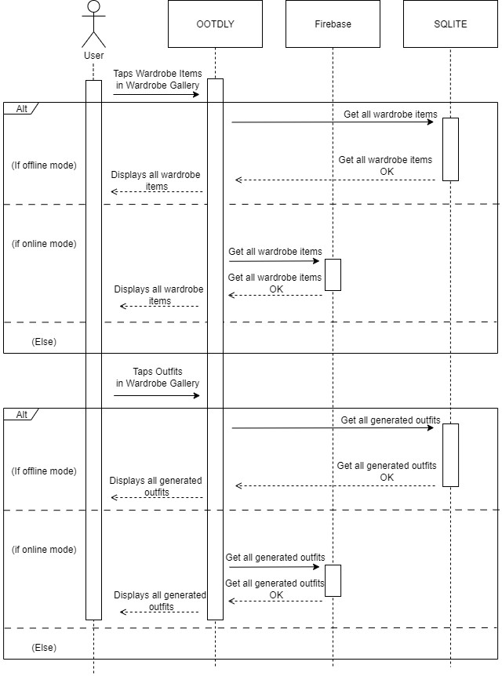

Figure No. 57: Wardrobe Gallery Items Module

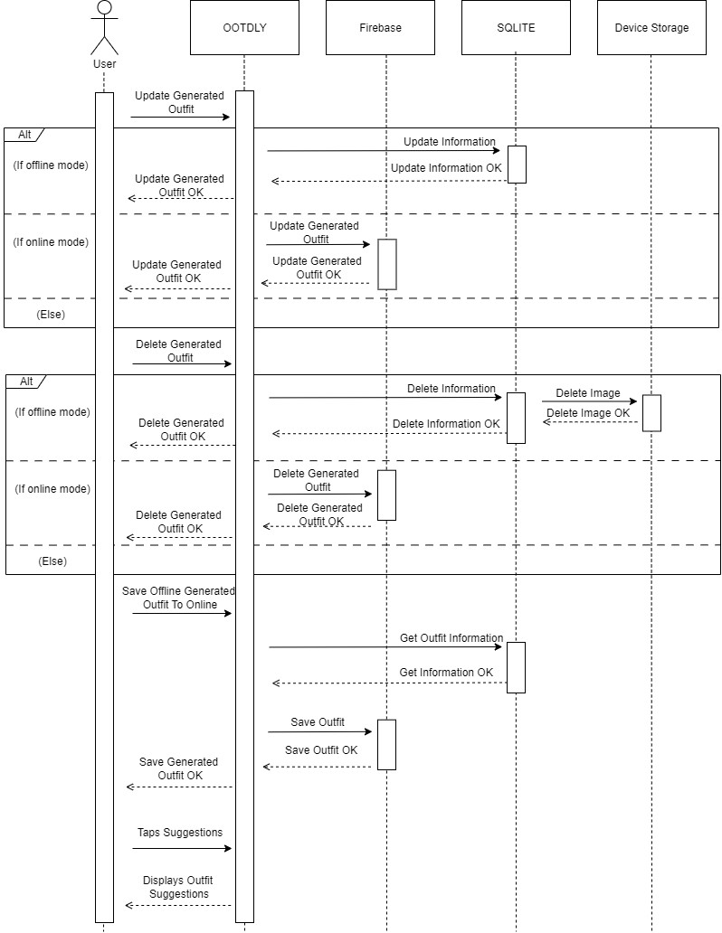

Figure No. 58: Generated Outfits Module

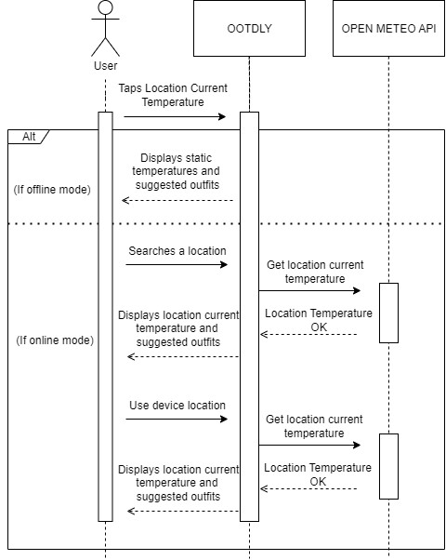

Figure No. 59: Location Temperature Module

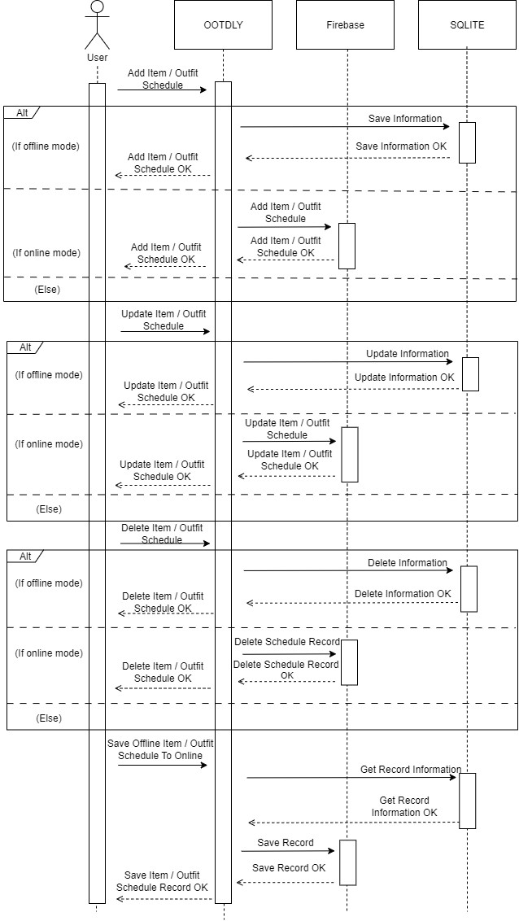

Figure No. 60: Calendar Tab Module

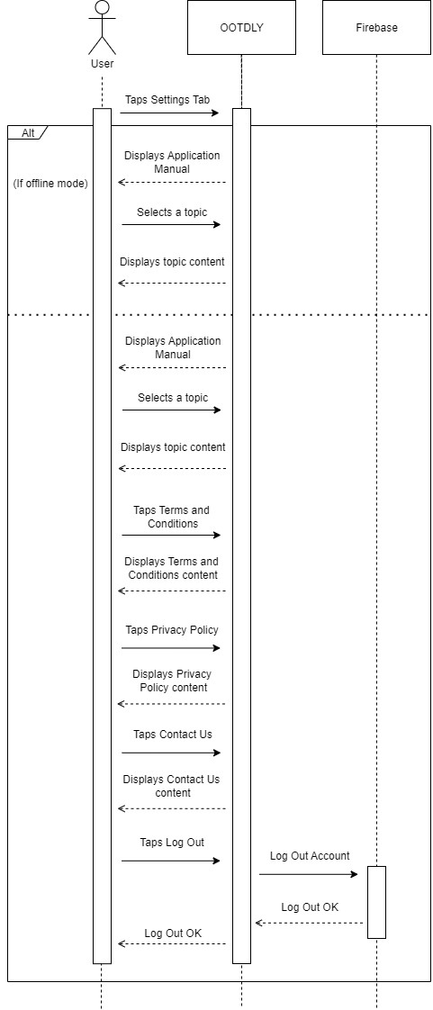

Figure No. 61: Profile Tab Module

C. Activity Diagram
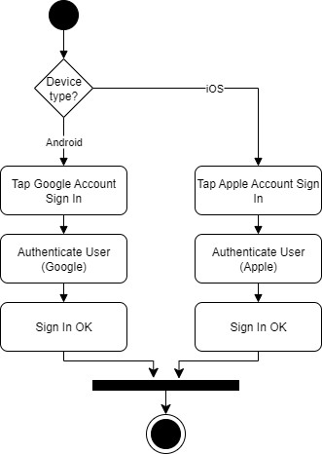

Figure No. 62: Activity Diagram – Login Module

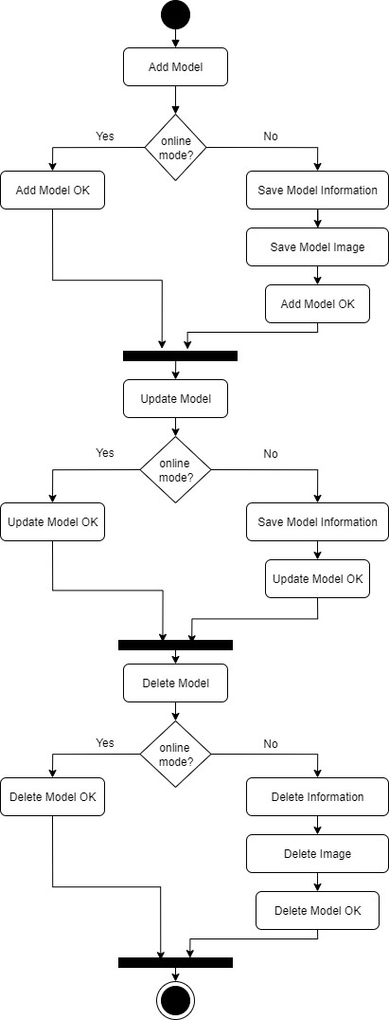

Figure No. 63: Activity Diagram – Models Module

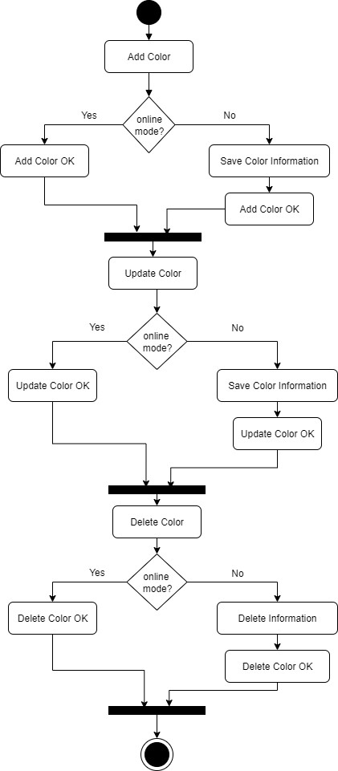
Figure No. 64: Activity Diagram – Colors Module

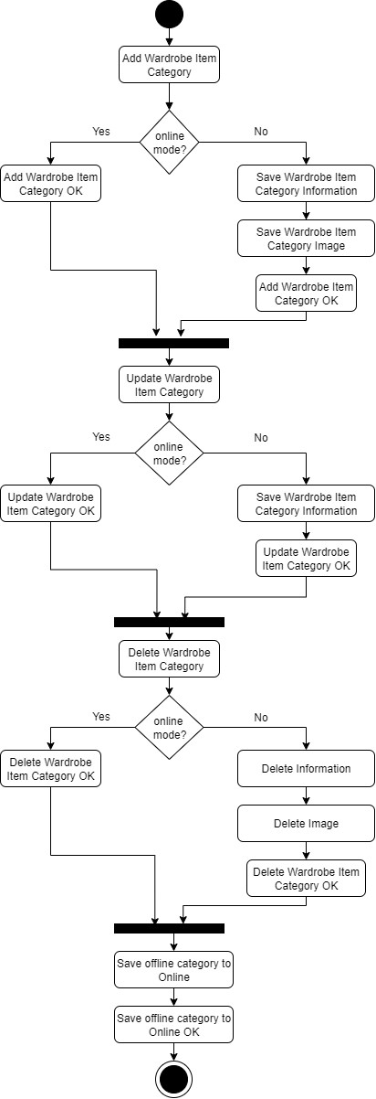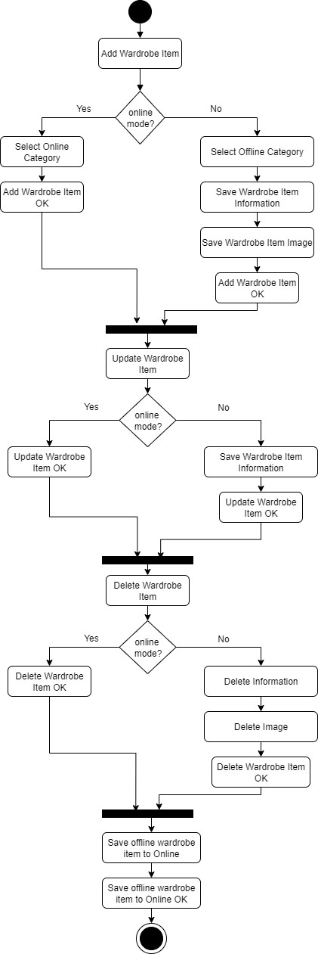

Figure No. 65: Activity Diagram – My Wardrobe Module
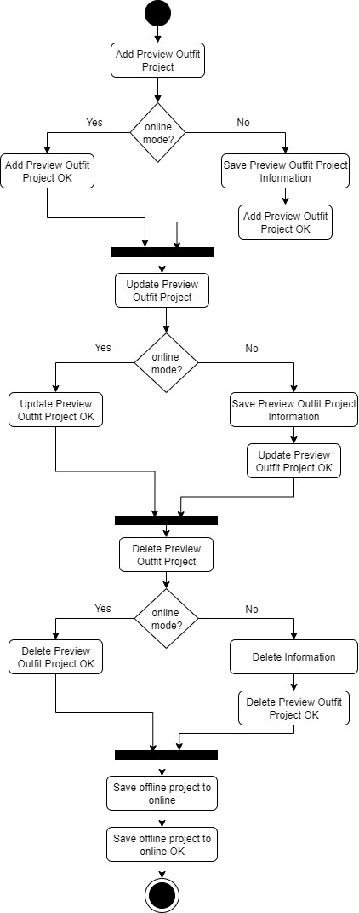
Figure No. 66: Activity Diagram – Preview Outfit Module

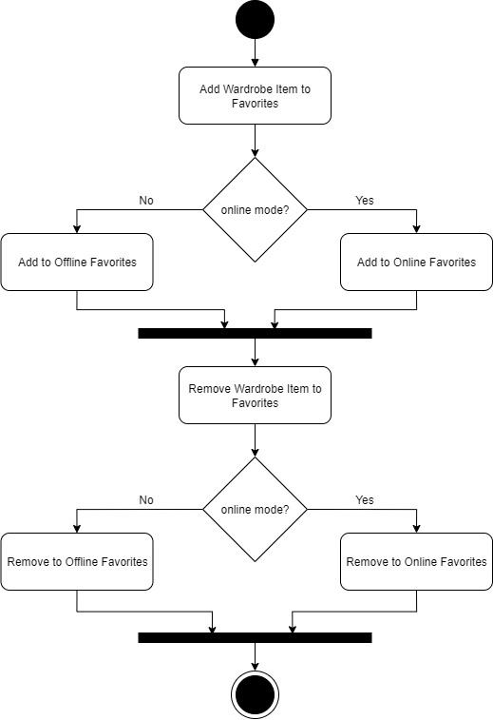

Figure No. 67: Activity Diagram – Favorites Module

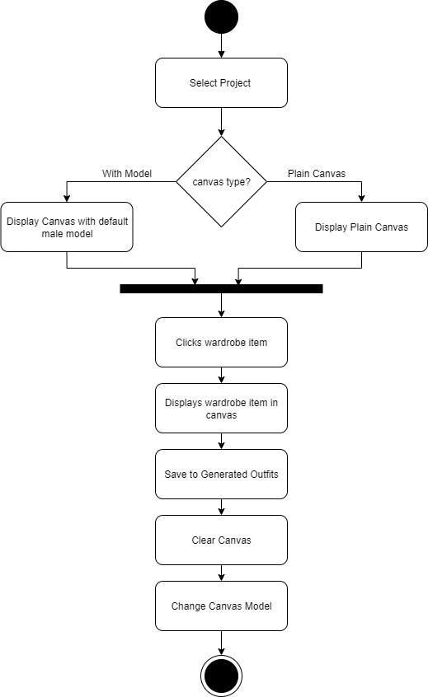

Figure No. 68: Activity Diagram – Add New Project Module 1


Figure No. 69: Activity Diagram – Add New Project Module 2
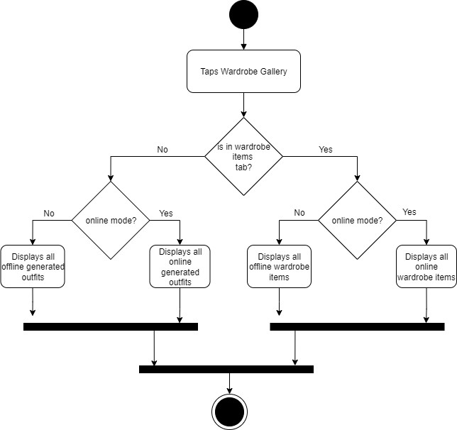
Figure No. 70: Activity Diagram – Wardrobe Gallery Module

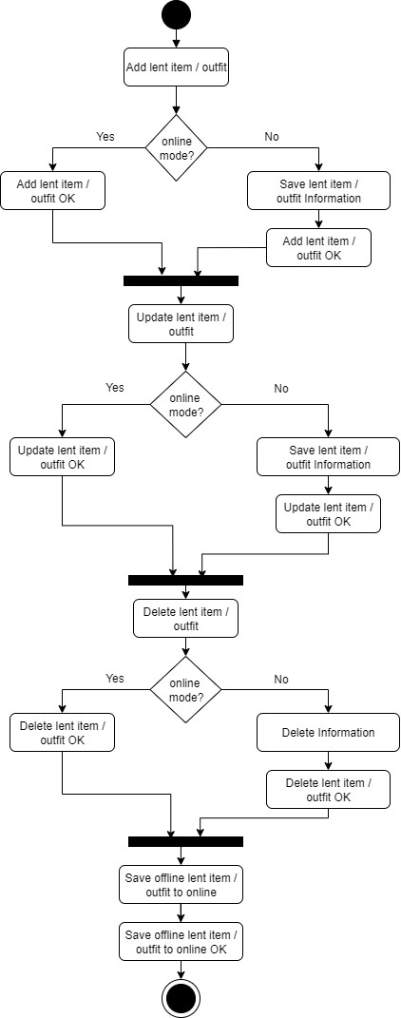
Figure No. 71: Activity Diagram – Lent Record Module

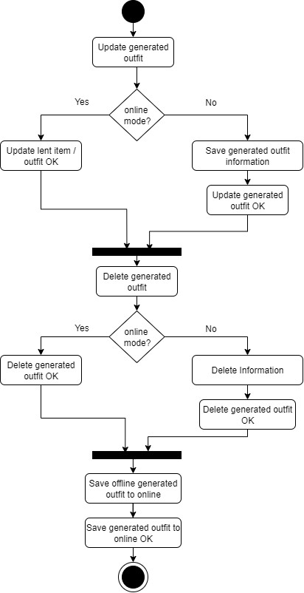
Figure No. 72: Activity Diagram – Generated Outfits Module
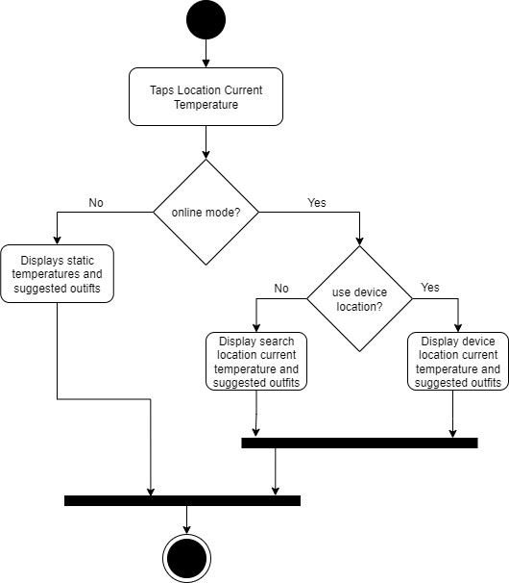

Figure No. 73: Activity Diagram – Location Temperature Module

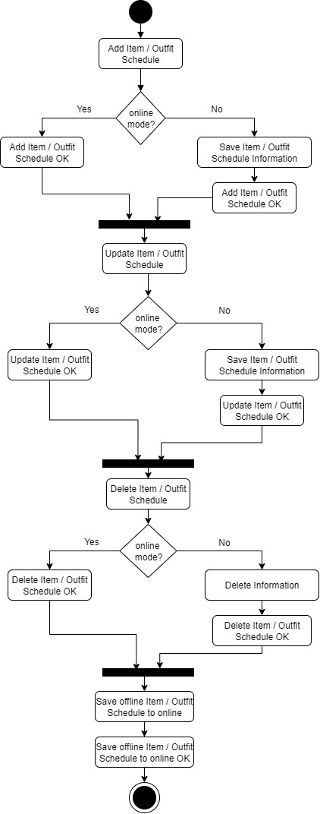

Figure No. 74: Activity Diagram – Calendar Tab Module
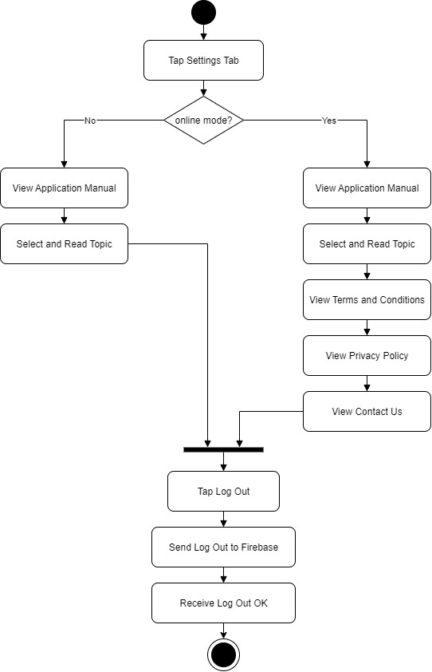

Figure No. 75: Activity Diagram –Profile Tab Module
4.2.6 Risk Assessment / Analysis
The proponents relied solely on online resources and guidance of adviser to develop the OOTDLY application. Implementing preview outfit canvas, and outfit scheduling was challenging because it required proper data handling and good algorithm. Interactive features, such as the ability to combine different wardrobe items to canvas and save as outfit, were also challenging, as the proponents needed to manage user actions. Online and offline modes were another challenging part because it required proper data sync to avoid conflicts. Additionally, ensuring the accurateness and functionality of schedule reminders and notifications increased the development complexity. To address these challenges, the proponents invested time and effort in learning about mobile application development.
4.3 Design
4.3.1 Output and User-interface Design Forms
The OOTDLY application had a simple and organized design. The main theme color, Amethyst (#B771E5), displayed a simple and stylish look, while Mauve (#CB9DF0) provided a lighter accent. Black and white were used for text and icons to keep everything readable.
Additional colors were used for different features. Mint Green (#80CA7E) highlighted positive actions, Salmon Pink (#F38484) indicated alerts, and Sky Blue (#7CC1E9) was used for buttons. These colors helped separate different sections of the app. The interface had a clean layout with clear labels. Buttons will be accurately sized for easy tapping, and appropriate icon usage helped users recognize features quickly.




(Hex: #CB9DF0) (Hex: #B771E5) (Hex: #000000) (Hex: #FFFFFF)
(Hex: #7CC1E9) (Hex: #F38484) (Hex: #80CA7E)




Figure No. 76: Color Palettes

The proponents chose Imprima and Roboto as the primary fonts for the application. Both fonts are known for their readability and modern design, making them suitable for various text elements. With multiple weights like regular and bold, they provided a clean and professional look.
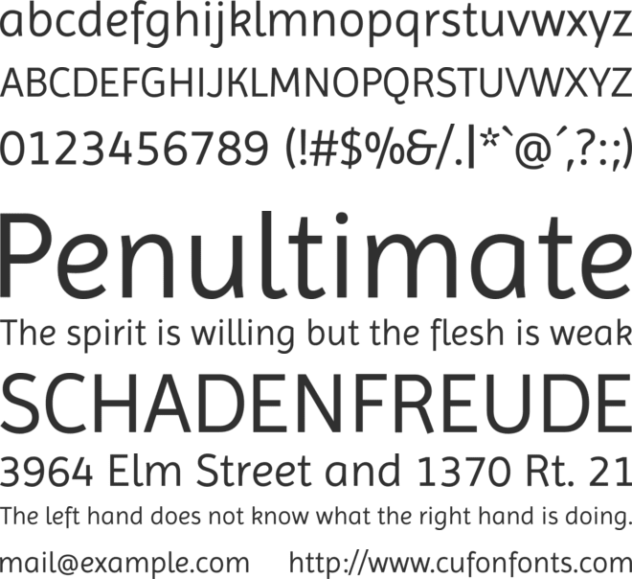

Figure No. 77: Imprima Font


Figure No. 78: Roboto Font

4.3.2 Application Logo
The proponents used the logo below for the application. The proponents selected the logo because the logo design is fit to the application.
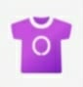

Figure No. 79: Application Logo

4.3.3 Data Design
A. Entity Relationship Diagram

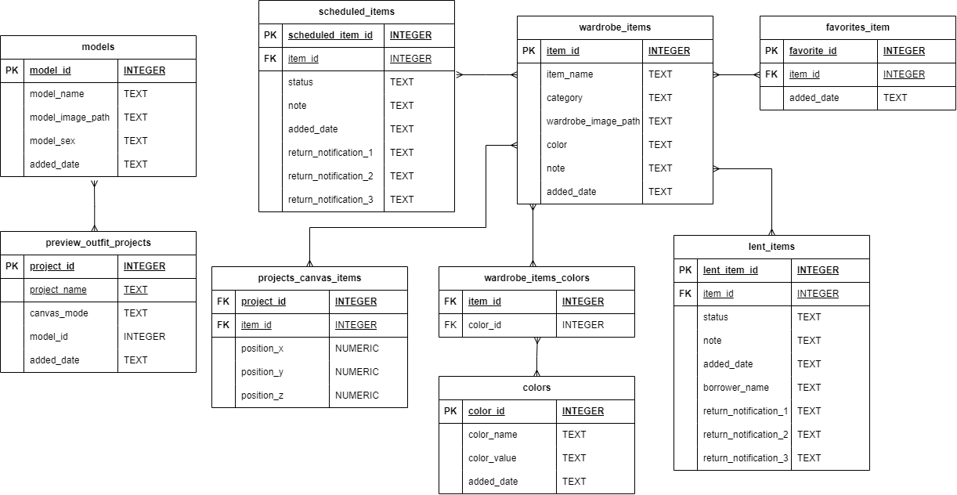

Figure No. 80: Entity Relationship Diagram
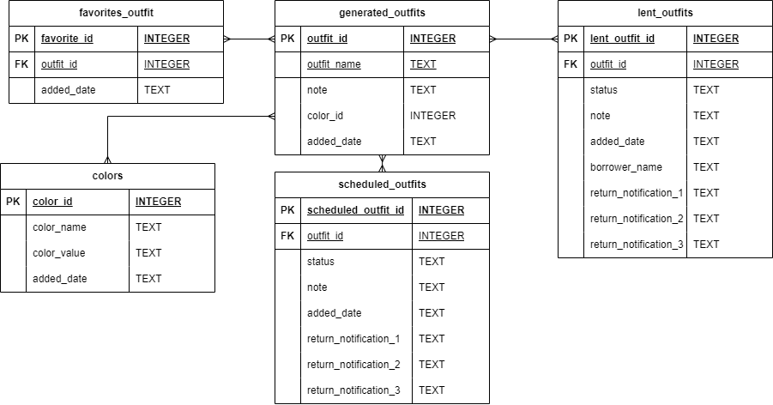
Figure No. 81: Entity Relationship Diagram

B. Data Dictionary

Table No. 12: Models

Column Name | Description | Data Type
model_id | Unique identification for each models. | INTEGER
model_name | Name of the model. | TEXT
model_image_path | Path of the model image to the local storage. | TEXT
model_sex | Indicates two options: Male of Female. | TEXT
added_date | The date and time when the model is added. | TEXT

Table No. 13: Colors

color_id | Unique identification for each color. | INTEGER
color_name | Name of the color. | TEXT
color_value | The color equivalent HEX value. | TEXT
added_date | The date and time when the color is added. | TEXT

Table No. 14: Wardrobe Items

item_id | Unique identification for each item. | INTEGER
item_name | Name of the item. | TEXT
category | The category of the item. | TEXT
wardrobe_image_path | The local path of the wardrobe item image. | TEXT
note | Note or details about the item. | TEXT
added_date | The date and time when the item is added. | TEXT

Table No. 15: Wardrobe Item Colors

item_id | The id of the wardrobe item | INTEGER
color_id | Unique identification for each color. | INTEGER

Table No. 16: Scheduled Items

scheduled_item_id | Unique identification for each scheduled item. | INTEGER
item_id | Unique identification for each item. | INTEGER
status | Indicates the status if coming or finished. | TEXT
note | Note or details about the scheduled item. | TEXT
added_date | The date and time when the item is added. | TEXT
return_notification_1 | The date and time for the first return notification. | TEXT
return_notification_2 | The date and time for the second return notification. | TEXT
return_notification_3 | The date and time for the third return notification. | TEXT

Table No. 17: Favorites Item

favorite_id | Unique identification for each favorite item. | INTEGER
item_id | Unique identification for each item. | INTEGER
added_date | The date and time when the item is added. | TEXT

Table No. 18: Lent Items

lent_item_id | Unique identification for each lent item. | INTEGER
item_id | Unique identification for each added outfit. | INTEGER
status | Indicates the status if returned or not. | TEXT
note | Note or details about the scheduled item. | TEXT
added_date | The date and time when the item is added. | TEXT
return_notification_1 | The date and time for the first return notification. | TEXT
return_notification_2 | The date and time for the second return notification. | TEXT
return_notification_3 | The date and time for the third return notification. | TEXT

Table No. 19: Generated Outfits

outfit_id | Unique identification for each added outfit. | INTEGER
outfit_name | The name of the outfit. | TEXT
note | Note or details about the scheduled item. | TEXT
color_id | Reference ID of the outfit color | INTEGER
added_date | The date and time when the item is added. | TEXT

Table No. 20: Lent Outfits

lent_outfit_id | Unique identification for each lent outfit. | INTEGER
outfit_id | Reference ID for the outfit. | INTEGER
status | Indicates the status if returned or not. | TEXT
note | Note or details about the scheduled item. | TEXT
added_date | The date and time when the item is added. | TEXT
return_notification_1 | The date and time for the first return notification. | TEXT
return_notification_2 | The date and time for the second return notification. | TEXT
return_notification_3 | The date and time for the third return notification. | TEXT

Table No. 21: Preview Outfit Projects

project_id | Unique identification for each project. | INTEGER
project_name | The name of the project. | TEXT
canvas_mode | Indicates if the canvas is empty or with model. | TEXT
model_id | Reference ID for the model on with model canvas. | INTEGER
added_date | The date and time when the project is added. | TEXT

Table No. 22: Project Canvas Items

project_id | Unique identification for each project. | INTEGER
item_id | Reference ID for the wardrobe item. | INTEGER
position_x | The x-axis position of an item. | NUMERIC
position _y | The y-axis position of an item. | NUMERIC
position _z | The z-index of an item. | NUMERIC

Table No. 23: Scheduled Outfits

scheduled_outfit_id | Unique identification for each scheduled outfit. | INTEGER
outfit_id | Unique identification for each added outfit. | INTEGER
status | Indicates the status if coming or finished. | TEXT
note | Note or details about the scheduled outfit. | TEXT
added_date | The date and time when the outfit is added. | TEXT
scheduled_date | The scheduled day for the outfit. | TEXT

Table No. 24: Favorites Outfits

favorite_id | Unique identification for each favorite outfit. | INTEGER
outfit_id | Reference ID for the outfit. | INTEGER
added_date | The date and time when the favorite outfit is added. | TEXT

4.3.3 System Architecture
A. Network Model
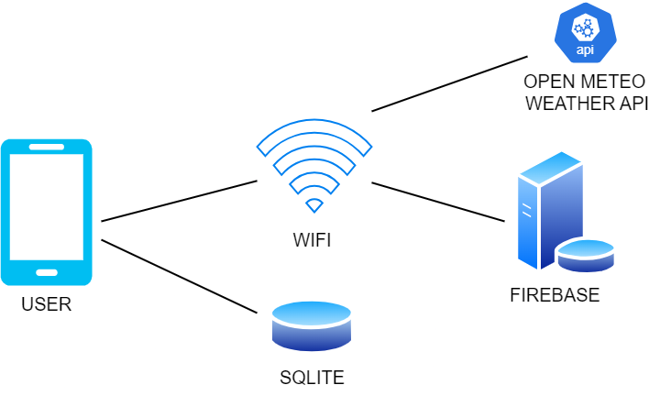
Figure No. 82: Network Model

B. Security
The application implement Google Account Registration and Google Account Log In to obtain access control. Only authenticated users were able to access online accounts.
B.1 Account Implementation
The OOTDLY application integrates Google Account Registration and Login as the primary method of authentication. This approach leverages Google's secure authentication infrastructure, allowing only authenticated users to access their online accounts within the application.
4.4.4 Program Specification
Table #: Program Specification of OOTDLY
Program Specification of OOTDLY: A MOBILE APP FOR ORGANIZING WARDROBES
User UI
Online Mode
Displays splash screen when application logo is
Displays Sign in with Google if the device is android device
Displays Sign in with Google and Sign in with Apple if the device is iOS device
Displays user signed in google accounts if device is android device
Displays user signed in icloud accounts if device is iOS device
Displays Home Tab when user selected an account
Module: Home Tab
Module : Models
Events:
Displays total model images
Displays View Models button
Displays Models screen when view models button is clicked
Displays Models screen name
Displays Models screen back arrow button
Displays Online Mode text
Displays reminder text about the two default models and user-added models
Displays the male and female default two models
Displays the user added models
Displays empty text field for model name search
Displays model based on model name in search input
Displays Add Model button
Displays Add Model screen when add model button was clicked
Display Add Model screen name
Display add model screen back arrow button
Displays auto background remove reminder text
Displays upload image icon button
Displays auto background remove toggle
displays select where to get the image text when upload image icon button is clicked
displays maximum file size for image and accepted image format text
displays camera option for image source
Displays background removed selected image from camera source if auto background remove is turned on
Displays raw image from camera source if auto background remove is turned off
displays gallery option for image source
Displays background removed selected image from gallery source if auto background remove is turned on
Displays raw image from gallery source if auto background remove is turned off
Displays “X” icon button on the selected image
Unselects the image when “X” icon button is clicked
Displays the upload image icon button when image is deselected
Displays the auto background remove toggle when image is deselected
Displays empty text field for model name
Displays empty dropdown for model sex selection : Male and Female
Displays the save button
Displays Incomplete Information error when name textfield is empty, model dropdown is empty, and no selected image when the save button is clicked
Displays File Too Large error when the selected image size is greater than 2MB when the save button is clicked
Display Success message dialog when the model is successfully saved
Navigates back to Models screen when “Ok” is clicked on the success message dialog
Displays Update Online Model screen when user-added model is clicked
Displays Update Online Model screen name
Displays Update Online Model back arrow button
Displays Online Mode text
Displays Model image
Displays an editable text field with the model name
Displays an editable dropdown with the value of the sex of the model
Displays save button
Displays Incomplete Information message dialog when there is empty model name in the text field
Displays success message dialog upon saving the model information
Displays delete model button
Displays delete model confirmation when delete model button is clicked
Navigates back to Model screen when delete button is clicked from delete model confirmation
Module : Colors
Events :
Displays total colors
Displays View Colors button
Displays Colors screen when view colors button is clicked
Displays Colors screen name
Displays Colors screen back arrow button
Displays Online Mode text
Displays reminder text about the default colors and user-added colors
Displays the 12 default colors from the color wheel
Displays user-added colors
Displays Add Color button
Displays Add New Color screen when add color button is clicked
Displays online mode text
Displays reminder about hex value input of the color
Displays a box to display the color of the selected or entered color
Displays a click here to pick color text button
Display empty text field for color name
Displays empty text field for color hex value
Display save button
Displays Incomplete error dialog when color name or hex value is empty or hex value is invalid
Display success message when color is successfully saved
Navigates back to colors screen when “Ok” is clicked on the success message saved color
Displays update color screen when user added color is clicked
Displays text field with color name
Displays text field with color hex value
Displays update button
Displays delete button
Displays error message dialog when color name or color hex value is set to empty
Display delete confirmation when delete color is clicked
Navigates back to Colors screen when “Ok” in success message is clicked
Navigates back to Colors screen when “Delete” in delete confirmation is clicked
Displays color combinations button
Displays color combinations screen name
Displays color combinations screen arrow back button
Displays color combination reminder text
Displays suggested colors with suggested combinations
Module : Total Wardrobe Items Module
Events :
Displays the total number of user added wardrobe items
Module : Total Generated Outfits Module
Events :
Displays the total number of user generated outfits
Module : Total Lent Items and Outfits
Events :
Displays the total number of user lent items and outfits
Module: Wardrobe Tab
Events:
Displays Categories Text
Displays Arrow back button
Displays Offline Categories button
Displays Online Categories button when Online Categories button is clicked
Displays Search Category Text field
Displays Ten default Category
Displays Saved to online Category Status
Displays Saved to offline Category Status
Displays Save to online Category Status
Displays Save to offline Category Status
Displays “+” Add New Category button
Modules: Add New Category
Events:
Displays add New Category text
Displays arrow back button
Displays auto background remove reminder text
Displays upload image button
Displays auto background remove toggle
Displays select where to get the image text when upload image icon button is clicked
Displays maximum file size for image and accepted image format text
Displays camera option for image source
Displays background removed selected image from camera source if auto background remove is turned on
Displays raw image from camera source if auto background remove is turned off
Displays “X” icon button on the selected image
Unselects the image when “X” icon button is clicked
Displays the upload image icon button when image is deselected
Displays the auto background remove toggle when image is deselected
Displays empty text field for Category name
Displays the save button
Displays Incomplete Information error when name textfield is empty and no selected image when the save button is clicked
Displays File Too Large error when the selected image size is greater than 2MB when the save button is clicked
Displays Success message dialog when the Category is successfully saved
Navigates back to Categories screen when “Ok” is clicked on the success message dialog
Module: Update Button from Category Items
Events:
Displays Update Category screen when Update Category button is clicked
Displays Update Category screen name
Displays auto background remove reminder text
Display present image
Displays “X” icon button on the selected image
Displays auto background remove toggle
Displays select where to get the image text when upload image icon button is clicked
Displays maximum file size for image and accepted image format text
Displays camera option for image source
Displays background removed selected image from camera source if auto background remove is turned on
Displays raw image from camera source if auto background remove is turned off
Unselects the image when “X” icon button is clicked
Displays the upload image icon button when image is deselected
Displays the auto background remove toggle when image is deselected
Displays present Category name
Displays the save button
Displays the delete button
Displays Incomplete Information error when name text field is empty and no selected image when the save button is clicked
Displays File Too Large error when the selected image size is greater than 2MB when the save button is clicked
Displays Success message dialog when the Category is successfully saved
Displays Delete message dialog when the delete button is clicked
Displays Success message dialog when the Category is successfully deleted
Navigates back to Categories screen when “Ok” is clicked on the success message dialog
Module: Wardrobe Online Items
Events:
Displays Wardrobe name Items
Displays Arrow back button
Displays Edit button text field
Displays Empty “Search items” text field
Displays Wardrobe items
Displays Add to favorite in Wardrobes items
Displays From Offline in Wardrobe items
Displays Add new Item button
Displays Suggestion button
Module: Wardrobe Offline Items
Events:
Displays Wardrobe name Items
Displays Arrow back button
Displays Edit button text field
Displays Empty “Search items” text field
Displays Wardrobe items
Displays Saved to Offline in Wardrobe items
Displays Save to Online in Wardrobe items
Displays Add new Item button
Displays Suggestion button
Module: Add New item button from Online and Offline
Events:
Displays Add new Item Text
Displays Arrow back button
Displays auto background remove reminder text
Display upload image button
Displays auto background remove toggle
Displays select where to get the image text when upload image icon button is clicked
Displays maximum file size for image and accepted image format text
Displays camera option and Stock for image source
Displays background removed selected image from camera source if auto background remove is turned on
Displays raw image from camera source if auto background remove is turned off
Displays “X” icon button on the selected image
Unselects the image when “X” icon button is clicked
Displays the upload image icon button when image is deselected
Displays the auto background remove toggle when image is deselected
Displays empty text field for new item
Displays dropdown button for color when dropdown button is clicked
Displays note text field
Displays save button
Displays Incomplete Information error when name text field is empty and no selected image when the save button is clicked
Displays File Too Large error when the selected image size is greater than 2MB when the save button is clicked
Display Success message dialog when the New Item is successfully saved
Module: Update button from Wardrobe items
Events:
Displays Update Wardrobe Items screen when Update Wardrobe item button is clicked
Displays Update Wardrobe item screen name
Displays Note “You can change the wardrobe items”
Displays the Present Wardrobe item name
Displays the Present Color item
Displays the present Note
Displays the Save button
Displays the Delete button
Displays Success message dialog when the Update Wardrobe items is successfully saved
Displays Delete message dialog when the delete button is clicked
Displays Success message dialog when the Update Wardrobe item is successfully deleted
Navigates back to Wardrobe Items screen when “Ok” is clicked on the success message dialog
Module: Wardrobe Items Suggestion
Events:
Displays Items suggestion screen name
Displays Arrow back button
Displays text about suggestion wardrobe items
Displays images of example wardrobe items
Module: Preview Outfits
Events
Displays Preview Outfits Projects screen name
Displays Arrow back button
Displays Online Projects button
Displays Empty “Search items” text field
Displays List of Online Projects
Displays From offline in the project list
Displays “+” Add new Project button
Module: Add New Project Button
Events:
Displays Add New Project screen name
Displays Arrow back button
Displays Project name text field
Displays Canvas Mode Text
Displays Plain Canvas image button
Displays With model image button
Displays Create Project text button
Module: Plain Canvas Button
Events:
Displays Project name text screen name
Displays Arrow back button
Displays Empty Canvas
Displays Clear Button
Displays Save Project Button
Displays Save Outfit Button
Displays Select Category text
Displays Empty Search Category items
Displays List of Category items
Module: With Model Button
Events:
Displays Project name text screen name
Displays Arrow back button
Displays Change model button
Displays List of model and empty search text field when the change model button is clicked
Displays Empty Canvas With Model
Displays Clear Button
Displays Save Project Button
Displays Save Outfit Button
Displays Select Category text
Displays Empty Search Category items
Displays List of Category items to allow user to choose category where to save the combined wardrobe items as outfit.
Module: Save Outfit Button
Events
Displays Save outfit text screen name
Displays Arrow back button
Displays the created project outfit
Displays text field of the project outfit
Displays empty Color
Displays color when the dropdown button is clicked
Displays text field for Note
Displays Save Outfit button
Displays Success message dialog when the Project Outfit is successfully saved
Module: Edit Projects
Events
Displays Edited Project text screen name
Displays Arrow back button
Displays project name text field
Displays Save button
Displays Success message dialog when the Update Project Outfit is successfully saved
Displays the Delete button
Displays Success message dialog when the Update Project Outfit is successfully deleted
Module: Favorites
Events:
Displays Favorite text screen name
Displays Arrow Back button
Displays Items Button
Displays List of Favorite items when Items button is clicked
Displays Outfits Button
Displays List of Favorite Outfits when Outfits button is clicked
Module: Wardrobe Gallery
Events:
Displays Wardrobe Gallery text screen name
Displays Arrow Back button
Displays Items Button
Displays List of items when Items button is clicked
Displays Outfits Button
Displays List of Outfits when Outfits button is clicked
Module: Lent Items
Events:
Displays Lent Items / Outfits Text screen name
Displays Arrow Back button
Displays Calendar
Module: Add Lent Record button
Events
Displays Add Lent Item / Outfit screen name
Displays Arrow back button
Displays note about generated outfit and barrower outfit
Displays Add image button
Displays Empty text field for borrower name
Displays Empty Text field for Note
Displays Save button
Displays two option for Item and outfit when “+” add image button is clicked
Displays reminder note about items and generated outfits
Displays Success message dialog when the Lent Item / Outfit is successfully saved
Module: Update Lent Items / Outfits
Events:
Displays Add Update Lent Item / Outfit screen name
Displays Arrow back button
Displays Current Lent Items / Outfits
Displays borrower name
Displays Note
Displays Returned Status
Displays Save button
Displays Save Delete Button
Displays Success message dialog when the Update Lent Item / Outfit is successfully saved
Displays two options yes or no when the Delete button is clicked
Displays Success message dialog when the Update Lent Item / Outfit is successfully deleted
Module: Generated Items
Events:
Displays Categories text screen name
Displays Arrow back button
Displays Empty Search text field
Displays list of Categories
Displays “+” Add new Category
Displays Add new category when add new category button is clicked
Displays arrow back button
Displays auto background remove reminder text
Displays select where to get the image text when upload image icon button is clicked
Displays maximum file size for image and accepted image format text
Displays background removed selected image from camera source if auto background remove is turned on
Displays raw image from camera source if auto background remove is turned off
Displays “X” icon button on the selected image
Unselects the image when “X” icon button is clicked
Displays the upload image icon button when image is deselected
Displays the auto background remove toggle when image is deselected
Displays empty text field for new category item
Displays Save button
Displays Incomplete Information error when name text field is empty and no selected image when the save button is clicked
Displays File Too Large error when the selected image size is greater than 2MB when the save button is clicked
Display Success message dialog when the New Category Item is successfully saved
Displays Update category when update category button is clicked
Displays Update category text screen name
Displays arrow back button
Displays current image category item
Displays current category name
Displays Save button
Displays Delete button
Displays two options yes or no when the Delete button is clicked
Displays Success message dialog when the Update Category Item is successfully deleted
Display Success message dialog when the Update Category Item is successfully saved
Module: Location Current Temperature
Events:
Displays Location Temperature text screen name
Displays arrow back button
Displays reminder note about device location
Displays Search text field for location
Displays current temperature and outfit to wear when the location device is on
Module: Calendar Tab
Events:
Displays Item / Outfit Scheduling text screen name
Displays current calendar date
Displays the four tabs home, wardrobe, calendar, and settings
Module: Online schedule button
Events:
Displays the current date
Displays Empty search Textfield
Displays “+” Add button
Module: Add button from Online schedules
Events:
Displays Add Item / Outfit Scheduling screen name
Displays Arrow back button
Displays note about generated outfit and barrower outfit
Displays Add image button
Displays Empty Text field for Note
Displays Save button
Displays two option for Item and outfit when “+” add image button is clicked
Displays reminder note about items and generated outfits
Displays Success message dialog when the Item / Outfit Scheduling is successfully saved
Module: Update Schedule Item / Outfit from Outfit Scheduling
Events:
Displays Update Schedule Item / Outfit text screen name
Displays Arrow back button
Displays Current image item / outfit
Displays Current Date
Displays Note
Displays Save button
Displays Delete button
Displays two option for Item and outfit when “+” add image button is clicked
Displays reminder note about items and generated outfits
Displays two options yes or no when the Delete button is clicked
Displays Success message dialog when the Update Item / Outfit Scheduling is successfully deleted
Displays Success message dialog when the Update Item / Outfit Scheduling is successfully saved
Settings Tab
Module : Account Information Module
Displays the signed in google account first name and last name
Displays the signed in google account email
Displays online mode
Module : Terms and Conditions Module
Events :
Displays the terms and condition text
Module: Delete Account Module
Events:
Displays the Delete Account screen name
Displays Arrow Back button
Displays note about Account Deletion Warning
Displays note about What happens when you delete your account
Displays four confirmation check box
Displays note for help and contact support team
Displays Delete Account Button
Displays confirmation message “Are you absolutely sure you want to permanently delete your account? This action cannot be undone. With two options “Cancel” and “Delete Forever”” When Delete Account button is Clicked.
Stay in the current module when “Cancel” button is clicked.
Navigate to login module when the “Delete Forever” is clicked
Module : Privacy Policy Module
Events :
Displays the privacy policy text
Module : Contact Us Module
Events :
Displays the Contact information text
Module : Application Guide Module
Events :
Displays the application guide topics
Displays a “Tips” button on topics
Navigates to the topic page when “View More” button is clicked
Module : Log Out Module
Events :
Displays Log Out button

Offline Mode
Displays splash screen when application logo is
Displays Home Tab
Module: Home Tab
Module : Models
Events:
Displays total model images
Displays View Models button
Displays Models screen when view models button is clicked
Displays Models screen name
Displays Models screen back arrow button
Displays Online Mode text
Displays reminder text about the two default models and user-added models
Displays the male and female default two models
Displays the user added models
Displays empty text field for model name search
Displays model based on model name in search input
Displays Add Model button
Displays Add Model screen when add model button was clicked
Display Add Model screen name
Display add model screen back arrow button
Displays auto background remove reminder text
Displays upload image icon button
Displays auto background remove toggle
displays select where to get the image text when upload image icon button is clicked
displays maximum file size for image and accepted image format text
displays camera option for image source
Displays background removed selected image from camera source if auto background remove is turned on
Displays raw image from camera source if auto background remove is turned off
displays gallery option for image source
Displays background removed selected image from gallery source if auto background remove is turned on
Displays raw image from gallery source if auto background remove is turned off
Displays “X” icon button on the selected image
Unselects the image when “X” icon button is clicked
Displays the upload image icon button when image is deselected
Displays the auto background remove toggle when image is deselected
Displays empty text field for model name
Displays empty dropdown for model sex selection : Male and Female
Displays the save button
Displays Incomplete Information error when name textfield is empty, model dropdown is empty, and no selected image when the save button is clicked
Displays File Too Large error when the selected image size is greater than 2MB when the save button is clicked
Display Success message dialog when the model is successfully saved
Navigates back to Models screen when “Ok” is clicked on the success message dialog
Displays Update Model screen when user-added model is clicked
Displays Update Model screen name
Displays Update Model back arrow button
Displays Offline Mode text
Displays Model image
Displays an editable text field with the model name
Displays an editable dropdown with the value of the sex of the model
Displays save button
Displays Incomplete Information message dialog when there is empty model name in the text field
Displays success message dialog upon saving the model information
Displays delete model button
Displays delete model confirmation when delete model button is clicked
Navigates back to Model screen when delete button is clicked from delete model confirmation
Module : Colors
Events :
Displays total colors
Displays View Colors button
Displays Colors screen when view colors button is clicked
Displays Colors screen name
Displays Colors screen back arrow button
Displays Online Mode text
Displays reminder text about the default colors and user-added colors
Displays the 12 default colors from the color wheel
Displays user-added colors
Displays Add Color button
Displays Add New Color screen when add color button is clicked
Displays online mode text
Displays reminder about hex value input of the color
Displays a box to display the color of the selected or entered color
Displays a click here to pick color text button
Display empty text field for color name
Displays empty text field for color hex value
Display save button
Displays Incomplete error dialog when color name or hex value is empty or hex value is invalid
Display success message when color is successfully saved
Navigates back to colors screen when “Ok” is clicked on the success message saved color
Displays update color screen when user added color is clicked
Displays text field with color name
Displays text field with color hex value
Displays update button
Displays delete button
Displays error message dialog when color name or color hex value is set to empty
Display delete confirmation when delete color is clicked
Navigates back to Colors screen when “Ok” in success message is clicked
Navigates back to Colors screen when “Delete” in delete confirmation is clicked
Displays color combinations button
Displays color combinations screen name
Displays color combinations screen arrow back button
Displays color combination reminder text
Displays suggested colors with suggested combinations
Module : Total Wardrobe Items Module
Events :
Displays the total number of user added wardrobe items
Module : Total Generated Outfits Module
Events :
Displays the total number of user generated outfits
Module : Total Lent Items and Outfits
Events :
Displays the total number of user lent items and outfits
My Wardrobe Module/Offline
Events:
Press My Wardrobe
Display Offline Categories
Display Search text field, User can search the name of the category.
User can browse all the available categories.
Display default categories (Formal, Casual, Work, Sports, Seasonal Outfit, Classic Outfit, Travel, Party, Street Style, and Date)
Press Add New Category
Display a reminder “Category will be saved offline”
Display a reminder if user want the photo background remove or not.
Click switch button on for auto background removal, and off to disabled it.
Press Upload Image.
Display a reminder that photo or image should be 2mb in size and jpg., jpeg., or png. In format.
User can select where to get the image.
Press camera icon to take photo of the item or gallery icon to choose item from the user mobile album.
Press check button to add the item.
Enter category name.
Press save.
Display success dialog and incomplete dialog if the information is incomplete.
Press ok to exit the dialog
User can select preferred category.
Display search text field, edit icon, add new item, and suggestion.
User can search for an item.
User can browse all items available.
Press edit icon to delete and update category.
Press delete if user want to delete the category.
Press update if user want to update the category information.
Press add new item to add and item in the category.
Display a reminder that in offline colors will be from offline account.
Click switch button on for auto background removal, and off to disabled it.
Press upload image.
Display 3 icons, camera, gallery, and stock. User can select the source of the item.
Press camera, user will take photo of the item.
Press check button to add the image taken by the user.
Enter item name, the user can name the item.
Choose color, user will choose the color of the item.
User can add notes to the item, but it is optional.
Press save
Display success dialog and incomplete dialog if the information is incomplete.
Press ok to exit.
Press stock, user can select wardrobe item image from stock or default wardrobe images from the app.
Press edit icon
User can update the wardrobe name, color, note or delete the wardrobe item.
Press delete button.
Display confirmation dialog if the user really want to delete the item.
Press suggestions.
User can view the suggested wardrobe items of the 10 default categories.
Preview Outfit module/Offline
Events:
User can browse, search, and add project.
Display all the generated outfits of the user.
Press add project.
Display text field that allows user to enter the name of the project.
Display canvas mode that allows user to choose plain canvas or with model.
Display available wardrobe items below.
User can manage the size of the wardrobe item.
Press plain canvas.
Display plain working area.
User can combine wardrobe items on plain canvas
Drag the item on to the working area to match them up.
Press clear, user can clear all the selected wardrobe items.
Press saved project, to save the project.
Press save outfit, user can choose category where to save the combined wardrobe items as outfit.
Display successful message when outfit saving is successful.
Press Model Canvas.
Display available models.
User can choose preferred model.
User can combine wardrobe items on the image model.
Drag the item on to the working area to fit with the model.
Press saved project, to save the project.
Press save outfit, user can choose category where to save the combined wardrobe items as outfit.
Display successful message when outfit saving is successful.
Press delete project, user can delete the preview outfit project.
Display confirmation dialog if the user really want to delete the project.
Favorite module/Offline
Events:
Display favorite items and outfits
Display all the favorite items.
User can browse favorite wardrobe items.
Press outfits to display all the favorite outfits.
User can browse favorite generated outfits.
Wardrobe Gallery Module Offline
Events:
Display all the wardrobe items.
User can browse all the wardrobe items
Display all the generated outfits.
User can browse all the generated outfits.
Lent items / Outfits
Events:
Displays Lent Items / Outfits Text screen name
Displays Arrow Back button
Displays Calendar
Module: Add Lent Record button
Events
Displays Add Lent Item / Outfit screen name
Displays Arrow back button
Displays note about generated outfit and barrower outfit
Displays Add image button
Displays Empty text field for borrower name
Displays Empty Text field for Note
Displays Save button
Displays two option for Item and outfit when “+” add image button is clicked
Displays reminder note about items and generated outfits
Displays Success message dialog when the Lent Item / Outfit is successfully saved
Module: Update Lent Items / Outfits
Events:
Displays Add Update Lent Item / Outfit screen name
Displays Arrow back button
Displays Current Lent Items / Outfits
Displays borrower name
Displays Note
Displays Returned Status
Displays Save button
Displays Save Delete Button
Displays Success message dialog when the Update Lent Item / Outfit is successfully saved
Displays two options yes or no when the Delete button is clicked
Displays Success message dialog when the Update Lent Item / Outfit is successfully deleted
Generated Outfits Module/offline
Events:
Display offline and online generated outfit category.
User can browse offline and online generated outfit category.
Display add new category for the generated outfit.
Press add new category.
Display note if user want category image to auto background remove or not.
Display camera icon and gallery icon, user can choose the source where to get the image.
Enter category name.
Press save to save the generated category.
Display a successful message when category is added.
User can updated and delete the generated outfit category.
Press save to save the updated information.
Display successful message when update is successful.
Press delete category.
Display a reminder all outfits in the category will be deleted.
Location current temperature module
Events:
Display a notes that user can search a location or use the device location to get the current temperature.
Type the location on the search text field.
The indicator at the right side will appear red if device location is not use and green if it use.
Display the location and current temperature below based on device location and see the recommended outfits to wear
Display a reminder base on the temperature on what kind clothes the user can wear.
Display default suggested clothes base on the temperature.
Module: Calendar Tab
Events:
Displays Item / Outfit Scheduling text screen name
Displays current calendar date
Displays the four tabs home, wardrobe, calendar, and settings
Module: Offline schedule button
Events:
Displays the current date
Displays Empty search input
Displays “+” Add button
Module: Add button from schedules
Events
Displays Add Item / Outfit Scheduling screen name
Displays Arrow back button
Displays note about generated outfit and barrower outfit
Displays Add image button
Displays Empty Text field for Note
Displays Save button
Displays two option for Item and outfit when “+” add image button is clicked
Displays reminder note about items and generated outfits
Displays Success message dialog when the Item / Outfit Scheduling is successfully saved
Module: Update Schedule Item / Outfit from Outfit Scheduling
Events
Displays Update Schedule Item / Outfit text screen name
Displays Arrow back button
Displays Current image item / outfit
Displays Current Date
Displays Note
Displays Save button
Displays Delete button
Displays two option for Item and outfit when “+” add image button is clicked
Displays reminder note about items and generated outfits
Displays two options yes or no when the Delete button is clicked
Displays Success message dialog when the Update Item / Outfit Scheduling is successfully deleted
Displays Success message dialog when the Update Item / Outfit Scheduling is successfully saved
Settings Tab
Displays Offline mode
Displays Offline User Text
Displays Offline Account Text
Module : Application Guide Module
Events :
Displays the application guide topics
Displays a “View More” button on each topics
Navigates to the topic page when “View More” button is clicked
4.4.5 Test Plan
To find any problems affecting performance and to find any possible errors and bugs the OOTDLY app is tested. In order to get user feedback and help the proponents identify the areas that needed attention. The advocates made adjustments to enhance the apps overall functionality and make it more dependable and user-friendly in response to the feedback
A.1 Test Data
Table #: Test Data used in Developing and Integrating the Application
Program Specification of OOTDLY: A MOBILE APP FOR ORGANIZING WARDROBES
User UI
Online Mode
Displays splash screen when application logo is
Displays Sign in with Google if the device is android device
Displays Sign in with Google and Sign in with Apple if the device is iOS device
Displays user signed in google accounts if device is android device
Displays user signed in icloud accounts if device is iOS device
Displays Home Tab when user selected an account
Module: Home Tab
Module : Models
Events:
Displays total model images
Displays View Models button
Displays Models screen when view models button is clicked
Displays Models screen name
Displays Models screen back arrow button
Displays Online Mode text
Displays reminder text about the two default models and user-added models
Displays the male and female default two models
Displays the user added models
Displays empty text field for model name search
Displays model based on model name in search input
Displays Add Model button
Displays Add Model screen when add model button was clicked
Display Add Model screen name
Display add model screen back arrow button
Displays auto background remove reminder text
Displays upload image icon button
Displays auto background remove toggle
displays select where to get the image text when upload image icon button is clicked
displays maximum file size for image and accepted image format text
displays camera option for image source
Displays background removed selected image from camera source if auto background remove is turned on
Displays raw image from camera source if auto background remove is turned off
displays gallery option for image source
Displays background removed selected image from gallery source if auto background remove is turned on
Displays raw image from gallery source if auto background remove is turned off
Displays “X” icon button on the selected image
Unselects the image when “X” icon button is clicked
Displays the upload image icon button when image is deselected
Displays the auto background remove toggle when image is deselected
Displays empty text field for model name
Displays empty dropdown for model sex selection : Male and Female
Displays the save button
Displays Incomplete Information error when name textfield is empty, model dropdown is empty, and no selected image when the save button is clicked
Displays File Too Large error when the selected image size is greater than 2MB when the save button is clicked
Display Success message dialog when the model is successfully saved
Navigates back to Models screen when “Ok” is clicked on the success message dialog
Displays Update Online Model screen when user-added model is clicked
Displays Update Online Model screen name
Displays Update Online Model back arrow button
Displays Online Mode text
Displays Model image
Displays an editable text field with the model name
Displays an editable dropdown with the value of the sex of the model
Displays save button
Displays Incomplete Information message dialog when there is empty model name in the text field
Displays success message dialog upon saving the model information
Displays delete model button
Displays delete model confirmation when delete model button is clicked
Navigates back to Model screen when delete button is clicked from delete model confirmation
Module : Colors
Events :
Displays total colors
Displays View Colors button
Displays Colors screen when view colors button is clicked
Displays Colors screen name
Displays Colors screen back arrow button
Displays Online Mode text
Displays reminder text about the default colors and user-added colors
Displays the 12 default colors from the color wheel
Displays user-added colors
Displays Add Color button
Displays Add New Color screen when add color button is clicked
Displays online mode text
Displays reminder about hex value input of the color
Displays a box to display the color of the selected or entered color
Displays a click here to pick color text button
Display empty text field for color name
Displays empty text field for color hex value
Display save button
Displays Incomplete error dialog when color name or hex value is empty or hex value is invalid
Display success message when color is successfully saved
Navigates back to colors screen when “Ok” is clicked on the success message saved color
Displays update color screen when user added color is clicked
Displays text field with color name
Displays text field with color hex value
Displays update button
Displays delete button
Displays error message dialog when color name or color hex value is set to empty
Display delete confirmation when delete color is clicked
Navigates back to Colors screen when “Ok” in success message is clicked
Navigates back to Colors screen when “Delete” in delete confirmation is clicked
Displays color combinations button
Displays color combinations screen name
Displays color combinations screen arrow back button
Displays color combination reminder text
Displays suggested colors with suggested combinations
Module : Total Wardrobe Items Module
Events :
Displays the total number of user added wardrobe items
Module : Total Generated Outfits Module
Events :
Displays the total number of user generated outfits
Module : Total Lent Items and Outfits
Events :
Displays the total number of user lent items and outfits
Module: Wardrobe Tab
Events:
Displays Categories Text
Displays Arrow back button
Displays Offline Categories button
Displays Online Categories button when Online Categories button is clicked
Displays Search Category Text field
Displays Ten default Category
Displays Saved to online Category Status
Displays Saved to offline Category Status
Displays Save to online Category Status
Displays Save to offline Category Status
Displays “+” Add New Category button
Modules: Add New Category
Events:
Displays add New Category text
Displays arrow back button
Displays auto background remove reminder text
Displays upload image button
Displays auto background remove toggle
Displays select where to get the image text when upload image icon button is clicked
Displays maximum file size for image and accepted image format text
Displays camera option for image source
Displays background removed selected image from camera source if auto background remove is turned on
Displays raw image from camera source if auto background remove is turned off
Displays “X” icon button on the selected image
Unselects the image when “X” icon button is clicked
Displays the upload image icon button when image is deselected
Displays the auto background remove toggle when image is deselected
Displays empty text field for Category name
Displays the save button
Displays Incomplete Information error when name textfield is empty and no selected image when the save button is clicked
Displays File Too Large error when the selected image size is greater than 2MB when the save button is clicked
Displays Success message dialog when the Category is successfully saved
Navigates back to Categories screen when “Ok” is clicked on the success message dialog
Module: Update Button from Category Items
Events:
Displays Update Category screen when Update Category button is clicked
Displays Update Category screen name
Displays auto background remove reminder text
Display present image
Displays “X” icon button on the selected image
Displays auto background remove toggle
Displays select where to get the image text when upload image icon button is clicked
Displays maximum file size for image and accepted image format text
Displays camera option for image source
Displays background removed selected image from camera source if auto background remove is turned on
Displays raw image from camera source if auto background remove is turned off
Unselects the image when “X” icon button is clicked
Displays the upload image icon button when image is deselected
Displays the auto background remove toggle when image is deselected
Displays present Category name
Displays the save button
Displays the delete button
Displays Incomplete Information error when name text field is empty and no selected image when the save button is clicked
Displays File Too Large error when the selected image size is greater than 2MB when the save button is clicked
Displays Success message dialog when the Category is successfully saved
Displays Delete message dialog when the delete button is clicked
Displays Success message dialog when the Category is successfully deleted
Navigates back to Categories screen when “Ok” is clicked on the success message dialog
Module: Wardrobe Online Items
Events:
Displays Wardrobe name Items
Displays Arrow back button
Displays Edit button text field
Displays Empty “Search items” text field
Displays Wardrobe items
Displays Add to favorite in Wardrobes items
Displays From Offline in Wardrobe items
Displays Add new Item button
Displays Suggestion button
Module: Wardrobe Offline Items
Events:
Displays Wardrobe name Items
Displays Arrow back button
Displays Edit button text field
Displays Empty “Search items” text field
Displays Wardrobe items
Displays Saved to Offline in Wardrobe items
Displays Save to Online in Wardrobe items
Displays Add new Item button
Displays Suggestion button
Module: Add New item button from Online and Offline
Events:
Displays Add new Item Text
Displays Arrow back button
Displays auto background remove reminder text
Display upload image button
Displays auto background remove toggle
Displays select where to get the image text when upload image icon button is clicked
Displays maximum file size for image and accepted image format text
Displays camera option and Stock for image source
Displays background removed selected image from camera source if auto background remove is turned on
Displays raw image from camera source if auto background remove is turned off
Displays “X” icon button on the selected image
Unselects the image when “X” icon button is clicked
Displays the upload image icon button when image is deselected
Displays the auto background remove toggle when image is deselected
Displays empty text field for new item
Displays dropdown button for color when dropdown button is clicked
Displays note text field
Displays save button
Displays Incomplete Information error when name text field is empty and no selected image when the save button is clicked
Displays File Too Large error when the selected image size is greater than 2MB when the save button is clicked
Display Success message dialog when the New Item is successfully saved
Module: Update button from Wardrobe items
Events:
Displays Update Wardrobe Items screen when Update Wardrobe item button is clicked
Displays Update Wardrobe item screen name
Displays Note “You can change the wardrobe items”
Displays the Present Wardrobe item name
Displays the Present Color item
Displays the present Note
Displays the Save button
Displays the Delete button
Displays Success message dialog when the Update Wardrobe items is successfully saved
Displays Delete message dialog when the delete button is clicked
Displays Success message dialog when the Update Wardrobe item is successfully deleted
Navigates back to Wardrobe Items screen when “Ok” is clicked on the success message dialog
Module: Wardrobe Items Suggestion
Events:
Displays Items suggestion screen name
Displays Arrow back button
Displays text about suggestion wardrobe items
Displays images of example wardrobe items
Module: Preview Outfits
Events
Displays Preview Outfits Projects screen name
Displays Arrow back button
Displays Online Projects button
Displays Empty “Search items” text field
Displays List of Online Projects
Displays From offline in the project list
Displays “+” Add new Project button
Module: Add New Project Button
Events:
Displays Add New Project screen name
Displays Arrow back button
Displays Project name text field
Displays Canvas Mode Text
Displays Plain Canvas image button
Displays With model image button
Displays Create Project text button
Module: Plain Canvas Button
Events:
Displays Project name text screen name
Displays Arrow back button
Displays Empty Canvas
Displays Clear Button
Displays Save Project Button
Displays Save Outfit Button
Displays Select Category text
Displays Empty Search Category items
Displays List of Category items
Module: With Model Button
Events:
Displays Project name text screen name
Displays Arrow back button
Displays Change model button
Displays List of model and empty search text field when the change model button is clicked
Displays Empty Canvas With Model
Displays Clear Button
Displays Save Project Button
Displays Save Outfit Button
Displays Select Category text
Displays Empty Search Category items
Displays List of Category items to allow user to choose category where to save the combined wardrobe items as outfit.
Module: Save Outfit Button
Events
Displays Save outfit text screen name
Displays Arrow back button
Displays the created project outfit
Displays text field of the project outfit
Displays empty Color
Displays color when the dropdown button is clicked
Displays text field for Note
Displays Save Outfit button
Displays Success message dialog when the Project Outfit is successfully saved
Module: Edit Projects
Events
Displays Edited Project text screen name
Displays Arrow back button
Displays project name text field
Displays Save button
Displays Success message dialog when the Update Project Outfit is successfully saved
Displays the Delete button
Displays Success message dialog when the Update Project Outfit is successfully deleted
Module: Favorites
Events:
Displays Favorite text screen name
Displays Arrow Back button
Displays Items Button
Displays List of Favorite items when Items button is clicked
Displays Outfits Button
Displays List of Favorite Outfits when Outfits button is clicked
Module: Wardrobe Gallery
Events:
Displays Wardrobe Gallery text screen name
Displays Arrow Back button
Displays Items Button
Displays List of items when Items button is clicked
Displays Outfits Button
Displays List of Outfits when Outfits button is clicked
Module: Lent Items
Events:
Displays Lent Items / Outfits Text screen name
Displays Arrow Back button
Displays Calendar
Module: Add Lent Record button
Events
Displays Add Lent Item / Outfit screen name
Displays Arrow back button
Displays note about generated outfit and barrower outfit
Displays Add image button
Displays Empty text field for borrower name
Displays Empty Text field for Note
Displays Save button
Displays two option for Item and outfit when “+” add image button is clicked
Displays reminder note about items and generated outfits
Displays Success message dialog when the Lent Item / Outfit is successfully saved
Module: Update Lent Items / Outfits
Events:
Displays Add Update Lent Item / Outfit screen name
Displays Arrow back button
Displays Current Lent Items / Outfits
Displays borrower name
Displays Note
Displays Returned Status
Displays Save button
Displays Save Delete Button
Displays Success message dialog when the Update Lent Item / Outfit is successfully saved
Displays two options yes or no when the Delete button is clicked
Displays Success message dialog when the Update Lent Item / Outfit is successfully deleted
Module: Generated Items
Events:
Displays Categories text screen name
Displays Arrow back button
Displays Empty Search text field
Displays list of Categories
Displays “+” Add new Category
Displays Add new category when add new category button is clicked
Displays arrow back button
Displays auto background remove reminder text
Displays select where to get the image text when upload image icon button is clicked
Displays maximum file size for image and accepted image format text
Displays background removed selected image from camera source if auto background remove is turned on
Displays raw image from camera source if auto background remove is turned off
Displays “X” icon button on the selected image
Unselects the image when “X” icon button is clicked
Displays the upload image icon button when image is deselected
Displays the auto background remove toggle when image is deselected
Displays empty text field for new category item
Displays Save button
Displays Incomplete Information error when name text field is empty and no selected image when the save button is clicked
Displays File Too Large error when the selected image size is greater than 2MB when the save button is clicked
Display Success message dialog when the New Category Item is successfully saved
Displays Update category when update category button is clicked
Displays Update category text screen name
Displays arrow back button
Displays current image category item
Displays current category name
Displays Save button
Displays Delete button
Displays two options yes or no when the Delete button is clicked
Displays Success message dialog when the Update Category Item is successfully deleted
Display Success message dialog when the Update Category Item is successfully saved
Module: Location Current Temperature
Events:
Displays Location Temperature text screen name
Displays arrow back button
Displays reminder note about device location
Displays Search text field for location
Displays current temperature and outfit to wear when the location device is on
Module: Calendar Tab
Events:
Displays Item / Outfit Scheduling text screen name
Displays current calendar date
Displays the four tabs home, wardrobe, calendar, and settings
Module: Online schedule button
Events:
Displays the current date
Displays Empty search Textfield
Displays “+” Add button
Module: Add button from Online schedules
Events:
Displays Add Item / Outfit Scheduling screen name
Displays Arrow back button
Displays note about generated outfit and barrower outfit
Displays Add image button
Displays Empty Text field for Note
Displays Save button
Displays two option for Item and outfit when “+” add image button is clicked
Displays reminder note about items and generated outfits
Displays Success message dialog when the Item / Outfit Scheduling is successfully saved
Module: Update Schedule Item / Outfit from Outfit Scheduling
Events:
Displays Update Schedule Item / Outfit text screen name
Displays Arrow back button
Displays Current image item / outfit
Displays Current Date
Displays Note
Displays Save button
Displays Delete button
Displays two option for Item and outfit when “+” add image button is clicked
Displays reminder note about items and generated outfits
Displays two options yes or no when the Delete button is clicked
Displays Success message dialog when the Update Item / Outfit Scheduling is successfully deleted
Displays Success message dialog when the Update Item / Outfit Scheduling is successfully saved
Settings Tab
Module : Account Information Module
Displays the signed in google account first name and last name
Displays the signed in google account email
Displays online mode
Module : Terms and Conditions Module
Events :
Displays the terms and condition text
Module: Delete Account Module
Events:
Displays the Delete Account screen name
Displays Arrow Back button
Displays note about Account Deletion Warning
Displays note about What happens when you delete your account
Displays four confirmation check box
Displays note for help and contact support team
Displays Delete Account Button
Displays confirmation message “Are you absolutely sure you want to permanently delete your account? This action cannot be undone. With two options “Cancel” and “Delete Forever”” When Delete Account button is Clicked.
Stay in the current module when “Cancel” button is clicked.
Navigate to login module when the “Delete Forever” is clicked
Module : Privacy Policy Module
Events :
Displays the privacy policy text
Module : Contact Us Module
Events :
Displays the Contact information text
Module : Application Guide Module
Events :
Displays the application guide topics
Displays a “Tips” button on topics
Navigates to the topic page when “View More” button is clicked
Module : Log Out Module
Events :
Displays Log Out button

Offline Mode
Displays splash screen when application logo is
Displays Home Tab
Module: Home Tab
Module : Models
Events:
Displays total model images
Displays View Models button
Displays Models screen when view models button is clicked
Displays Models screen name
Displays Models screen back arrow button
Displays Online Mode text
Displays reminder text about the two default models and user-added models
Displays the male and female default two models
Displays the user added models
Displays empty text field for model name search
Displays model based on model name in search input
Displays Add Model button
Displays Add Model screen when add model button was clicked
Display Add Model screen name
Display add model screen back arrow button
Displays auto background remove reminder text
Displays upload image icon button
Displays auto background remove toggle
displays select where to get the image text when upload image icon button is clicked
displays maximum file size for image and accepted image format text
displays camera option for image source
Displays background removed selected image from camera source if auto background remove is turned on
Displays raw image from camera source if auto background remove is turned off
displays gallery option for image source
Displays background removed selected image from gallery source if auto background remove is turned on
Displays raw image from gallery source if auto background remove is turned off
Displays “X” icon button on the selected image
Unselects the image when “X” icon button is clicked
Displays the upload image icon button when image is deselected
Displays the auto background remove toggle when image is deselected
Displays empty text field for model name
Displays empty dropdown for model sex selection : Male and Female
Displays the save button
Displays Incomplete Information error when name textfield is empty, model dropdown is empty, and no selected image when the save button is clicked
Displays File Too Large error when the selected image size is greater than 2MB when the save button is clicked
Display Success message dialog when the model is successfully saved
Navigates back to Models screen when “Ok” is clicked on the success message dialog
Displays Update Model screen when user-added model is clicked
Displays Update Model screen name
Displays Update Model back arrow button
Displays Offline Mode text
Displays Model image
Displays an editable text field with the model name
Displays an editable dropdown with the value of the sex of the model
Displays save button
Displays Incomplete Information message dialog when there is empty model name in the text field
Displays success message dialog upon saving the model information
Displays delete model button
Displays delete model confirmation when delete model button is clicked
Navigates back to Model screen when delete button is clicked from delete model confirmation
Module : Colors
Events :
Displays total colors
Displays View Colors button
Displays Colors screen when view colors button is clicked
Displays Colors screen name
Displays Colors screen back arrow button
Displays Online Mode text
Displays reminder text about the default colors and user-added colors
Displays the 12 default colors from the color wheel
Displays user-added colors
Displays Add Color button
Displays Add New Color screen when add color button is clicked
Displays online mode text
Displays reminder about hex value input of the color
Displays a box to display the color of the selected or entered color
Displays a click here to pick color text button
Display empty text field for color name
Displays empty text field for color hex value
Display save button
Displays Incomplete error dialog when color name or hex value is empty or hex value is invalid
Display success message when color is successfully saved
Navigates back to colors screen when “Ok” is clicked on the success message saved color
Displays update color screen when user added color is clicked
Displays text field with color name
Displays text field with color hex value
Displays update button
Displays delete button
Displays error message dialog when color name or color hex value is set to empty
Display delete confirmation when delete color is clicked
Navigates back to Colors screen when “Ok” in success message is clicked
Navigates back to Colors screen when “Delete” in delete confirmation is clicked
Displays color combinations button
Displays color combinations screen name
Displays color combinations screen arrow back button
Displays color combination reminder text
Displays suggested colors with suggested combinations
Module : Total Wardrobe Items Module
Events :
Displays the total number of user added wardrobe items
Module : Total Generated Outfits Module
Events :
Displays the total number of user generated outfits
Module : Total Lent Items and Outfits
Events :
Displays the total number of user lent items and outfits
My Wardrobe Module/Offline
Events:
Press My Wardrobe
Display Offline Categories
Display Search text field, User can search the name of the category.
User can browse all the available categories.
Display default categories (Formal, Casual, Work, Sports, Seasonal Outfit, Classic Outfit, Travel, Party, Street Style, and Date)
Press Add New Category
Display a reminder “Category will be saved offline”
Display a reminder if user want the photo background remove or not.
Click switch button on for auto background removal, and off to disabled it.
Press Upload Image.
Display a reminder that photo or image should be 2mb in size and jpg., jpeg., or png. In format.
User can select where to get the image.
Press camera icon to take photo of the item or gallery icon to choose item from the user mobile album.
Press check button to add the item.
Enter category name.
Press save.
Display success dialog and incomplete dialog if the information is incomplete.
Press ok to exit the dialog
User can select preferred category.
Display search text field, edit icon, add new item, and suggestion.
User can search for an item.
User can browse all items available.
Press edit icon to delete and update category.
Press delete if user want to delete the category.
Press update if user want to update the category information.
Press add new item to add and item in the category.
Display a reminder that in offline colors will be from offline account.
Click switch button on for auto background removal, and off to disabled it.
Press upload image.
Display 3 icons, camera, gallery, and stock. User can select the source of the item.
Press camera, user will take photo of the item.
Press check button to add the image taken by the user.
Enter item name, the user can name the item.
Choose color, user will choose the color of the item.
User can add notes to the item, but it is optional.
Press save
Display success dialog and incomplete dialog if the information is incomplete.
Press ok to exit.
Press stock, user can select wardrobe item image from stock or default wardrobe images from the app.
Press edit icon
User can update the wardrobe name, color, note or delete the wardrobe item.
Press delete button.
Display confirmation dialog if the user really want to delete the item.
Press suggestions.
User can view the suggested wardrobe items of the 10 default categories.
Preview Outfit module/Offline
Events:
User can browse, search, and add project.
Display all the generated outfits of the user.
Press add project.
Display text field that allows user to enter the name of the project.
Display canvas mode that allows user to choose plain canvas or with model.
Display available wardrobe items below.
User can manage the size of the wardrobe item.
Press plain canvas.
Display plain working area.
User can combine wardrobe items on plain canvas
Drag the item on to the working area to match them up.
Press clear, user can clear all the selected wardrobe items.
Press saved project, to save the project.
Press save outfit, user can choose category where to save the combined wardrobe items as outfit.
Display successful message when outfit saving is successful.
Press Model Canvas.
Display available models.
User can choose preferred model.
User can combine wardrobe items on the image model.
Drag the item on to the working area to fit with the model.
Press saved project, to save the project.
Press save outfit, user can choose category where to save the combined wardrobe items as outfit.
Display successful message when outfit saving is successful.
Press delete project, user can delete the preview outfit project.
Display confirmation dialog if the user really want to delete the project.
Favorite module/Offline
Events:
Display favorite items and outfits
Display all the favorite items.
User can browse favorite wardrobe items.
Press outfits to display all the favorite outfits.
User can browse favorite generated outfits.
Wardrobe Gallery Module Offline
Events:
Display all the wardrobe items.
User can browse all the wardrobe items
Display all the generated outfits.
User can browse all the generated outfits.
Lent items / Outfits
Events:
Displays Lent Items / Outfits Text screen name
Displays Arrow Back button
Displays Calendar
Module: Add Lent Record button
Events
Displays Add Lent Item / Outfit screen name
Displays Arrow back button
Displays note about generated outfit and barrower outfit
Displays Add image button
Displays Empty text field for borrower name
Displays Empty Text field for Note
Displays Save button
Displays two option for Item and outfit when “+” add image button is clicked
Displays reminder note about items and generated outfits
Displays Success message dialog when the Lent Item / Outfit is successfully saved
Module: Update Lent Items / Outfits
Events:
Displays Add Update Lent Item / Outfit screen name
Displays Arrow back button
Displays Current Lent Items / Outfits
Displays borrower name
Displays Note
Displays Returned Status
Displays Save button
Displays Save Delete Button
Displays Success message dialog when the Update Lent Item / Outfit is successfully saved
Displays two options yes or no when the Delete button is clicked
Displays Success message dialog when the Update Lent Item / Outfit is successfully deleted
Generated Outfits Module/offline
Events:
Display offline and online generated outfit category.
User can browse offline and online generated outfit category.
Display add new category for the generated outfit.
Press add new category.
Display note if user want category image to auto background remove or not.
Display camera icon and gallery icon, user can choose the source where to get the image.
Enter category name.
Press save to save the generated category.
Display a successful message when category is added.
User can updated and delete the generated outfit category.
Press save to save the updated information.
Display successful message when update is successful.
Press delete category.
Display a reminder all outfits in the category will be deleted.
Location current temperature module
Events:
Display a notes that user can search a location or use the device location to get the current temperature.
Type the location on the search text field.
The indicator at the right side will appear red if device location is not use and green if it use.
Display the location and current temperature below based on device location and see the recommended outfits to wear
Display a reminder base on the temperature on what kind clothes the user can wear.
Display default suggested clothes base on the temperature.
Module: Calendar Tab
Events:
Displays Item / Outfit Scheduling text screen name
Displays current calendar date
Displays the four tabs home, wardrobe, calendar, and settings
Module: Offline schedule button
Events:
Displays the current date
Displays Empty search input
Displays “+” Add button
Module: Add button from schedules
Events
Displays Add Item / Outfit Scheduling screen name
Displays Arrow back button
Displays note about generated outfit and barrower outfit
Displays Add image button
Displays Empty Text field for Note
Displays Save button
Displays two option for Item and outfit when “+” add image button is clicked
Displays reminder note about items and generated outfits
Displays Success message dialog when the Item / Outfit Scheduling is successfully saved
Module: Update Schedule Item / Outfit from Outfit Scheduling
Events
Displays Update Schedule Item / Outfit text screen name
Displays Arrow back button
Displays Current image item / outfit
Displays Current Date
Displays Note
Displays Save button
Displays Delete button
Displays two option for Item and outfit when “+” add image button is clicked
Displays reminder note about items and generated outfits
Displays two options yes or no when the Delete button is clicked
Displays Success message dialog when the Update Item / Outfit Scheduling is successfully deleted
Displays Success message dialog when the Update Item / Outfit Scheduling is successfully saved
Settings Tab
Displays Offline mode
Displays Offline User Text
Displays Offline Account Text
Module : Application Guide Module
Events :
Displays the application guide topics
Displays a “View More” button on each topics
Navigates to the topic page when “View More” button is clicked
4.4.6 Programming Environment
A. Front End
The OOTDY apps front-end is developed with Flutter for cross-platform compatibility enabling a single codebase for iOS and Android smartphones. For UI design and styling Flutters widget-based framework is utilized resulting in a responsive and aesthetically pleasing user experience. Its hot reload function facilitates testing and development even more and offers a better setting for handling mobile functionalities.
B. Back End
Firebase is used to build the OOTDY apps back-end for online server-side processing which allows for dependable data synchronization cloud storage and secure authentication. The system integrates SQLite for offline functionality allowing users to manage and access their outfit data without requiring a continuous internet connection. The application also supports essential features like wardrobe management outfit planning and real-time weather-driven updates by connecting to the Open-Meteo Weather API to offer Temperature based outfit recommendations.
4.5 Verification, Validation, Testing
4.5.1 Unit Testing
Table # : Unit Testing
Unit Test of OOTDLY: A MOBILE APP FOR ORAGANIZING WARDROBE
Overall: Passed
Online Mode | Passed | Failed
User UI
Displays splash screen when application logo is clicked
Displays Sign in with Google if the device is android device
Displays Sign in with Google and Sign in with Apple if the device is iOS device
Displays user signed in google accounts if device is android device
Displays user signed in icloud accounts if device is iOS device
Displays Home Tab when user selected an account
Module: Home Tab
Module : Models
Events:
Displays total model images
Displays View Models button
Displays Models screen when view models button is clicked
Displays Models screen name
Displays Models screen back arrow button
Displays Online Mode text
Displays reminder text about the two default models and user-added models
Displays the male and female default two models
Displays the user added models
Displays empty text field for model name search
Displays model based on model name in search input
Displays Add Model button
Displays Add Model screen when add model button was clicked
Display Add Model screen name
Display add model screen back arrow button
Displays auto background remove reminder text
Displays upload image icon button
Displays auto background remove toggle
displays select where to get the image text when upload image icon button is clicked
displays maximum file size for image and accepted image format text
displays camera option for image source
Displays background removed selected image from camera source if auto background remove is turned on
Displays raw image from camera source if auto background remove is turned off
displays gallery option for image source
Displays background removed selected image from gallery source if auto background remove is turned on
Displays raw image from gallery source if auto background remove is turned off
Displays “X” icon button on the selected image
Unselects the image when “X” icon button is clicked
Displays the upload image icon button when image is deselected
Displays the auto background remove toggle when image is deselected
Displays empty text field for model name
Displays empty dropdown for model sex selection : Male and Female
Displays the save button
Displays Incomplete Information error when name textfield is empty, model dropdown is empty, and no selected image when the save button is clicked
Displays File Too Large error when the selected image size is greater than 2MB when the save button is clicked
Display Success message dialog when the model is successfully saved
Navigates back to Models screen when “Ok” is clicked on the success message dialog
Displays Update Online Model screen when user-added model is clicked
Displays Update Online Model screen name
Displays Update Online Model back arrow button
Displays Online Mode text
Displays Model image
Displays an editable text field with the model name
Displays an editable dropdown with the value of the sex of the model
Displays save button
Displays Incomplete Information message dialog when there is empty model name in the text field
Displays success message dialog upon saving the model information
Displays delete model button
Displays delete model confirmation when delete model button is clicked
Navigates back to Model screen when delete button is clicked from delete model confirmation
Module : Colors
Events :
Displays total colors
Displays View Colors button
Displays Colors screen when view colors button is clicked
Displays Colors screen name
Displays Colors screen back arrow button
Displays Online Mode text
Displays reminder text about the default colors and user-added colors
Displays the 12 default colors from the color wheel
Displays user-added colors
Displays Add Color button
Displays Add New Color screen when add color button is clicked
Displays online mode text
Displays reminder about hex value input of the color
Displays a box to display the color of the selected or entered color
Displays a click here to pick color text button
Display empty text field for color name
Displays empty text field for color hex value
Display save button
Displays Incomplete error dialog when color name or hex value is empty or hex value is invalid
Display success message when color is successfully saved
Navigates back to colors screen when “Ok” is clicked on the success message saved color
Displays update color screen when user added color is clicked
Displays text field with color name
Displays text field with color hex value
Displays update button
Displays delete button
Displays error message dialog when color name or color hex value is set to empty
Display delete confirmation when delete color is clicked
Navigates back to Colors screen when “Ok” in success message is clicked
Navigates back to Colors screen when “Delete” in delete confirmation is clicked
Displays color combinations button
Displays color combinations screen name
Displays color combinations screen arrow back button
Displays color combination reminder text
Displays suggested colors with suggested combinations
Module : Total Wardrobe Items Module
Events :
Displays the total number of user added wardrobe items
Module : Total Generated Outfits Module
Events :
Displays the total number of user generated outfits
Module : Total Lent Items and Outfits
Events :
Displays the total number of user lent items and outfits
Module: Wardrobe Tab
Events:
Displays Categories Text
Displays Arrow back button
Displays Offline Categories button
Displays Online Categories button when Online Categories button is clicked
Displays Search Category Text field
Displays Ten default Category
Displays Saved to online Category Status
Displays Saved to offline Category Status
Displays Save to online Category Status
Displays Save to offline Category Status
Displays “+” Add New Category button
Modules: Add New Category
Events:
Displays add New Category text
Displays arrow back button
Displays auto background remove reminder text
Displays upload image button
Displays auto background remove toggle
Displays select where to get the image text when upload image icon button is clicked
Displays maximum file size for image and accepted image format text
Displays camera option for image source
Displays background removed selected image from camera source if auto background remove is turned on
Displays raw image from camera source if auto background remove is turned off
Displays “X” icon button on the selected image
Unselects the image when “X” icon button is clicked
Displays the upload image icon button when image is deselected
Displays the auto background remove toggle when image is deselected
Displays empty text field for Category name
Displays the save button
Displays Incomplete Information error when name textfield is empty and no selected image when the save button is clicked
Displays File Too Large error when the selected image size is greater than 2MB when the save button is clicked
Displays Success message dialog when the Category is successfully saved
Navigates back to Categories screen when “Ok” is clicked on the success message dialog
Module: Update Button from Category Items
Events:
Displays Update Category screen when Update Category button is clicked
Displays Update Category screen name
Displays auto background remove reminder text
Display present image
Displays “X” icon button on the selected image
Displays auto background remove toggle
Displays select where to get the image text when upload image icon button is clicked
Displays maximum file size for image and accepted image format text
Displays camera option for image source
Displays background removed selected image from camera source if auto background remove is turned on
Displays raw image from camera source if auto background remove is turned off
Unselects the image when “X” icon button is clicked
Displays the upload image icon button when image is deselected
Displays the auto background remove toggle when image is deselected
Displays present Category name
Displays the save button
Displays the delete button
Displays Incomplete Information error when name text field is empty and no selected image when the save button is clicked
Displays File Too Large error when the selected image size is greater than 2MB when the save button is clicked
Displays Success message dialog when the Category is successfully saved
Displays Delete message dialog when the delete button is clicked
Displays Success message dialog when the Category is successfully deleted
Navigates back to Categories screen when “Ok” is clicked on the success message dialog
Module: Wardrobe Online Items
Events:
Displays Wardrobe name Items
Displays Arrow back button
Displays Edit button text field
Displays Empty “Search items” text field
Displays Wardrobe items
Displays Add to favorite in Wardrobes items
Displays From Offline in Wardrobe items
Displays Add new Item button
Displays Suggestion button
Module: Wardrobe Offline Items
Events:
Displays Wardrobe name Items
Displays Arrow back button
Displays Edit button text field
Displays Empty “Search items” text field
Displays Wardrobe items
Displays Saved to Offline in Wardrobe items
Displays Save to Online in Wardrobe items
Displays Add new Item button
Displays Suggestion button
Module: Add New item button from Online and Offline
Events:
Displays Add new Item Text
Displays Arrow back button
Displays auto background remove reminder text
Display upload image button
Displays auto background remove toggle
Displays select where to get the image text when upload image icon button is clicked
Displays maximum file size for image and accepted image format text
Displays camera option and Stock for image source
Displays background removed selected image from camera source if auto background remove is turned on
Displays raw image from camera source if auto background remove is turned off
Displays “X” icon button on the selected image
Unselects the image when “X” icon button is clicked
Displays the upload image icon button when image is deselected
Displays the auto background remove toggle when image is deselected
Displays empty text field for new item
Displays dropdown button for color when dropdown button is clicked
Displays note text field
Displays save button
Displays Incomplete Information error when name text field is empty and no selected image when the save button is clicked
Displays File Too Large error when the selected image size is greater than 2MB when the save button is clicked
Display Success message dialog when the New Item is successfully saved
Module: Update button from Wardrobe items
Events:
Displays Update Wardrobe Items screen when Update Wardrobe item button is clicked
Displays Update Wardrobe item screen name
Displays Note “You can change the wardrobe items”
Displays the Present Wardrobe item name
Displays the Present Color item
Displays the present Note
Displays the Save button
Displays the Delete button
Displays Success message dialog when the Update Wardrobe items is successfully saved
Displays Delete message dialog when the delete button is clicked
Displays Success message dialog when the Update Wardrobe item is successfully deleted
Navigates back to Wardrobe Items screen when “Ok” is clicked on the success message dialog
Module: Wardrobe Items Suggestion
Events:
Displays Items suggestion screen name
Displays Arrow back button
Displays text about suggestion wardrobe items
Displays images of example wardrobe items
Module: Preview Outfits
Events
Displays Preview Outfits Projects screen name
Displays Arrow back button
Displays Online Projects button
Displays Empty “Search items” text field
Displays List of Online Projects
Displays From offline in the project list
Displays “+” Add new Project button
Module: Add New Project Button
Events:
Displays Add New Project screen name
Displays Arrow back button
Displays Project name text field
Displays Canvas Mode Text
Displays Plain Canvas image button
Displays With model image button
Displays Create Project text button
Module: Plain Canvas Button
Events:
Displays Project name text screen name
Displays Arrow back button
Displays Empty Canvas
Displays Clear Button
Displays Save Project Button
Displays Save Outfit Button
Displays Select Category text
Displays Empty Search Category items
Displays List of Category items
Module: With Model Button
Events:
Displays Project name text screen name
Displays Arrow back button
Displays Change model button
Displays List of model and empty search text field when the change model button is clicked
Displays Empty Canvas With Model
Displays Clear Button
Displays Save Project Button
Displays Save Outfit Button
Displays Select Category text
Displays Empty Search Category items
Displays List of Category items to allow user to choose category where to save the combined wardrobe items as outfit.
Module: Save Outfit Button
Events
Displays Save outfit text screen name
Displays Arrow back button
Displays the created project outfit
Displays text field of the project outfit
Displays empty Color
Displays color when the dropdown button is clicked
Displays text field for Note
Displays Save Outfit button
Displays Success message dialog when the Project Outfit is successfully saved
Module: Edit Projects
Events
Displays Edited Project text screen name
Displays Arrow back button
Displays project name text field
Displays Save button
Displays Success message dialog when the Update Project Outfit is successfully saved
Displays the Delete button
Displays Success message dialog when the Update Project Outfit is successfully deleted
Module: Favorites
Events:
Displays Favorite text screen name
Displays Arrow Back button
Displays Items Button
Displays List of Favorite items when Items button is clicked
Displays Outfits Button
Displays List of Favorite Outfits when Outfits button is clicked
Module: Wardrobe Gallery
Events:
Displays Wardrobe Gallery text screen name
Displays Arrow Back button
Displays Items Button
Displays List of items when Items button is clicked
Displays Outfits Button
Displays List of Outfits when Outfits button is clicked
Module: Lent Items
Events:
Displays Lent Items / Outfits Text screen name
Displays Arrow Back button
Displays Calendar
Module: Add Lent Record button
Events
Displays Add Lent Item / Outfit screen name
Displays Arrow back button
Displays note about generated outfit and barrower outfit
Displays Add image button
Displays Empty text field for borrower name
Displays Empty Text field for Note
Displays Save button
Displays two option for Item and outfit when “+” add image button is clicked
Displays reminder note about items and generated outfits
Displays Success message dialog when the Lent Item / Outfit is successfully saved
Module: Update Lent Items / Outfits
Events:
Displays Add Update Lent Item / Outfit screen name
Displays Arrow back button
Displays Current Lent Items / Outfits
Displays borrower name
Displays Note
Displays Returned Status
Displays Save button
Displays Save Delete Button
Displays Success message dialog when the Update Lent Item / Outfit is successfully saved
Displays two options yes or no when the Delete button is clicked
Displays Success message dialog when the Update Lent Item / Outfit is successfully deleted
Module: Generated Items
Events:
Displays Categories text screen name
Displays Arrow back button
Displays Empty Search text field
Displays list of Categories
Displays “+” Add new Category
Displays Add new category when add new category button is clicked
Displays arrow back button
Displays auto background remove reminder text
Displays select where to get the image text when upload image icon button is clicked
Displays maximum file size for image and accepted image format text
Displays background removed selected image from camera source if auto background remove is turned on
Displays raw image from camera source if auto background remove is turned off
Displays “X” icon button on the selected image
Unselects the image when “X” icon button is clicked
Displays the upload image icon button when image is deselected
Displays the auto background remove toggle when image is deselected
Displays empty text field for new category item
Displays Save button
Displays Incomplete Information error when name text field is empty and no selected image when the save button is clicked
Displays File Too Large error when the selected image size is greater than 2MB when the save button is clicked
Display Success message dialog when the New Category Item is successfully saved
Displays Update category when update category button is clicked
Displays Update category text screen name
Displays arrow back button
Displays current image category item
Displays current category name
Displays Save button
Displays Delete button
Displays two options yes or no when the Delete button is clicked
Displays Success message dialog when the Update Category Item is successfully deleted
Display Success message dialog when the Update Category Item is successfully saved
Module: Location Current Temperature
Events:
Displays Location Temperature text screen name
Displays arrow back button
Displays reminder note about device location
Displays Search text field for location
Displays current temperature and outfit to wear when the location device is on
Module: Calendar Tab
Events:
Displays Item / Outfit Scheduling text screen name
Displays current calendar date
Displays the four tabs home, wardrobe, calendar, and settings
Module: Online schedule button
Events:
Displays the current date
Displays Empty search Textfield
Displays “+” Add button
Module: Add button from Online schedules
Events
Displays Add Item / Outfit Scheduling screen name
Displays Arrow back button
Displays note about generated outfit and barrower outfit
Displays Add image button
Displays Empty Text field for Note
Displays Save button
Displays two option for Item and outfit when “+” add image button is clicked
Displays reminder note about items and generated outfits
Displays Success message dialog when the Item / Outfit Scheduling is successfully saved
Module: Update Schedule Item / Outfit from Outfit Scheduling
Events
Displays Update Schedule Item / Outfit text screen name
Displays Arrow back button
Displays Current image item / outfit
Displays Current Date
Displays Note
Displays Save button
Displays Delete button
Displays two option for Item and outfit when “+” add image button is clicked
Displays reminder note about items and generated outfits
Displays two options yes or no when the Delete button is clicked
Displays Success message dialog when the Update Item / Outfit Scheduling is successfully deleted
Displays Success message dialog when the Update Item / Outfit Scheduling is successfully saved
Settings Tab
Module : Account Information Module
Events:
Displays the signed in google account first name and last name
Displays the signed in google account email
Displays online mode
Module : Terms and Conditions Module
Events :
Displays the terms and condition text
Module: Delete Account Module
Events:
Displays the Delete Account screen name
Displays Arrow Back button
Displays note about Account Deletion Warning
Displays note about What happens when you delete your account
Displays four confirmation check box
Displays note for help and contact support team
Displays Delete Account Button
Displays confirmation message “Are you absolutely sure you want to permanently delete your account? This action cannot be undone. With two options “Cancel” and “Delete Forever”” When Delete Account button is Clicked.
Stay in the current module when “Cancel” button is clicked.
Navigate to login module when the “Delete Forever” is clicked
Module : Privacy Policy Module
Events :
Displays the privacy policy text
Module : Contact Us Module
Events :
Displays the Contact information text
Module : Application Guide Module
Events :
Displays the application guide topics
Displays a “View More” button on each topics
Navigates to the topic page when “View More” button is clicked
Module : Log Out Module
Events :
Displays Log Out button

Offline Mode
Displays splash screen when application logo is
Displays Home Tab
Module: Home Tab
Module : Models
Events:
Displays total model images
Displays View Models button
Displays Models screen when view models button is clicked
Displays Models screen name
Displays Models screen back arrow button
Displays Online Mode text
Displays reminder text about the two default models and user-added models
Displays the male and female default two models
Displays the user added models
Displays empty text field for model name search
Displays model based on model name in search input
Displays Add Model button
Displays Add Model screen when add model button was clicked
Display Add Model screen name
Display add model screen back arrow button
Displays auto background remove reminder text
Displays upload image icon button
Displays auto background remove toggle
displays select where to get the image text when upload image icon button is clicked
displays maximum file size for image and accepted image format text
displays camera option for image source
Displays background removed selected image from camera source if auto background remove is turned on
Displays raw image from camera source if auto background remove is turned off
displays gallery option for image source
Displays background removed selected image from gallery source if auto background remove is turned on
Displays raw image from gallery source if auto background remove is turned off
Displays “X” icon button on the selected image
Unselects the image when “X” icon button is clicked
Displays the upload image icon button when image is deselected
Displays the auto background remove toggle when image is deselected
Displays empty text field for model name
Displays empty dropdown for model sex selection : Male and Female
Displays the save button
Displays Incomplete Information error when name textfield is empty, model dropdown is empty, and no selected image when the save button is clicked
Displays File Too Large error when the selected image size is greater than 2MB when the save button is clicked
Display Success message dialog when the model is successfully saved
Navigates back to Models screen when “Ok” is clicked on the success message dialog
Displays Update Model screen when user-added model is clicked
Displays Update Model screen name
Displays Update Model back arrow button
Displays Offline Mode text
Displays Model image
Displays an editable text field with the model name
Displays an editable dropdown with the value of the sex of the model
Displays save button
Displays Incomplete Information message dialog when there is empty model name in the text field
Displays success message dialog upon saving the model information
Displays delete model button
Displays delete model confirmation when delete model button is clicked
Navigates back to Model screen when delete button is clicked from delete model confirmation
Module : Colors
Events :
Displays total colors
Displays View Colors button
Displays Colors screen when view colors button is clicked
Displays Colors screen name
Displays Colors screen back arrow button
Displays Online Mode text
Displays reminder text about the default colors and user-added colors
Displays the 12 default colors from the color wheel
Displays user-added colors
Displays Add Color button
Displays Add New Color screen when add color button is clicked
Displays online mode text
Displays reminder about hex value input of the color
Displays a box to display the color of the selected or entered color
Displays a click here to pick color text button
Display empty text field for color name
Displays empty text field for color hex value
Display save button
Displays Incomplete error dialog when color name or hex value is empty or hex value is invalid
Display success message when color is successfully saved
Navigates back to colors screen when “Ok” is clicked on the success message saved color
Displays update color screen when user added color is clicked
Displays text field with color name
Displays text field with color hex value
Displays update button
Displays delete button
Displays error message dialog when color name or color hex value is set to empty
Display delete confirmation when delete color is clicked
Navigates back to Colors screen when “Ok” in success message is clicked
Navigates back to Colors screen when “Delete” in delete confirmation is clicked
Displays color combinations button
Displays color combinations screen name
Displays color combinations screen arrow back button
Displays color combination reminder text
Displays suggested colors with suggested combinations
Module : Total Wardrobe Items Module
Events :
Displays the total number of user added wardrobe items
Module : Total Generated Outfits Module
Events :
Displays the total number of user generated outfits
Module : Total Lent Items and Outfits
Events :
Displays the total number of user lent items and outfits
My Wardrobe Module/Offline
Events:
Press My Wardrobe
Display Offline Categories
Display Search text field, User can search the name of the category.
User can browse all the available categories.
Display default categories (Formal, Casual, Work, Sports, Seasonal Outfit, Classic Outfit, Travel, Party, Street Style, and Date)
Press Add New Category
Display a reminder “Category will be saved offline”
Display a reminder if user want the photo background remove or not.
Click switch button on for auto background removal, and off to disabled it.
Press Upload Image.
Display a reminder that photo or image should be 2mb in size and jpg., jpeg., or png. In format.
User can select where to get the image.
Press camera icon to take photo of the item or gallery icon to choose item from the user mobile album.
Press check button to add the item.
Enter category name.
Press save.
Display success dialog and incomplete dialog if the information is incomplete.
Press ok to exit the dialog
User can select preferred category.
Display search text field, edit icon, add new item, and suggestion.
User can search for an item.
User can browse all items available.
Press edit icon to delete and update category.
Press delete if user want to delete the category.
Press update if user want to update the category information.
Press add new item to add and item in the category.
Display a reminder that in offline colors will be from offline account.
Click switch button on for auto background removal, and off to disabled it.
Press upload image.
Display 3 icons, camera, gallery, and stock. User can select the source of the item.
Press camera, user will take photo of the item.
Press check button to add the image taken by the user.
Enter item name, the user can name the item.
Choose color, user will choose the color of the item.
User can add notes to the item, but it is optional.
Press save
Display success dialog and incomplete dialog if the information is incomplete.
Press ok to exit.
Press stock, user can select wardrobe item image from stock or default wardrobe images from the app.
Press edit icon
User can update the wardrobe name, color, note or delete the wardrobe item.
Press delete button.
Display confirmation dialog if the user really want to delete the item.
Press suggestions.
User can view the suggested wardrobe items of the 10 default categories.
Preview Outfit module/Offline
Events:
User can browse, search, and add project.
Display all the generated outfits of the user.
Press add project.
Display text field that allows user to enter the name of the project.
Display canvas mode that allows user to choose plain canvas or with model.
Display available wardrobe items below.
User can manage the size of the wardrobe item.
Press plain canvas.
Display plain working area.
User can combine wardrobe items on plain canvas
Drag the item on to the working area to match them up.
Press clear, user can clear all the selected wardrobe items.
Press saved project, to save the project.
Press save outfit, user can choose category where to save the combined wardrobe items as outfit.
Display successful message when outfit saving is successful.
Press Model Canvas.
Display available models.
User can choose preferred model.
User can combine wardrobe items on the image model.
Drag the item on to the working area to fit with the model.
Press saved project, to save the project.
Press save outfit, user can choose category where to save the combined wardrobe items as outfit.
Display successful message when outfit saving is successful.
Press delete project, user can delete the preview outfit project.
Display confirmation dialog if the user really want to delete the project.
Favorite module/Offline
Events:
Display favorite items and outfits
Display all the favorite items.
User can browse favorite wardrobe items.
Press outfits to display all the favorite outfits.
User can browse favorite generated outfits.
Wardrobe Gallery Module Offline
Events:
Display all the wardrobe items.
User can browse all the wardrobe items
Display all the generated outfits.
User can browse all the generated outfits.
Lent items / Outfits
Events:
Displays Lent Items / Outfits Text screen name
Displays Arrow Back button
Displays Calendar
Module: Add Lent Record button
Events
Displays Add Lent Item / Outfit screen name
Displays Arrow back button
Displays note about generated outfit and barrower outfit
Displays Add image button
Displays Empty text field for borrower name
Displays Empty Text field for Note
Displays Save button
Displays two option for Item and outfit when “+” add image button is clicked
Displays reminder note about items and generated outfits
Displays Success message dialog when the Lent Item / Outfit is successfully saved
Module: Update Lent Items / Outfits
Events:
Displays Add Update Lent Item / Outfit screen name
Displays Arrow back button
Displays Current Lent Items / Outfits
Displays borrower name
Displays Note
Displays Returned Status
Displays Save button
Displays Save Delete Button
Displays Success message dialog when the Update Lent Item / Outfit is successfully saved
Displays two options yes or no when the Delete button is clicked
Displays Success message dialog when the Update Lent Item / Outfit is successfully deleted
Generated Outfits Module/offline
Events:
Display offline and online generated outfit category.
User can browse offline and online generated outfit category.
Display add new category for the generated outfit.
Press add new category.
Display note if user want category image to auto background remove or not.
Display camera icon and gallery icon, user can choose the source where to get the image.
Enter category name.
Press save to save the generated category.
Display a successful message when category is added.
User can updated and delete the generated outfit category.
Press save to save the updated information.
Display successful message when update is successful.
Press delete category.
Display a reminder all outfits in the category will be deleted.
Location current temperature module
Events:
Display a notes that user can search a location or use the device location to get the current temperature.
Type the location on the search text field.
The indicator at the right side will appear red if device location is not use and green if it use.
Display the location and current temperature below based on device location and see the recommended outfits to wear
Display a reminder base on the temperature on what kind clothes the user can wear.
Display default suggested clothes base on the temperature.
Module: Calendar Tab
Events:
Displays Item / Outfit Scheduling text screen name
Displays current calendar date
Displays the four tabs home, wardrobe, calendar, and settings
Module: Offline schedule button
Events:
Displays the current date
Displays Empty search input
Displays “+” Add button
Module: Add button from schedules
Events
Displays Add Item / Outfit Scheduling screen name
Displays Arrow back button
Displays note about generated outfit and barrower outfit
Displays Add image button
Displays Empty Text field for Note
Displays Save button
Displays two option for Item and outfit when “+” add image button is clicked
Displays reminder note about items and generated outfits
Displays Success message dialog when the Item / Outfit Scheduling is successfully saved
Module: Update Schedule Item / Outfit from Outfit Scheduling
Events
Displays Update Schedule Item / Outfit text screen name
Displays Arrow back button
Displays Current image item / outfit
Displays Current Date
Displays Note
Displays Save button
Displays Delete button
Displays two option for Item and outfit when “+” add image button is clicked
Displays reminder note about items and generated outfits
Displays two options yes or no when the Delete button is clicked
Displays Success message dialog when the Update Item / Outfit Scheduling is successfully deleted
Displays Success message dialog when the Update Item / Outfit Scheduling is successfully saved
Settings Tab
Displays Offline mode
Displays Offline User Text
Displays Offline Account Text
Module : Tips Module
Events :
Displays the application guide topics
Displays a “Tips” button on topics
Navigates to the topic page when “View More” button is clicked
4.5.2 Integration Testing
A. Compatability Testing
To make sure it worked properly on a variety of platforms the OOTDLY app was tested on a number of mobile devices running varying versions of iOS and Android. This method verified that users irrespective of the model or operating system version of their device receive a consistent experience from the app.
Table #: Compatablitiy Test Result For Android
Compatibility Testing of OOTDLY : A Mobile App for Organizing Wardrobe
Android
 | Redmi Note 14 4g (Android 16) | Tecno Camon 40  (Android 50) | Vivo 1901  (Android 11)
Module: Online |  | Passed | Passed
Did the application install properly? | Passed | Passed | Passed
Did the application launch within a reasonable time frame on devices? | Passed | Passed | Passed
Did the application launch properly? | Passed | Passed | Passed
Did the screen resolution of the UI adjust properly? | Passed | Passed | Passed
Did the Login Module Display Properly? | Passed | Passed | Passed
Did the Google Account Selection Display Properly? | Passed | Passed | Passed
Did the Home Tab Display Properly After Account Selection? | Passed | Passed | Passed
Did the Online Indicator Display Properly at the Top of the Screen? | Passed | Passed | Passed
Did all buttons, input fields, and other UI elements responsive and easily navigate? | Passed | Passed | Passed
The navigation between the Home Tab, Wardrobe Tab, Calendar, and Settings Tab responsive and smooth? | Passed | Passed | Passed
Did the Add Models Module Display Properly When the “View Models” Button Was Clicked? | Passed | Passed | Passed
Did the Camera and Gallery Options Display Properly? | Passed | Passed | Passed
Did the Selected Image Display Properly With or Without Background Removal? | Passed | Passed | Passed
Did the app respond smoothly to gestures (scrolling, tapping, pinch to zoom)? | Passed | Passed | Passed
Did the Incomplete Information Error Display Properly When Required Fields Were Missing? | Passed | Passed | Passed
Did the Success Message Display Properly After Saving? | Passed | Passed | Passed
Did Errors Display Properly for Missing Info or File Size Limit 2MB? | Passed | Passed | Passed
Did the Colors Module Display Properly? | Passed | Passed | Passed
Did the Default 12 Colors Display Properly? | Passed | Passed | Passed
Did the User Added Colors Display Properly? | Passed | Passed | Passed
Did the Color Combinations Screen Display Properly? | Passed | Passed | Passed
Did the Calendar Tab Display Properly? | Passed | Passed | Passed
Did the Completed Schedules List Display Properly? | Passed | Passed | Passed
Did the Favorites Module Display Properly (Items/Outfits)? | Passed | Passed | Passed
Did the Wardrobe Gallery Module Display Properly (Items/Outfits)? | Passed | Passed | Passed
Did the back and home buttons functioning correctly, leading to the expected pages? | Passed | Passed | Passed
Did the Recommended Outfits Display Properly Based on the Current Temperature? | Passed | Passed | Passed
Did the Lent Items/Outfits Module Display Properly? | Passed | Passed | Passed
Did the Total Wardrobe Items Display Properly? | Passed | Passed | Passed
Did the Total Generated Outfits Display Properly? | Passed | Passed | Passed
Did the Settings Tab Display Properly? | Passed | Passed | Passed
Did the Account Information Module Display Properly? | Passed | Passed | Passed
Did the Contact Us Information Display Properly? | Passed | Passed | Passed
Did the Tips Module and “Tips” Buttons Display Properly? | Passed | Passed | Passed
Did the Log Out Button Functional and Display Properly? | Passed | Passed | Passed
Did the application correctly capture images? | Passed | Passed | Passed
Did the app perform well under heavy use without slowdowns or crashes? | Passed | Passed | Passed
Module: Offline
Did the application launch within a reasonable time frame on devices? | Passed | Passed | Passed
Did the application launch properly? | Passed | Passed | Passed
Did the screen resolution of the UI adjust properly? | Passed | Passed | Passed
Did the Home Tab Display Properly? | Passed | Passed | Passed
Did the Offline Indicator Display Properly at the Top of the Screen? | Passed | Passed | Passed
Did all buttons, input fields, and other UI elements responsive and easily navigate? | Passed | Passed | Passed
Was the navigation between the Home Tab, Wardrobe Tab, Calendar, and Settings Tab responsive and smooth? | Passed | Passed | Passed
Did the Add Models Module Display Properly When the “View Models” Button Was Clicked? | Passed | Passed | Passed
Did the Camera and Gallery Options Display Properly? | Passed | Passed | Passed
Did the Selected Image Display Properly With or Without Background Removal? | Passed | Passed | Passed
Did the app respond smoothly to gestures (scrolling, tapping, pinch to zoom)? | Passed | Passed | Passed
Did the Incomplete Information Error Display Properly When Required Fields Were Missing? | Passed | Passed | Passed
Did the Success Message Display Properly After Saving? | Passed | Passed | Passed
Did Errors Display Properly for Missing Info or File Size Limit 2MB? | Passed | Passed | Passed
Did the Colors Module Display Properly? | Passed | Passed | Passed
Did the Default 12 Colors Display Properly? | Passed | Passed | Passed
Did the User Added Colors Display Properly? | Passed | Passed | Passed
Did the Color Combinations Screen Display Properly? | Passed | Passed | Passed
Did the Calendar Tab Display Properly? | Passed | Passed | Passed
Did the Favorites Module Display Properly (Items/Outfits)? | Passed | Passed | Passed
Did the Wardrobe Gallery Module Display Properly (Items/Outfits)? | Passed | Passed | Passed
Did the back and home buttons functioning correctly, leading to the expected pages? | Passed | Passed | Passed
Did the Recommended Static Outfits Display Properly Based on the Temperature? | Passed | Passed | Passed
Did the Lent Items/Outfits Module Display Properly? | Passed | Passed | Passed
Did the Total Wardrobe Items Display Properly? | Passed | Passed | Passed
Did the Total Generated Outfits Display Properly? | Passed | Passed | Passed
Did the Settings Tab Display Properly? | Passed | Passed | Passed
Did the Contact Us Information Display Properly? | Passed | Passed | Passed
Did the Tips Module and “Tips” Buttons Display Properly? | Passed | Passed | Passed
Did the application correctly capture images? | Passed | Passed | Passed
Did the app perform well under heavy use without slowdowns or crashes? | Passed | Passed | Passed
IOS
 | IPhone 13  (Version 18.5) | iPhone 11  (Version 18.5) | iPhone 14  (Version 18.5)
Module: Online
Did the application install properly? | Passed | Passed | Passed
Did the application launch within a reasonable time frame on devices? | Passed | Passed | Passed
Did the application launch properly? | Passed | Passed | Passed
Did the screen resolution of the UI adjust properly? | Passed | Passed | Passed
Did the Login Module Display Properly? | Passed | Passed | Passed
Did the Sign in with Google and Sign in with Apple Account Selection Display Properly? | Passed | Passed | Passed
Did the Home Tab Display Properly After Account Selection? | Passed | Passed | Passed
Did the Online Indicator Display Properly at the Top of the Screen? | Passed | Passed | Passed
Did all buttons, input fields, and other UI elements responsive and easily navigate? | Passed | Passed | Passed
Was the navigation between the Home Tab, Wardrobe Tab, Calendar, and Settings Tab responsive and smooth? | Passed | Passed | Passed
Did the Add Models Module Display Properly When the “View Models” Button Was Clicked? | Passed | Passed | Passed
Did the Camera and Gallery Options Display Properly? | Passed | Passed | Passed
Did the Selected Image Display Properly With or Without Background Removal? | Passed | Passed | Passed
Did the app respond smoothly to gestures (scrolling, tapping, pinch to zoom)? | Passed | Passed | Passed
Did the Incomplete Information Error Display Properly When Required Fields Were Missing? | Passed | Passed | Passed
Did the Success Message Display Properly After Saving? | Passed | Passed | Passed
Did Errors Display Properly for Missing Info or File Size Limit 2MB? | Passed | Passed | Passed
Did the Colors Module Display Properly? | Passed | Passed | Passed
Did the Default 12 Colors Display Properly? | Passed | Passed | Passed
Did the User Added Colors Display Properly? | Passed | Passed | Passed
Did the Color Combinations Screen Display Properly? | Passed | Passed | Passed
Did the Calendar Tab Display Properly? | Passed | Passed | Passed
Did the Completed Schedules List Display Properly? | Passed | Passed | Passed
Did the Favorites Module Display Properly (Items/Outfits)? | Passed | Passed | Passed
Did the Wardrobe Gallery Module Display Properly (Items/Outfits)? | Passed | Passed | Passed
Did the back and home buttons functioning correctly, leading to the expected pages? | Passed | Passed | Passed
Did the Recommended Outfits Display Properly Based on the Current Temperature? | Passed | Passed | Passed
Did the Lent Items/Outfits Module Display Properly? | Passed | Passed | Passed
Did the Total Wardrobe Items Display Properly? | Passed | Passed | Passed
Did the Total Generated Outfits Display Properly? | Passed | Passed | Passed
Did the Settings Tab Display Properly? | Passed | Passed | Passed
Did the Account Information Module Display Properly? | Passed | Passed | Passed
Did the Contact Us Information Display Properly? | Passed | Passed | Passed
Did the Tips Module and “Tips” Buttons Display Properly? | Passed | Passed | Passed
Did the Log Out Button Functional and Display Properly? | Passed | Passed | Passed
Did the application correctly capture images? | Passed | Passed | Passed
Did the app perform well under heavy use without slowdowns or crashes? | Passed | Passed | Passed
Module: Offline
Did the application launch within a reasonable time frame on devices? | Passed | Passed | Passed
Did the application launch properly? | Passed | Passed | Passed
Did the screen resolution of the UI adjust properly? | Passed | Passed | Passed
Did the Home Tab Display Properly? | Passed | Passed | Passed
Did the Offline Indicator Display Properly at the Top of the Screen? | Passed | Passed | Passed
Did all buttons, input fields, and other UI elements responsive and easily navigate? | Passed | Passed | Passed
Was the navigation between the Home Tab, Wardrobe Tab, Calendar, and Settings Tab responsive and smooth? | Passed | Passed | Passed
Did the Add Models Module Display Properly When the “View Models” Button Was Clicked? | Passed | Passed | Passed
Did the Camera and Gallery Options Display Properly? | Passed | Passed | Passed
Did the Selected Image Display Properly With or Without Background Removal? | Passed | Passed | Passed
Did the app respond smoothly to gestures (scrolling, tapping, pinch to zoom)? | Passed | Passed | Passed
Did the Incomplete Information Error Display Properly When Required Fields Were Missing? | Passed | Passed | Passed
Did the Success Message Display Properly After Saving? | Passed | Passed | Passed
Did Errors Display Properly for Missing Info or File Size Limit 2MB? | Passed | Passed | Passed
Did the Colors Module Display Properly? | Passed | Passed | Passed
Did the Default 12 Colors Display Properly? | Passed | Passed | Passed
Did the User Added Colors Display Properly? | Passed | Passed | Passed
Did the Color Combinations Screen Display Properly? | Passed | Passed | Passed
Did the Calendar Tab Display Properly? | Passed | Passed | Passed
Did the Completed Schedules List Display Properly? | Passed | Passed | Passed
Did the Favorites Module Display Properly (Items/Outfits)? | Passed | Passed | Passed
Did the Wardrobe Gallery Module Display Properly (Items/Outfits)? | Passed | Passed | Passed
Did the back and home buttons functioning correctly, leading to the expected pages? | Passed | Passed | Passed
Did the Recommended Static Outfits Display Properly Based on the Temperature? | Passed | Passed | Passed
Did the Lent Items/Outfits Module Display Properly? | Passed | Passed | Passed
Did the Total Wardrobe Items Display Properly? | Passed | Passed | Passed
Did the Total Generated Outfits Display Properly? | Passed | Passed | Passed
Did the Settings Tab Display Properly? | Passed | Passed | Passed
Did the Contact Us Information Display Properly? | Passed | Passed | Passed
Did the Tips Module and “Tips” Buttons Display Properly? | Passed | Passed | Passed
Did the application correctly capture images? | Passed | Passed | Passed
Did the app perform well under heavy use without slowdowns or crashes? | Passed | Passed | Passed

4.5.3 Performance Testing
A. Load Testing
To assess the OOTDY applications performance under high user demand load testing was done. In order to see if performance slowed down or if there were system outages this test simulated numerous users including OOTDY members and IT students accessing the app at once. The findings gave information about the applications functionality and directed the required changes to guarantee that it could efficiently serve a sizable user base.

A.1 Pacing Time Testing
Knowing how users and OOTDY members use the OOTDY app was crucial to understanding pacing time. It calculates the intervals between user actions within the application. In order to conduct this analysis the proponents examined how users moved through the OOTDY apps primary features and modules. Through the measurement of action intervals the proponers able to learn more about the natural interaction rhythm of users and OOTDY members as well as how long they needed to make decisions. The proponents meticulously documented the amount of time users waited between actions like uploading an image by measuring pacing times with a stopwatch. In order to improve the responsiveness of the app and the user experience overall this data helps guide improvements by providing an average pacing time for key interactions.

Table# Pacing Time Result
Pacing Time Result of OOTDLY : A Mobile App for Organizing Wardrobe
Online
Module | Action | Pacing Time
 | Displays the splash screen when the application logo is clicked | 3500.25 ms
Login
 | Tap “Sign in with Google” option on Android | 5230.48 ms
 | Tap “Sign in with Apple ID” option on IOS | 6730.48 ms
Home Tab
 | Tap “View Models” | 1600.35 ms
 | Tap “View Colors” | 1700.82 ms
Model Module
 | Tap “Add Model” | 3210.64 ms
 | Tap “Delete Model” | 1800.73 ms
 | Tap “Save” | 1900.52 ms
Colors Module
 | Tap “Add Color” | 3320.11 ms
 | Tap “Update Color” | 2000.89 ms
Wardrobe Tab
 | Tap “My Wardrobe” | 1510.47 ms
 | Tap “Add New Category” | 3420.68 ms
 | Tap “Add New Project” | 3640.91 ms
 | Tap “Add New Item” | 3890.27 ms
 | Tap “Upload Image” | 7260.36 ms
 | Tap “Lent Record” | 4670.14 ms
 | Tap “Sample Outfits” | 1840.63 ms
 | Tap Search Field” | 1140.22 ms
 | Tap “Heart Icon” to save to gallery | 1280.55 ms
Calendar Tab
 | Tap “+” Add Schedule Record | 3510.48 ms
Settings Tab
 | Tap “Tips” | 1010.82 ms
Offline
Home Tab
 | Tap “View Models” | 1200.34 ms
 | Tap “View Colors” | 1300.56 ms
Model Module
 | Tap “Add Model” | 1450.82 ms
 | Tap “Delete Model” | 1600.47 ms
 | Tap “Save” | 1700.29 ms
Colors Module
 | Tap “Add Color” | 1550.63 ms
 | Tap “Update Color” | 1800.51 ms
Wardrobe Tab
 | Tap “My Wardrobe” | 1900.92 ms
 | Tap “Add New Category” | 1400.37 ms
 | Tap “Add New Project” | 1500.68 ms
 | Tap “Add New Item” | 1750.83 ms
 | Tap “Upload Image” | 2360.45 ms
 | Tap “Lent Record” | 1850.71 ms
 | Tap “Sample Outfits” | 1950.26 ms
 | Tap Search Field” | 1100.39 ms
 | Tap “Heart Icon” to save to gallery | 1250.44 ms
Calendar Tab
 | Tap “+” Add Schedule Record | 1650.88 ms
Settings Tab
 | Tap “Tips” | 1000.53 ms

A.2 Respose Time
When evaluating the OOTDY apps functionality and user experience response time is a crucial consideration. It describes how long it takes the app to react to a users request or action. In the context of the OOTDY application response time analysis enables us to comprehend how rapidly the application responds to interactions between users and OOTDY members across its various modules and features. This covers essential functions like picture uploading. The apps processing and completion times for each interaction were meticulously documented by the proponents using a stopwatch to measure response times. By looking at these response times we were able to determine which parts of the app work well and which ones might use some improvement. This information helps make improvements to the app that will guarantee a quick and easy experience for users.
Table#: Response Time Result
Pacing Time Result of OOTDLY : A Mobile App for Organizing Wardrobe
Online
Module | Action | Response Time
 | Displays the splash screen when the application loads | 6520.45 ms
Login
 | Tap “Sign in with Google” option on Android | 5480.67 ms
 | Tap “Sign in with Apple ID” option on IOS | 5610.32 ms
Home Tab
 | Tap “View Models” | 1680.21 ms
 | Tap “View Colors” | 1725.36 ms
Model Module
 | Tap “Add Model” | 3240.58 ms
 | Tap “Save” | 3420.74 ms
Colors Module
 | Tap “Add Color” | 3560.19 ms
 | Tap “Update Color” | 3680.92 ms
Wardrobe Tab
 | Tap “Open My Wardrobe” | 2120.55 ms
 | Tap “Add New Category” | 3790.44 ms
 | Tap “Add New Project” | 3920.11 ms
 | Tap “Add New Item” | 4180.66 ms
 | Tap “Upload Image” | 7260.33 ms
 | Tap “Lent Record” | 2350.77 ms
 | Tap “Sample Outfits” | 2475.89 ms
 | Tap Search Field” | 1890.42 ms
 | Tap “Heart Icon” to save to gallery | 1940.53 ms
Calendar Tab
 | Tap “+” Add Schedule Record | 4050.28 ms
Profile Tab
 | Tap “Tips” | 2280.81 ms
 | Tap “Delete Account” | 3120.64 ms
 | Tap “Logout” | 2980.39 ms
Offline
Home Tab
 | Tap “View Models” | 1180.42 ms
 | Tap “View Colors” | 1240.67 ms
Model Module
 | Tap “Add Model” | 1560.35 ms
 | Tap “Delete Model” | 1620.59 ms
Colors Module
 | Tap “Add Color” | 1490.83 ms
 | Tap “Update Color” | 1710.22 ms
Wardrobe Tab
 | Tap “My Wardrobe” | 1850.74 ms
 | Tap “Add New Category” | 1370.41 ms
 | Tap “Add New Project” | 1530.96 ms
 | Tap “Add New Item” | 1780.15 ms
 | Tap “Upload Image” | 2460.53 ms
 | Tap “Lent Record” | 1910.68 ms
 | Tap “Sample Outfits” | 1980.21 ms
 | Tap Search Field” | 1120.39 ms
 | Tap “Heart Icon” to save to gallery | 1280.44 ms
Calendar Tab
 | Tap “+” Add Schedule Record | 1640.88 ms
Profile Tab
 | Tap “Tips” | 1750.53 ms

A.3 Stress Testing
The performance and stability of the OOTDY app were evaluated during the stress testing phase which included multiple users accessing the app at once during peak hours and repeatedly pressing buttons in various modules. The purpose of this testing is to make sure OOTDY would work and respond in high-pressure scenarios. In order to ensure that it can manage high-demand situations and give its users a seamless outfit planning experience OOTDY has been tuned for consistent dependable performance.
Table#: Stress Testing Result
Stress Testing Result of OOTDLY : A Mobile App for Organizing Wardrobe
Online
Test Scenario | Load Applied | Response Time | Result | Observation
Login with Google account | 10 | 5480.67 ms | Passed | Login successful, slight delay if the internet connection is slow
Login with Apple ID | 10 | 5610.32 ms | Passed | Login successful, slight delay if the internet connection is slow
View Model | 10 | 1680.21 ms | Passed | Model list displayed correctly
Add Model | 10 | 3240.58 ms | Passed | Added successfully
Open Camera | 10 | 2120.15 ms | Passed | Camera opened smoothly
Open Gallery | 10 | 2230.44 ms | Passed | Gallery opened without issues
Captured Image | 10 | 2310.66 ms | Passed | Image capture response normal
Upload Images | 10 | 7260.33 ms | Passed | Upload successful, longer time online
View Color | 10 | 1725.36 ms | Passed | Colors displayed correctly
Add New Category | 10 | 3790.44 ms | Passed | Category successfully added
Create Project | 10 | 3920.11 ms | Passed | Project created successfully
Sample Items | 10 | 2475.89 ms | Passed | Items loaded correctly
Add New Project | 10 | 4180.66 ms | Passed | Add project successfully added
Add Lent Record | 10 | 2350.77 ms | Passed | Slightly delay when open Lent Record, added lent record successfully
Search Location | 10 | 2540.61 ms | Passed | Location search accurate
Add Schedule Items | 10 | 4050.28 ms | Passed | Schedule saved properly
Delete Account | 10 | 3120.64 ms | Passed | Account deleted successfully
Logout | 10 | 2980.39 ms | Passed | Logout completed with no error
Offline
Add Model | 10 | 1560.35 ms | Passed | Model added offline smoothly
Open Camera | 10 | 1820.66 ms | Passed | Camera opened instantly
Open Gallery | 10 | 1760.48 ms | Passed | Gallery displayed quickly
Captured Image | 10 | 1850.24 ms | Passed | Image captured successfully
Upload Images | 10 | 2460.53 ms | Passed | Faster upload in offline mode
Add Color | 10 | 1490.83 ms | Passed | Color added properly
Add New Category | 10 | 1370.41 ms | Passed | New category created
Create Project | 10 | 1530.96 ms | Passed | Project saved offline
Sample Items | 10 | 1980.21 ms | Passed | Items displayed smoothly
Add New Project | 10 | 1780.15 ms | Passed | Added successfully
Add Lent Record | 10 | 1910.68 ms | Passed | Record saved without issue
Open Location Temperature | 10 | 2120.47 ms | Passed | Temperature data loaded
Add Schedule Items | 10 | 1640.88 ms | Passed | Schedule added offline
Open Tips Module | 10 | 1750.53 ms | Passed | Tips opened correctly

A.4 Concurent Testing
To assess the OOTDY apps performance when numerous users access it simultaneously concurrent testing was done. In order to determine whether the app could manage multiple concurrent interactions without crashing or slowing down ten students tested it simultaneously during this phase. The outcomes gave important information about the apps stability and ability to accommodate numerous users at once by demonstrating how well it handled concurrent operations like uploading photos perusing the wardrobe and creating outfits.
Table# Concurent Testing Result
Concurrent Testing Result of OOTDLY : A Mobile App for Organizing Wardrobe
Online
Action | Concurrent User | Expected Result
Show splash screen when application logo is clicked | 10 | Splash screen loads within 5200.35ms
Sign in on Android (Google) | 10 | Login completes within 3100.55ms
Sign in on iOS (Google & Apple) | 10 | Login completes within 3250.22ms
Open Home Tab after Account Selection | 10 | Loads within 2100.33ms
Open Models Module | 10 | Opens within 2200.67ms
Upload New Model | 10 | Upload completes within 6100.89ms
Edit Existing Model that user added | 10 | Saves within 3100
Delete Model | 10 | Completes within 2100.11ms
Open Colors Module | 10 | Opens within 2150.23ms
Add New Color | 10 | Saves within 3100.42ms
Edit Existing Color that user added | 10 | Saves within 3150
Delete Color | 10 | Completes within 2200.55ms
Open Wardrobe Tab | 10 | Opens within 2250.33ms
Create New Category | 10 | Saves within 3150.67ms
Update Category | 10 | Updates within 3180.11ms
Delete Category | 10 | Completes within 2250.22ms
Add Category Item (Online) | 10 | Upload completes within 6200.48ms
Update Category Item | 10 | Updates within 3100.12ms
Delete Category Item | 10 | Completes within 2100.
Create Outfit in Preview (Plain Canvas) | 10 | Loads within 3300.48ms
Save Outfit | 10 | Saves within 3150.66ms
View Favorites (Items/ Outfits) | 10 | Opens within 2200.
Add Lent Record | 10 | Saves within 3250.45ms
Update Lent Record | 10 | Updates within 3200.32ms
Delete Lent Record | 10 | Completes within 2300.41ms
Add Calendar Schedule | 10 | Saves within 3250.67ms
Update Calendar Record | 10 | Updates within 3300.
Delete Calendar Record | 10 | Completes within 2250.
Open settings Ta | 10 | Opens within 2200.19ms
Delete Account | 10 | Completes within 4200.77ms
Log Out | 10 | Completes within 2300.
Offline
Show splash screen when application logo is clicked | 10 | Splash screen loads within 1100.14ms
Open Models Module | 10 | Opens within 1250.77ms
Upload New Model | 10 | Saves locally within 2100.44ms
Edit Existing Model that user added | 10 | Updates within 2200.23ms
Delete Model | 10 | Completes within 1200.59ms
Open Colors Module | 10 | Opens within 1250.28ms – 2000.34ms
Add New Color | 10 | Saves within 2150.67ms
Edit Existing Color that user added | 10 | Updates within 2200.
Delete Color | 10 | Completes within 1200.
Open Wardrobe Tab | 10 | Opens within 1300.66ms
Create New Category | 10 | Saves within 2150.48ms
Update Category | 10 | Updates within 2200.39ms
Delete Category | 10 | Completes within 1250.33ms
Add Category Item | 10 | Saves locally within 2100.57ms
Update Category Item | 10 | Updates within 2150.77ms
Delete Category Item | 10 | Completes within 1200.
Create Outfit in Preview (Plain Canvas) | 10 | Loads within 2200.23ms
Save Outfit | 10 | Saves within 2250.52ms
View Favorites (Items/ Outfits) | 10 | Opens within 1300.
Add Lent Record | 10 | Saves locally within 2150.38ms
Update Lent Record | 10 | Updates within 2200.41ms
Delete Lent Record | 10 | Completes within 1250.66ms
Add Calendar Schedule | 10 | Saves within 2200.
Update Calendar Record | 10 | Updates within 2250.
Delete Calendar Record | 10 | Completes within 1250.25ms
Open Profiles Tab | 10 | Opens within 1300.35ms

A.5 Load Testing
To assess the OOTDY apps performance in the face of high user demand load testing was done. Ten students tested the app at once during this phase to see if there were any interruptions or if performance slowed. The results shed light on the apps capabilities and directed the necessary changes to guarantee that it can efficiently accommodate numerous users concurrently.
Table#: Load testing Result
Load Testing Result of OOTDLY : A Mobile App for Organizing Wardrobe
Online
Action | Simulated User | Expected Result
Show splash screen when application logo is clicked | 10 | 7350.42 ms
Sign in on Android (Google) | 10 | 5120.55 ms
Sign in on iOS (Google & Apple) | 10 | 5280.77 ms
Open Home Tab after Account Selection | 10 | 4950.33 ms
Open Models Module | 10 | 3100.88 ms
Upload New Model | 10 | 7520.19 ms
Edit Existing Model that user added | 10 | 3680.62 ms
Delete Model | 10 | 2440.11 ms
Open Colors Module | 10 | 2050.74 ms
Add New Color | 10 | 2600.53 ms
Edit Existing Color that user added | 10 | 2740.22 ms
Delete Color | 10 | 2510.66 ms
Open Wardrobe Tab | 10 | 1150.44 ms
Create New Category | 10 | 2660.82 ms
Update Category | 10 | 2710.35 ms
Delete Category | 10 | 2550.29 ms
Add Category Item (Online) | 10 | 7850.66 ms
Update Category Item | 10 | 2590.71 ms
Delete Category Item | 10 | 2470.58 ms
Create Outfit in Preview (Plain Canvas) | 10 | 2880.91 ms
Save Outfit | 10 | 1640.37 ms
View Favorites (Items/ Outfits) | 10 | 1720.15 ms
Add Lent Record | 10 | 2760.28 ms
Update Lent Record | 10 | 2680.84 ms
Delete Lent Record | 10 | 2530.47 ms
Add Calendar Schedule | 10 | 3820.64 ms
Update Calendar Record | 10 | 3890.27 ms
Delete Calendar Record | 10 | 2600.49 ms
Open Profile Tab | 10 | 1750.93 ms
Delete Account | 10 | 1050.72 ms
Log Out | 10 | 2630.36 ms
Offline
Show splash screen when application logo is clicked | 10 | 6180.29 ms
Open Models Module | 10 | 1420.66 ms
Upload New Model | 10 | 2460.53 ms
Edit Existing Model that user added | 10 | 1980.74 ms
Delete Model | 10 | 1360.42 ms
Open Colors Module | 10 | 1410.58 ms
Add New Color | 10 | 1180.35 ms
Edit Existing Color that user added | 10 | 1230.67 ms
Delete Color | 10 | 1390.51 ms
Open Wardrobe Tab | 10 | 1320.46 ms
Create New Category | 10 | 1390.77 ms
Update Category | 10 | 1250.12 ms
Delete Category | 10 | 1220.39 ms
Add Category Item | 10 | 1390.54 ms
Update Category Item | 10 | 1280.64 ms
Delete Category Item | 10 | 1440.25 ms
Create Outfit in Preview (Plain Canvas) | 10 | 1360.88 ms
Save Outfit | 10 | 1290.73 ms
View Favorites (Items/ Outfits) | 10 | 1230.67 ms
Add Lent Record | 10 | 1240.15 ms
Update Lent Record | 10 | 1310.42 ms
Delete Lent Record | 10 | 1450.18 ms
Add Calendar Schedule | 10 | 1270.55 ms
Update Calendar Record | 10 | 1320.91 ms
Delete Calendar Record | 10 | 1270.26 ms
Open Profile Tab | 10 | 1140.83 ms

4.5.4 Acceptance Testing
The main goal of acceptance testing is to determine whether the OOTDY app satisfies the specifications and functions as intended for users. The apps proper operation and achievement of its goals are guaranteed by this testing. To make sure the app works as intended we examined its primary features and user interface during acceptance testing. Areas like uploading photos organizing wardrobe items making outfits and using the calendar to plan outfits were all assessed by the testers. This stage of testing assisted in confirming that the application satisfies both technical and user expectations.
A. Alpha Testing
Alpha testing gave the developers the chance to carefully check how OOTDLY: A Mobile App for Organizing Wardrobes worked by simulating different situations that users might encounter. The main purpose of this phase was to spot and fix issues related to functionality, usability, and design before the app was shared with real users. During this stage, the team tested important features such as uploading and editing model images with the auto background removal option, creating and updating wardrobe categories, and checking if the system displayed the right error messages when data was incomplete or incorrect. They also tried generating outfits using both plain canvas and model canvas, saving favorite items and outfits, recording borrowed clothes in the Lent Items module, and scheduling wardrobe items through the calendar. Other parts of the system, like the color combinations, location-based outfit suggestions, and account management features, were also reviewed. This process helped ensure that the system ran smoothly and that each module connected properly with the others.Some areas that needed improvement were identified, such as making the error prompts easier to understand, fixing small layout inconsistencies, and improving the navigation flow. After adjustments were made, the app became more stable and user-friendly, which prepared it for the next testing phase.
B. Beta Testing
Beta testing was done after completing alpha testing. In this phase, a nearly finished version of OOTDLY was given to a group of users outside the development team. The goal was to see how the app performed in real situations and to gather feedback from actual users.The testers explored the main features of the app on their own Android and iOS devices. They added and updated wardrobe items, created outfit combinations on the canvas, organized clothes into categories, saved favorites, and tried the location-based outfit recommendations. They also scheduled outfits in the calendar and recorded borrowed clothes through the Lent Items module. These activities allowed the users to try OOTDLY in ways that matched their daily routines.Feedback was collected on different aspects of the app, such as its design, ease of navigation, responsiveness, and overall usability. Some users suggested clearer instructions for outfit creation on the canvas and smoother transitions when switching between modules. Their feedback helped the team make improvements that enhanced the overall experience and ensured the app worked well on different devices.The beta testing stage was very important because it gave the developers insights from real users, which helped make OOTDLY not only functional but also practical, reliable, and enjoyable to use for organizing wardrobes.
B.1 Survey
In order to evaluate the OOTDY apps usefulness for users a survey was carried out to get input on its content user experience particular modules and general usability. Content usability module functionality and responsiveness of essential features like adding models uploading images making outfits and utilizing the schedule module were all assessed in the survey. Additionally inquiries centered on how satisfied users were overall with the apps dependability and layout. The proponents were able to make targeted improvements to usability content quality and overall performance thanks to the insightful feedback that pointed out areas for improvement. This helped to guarantee that OOTDY offers a seamless and easy-to-use outfit planning experience.
Table#: Survey Result
Frequency
 | 1 | 2 | 3 | 4 | 5 | 6
Content | Strongly Disagree | Somewhat Disagree | Disagree | Agree | Somewhat Agree | Strongly Agree
User Experience
The app design is easy to understand |  |  |  | 2 | 4 | 4
It is easy to find the buttons or options I need |  |  |  | 1 | 2 | 7
The text and labels are clear and readable |  |  | 1 | 1 | 2 | 6
The app works fast while I use it |  |  |  | 3 | 3 | 4
The app is fun and simple to use |  |  | 1 | 2 | 2 | 5
Home Module
The home screen shows the needed options clearly |  |  |  | 2 | 4 | 4
Navigation from home to other modules is easy |  |  |  | 1 | 3 | 6
The layout is consistent and organized |  |  |  | 2 | 1 | 7
Wardrobe Module
Wardrobe items display clearly |  |  |  | 3 | 4 | 3
Adding, editing, and deleting items works well |  |  |  | 1 | 3 | 6
Uploading images works well |  |  | 2 | 3 |  | 5
Editing items is easy |  |  |  | 4 | 1 | 5
Calendar Module
The schedule is easy to use |  |  | 1 | 3 | 3 | 3
Adding outfits or events works well |  |  |  | 3 | 4 | 3
Editing or deleting entries is simple |  |  |  | 2 | 4 | 4
Profile Module
The options are simple to understand |  |  |  | 4 | 3 | 3
The settings meet my needs |  |  |  | 3 | 3 | 4
Overall Usability
The app meets my expectations |  |  | 1 | 2 | 4 | 3
The app makes outfit planning easier |  |  |  | 2 | 2 | 6

4.6 Implementation Plan

4.6.1 Physical Environment
OOTDLY is a mobile application designed to run on both Android and iOS platforms. It is compatible with Android devices running version 8.0 (Oreo) and later, and iOS devices running iOS 15 and later. With an estimated installation size of around 120 MB on Android and 135 MB on iOS, the app remains lightweight and optimized for smartphones. The system is designed to perform efficiently without requiring high-end specifications, making it accessible to a wide range of mobile users.

4.6.2 Interface
OOTDLY provides a simple, intuitive, and interactive interface that allows users to easily manage their wardrobe. Users can tap buttons to add models, upload clothing images, create categories, and generate outfits on canvas. Navigation is supported by standard mobile interactions such as tapping, swiping, and scrolling, ensuring a smooth and user-friendly experience. Dialog prompts and success/error messages guide users throughout the process, making the application accessible even for first-time users.

4.6.3 Functionality
The core functionality of OOTDLY is to help users organize, manage, and preview their wardrobe. Major features include:
- Wardrobe Management: Adding, updating, and deleting clothing items across online and offline categories.
- Outfit Generation: Combining items on a plain canvas or model canvas and saving them as complete outfits.
- Model & Color Features: Uploading personal model images with optional background removal and adding colors with hex values or combinations.
- Favorites & Gallery: Saving frequently used items and outfits for quick access.
- Lent Items & Calendar: Recording borrowed clothes, tracking returns, and scheduling outfits for specific dates.
- Temperature-Based Suggestions: Recommending outfits depending on the user’s location and current weather conditions.
These features are supported by real-time error handling (e.g., file size validation, incomplete input prompts) and optimized database operations for smooth performance.

4.6.4 Data
OOTDLY uses structured data management to maintain accuracy and consistency across modules. Images are validated for file size (maximum of 2 MB) and format (JPEG/PNG), while text inputs such as model names, category names, and hex values are checked for completeness and validity. User data such as outfits, wardrobe items, and schedules are stored locally in offline mode and synchronized online when connected to the internet. This ensures flexibility and reliability regardless of internet availability.

4.6.5 Security
OOTDLY prioritizes user privacy and data protection. The application supports secure login using Google (for Android) and Apple ID (for iOS), ensuring authenticated access. No sensitive financial or personal information is collected beyond account credentials. Additionally, offline mode allows users to manage their wardrobe without transmitting any data online. Security measures such as error validation, input sanitization, and confirmation dialogs for deletion actions further safeguard user data.

4.7 Installation Process

4.7.1 Installing OOTDLY on Android Devices
- Open the Google Play Store on the Android device.
- Tap the search bar at the top of the screen.
- Type “OOTDLY: Wardrobe Organizer” into the search field.
- From the search results, select OOTDLY with the official logo.
- Tap the Install button to begin downloading the app.
- Once installation is complete, tap Open to launch the app.

4.7.2 Installing OOTDLY on iOS Devices
- Open the App Store on the iOS device.
- Tap the search tab at the bottom of the screen.
- Type “OOTDLY: Wardrobe Organizer” into the search bar.
- From the search results, select OOTDLY with the official logo.
- Tap Get, then confirm the download using Face ID, Touch ID, or Apple ID password.
- Once installation is complete, tap Open to launch the app.

5.0 Conclusion and Recommendations
5.1 Conclusion
The proponents, conducted a user acceptance survey with the BSIT 1-A students after the testing of OOTDLY, with the consent of their professor who was also present during the testing to oversee the process. For Content, a majority of the respondents expressed satisfaction with the app’s wardrobe management features, with (55% strongly agree, 30% somewhat agree, and 15% agree) that the system provides practical and useful tools. In terms of Modules, features such as the Wardrobe, Preview Outfits, Calendar, and Lent Items received favorable feedback, with (60% strongly agree, 25% somewhat agree, and 15% agree), confirming that the application’s core functions worked effectively. When asked about Multimedia Elements, including fonts, colors, and graphics, (65% strongly agree, 22% somewhat agree, and 13% agree), which reflects the appropriateness of the design in supporting usability. For Navigation, most users found the application simple and user-friendly, with (58% strongly agree, 28% somewhat agree, 12% agree, and 2% disagree). Lastly, in terms of Usefulness, the majority of the participants acknowledged that the application was effective in helping them organize their wardrobe, with (62% strongly agree, 26% somewhat agree, and 12% agree).
Overall, these results confirm that OOTDLY met its objectives of providing an efficient, accessible, and user-friendly wardrobe management tool. The system’s features not only supported organization and outfit planning but also offered convenience through modules such as Favorites, Calendar, and location-based outfit recommendations. Although a few areas for refinement were identified, such as clearer guidance for first-time users and smoother transitions between modules, the positive feedback highlights the app’s effectiveness and potential for further development.

5.2 Recommendations
Based on the findings and survey feedback, the proponents recommend the following improvements for future versions of OOTDLY:
A. Device Compatibility
Broaden optimization to cover more Android and iOS devices, ensuring smooth performance even on lower-end smartphones.
B. Enhanced User Guidance
Add an onboarding tutorial or tooltips to help first-time users navigate the canvas and wardrobe modules more easily.
C. Expanded Wardrobe Features
Allow multiple clothing items to be uploaded at once and integrate smart sorting (by type, color, or occasion) for easier wardrobe organization.
D. Advanced Calendar Integration
Sync the built-in calendar with external calendars (Google or Apple Calendar) and enable notifications or reminders for scheduled outfits.
E. Improved Security and Backup
Introduce optional cloud backup for wardrobe items, favorites, and scheduled outfits to secure user data.
F. Personalization and AI Integration
Develop AI-powered recommendations that analyze past outfit choices, colors, and frequently used items to suggest personalized combinations.
G. User Interface and Experience
Continue refining the overall design by adjusting layouts, improving responsiveness, and simplifying transitions across modules.

References

[1] | H. Bang and J. Su, "Who Uses Virtual Wardrobes? Investigating the Role of Consumer Traits in the Intention to Adopt Virtual Wardrobes," Sustainability, vol. 14, no. 3, 2022.
[2] | B. Girl, "THE EVERYGIRL : I Plan All My Outfits at the Beginning of the Week—Here’s Why You Should Too," 2 January 2025. [Online]. Available: https://theeverygirl.com/beginning-of-week-outfit-planning. [Accessed 19 February 2025].
[3] | R. Sharma, "Innovative mobile application, Weather Wear:," Dublin Business School, Dublin, 2024.
[4] | A. Kumar, A. Verma and S. Iqbal, "Wardrobe Management App: An Answer to Wardrobe Dilemmas," Crimson Publishers, Hyderabad, 2021.
[5] | A. N. Angulo, N. J. Goldstein and M. I. Norton, "SPSP : Friendship Fallout and Bailout Backlash: The Psychology of Borrowing and Lending," 17 May 2024. [Online]. Available: https://spsp.org/news/character-and-context-blog/angulo-goldstein-norton-friends-loaning-borrowing-money-problems. [Accessed 19 February 2025].
[6] | F. A. Ahmed and H. K. R. Singh, "Study on Image Background Removal using Deep Learning," JOURNAL OF DATA SCIENCE, vol. 2024:06, p. 6, 2024.
[7] | Z. Fang, A. Ignatov, E. Zamfir and R. Timofte, "SQAD: Automatic Smartphone Camera Quality Assessment and Benchmarking," pp. pp. 20532-20542, 2023.

APPENDICES
Appendix A

A.1 Work Assignment


DOMINICAN COLLEGE OF TARLAC INC.
Capas, Tarlac
COLLEGE OF COMPUTER STUDIES
Name of the Proponent: Baluyut, Lucilla M. Signature:
OOTDLY : A Mobile App for Organizing Wardrobe
Title Project: Date: April 2025

Project Participations:
- Participated in Brainstorming
- Participated in Documentation of Chapter 1
- Participated in Documentation of Chapter 2
- Participated in constructing Appendix B
- Participated in constructing Appendix D
- Project Manager




DOMINICAN COLLEGE OF TARLAC INC.
Capas, Tarlac
COLLEGE OF COMPUTER STUDIES
Name of the Proponent: Ningala, Vim Aurem Signature:
OOTDLY : A Mobile App for Organizing Wardrobe
Title Project: Date: April 2025

Project Participations:
- Participated in Brainstorming
- Participated in Documentation of Chapter 1
- Participated in Documentation of Chapter 2
- Participated in constructing Appendix B
- Participated in constructing Appendix D




DOMINICAN COLLEGE OF TARLAC
Capas, Tarlac
COLLEGE OF COMPUTER STUDIES
Name of the Proponent: Pasia, John Paul S. Signature:
OOTDLY : A Mobile App for Organizing Wardrobe
Title Project: Date: April 2025

Project Participations:
- Participated in Brainstorming
- Participated in Documentation of Chapter 1
- Composed Chapter 2
- Composed Chapter 3
- Participated in Documentation of Chapter 4
- Composed Appendix A
- Participated in constructing Appendix B
- Participated in constructing Appendix D
- Co-Programmer




DOMINICAN COLLEGE OF TARLAC
Capas, Tarlac
COLLEGE OF COMPUTER STUDIES
Name of the Proponent: Romero, John Adams S. Signature:
OOTDLY : A Mobile App for Organizing Wardrobe
Title Project: Date: April 2025

Project Participations:
- Participated in Brainstorming
- Participated in Documentation of Chapter 1
- Participated in Documentation of Chapter 2
- Participated in constructing Appendix B
- Participated in constructing Appendix D




DOMINICAN COLLEGE OF TARLAC
Capas, Tarlac
COLLEGE OF COMPUTER STUDIES
Name of the Proponent: Sembria, Marlon R. Signature:
OOTDLY : A Mobile App for Organizing Wardrobe
Title Project: Date: April 2025

Project Participations:
- Participated in Brainstorming
- Participated in Documentation of Chapter 1
- Participated in Documentation of Chapter 2
- Participated in constructing Appendix B
- Participated in constructing Appendix D




DOMINICAN COLLEGE OF TARLAC
Capas, Tarlac
COLLEGE OF COMPUTER STUDIES
Name of the Proponent: Tangonan, Armand Robin I. Signature:
OOTDLY : A Mobile App for Organizing Wardrobe
Title Project: Date: April 2025

Project Participations:
- Participated in Brainstorming
- Composed Chapter 1
- Participated in Documentation of Chapter 2
- Participated in Documentation of Chapter 3
- Composed Chapter 4
- Composed Appendix B
- Composed Appendix C
- Composed Appendix D
- Programmer

Appendix B
B.1 Definition of Terms:
- Wardrobe – A storage of clothes such as a tshirt, pants, or outfits.

- Digital - Something that is accessed on a phone, computer, or app.

- Organizer - Something that keeps things in order and organized.

- Closet - A room at home where the clothes are stored.

- Clothing - Things we wear such as shirts, pants, or dresses.

- Item - a single piece of clothing wear such as tshirt, polo, pant, etc.

- Outfits – Combination of items that looks good for a person.

- Gallery - A section in the app where you can view all your items and outfits.

- Module - A feature or component of the app that serves a particular purpose.

- Reminder - A notification that reminds you of something.

- Event - A special occasion or holiday when you might need to wear a pre-planned outfit.

- Schedule - To plan a time or date for wearing an outfit.

- Canvas - An area in the app where you can design or build outfits.

- Preview - To view what something appears as before one uses or saves it.

- Lent – Clothes that you allow a person to use temporarily.

- Favorites - Outfits or clothes that you most prefer and would want to save.

- Colors - Tags that organize items or outfits according to color.

- Models - Images of girl and boy that indicate how clothes appear when put on.

- User - The user operating the app.

- Account - Users personal profile used to log into the app.

- Calendar - An application in the app where your outfit schedule by date is displayed.

- API – Application Programming Interface or API is to integrate other useful software of other application.

Appendix C
C.1 Screen Designs
Screen No: 1
Screen Name: Online and Offline Loading Screen
Narrative Overview: Allows the user to see the loading status of the application before redirected to account registration or log in.

Screen Layout:

Screen No: 2
Screen Name: Online Account Registration or Log In
Narrative Overview: Allows the user to register or log in using google account.
Screen Layout:
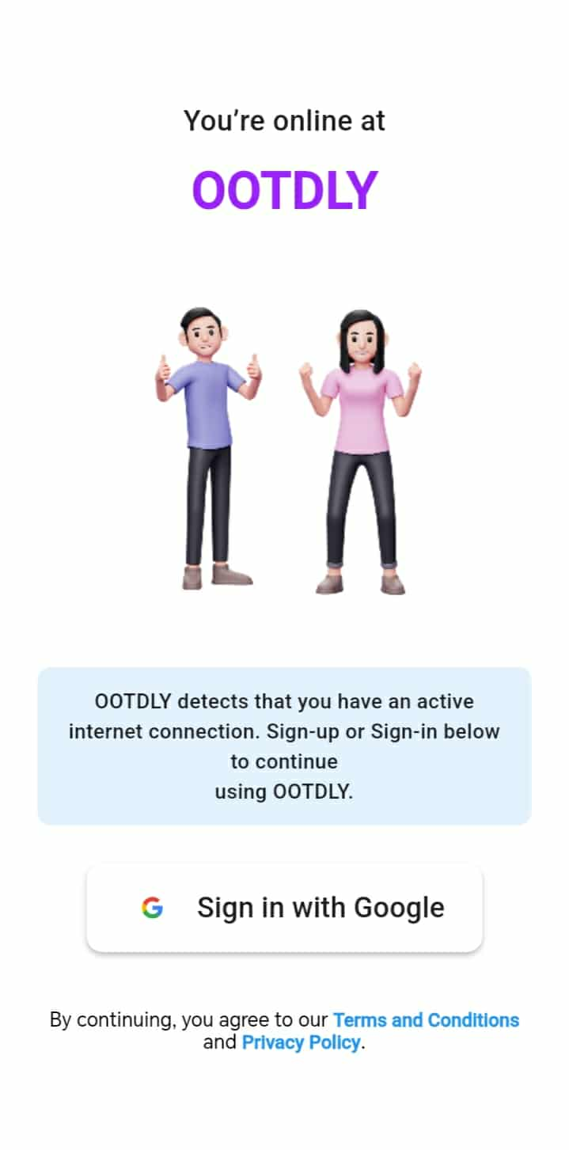

Screen No: 3
Screen Name: Choose Google Account
Narrative Overview: Allows the user to choose a google account for registration or login.
Screen Layout:
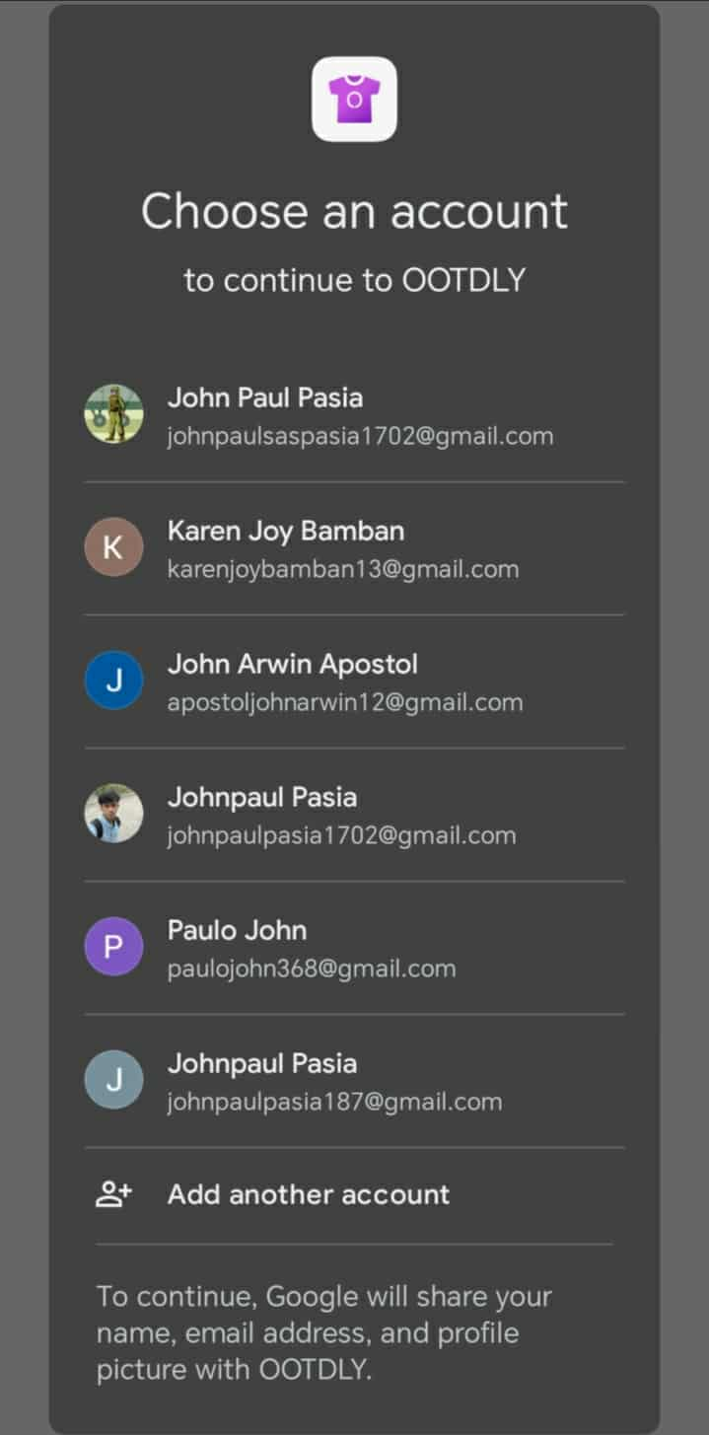

Screen No: 4
Screen Name: Online Mode Home Tab
Narrative Overview: Allows the user to view the home tab contents.
Screen Layout:
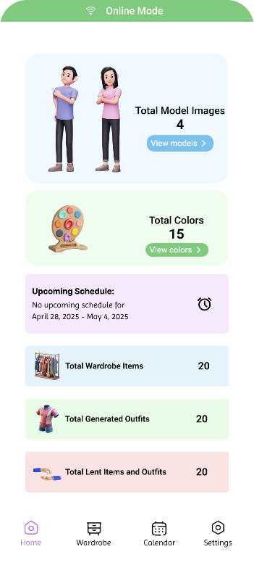

Screen No: 5
Screen Name: Online and offline Models
Narrative Overview: Allows the browse, search, and add model.
Screen Layout:
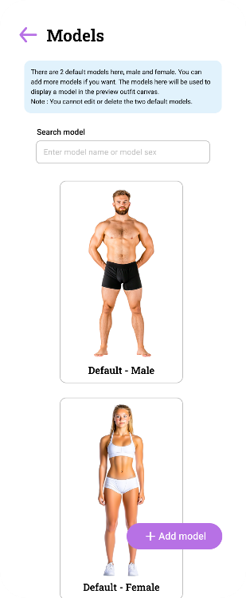

Screen No: 6
Screen Name: Online and Offline Add New Model
Narrative Overview: Allows the users to add new model.
Screen Layout:
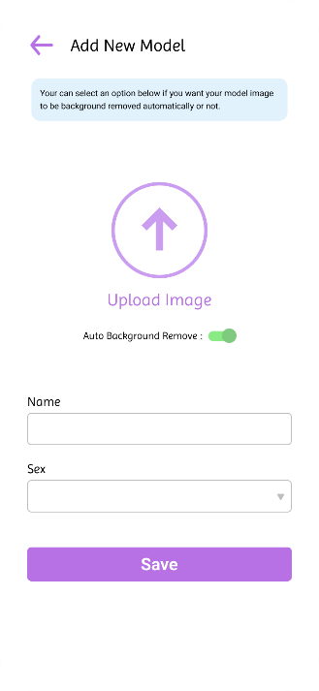

Screen No: 7
Screen Name: Online and Offline Select Model Image Source
Narrative Overview: Allows the user to select model image between camera and gallery.
Screen Layout:
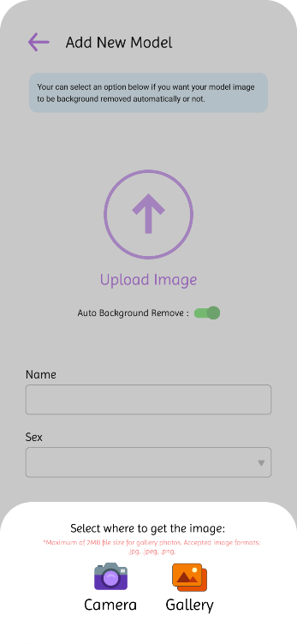

Screen No: 8
Screen Name: Online and Offline Add Model Information
Narrative Overview: Allows the user to enter model name and choose model sex.
Screen Layout:
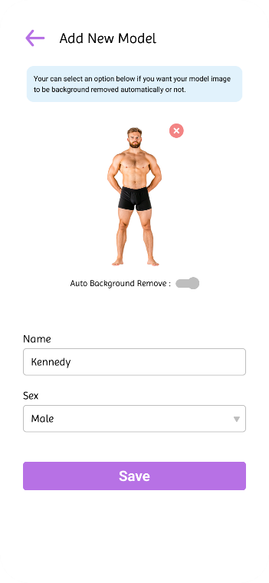

Screen No: 9
Screen Name: Added Online and Offline Model
Narrative Overview: Allows the user to see successful message when the model is added.
Screen Layout:
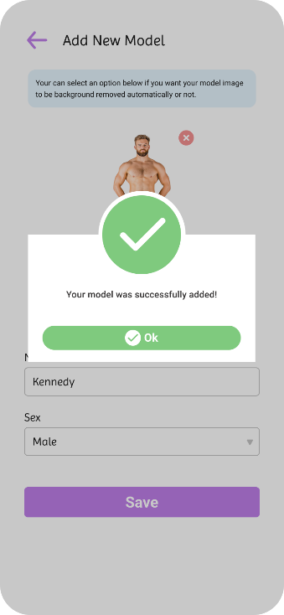

Screen No: 10
Screen Name: Online and Offline Update Model
Narrative Overview: Allows the user to update the model name and model sex.
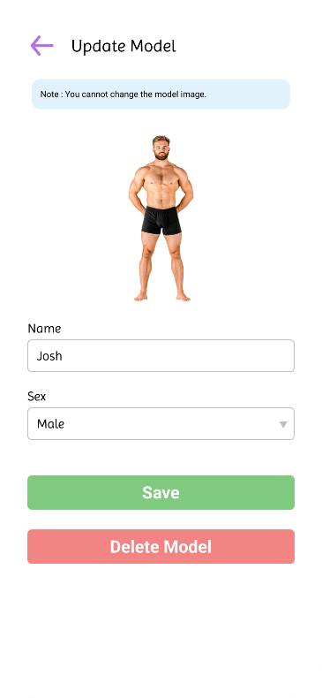
Screen Layout:

Screen No: 11
Screen Name: Online and Offline Update Model Successful
Narrative Overview: Allows the user to see successful message after updating the model.
Screen Layout:
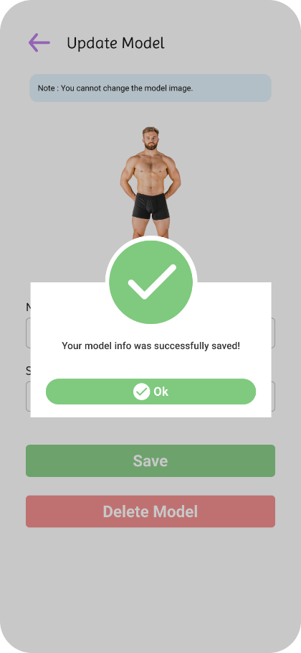

Screen No: 12
Screen Name: Online and Offline Delete Model
Narrative Overview: Allows the users to delete a model and confirm the deletion.
Screen Layout:
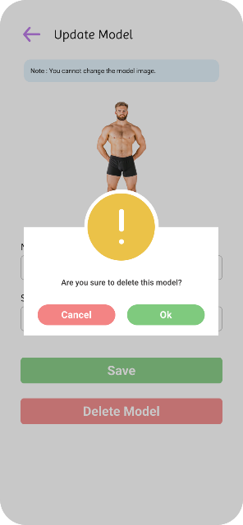

Screen No: 13
Screen Name: Online and Offline Colors
Narrative Overview: Allows the users to browse, search, add color, and view the color combinations.
Screen Layout:
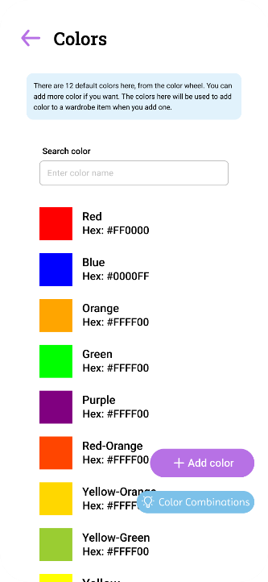

Screen No: 14
Screen Name: Online and Offline Add New Color
Narrative Overview: Allows the users to add a new color.
Screen Layout:
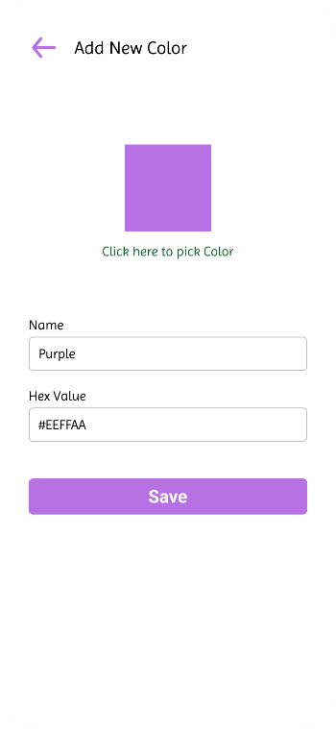

Screen No: 15
Screen Name: Online and Offline Add Color Success
Narrative Overview: Allows user to see successful message after the color was successfully added.
Screen Layout:
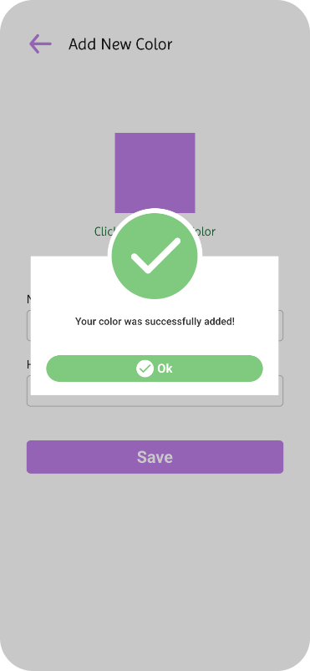

Screen No: 16
Screen Name: Online and Offline Update Color
Narrative Overview: Allows user to update the color, color name and color HEX.
Screen Layout:
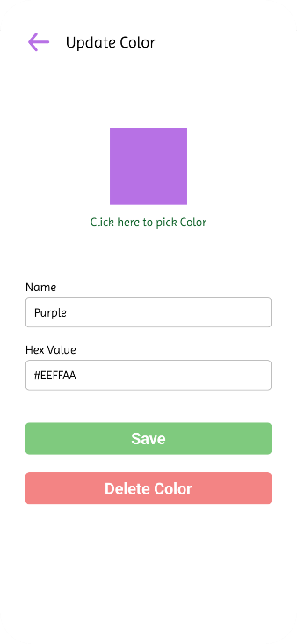
Screen No: 17
Screen Name: Online and Offline Update Color Success
Narrative Overview: Allows user to see successful message after the color was successfully updated.
Screen Layout:
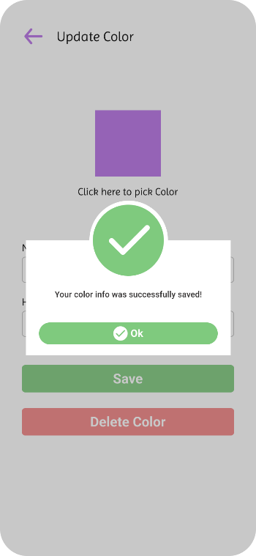

Screen No: 18
Screen Name: Online and Offline Delete Color
Narrative Overview: Allows user to delete the color and confirm the deletion.
Screen Layout:
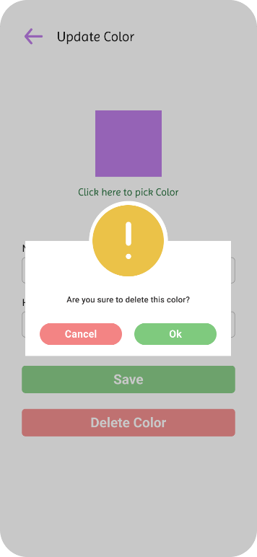

Screen No: 19
Screen Name: Online Wardrobe Tab
Narrative Overview: Allows user to see the wardrobe tab option features.
Screen Layout:
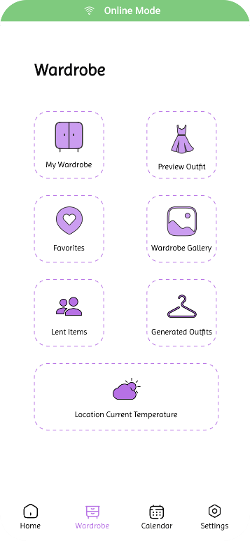

Screen No: 20
Screen Name: Online Wardrobe Item Categories
Narrative Overview: Allows the browse, search, and add a category.
Screen Layout:
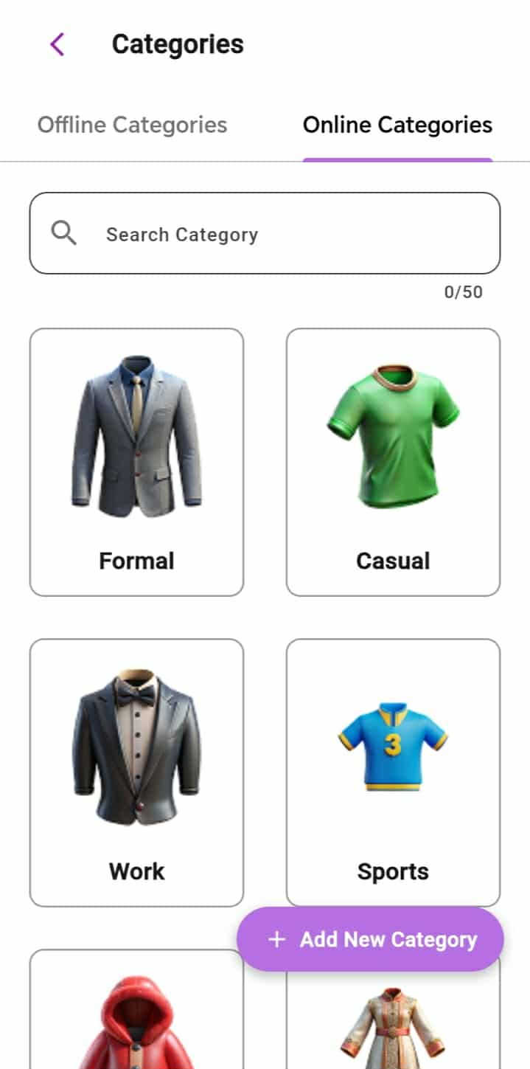

Screen No: 21
Screen Name: Offline Wardrobe Item Categories
Narrative Overview: Allows the user to browse, search, and add category.
Screen Layout:
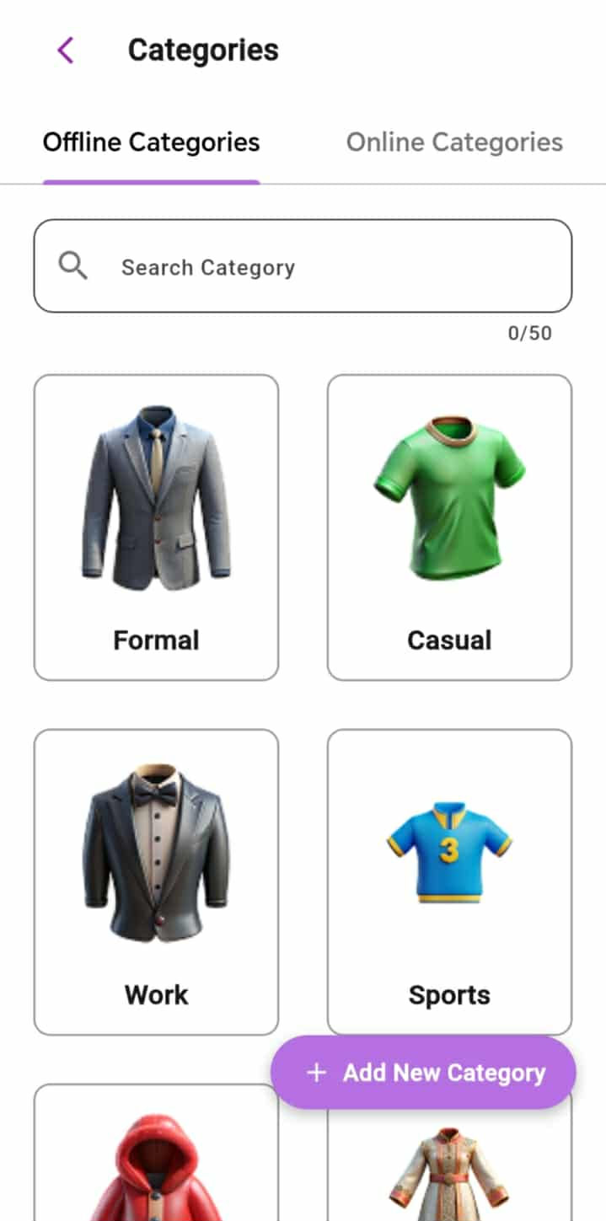

Screen No: 22
Screen Name: Online and Offline Add Wardrobe Item Category
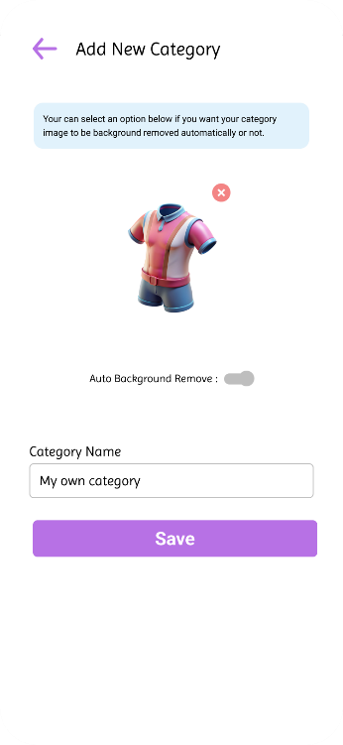
Narrative Overview: Allows the user to add new category.Screen Layout:

Screen No: 23
Screen Name: Online and Offline Add Category Success
Narrative Overview: Allows the user to see successful message after adding category.
Screen Layout:
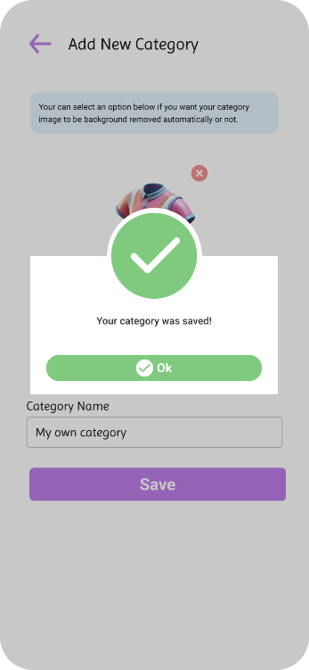

Screen No: 24
Screen Name: Online and Offline Update Category
Narrative Overview: Allows the user to update category name and image.
Screen Layout:
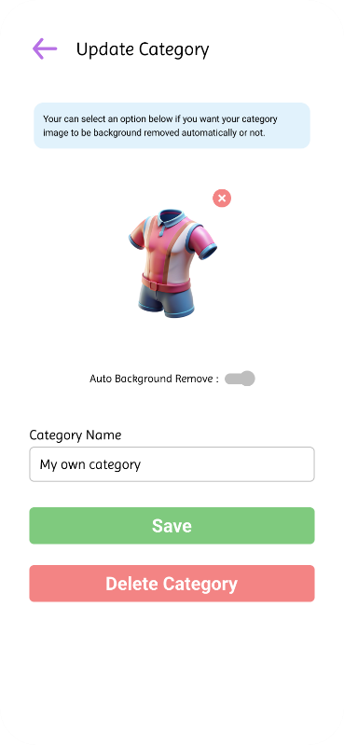

Screen No: 25
Screen Name: Online and Offline Update Wardrobe Item Category Success
Narrative Overview: Allows the user to see successful message after successfully category update.
Screen Layout:
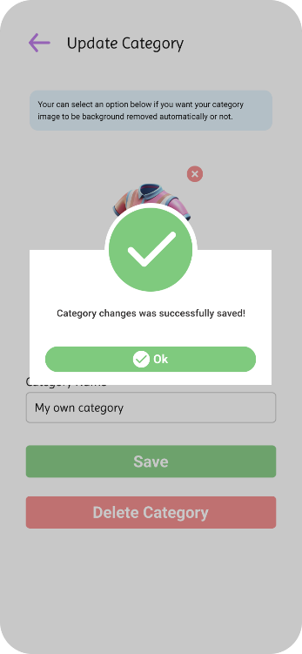

Screen No: 26
Screen Name: Online and Offline Delete Wardrobe Item Category
Narrative Overview: Allows user to delete a wardrobe item category.
Screen Layout:
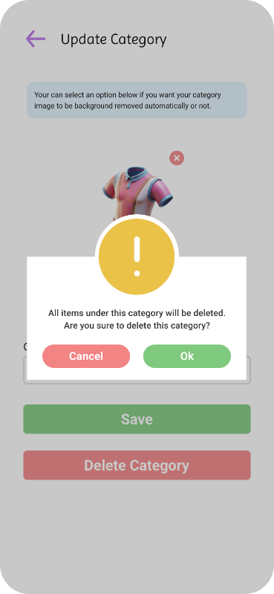

Screen No: 27
Screen Name: Online Wardrobe Items
Narrative Overview: allows the users to browse, search, and add wardrobe items.
Screen Layout:
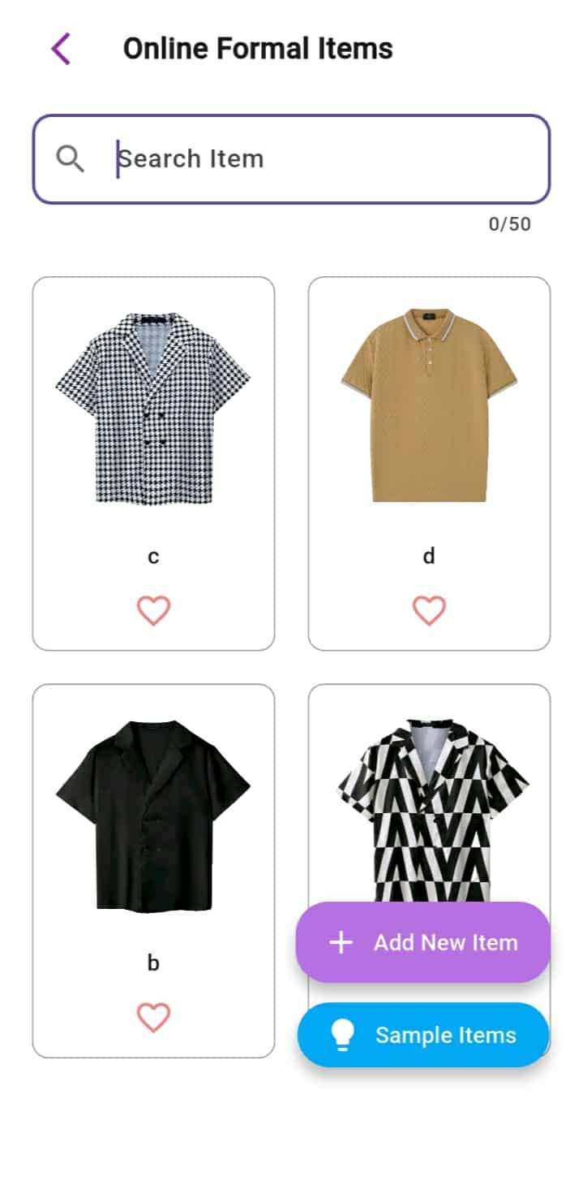

Screen No: 28
Screen Name: Offline Wardrobe Items
Narrative Overview: Allows the user to browse, search, and add wardrobe items.
Screen Layout:
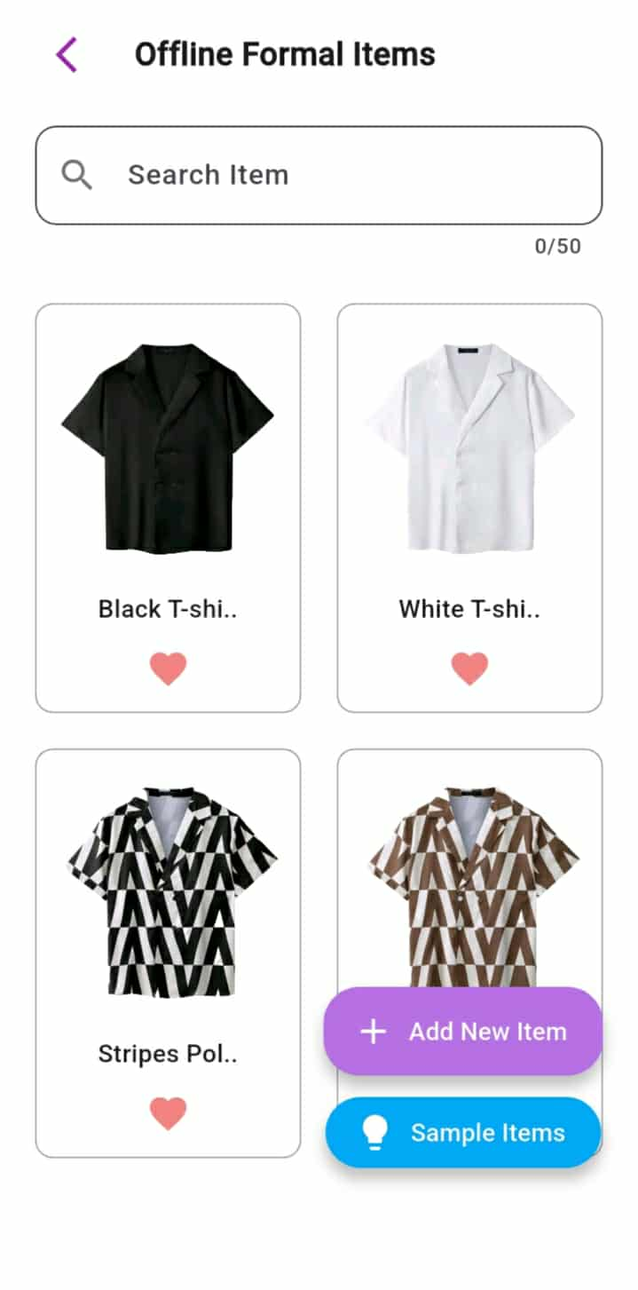

Screen No: 29
Screen Name: Online and Offline Add New Wardrobe Item
Narrative Overview: Allows user to add new wardrobe item.
Screen Layout:
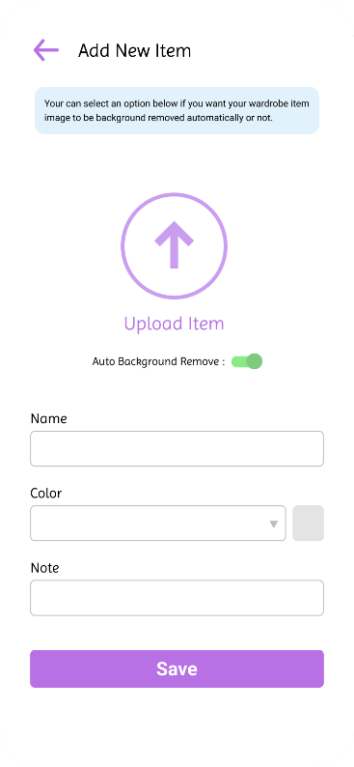

Screen No: 30
Screen Name: Online and Offline Wardrobe Item Image Source
Narrative Overview: Allows user to select the source to get the wardrobe image.
Screen Layout:
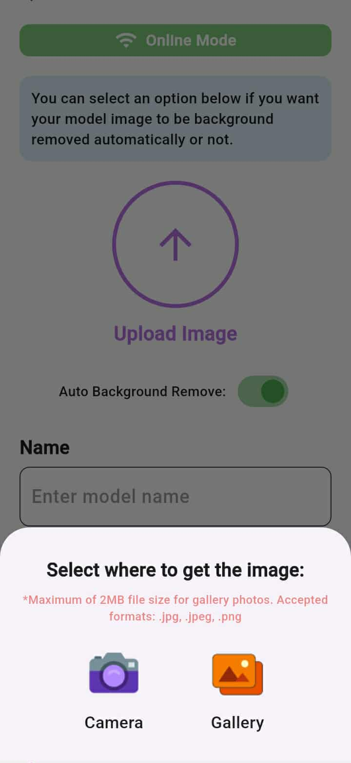

Screen No: 31
Screen Name: Online and Offline Add Wardrobe Item Information
Narrative Overview: Allows user to enter name, color, and note to the item.
Screen Layout:
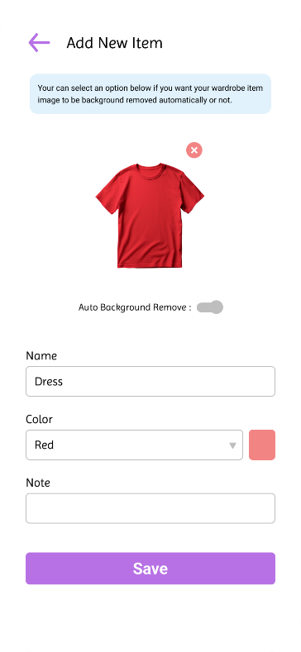

Screen No: 32
Screen Name: Online and Offline Add Wardrobe Item Success
Narrative Overview: Allows user see successful message when successfully added the wardrobe item.
Screen Layout:
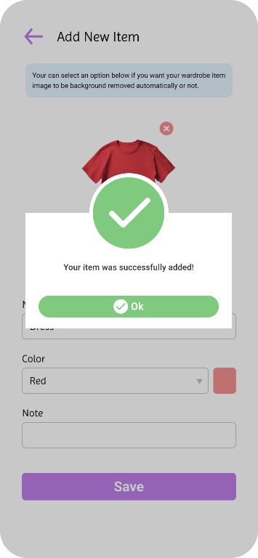

Screen No: 33
Screen Name: Online and Offline Update Wardrobe Item
Narrative Overview: Allows the user to update the wardrobe name, color, note or delete the wardrobe item.
Screen Layout:
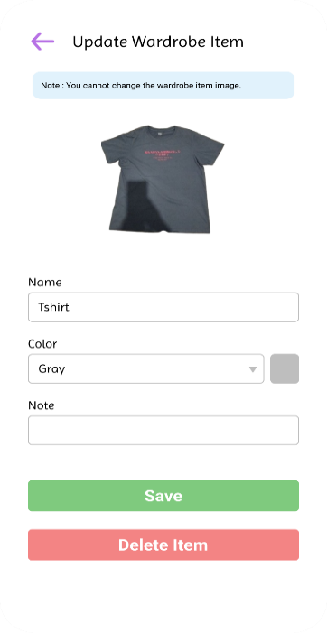

Screen No: 34
Screen Name: Online and Offline Update Wardrobe Item Success
Narrative Overview: Allows user see successful message when successfully updated the wardrobe item.
Screen Layout:
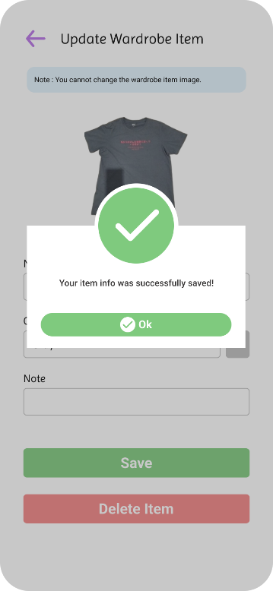

Screen No: 35
Screen Name: Online and Offline Delete Wardrobe Item
Narrative Overview: Allows the user to delete and confirm the deletion of a wardrobe item.
Screen Layout:
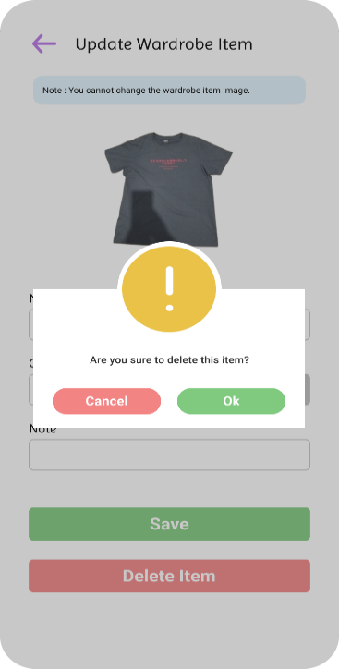

Screen No: 36
Screen Name: Online and Offline Default Category Item Suggestions
Narrative Overview: Allows user to view the suggested wardrobe items of the 10 default categories.
Screen Layout:
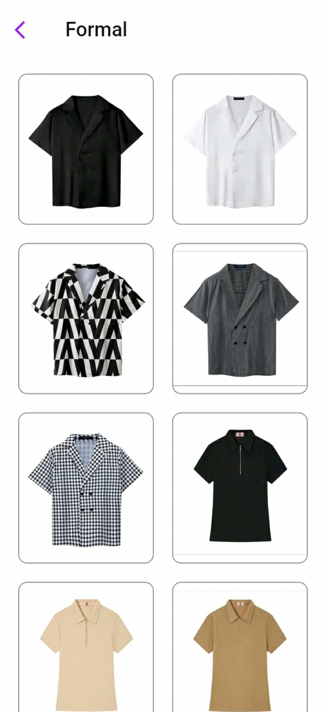

Screen No: 37
Screen Name: Online Preview Outfit Projects
Narrative Overview: Allows user to browse, search, and add project.
Screen Layout:
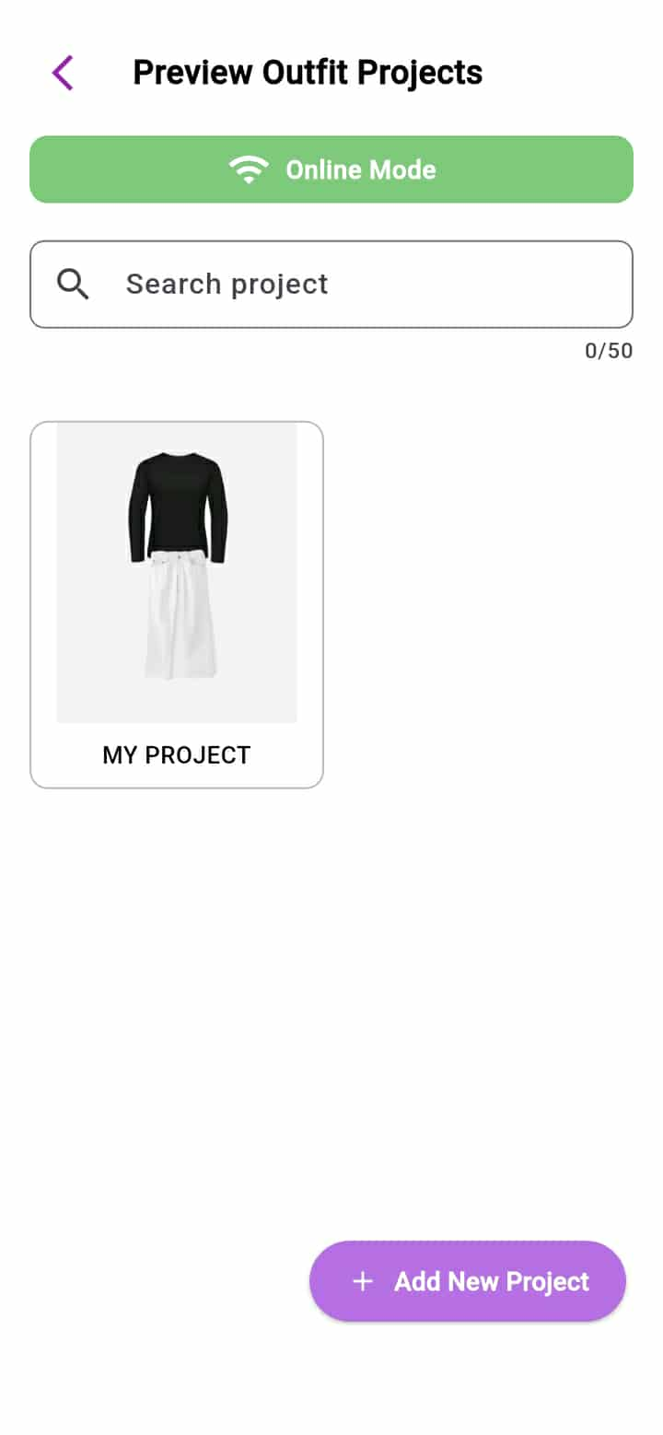

Screen No: 38
Screen Name: Online and Offline Add New Preview Outfit Category
Narrative Overview: Allows the user to add a project.
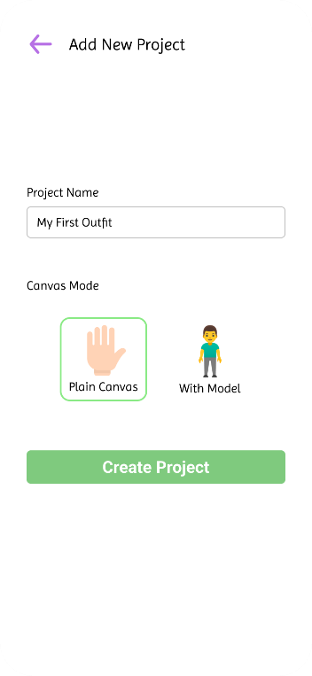
Screen Layout:

Screen No: 39
Screen Name: Online and Offline Preview Outfit Project Plain Canvas
Narrative Overview: Allows the user to combine wardrobe items on plain canvas.
Screen Layout:
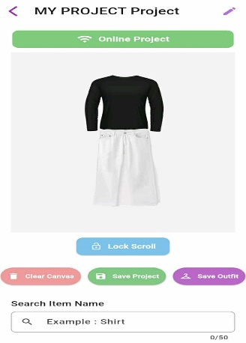
Screen No: 40
Screen Name: Online and Offline Preview Outfit Project with Model Canvas
Narrative Overview: Allows the user to combine wardrobe items on plain canvas.
Screen Layout:
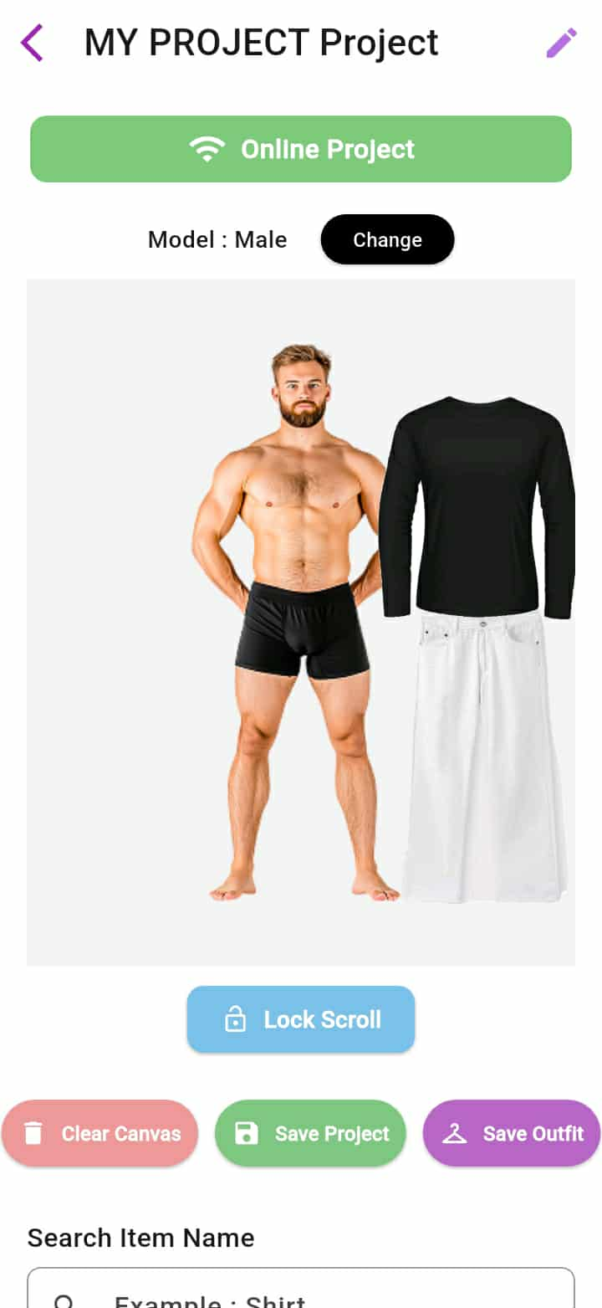

Screen No: 41
Screen Name: Online and Offline Change Model on With Canvas Project
Narrative Overview: Allows user to change model image on with canvas project.
Screen Layout:
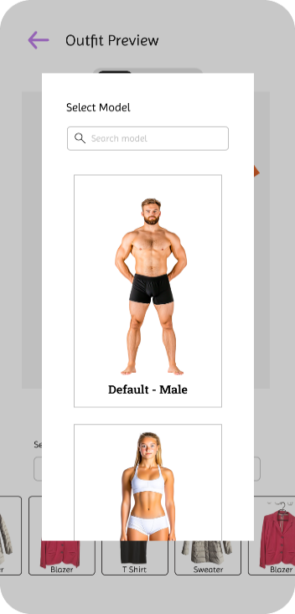

Screen No: 42
Screen Name: Online and Offline Save Outfit
Narrative Overview: Allows user to choose category where to save the combined wardrobe items as outfit.
Screen Layout:
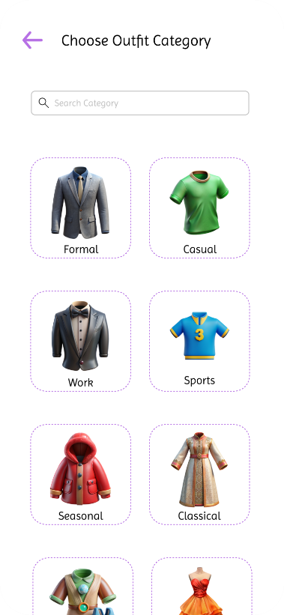

Screen No: 43
Screen Name: Online and Offline Save Outfit
Narrative Overview: Allows user to save outfit.
Screen Layout:
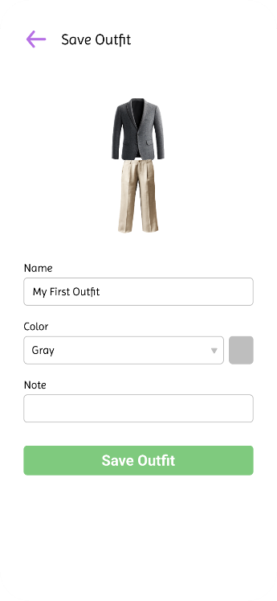

Screen No: 44
Screen Name: Online and Offline Save Outfit Success
Narrative Overview: Allows user to see successful message when outfit saving is successful.
Screen Layout:
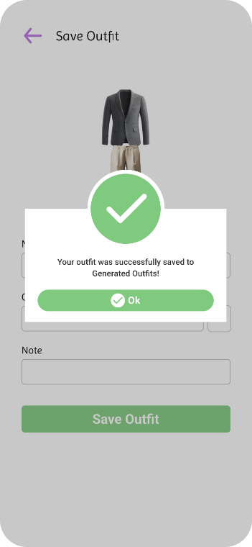

Screen No: 45
Screen Name: Online and Offline Update Project
Narrative Overview: Allows user to update the preview outfit project name.
Screen Layout:
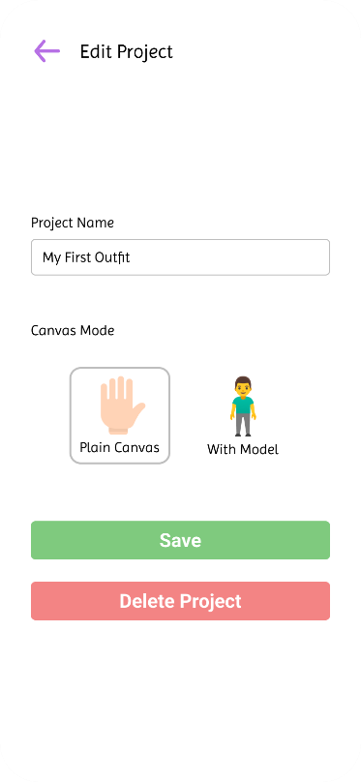

Screen No: 46
Screen Name: Online and Offline Delete Project
Narrative Overview: Allows user to delete a preview outfit project.
Screen Layout:
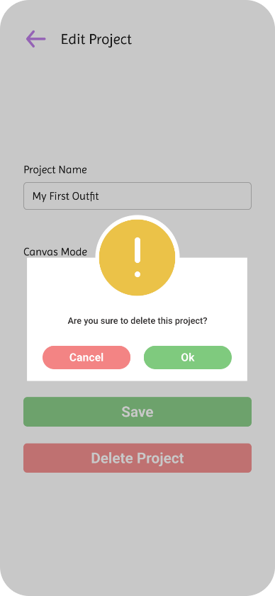

Screen No: 47
Screen Name: Online and Offline Favorite Wardrobe Items
Narrative Overview: Allows user to browse favorite wardrobe items
Screen Layout:
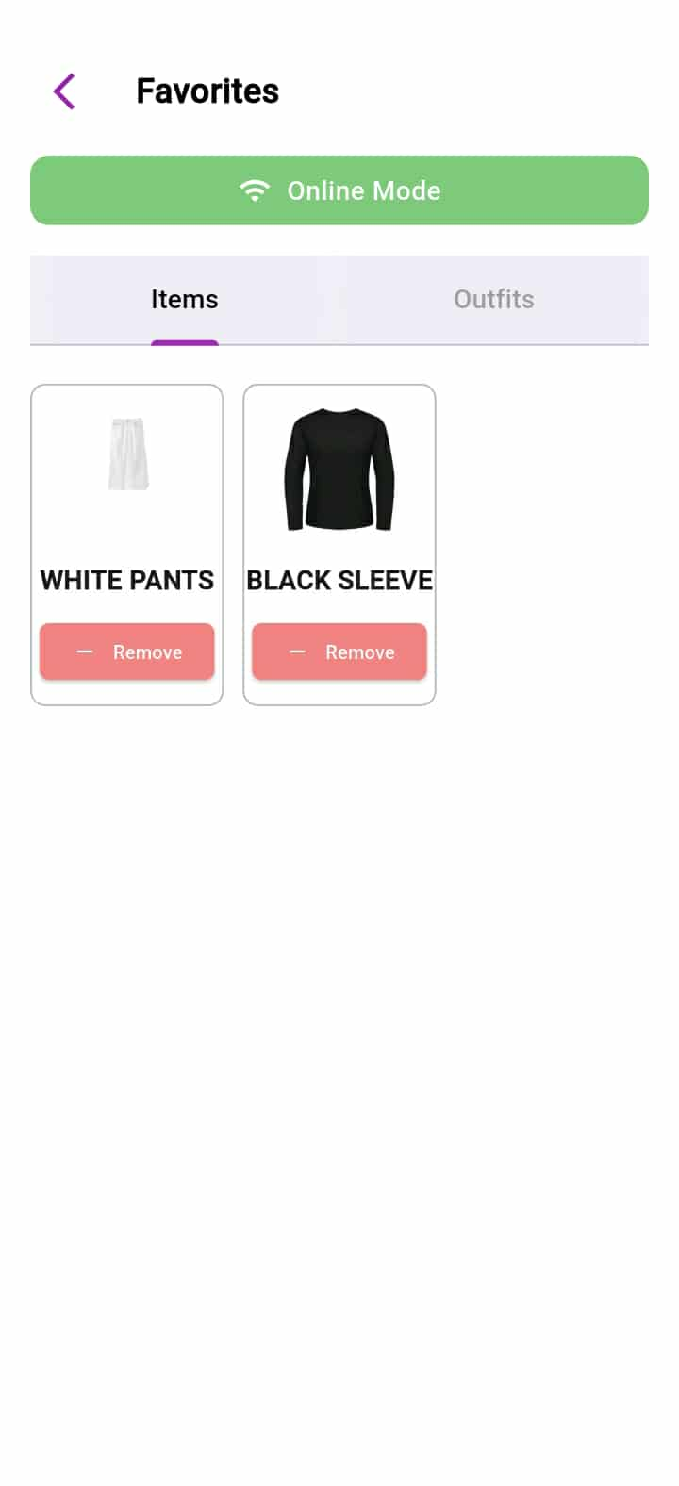

Screen No: 48
Screen Name: Online and Offline Favorite Outfit
Narrative Overview: Allows user to add browse the favorites generated outfits.
Screen Layout:

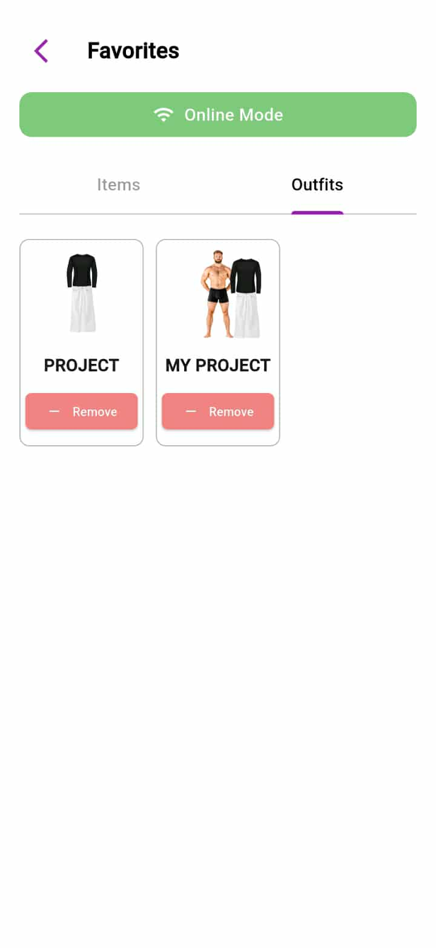

Screen No: 49
Screen Name: Online and Offline Wardrobe Item Gallery
Narrative Overview: Allows user to browse the all wardrobe items.
Screen Layout:
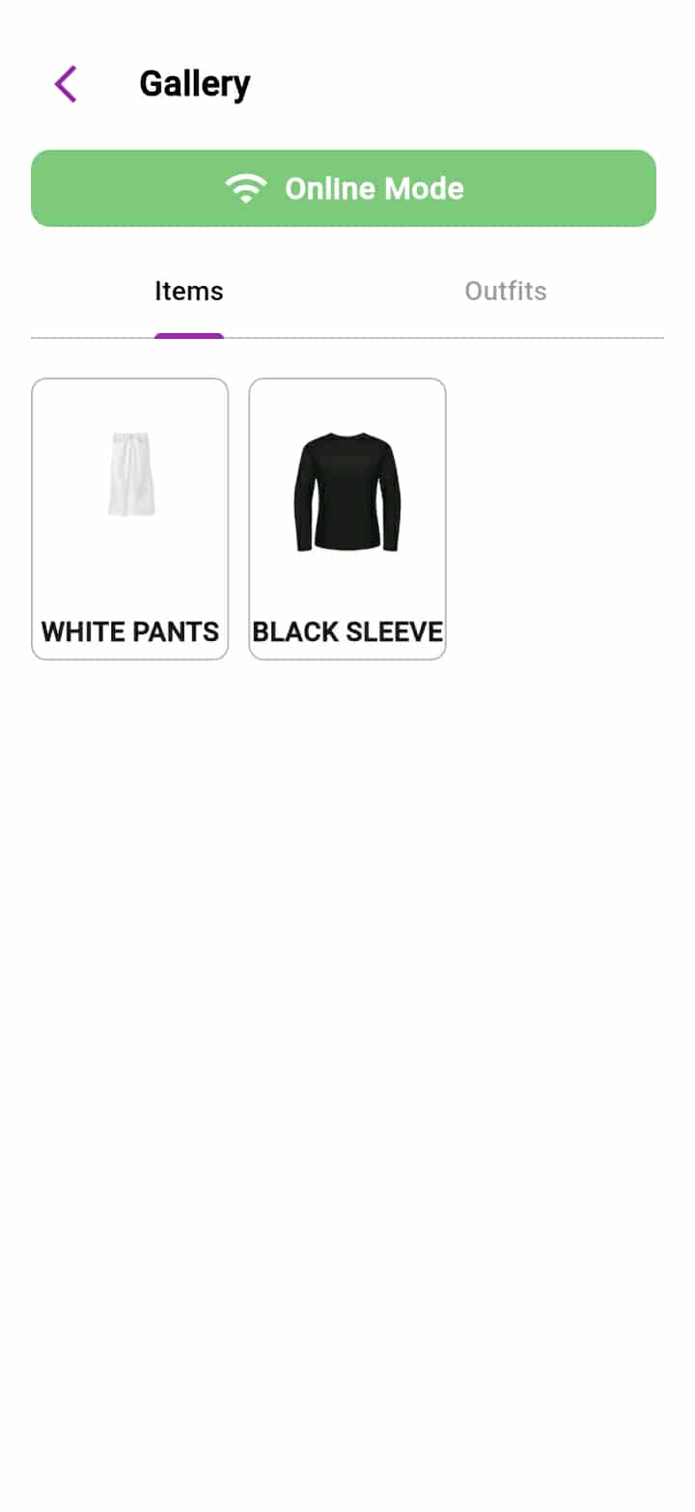

Screen No: 50
Screen Name: Online and Offline Outfits Gallery
Narrative Overview: Allows the user to browse all the generated outfits.
Screen Layout:
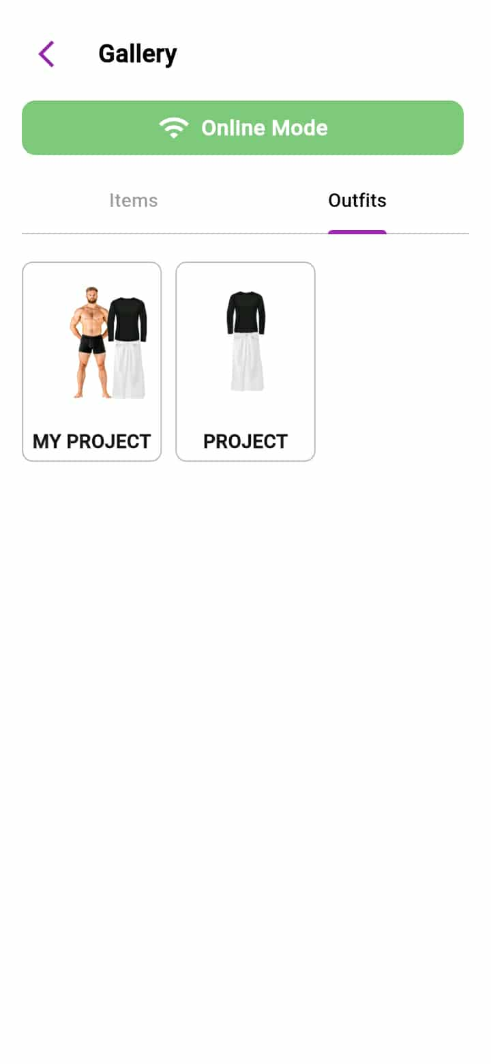

Screen No: 51
Screen Name: Online and Offline Lent Items / Outfits
Narrative Overview: Allows the user to browse, search. and add lent item record. Also users can select the status of the lent items.
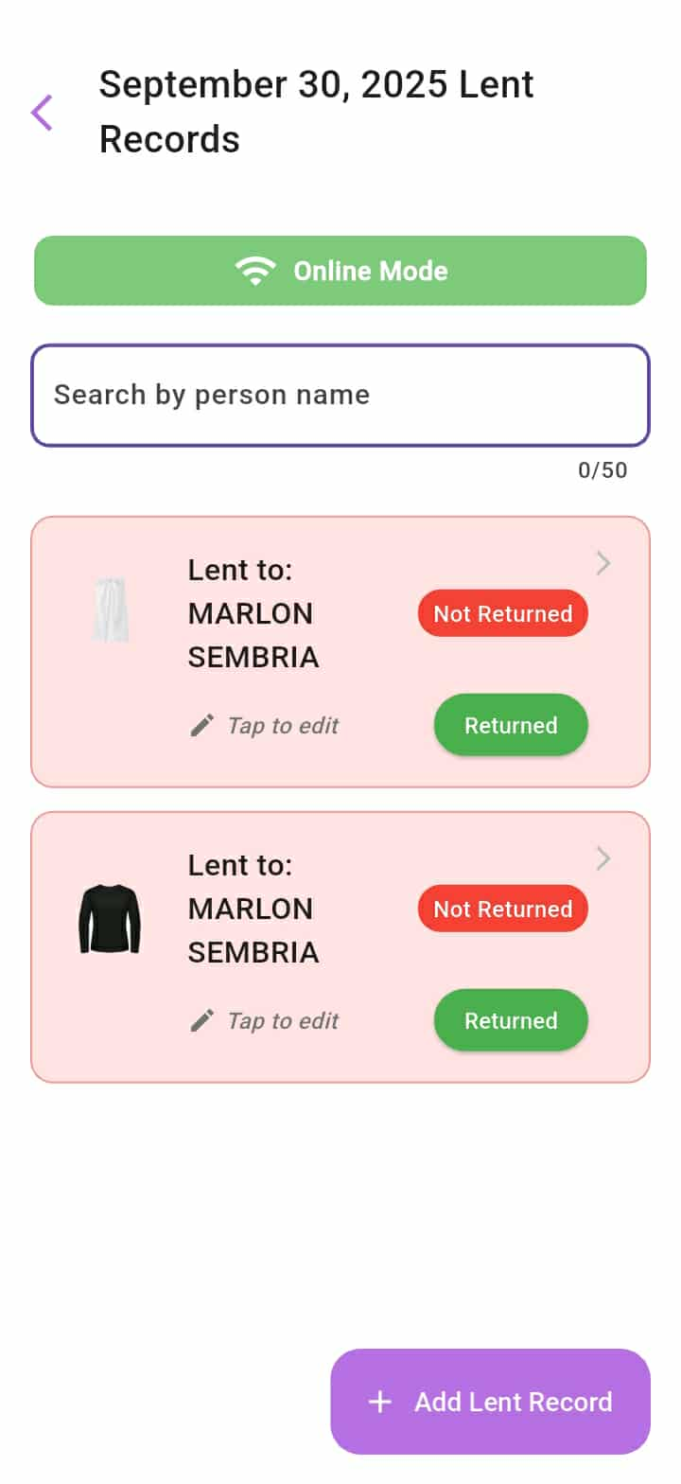

Screen No: 52
Screen Name: Online and Offline Add Lent Item Successful
Narrative Overview: Allows user to see a message after successful adding of lent record.
Screen Layout:
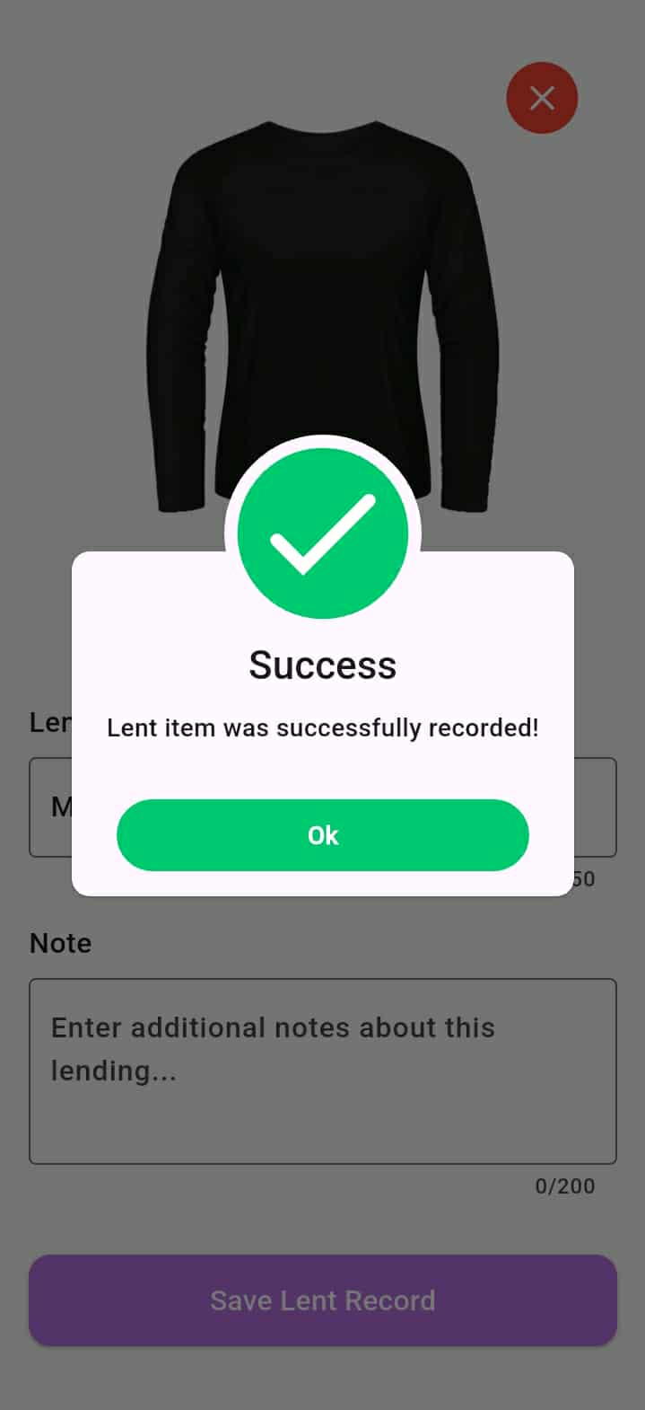

Screen No: 53
Screen Name: Online and Offline Update Lent Item or Outfit
Narrative Overview: Allows user to update or delete the lent item or outfit.
Screen Layout:
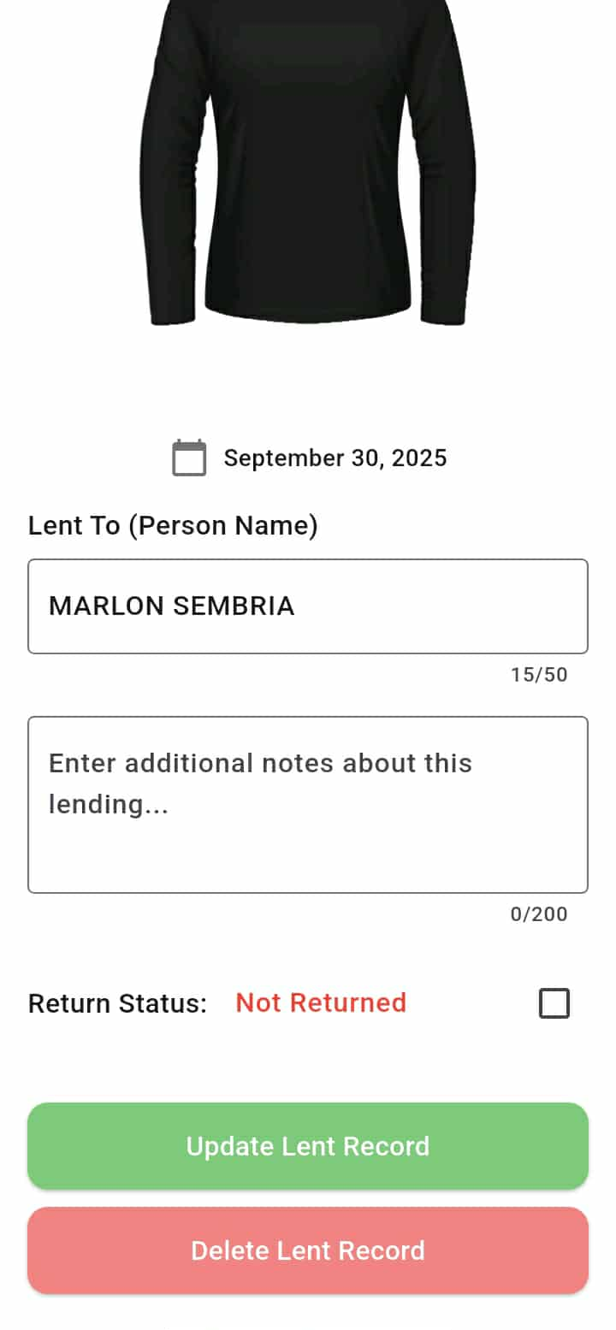

Screen No: 54
Screen Name: Online and Offline Update Lent Item or Outfit Successful
Narrative Overview: Allows user to see a message after successful update.
Screen Layout:
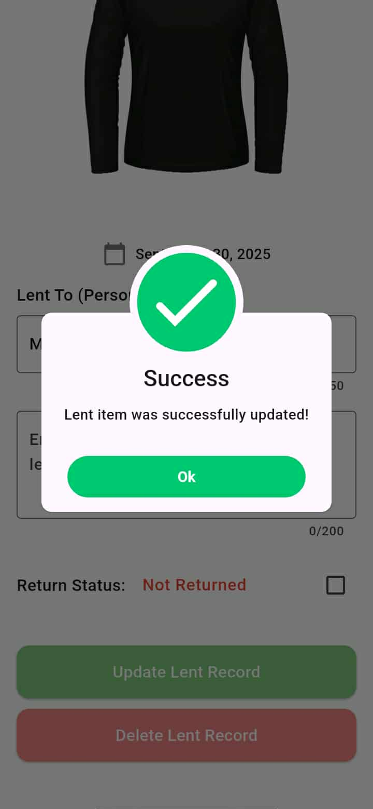

Screen No: 55
Screen Name: Online and Offline Delete Lent Item or Outfit Record
Narrative Overview: Allows the user to delete a lent record.
Screen Layout:
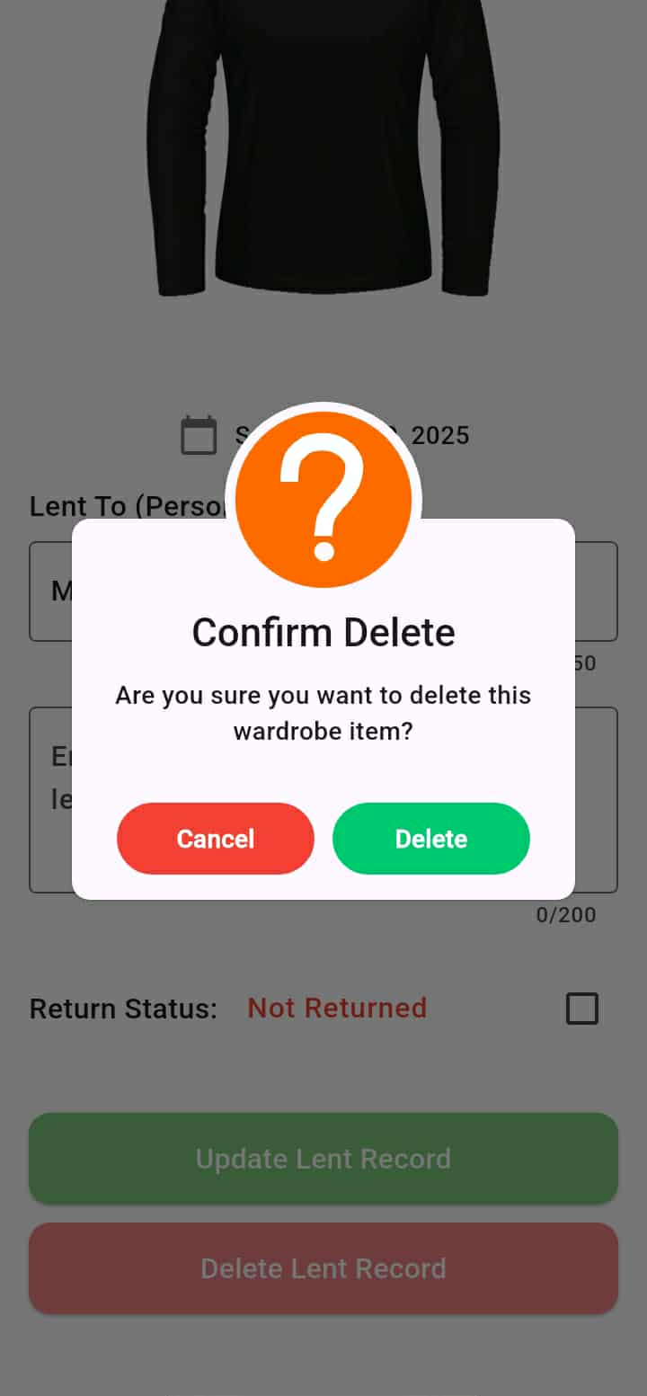

Screen No: 56
Screen Name: Online Generated Outfits Category
Narrative Overview: Allows the user to browse, search and add category.
Screen Layout:
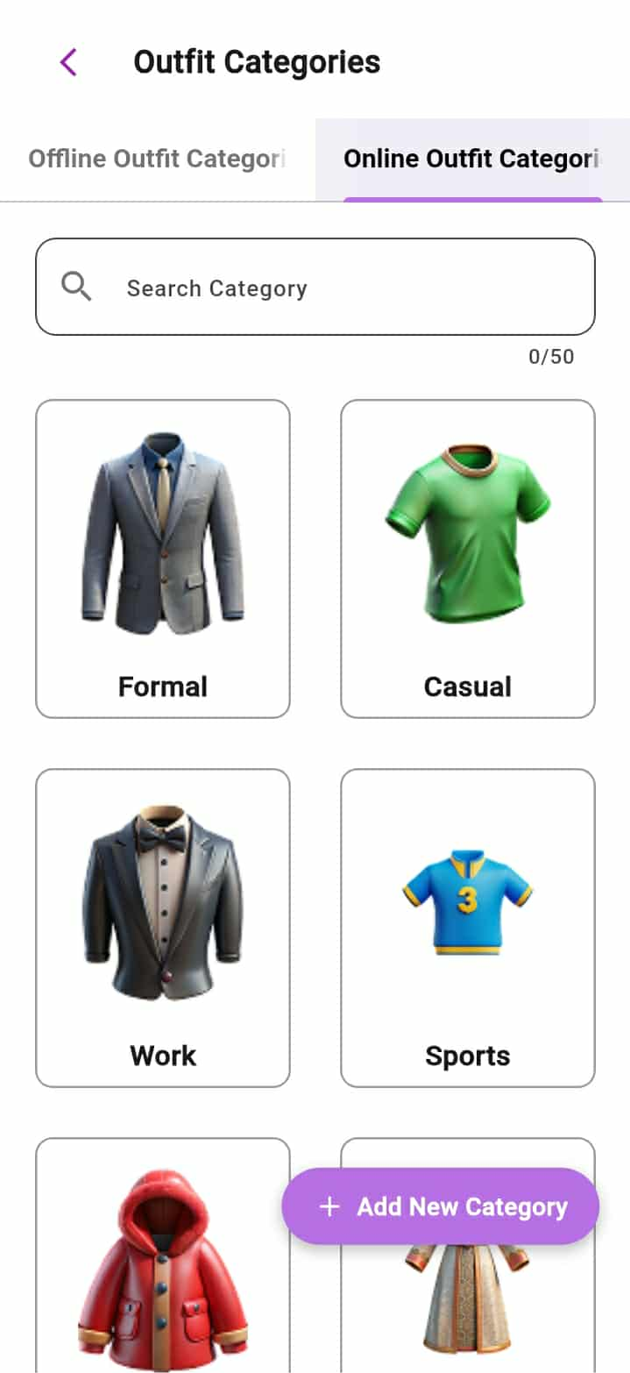

Screen No: 57
Screen Name: Offline Generated Outfits Category
Narrative Overview: Allows the user to browse, search and add category.
Screen Layout:
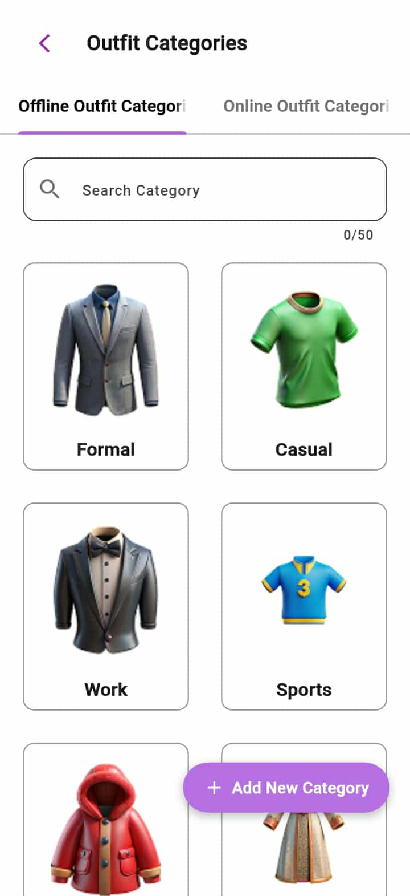

Screen No: 58
Screen Name: Online and Offline Add New Generated Outfit Category
Narrative Overview: Allows user to add a generated outfit category..
Screen Layout:

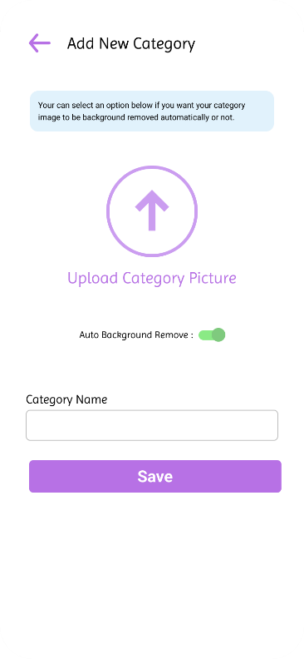

Screen No: 59
Screen Name: Online and Offline Generated Category Image Source
Narrative Overview: Allows user to select image source for category image.
Screen Layout:

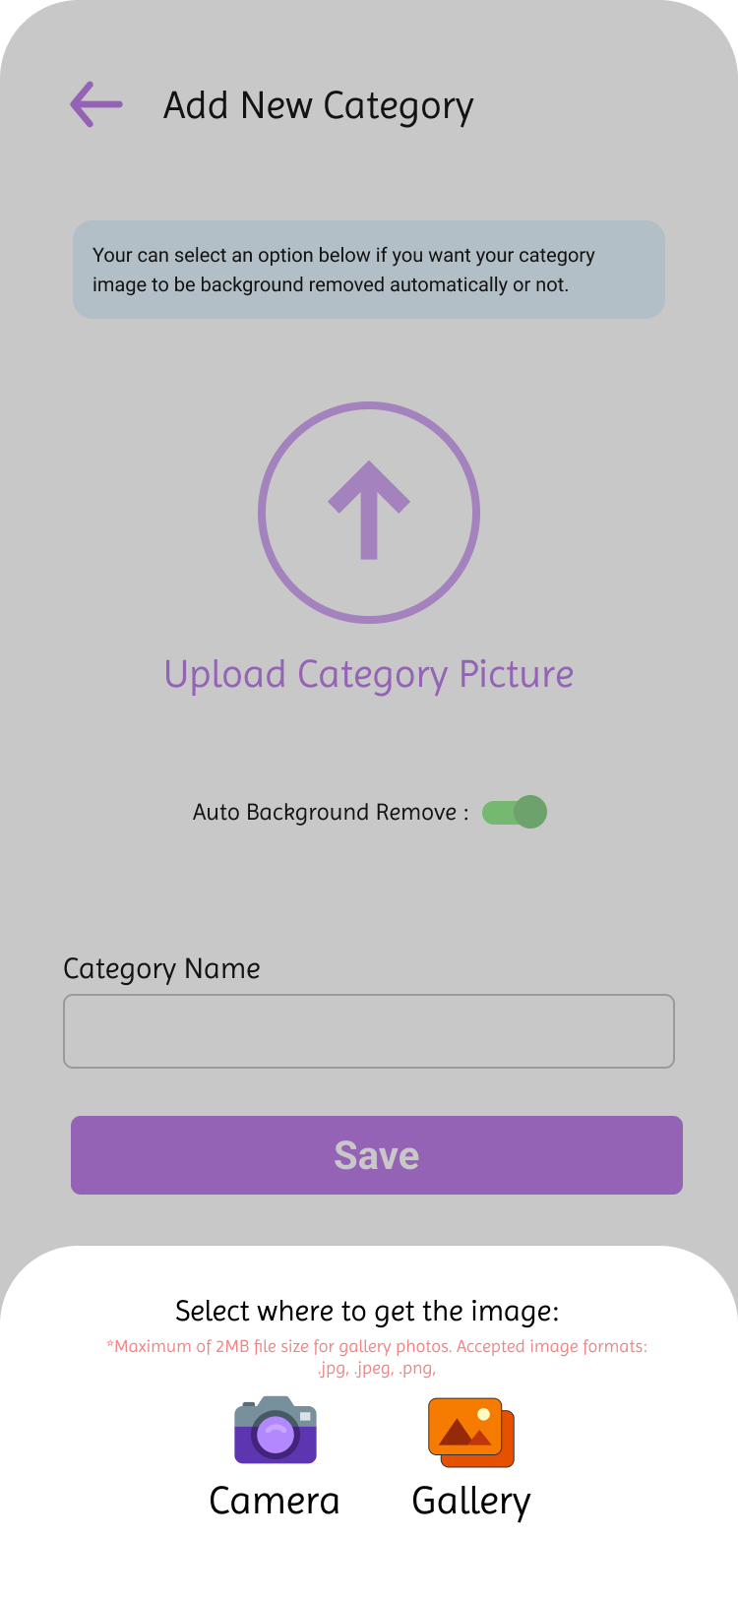

Screen No: 60
Screen Name: Online and Offline Add Generated Category Information
Narrative Overview: Allows user to enter category name.
Screen Layout:
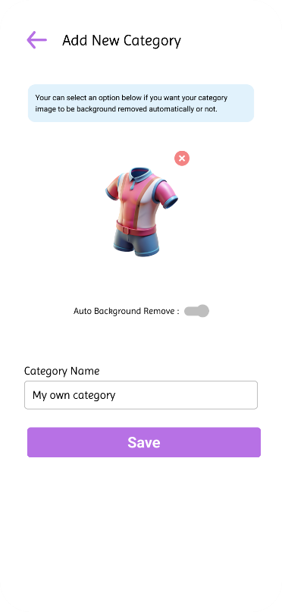

Screen No: 61
Screen Name: Online and Offline Add Generated Outfit Category Success
Narrative Overview: Allows the user to see successful message when category is added.
Screen Layout:
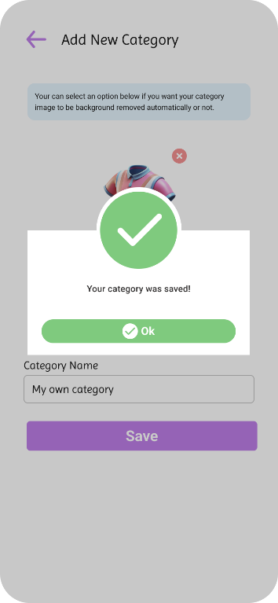

Screen No: 62
Screen Name: Online and Offline Update Generated Outfits Category
Narrative Overview: Allows the user to update the category name and image, or delete the category.
Screen Layout:
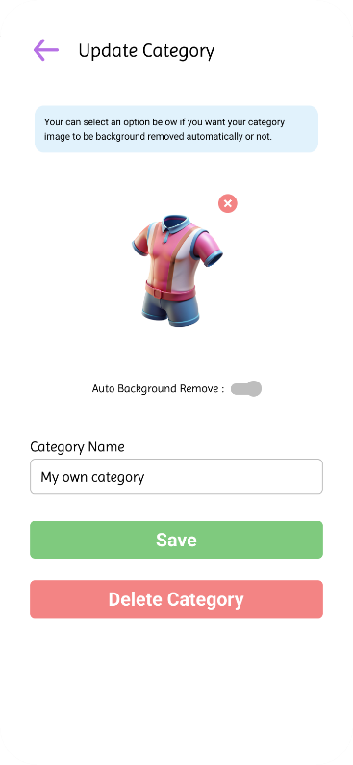

Screen No: 63
Screen Name: Online and Offline Update Generated Outfits Category Success
Narrative Overview: Allows the user to see message when update is successful.
Screen Layout:
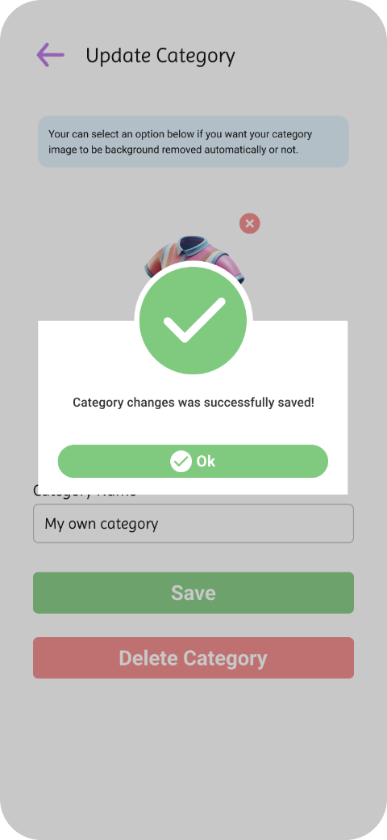

Screen No: 64
Screen Name: Online and Offline Delete Generated Outfit Category
Narrative Overview: Allows user to delete generated outfit category Screen Layout:

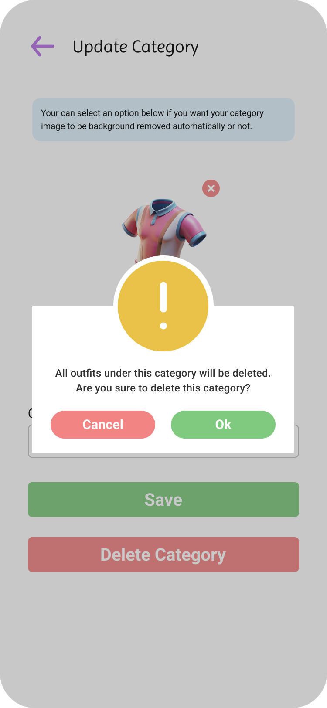

Screen No: 65
Screen Name: Online Category Outfits
Narrative Overview: Allows the user to browse, search, and view outfit suggestions.
Screen Layout:
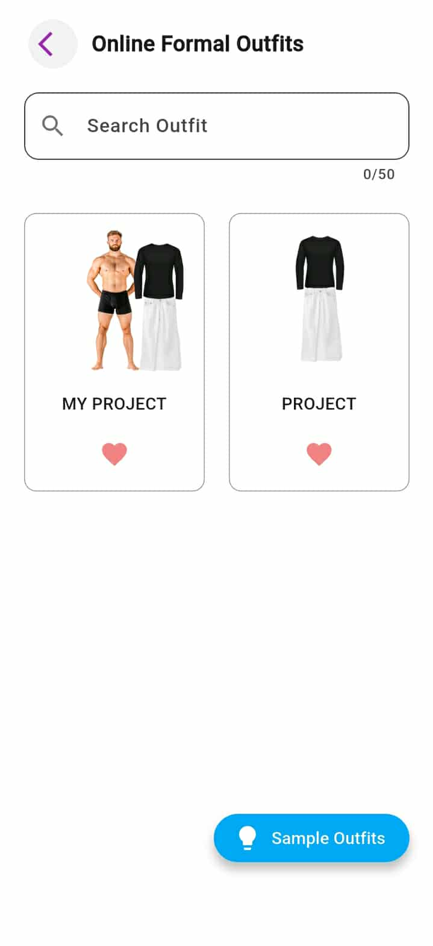

Screen No: 66
Screen Name: Online and Offline Update Outfit
Narrative Overview: Allows a user to update outfit name, color, and note.
Screen Layout:
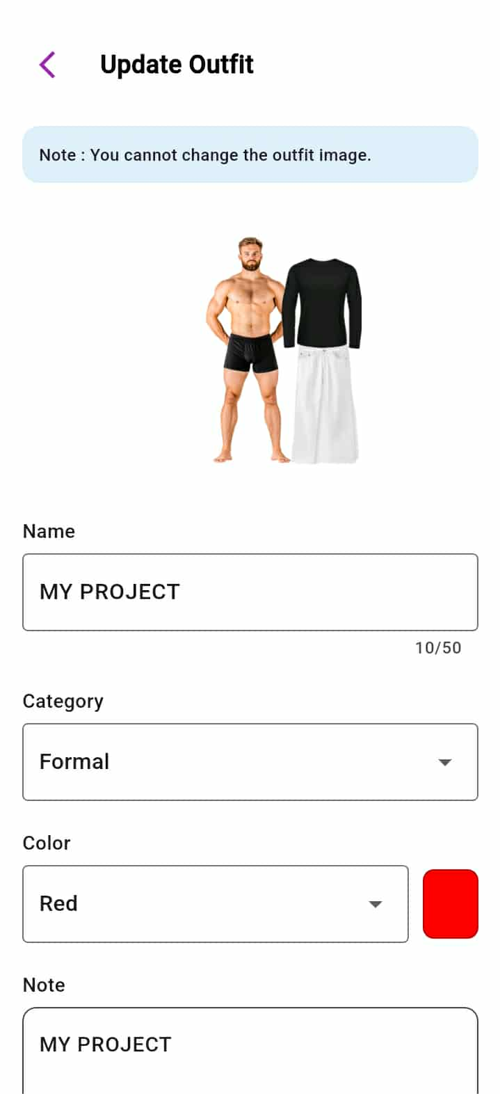

Screen No: 67
Screen Name: Online and Offline Update Outfit Success
Narrative Overview: Allows the user to message when update is success.
Screen Layout:
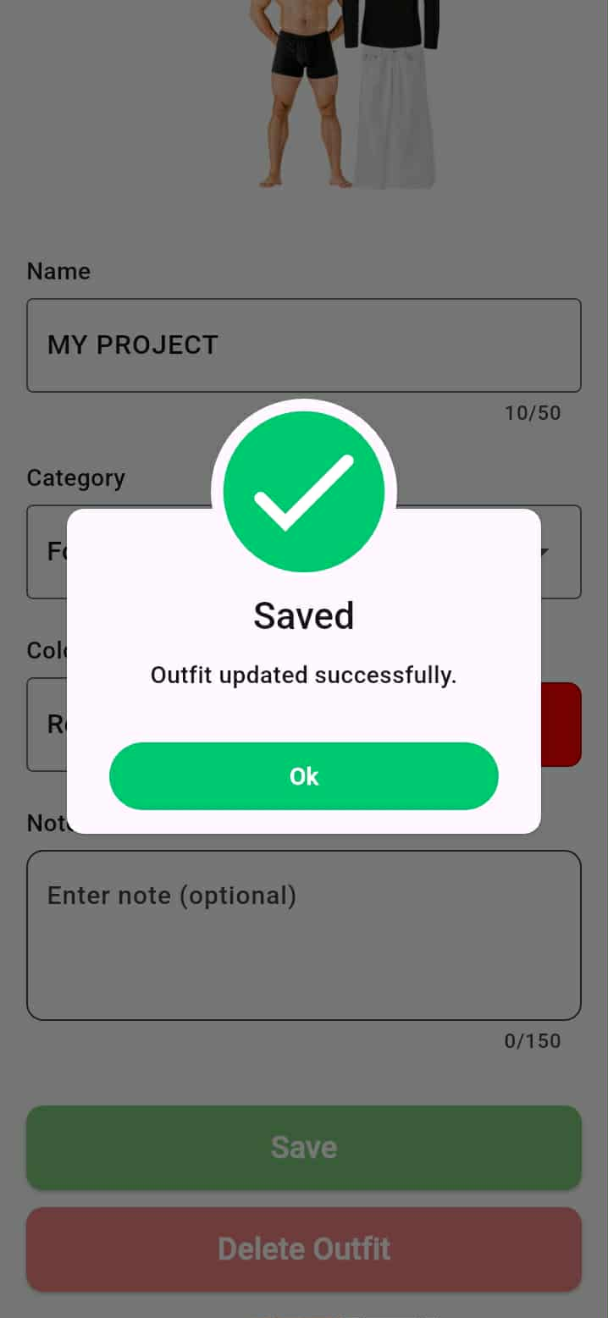

Screen No: 68
Screen Name: Online and Offline Delete Generated Outfit
Narrative Overview: Allows the user to delete generated outfit.
Screen Layout:
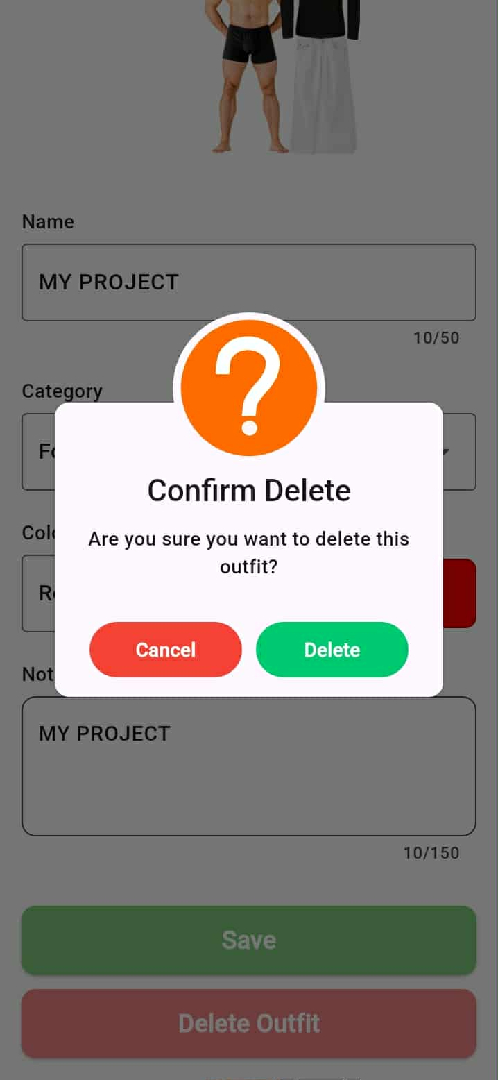

Screen No: 69
Screen Name: Online and Offline Default Category Outfit Suggestions
Narrative Overview: Allows the user to view default categories outfit suggestions.
Screen Layout:
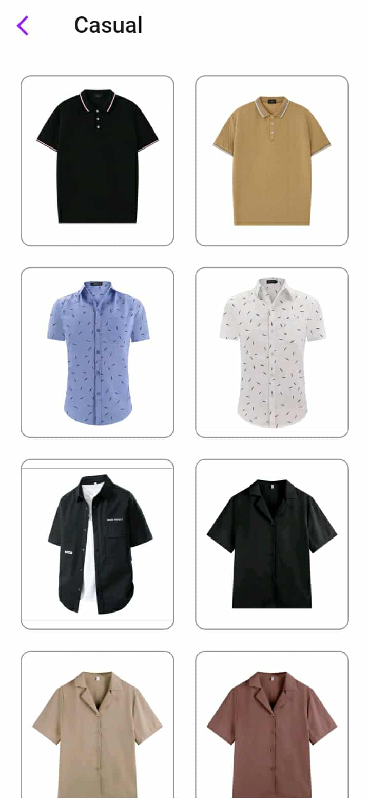

Screen No: 70
Screen Name: Search Location Current Temperature
Narrative Overview: Allows the user to view the current temperature based on searched location and see the recommended outfits to wear.
Screen Layout:
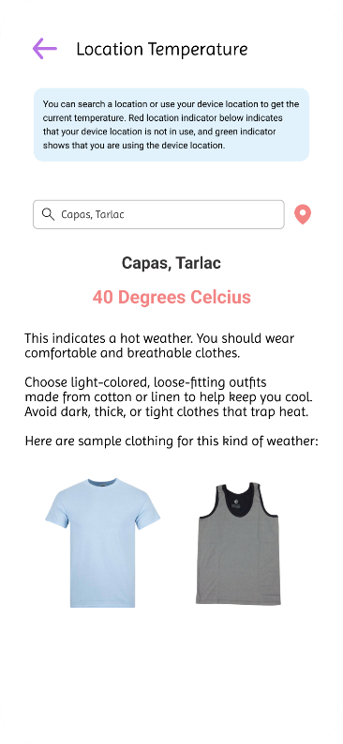

Screen No: 71
Screen Name: Device Location Current Temperature
Narrative Overview: Allows the user to view the current temperature based on device location and see the recommended outfits to wear.
Screen Layout:
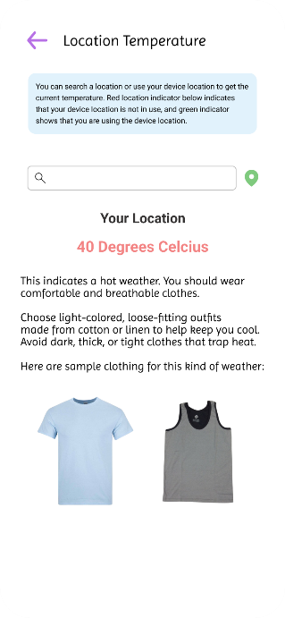

Screen No: 72
Screen Name: Calendar Module
Narrative Overview: Allows the user to view the scheduled items or outfits on different dates.
Screen Layout:
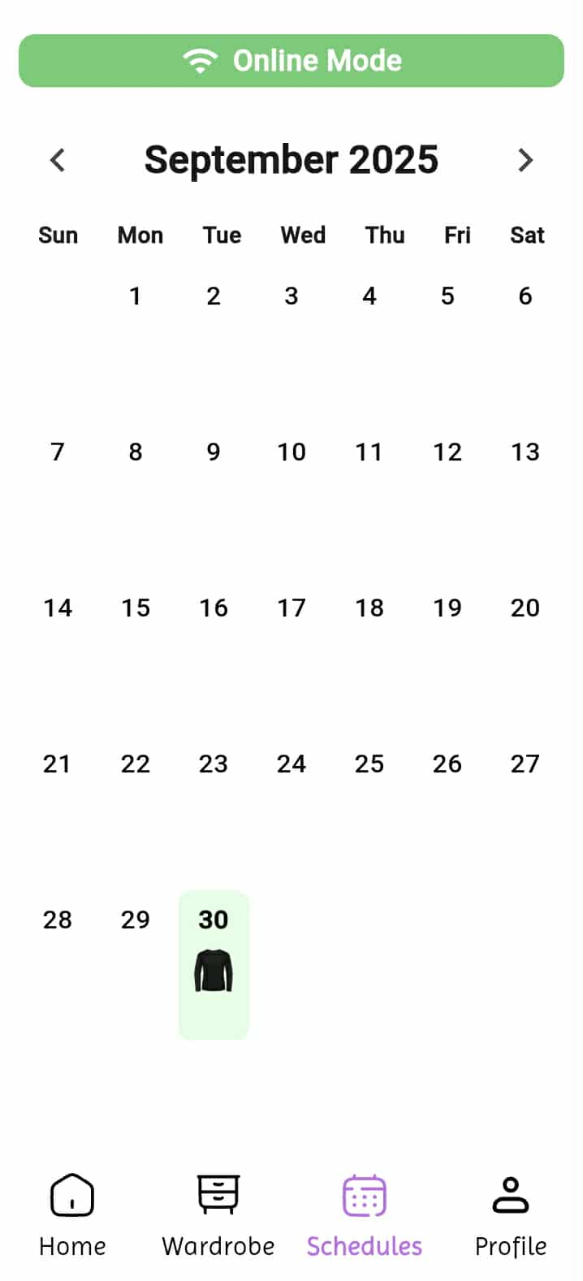

Screen No: 73
Screen Name: Online and Offline Items or Outfits Upcoming Schedules
Narrative Overview: Allows the user to browse, search, and add scheduled items or outfits.
Screen Layout:
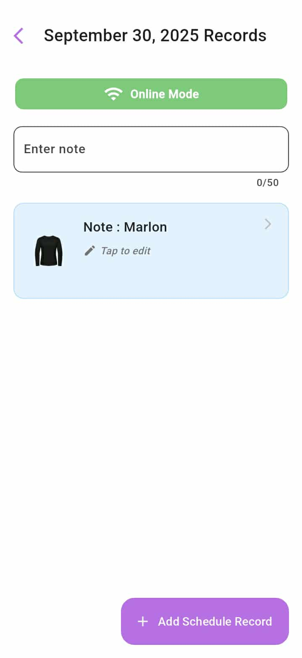

Screen No: 74
Screen Name: Online and Offline Item or Outfit Scheduling
Narrative Overview: Allows the user to schedule an item or outfit.
Screen Layout:

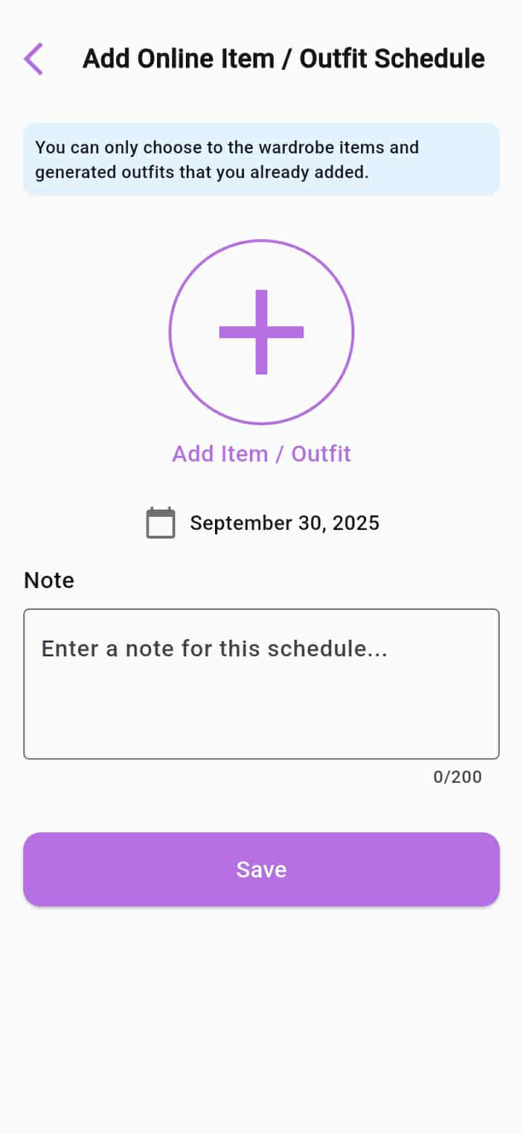

Screen No: 75
Screen Name: Online and Offline Add Item or Outfit Scheduling Success
Narrative Overview: Allows the user to save the item outfit schedule.
Screen Layout:
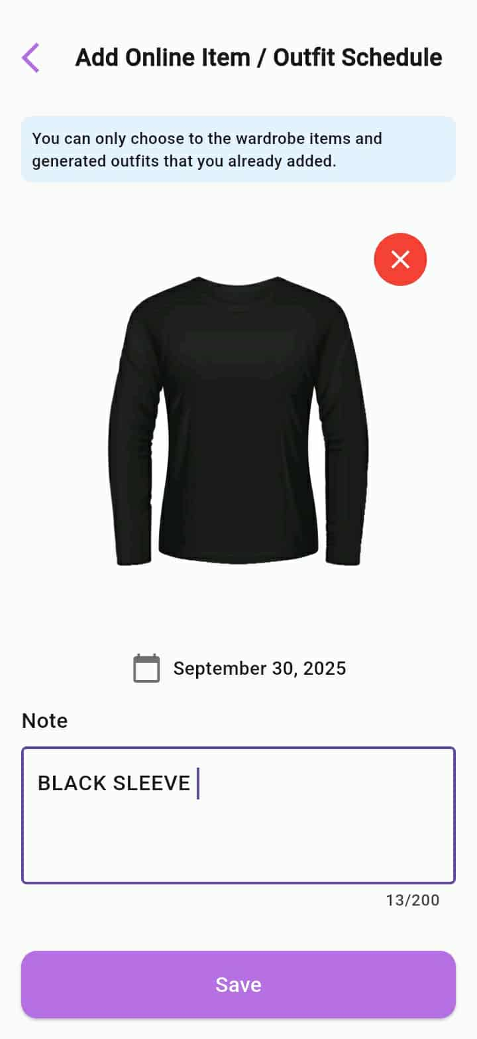

Screen No: 76
Screen Name: Online and Offline Update Item or Outfit Scheduling
Narrative Overview: Allows the user to update the item or outfit schedule.
Screen Layout:

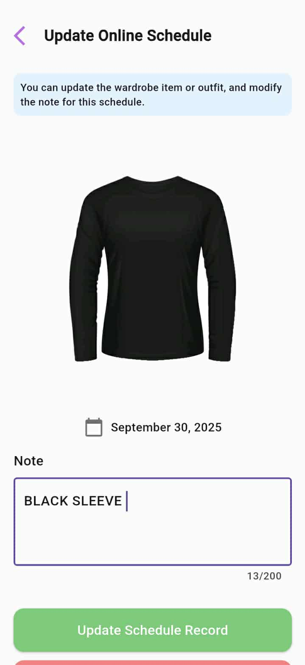

Screen No: 77
Screen Name: Online and Offline Delete Item or Outfit Schedule
Narrative Overview: Allows the user to delete the item or outfit schedule.
Screen Layout:
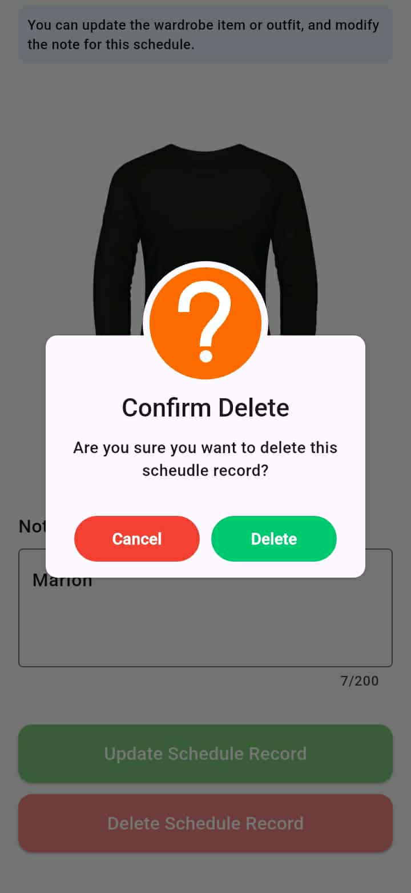

Screen No: 78
Screen Name: Online Profile Tab
Narrative Overview: Allows users to view the options under Profile.
Screen Layout:
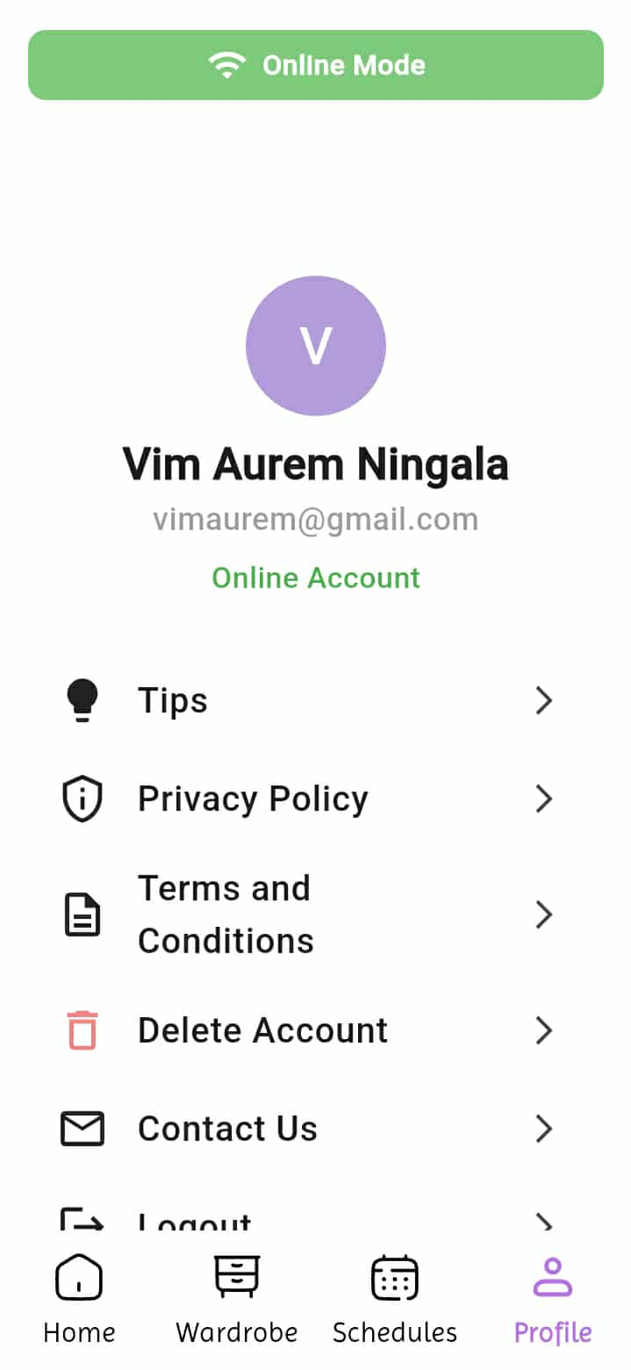

Screen No: 79
Screen Name: Online and Offline Tips
Narrative Overview: Allows user to view the topics on the application manual.
Screen Layout:
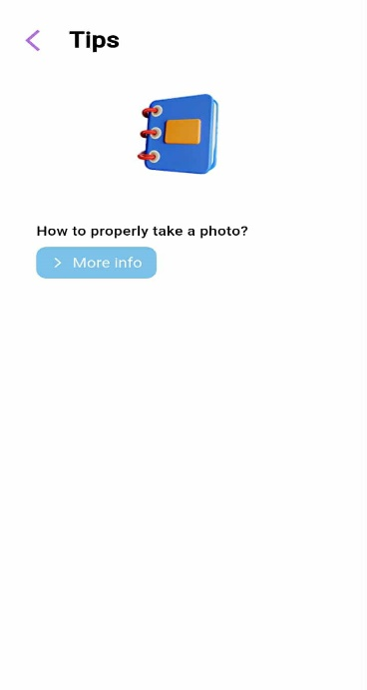

Screen No: 80
Screen Name: Online and Online Tips Guide Topic
Narrative Overview: Allows user to view the topic on the application Tips.
Screen Layout:
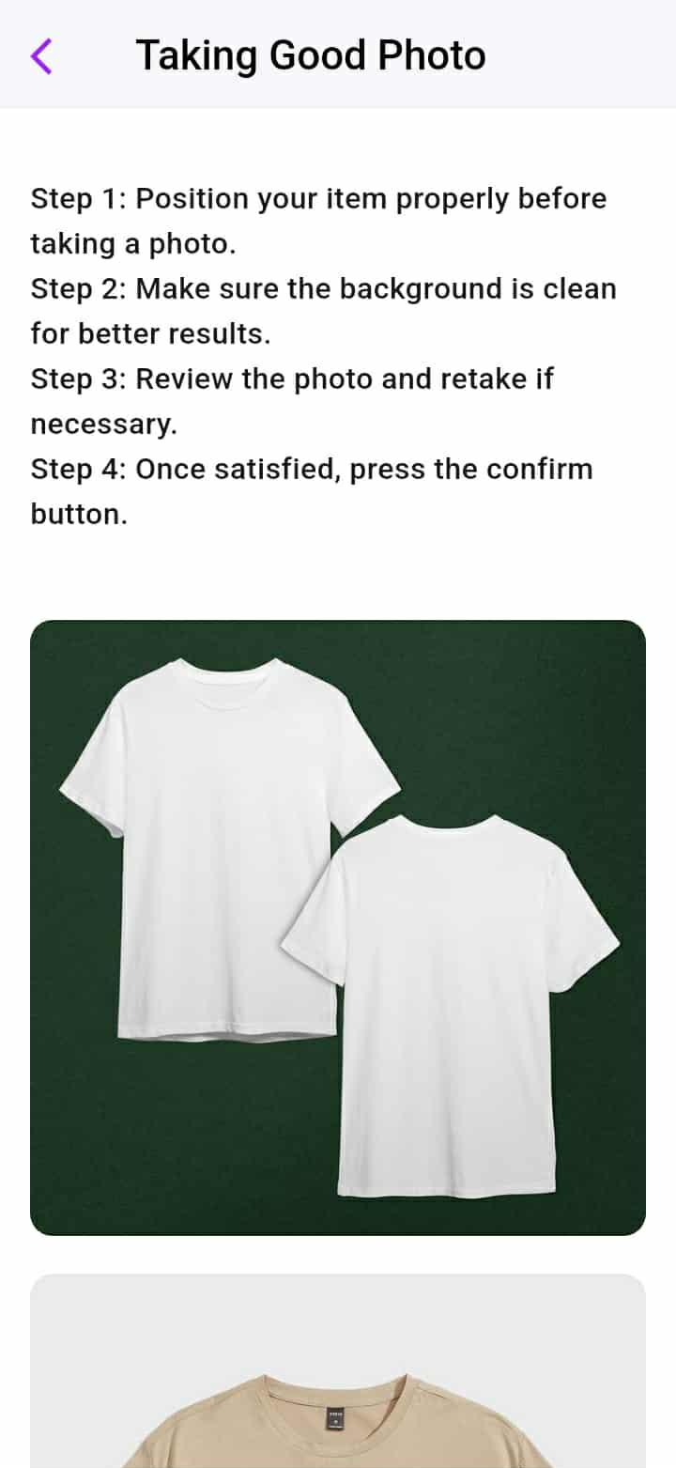

Screen No: 81
Screen Name: Online Contact
Narrative Overview: Allows user to view contact information of the developers.
Screen Layout:
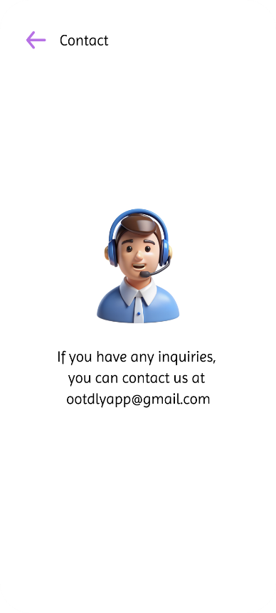

Screen No: 82
Screen Name: Online Delete Account
Narrative Overview: Allows users to delete their account by confirming multiple prompts before proceeding.
Screen Layout:
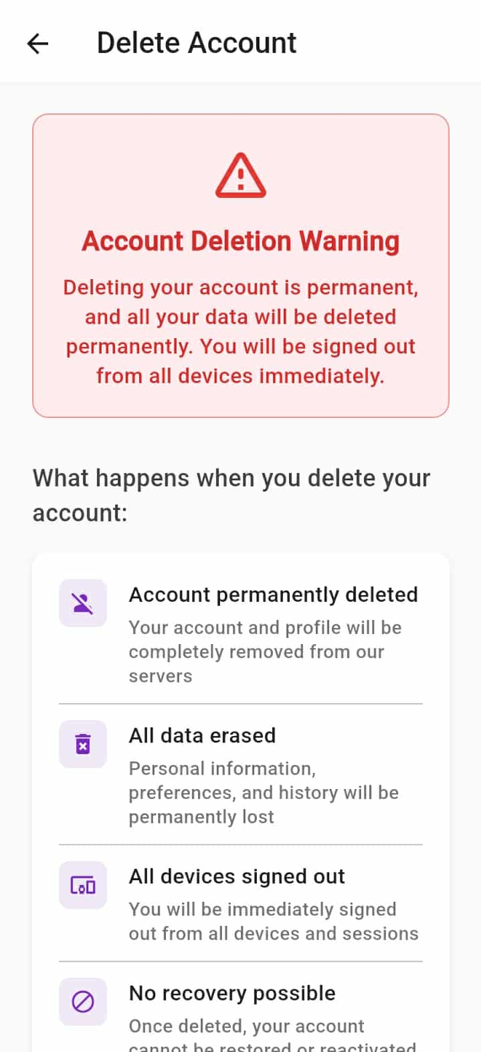

Screen No: 83
Screen Name: Online Terms and Conditions
Narrative Overview: Allows user to view the terms and conditions implemented on the app.
Screen Layout:
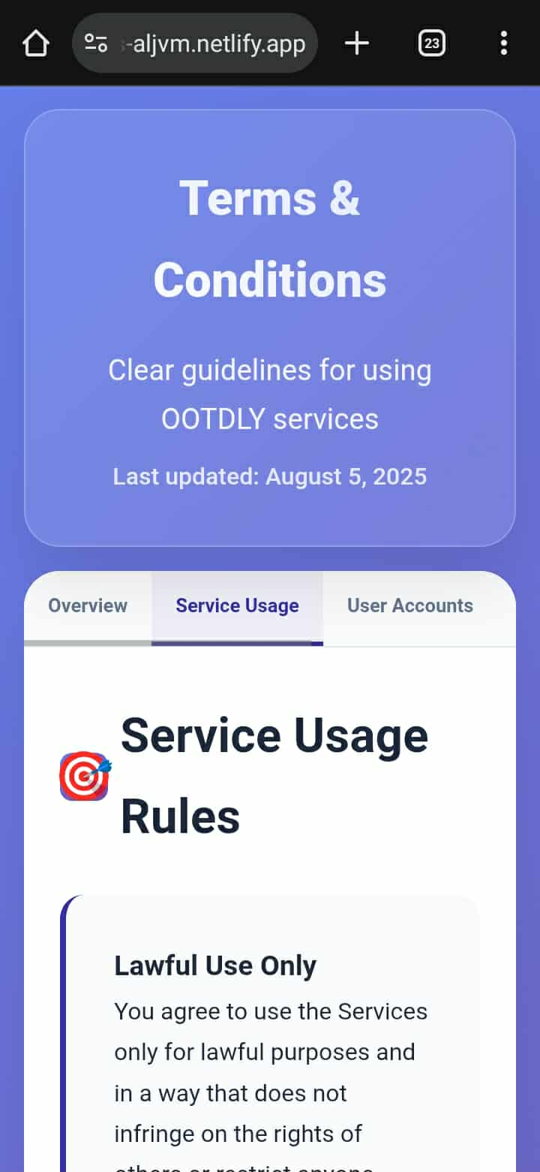

Screen No: 84
Screen Name: Online Privacy Policy
Narrative Overview: Allows user to view the privacy policy implemented on the app.
Screen Layout:
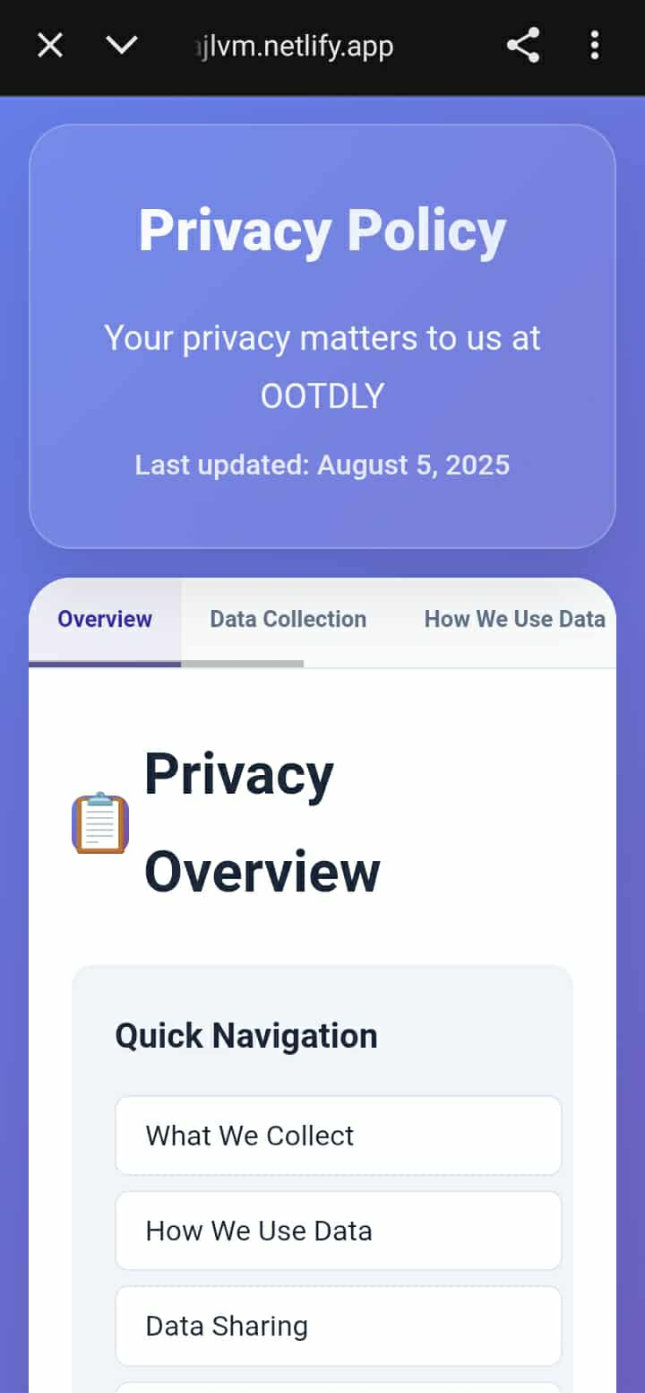

Screen No: 85
Screen Name: Online Log Out
Narrative Overview: Allows user to log out to the online account.
Screen Layout:
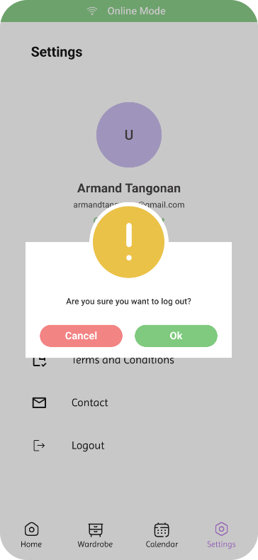

Screen No: 86
Screen Name: Offline Account Home Tab
Narrative Overview: Allows user to see the offline home tab.
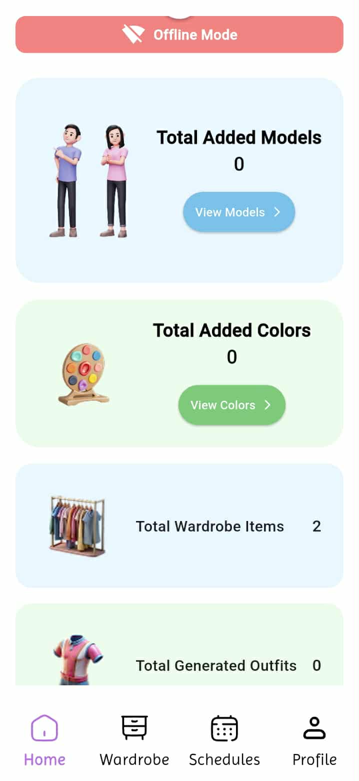
Screen Layout:

Screen No: 87
Screen Name: Offline Wardrobe Tab
Narrative Overview: Allows user to see the offline wardrobe tab.
Screen Layout:
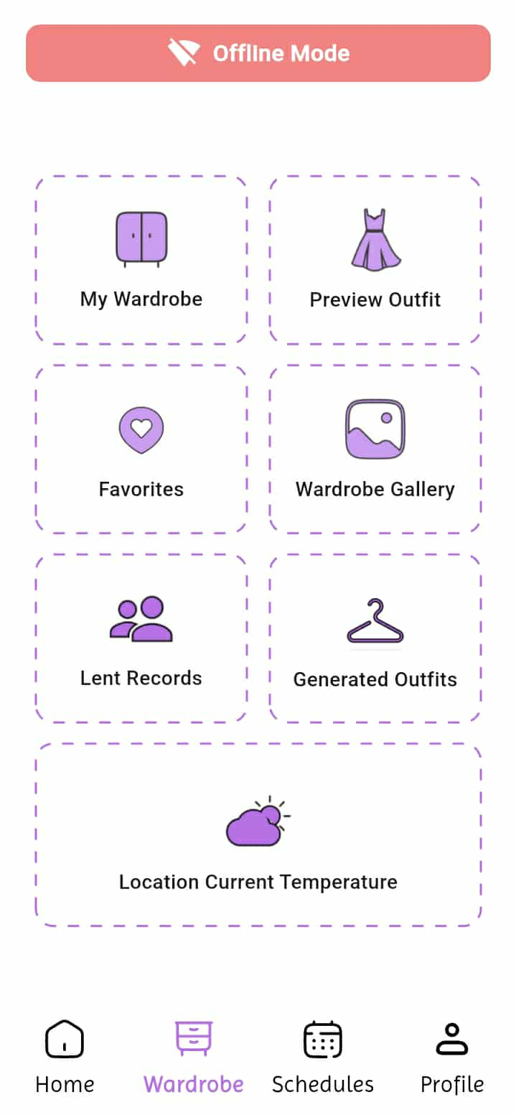

Screen No: 88
Screen Name: Offline Calendar Tab
Narrative Overview: Allows user to see the offline calendar tab. Screen Layout:
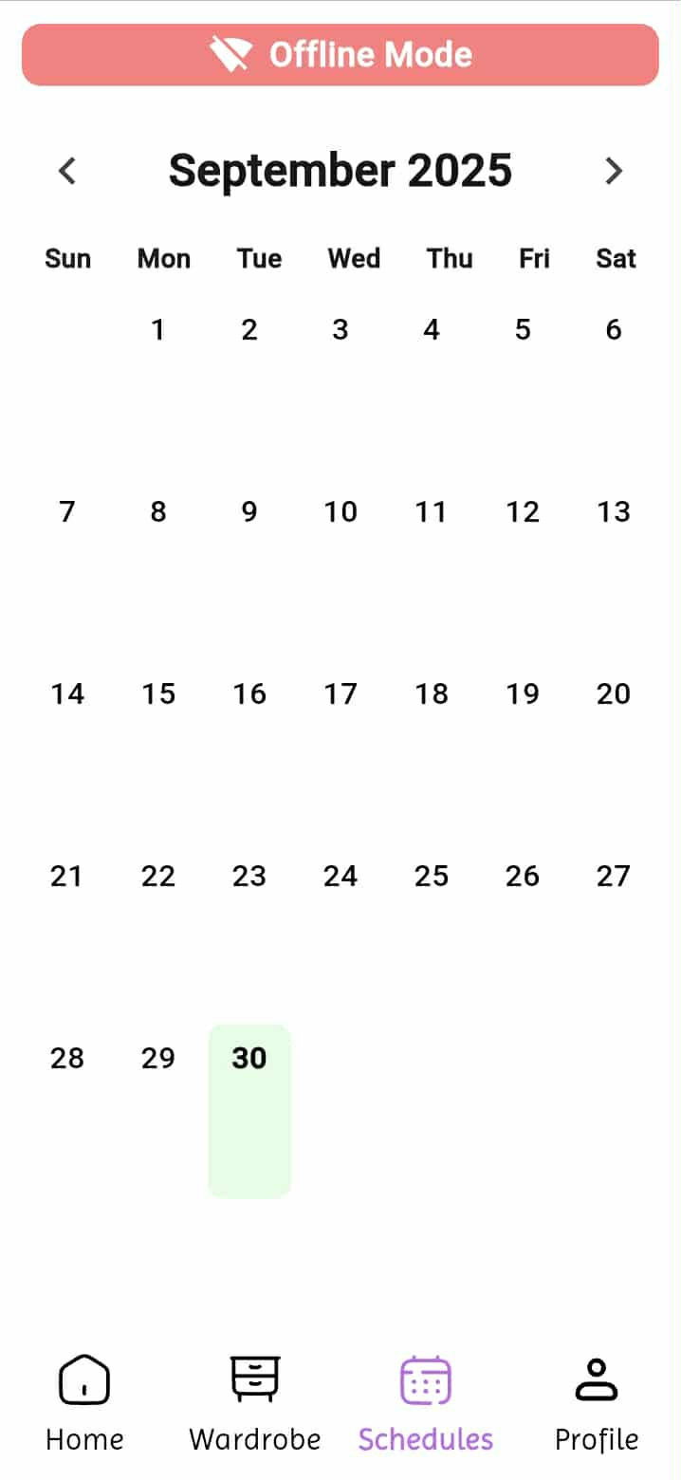

Screen No: 89
Screen Name: Offline ProfileTab
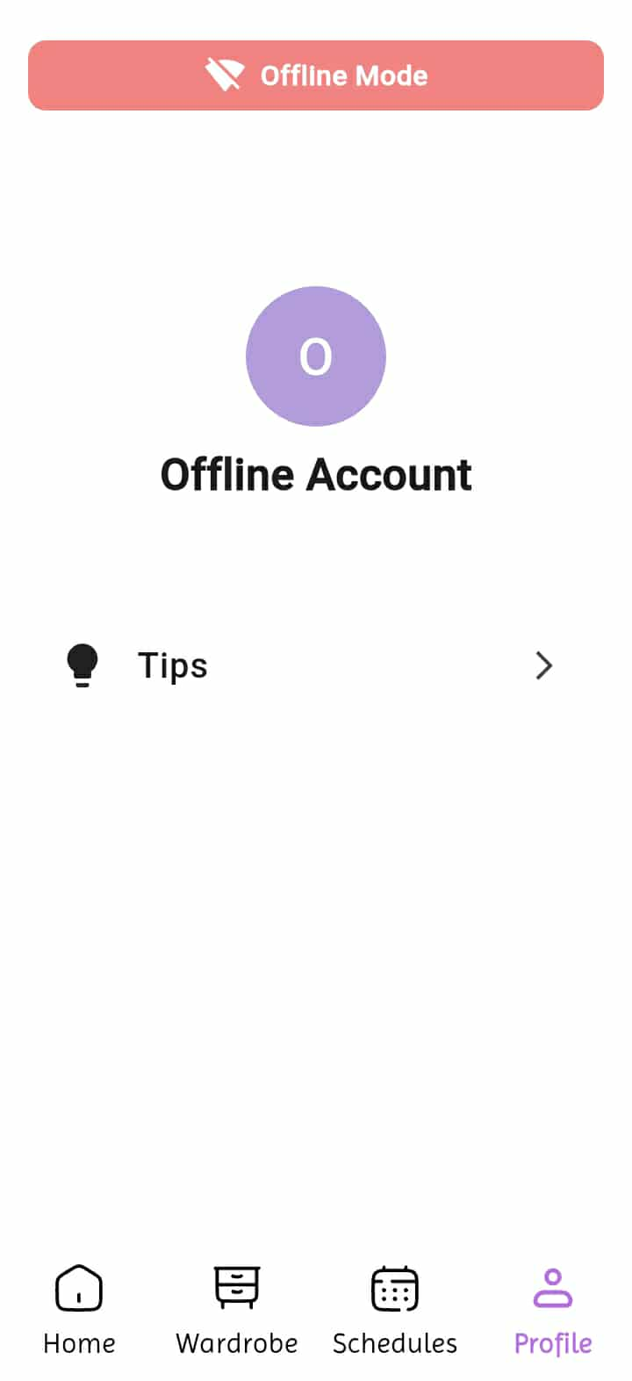
Narrative Overview: Allows user to see the offline calendar tab. Screen Layout:

Appendix D
D.1 Transcript of Interview
D.1.1 Trisha Joy G. Tañedo


“Nakaranas na ba kayo ng pangyayari na mayroon kayong event na pupuntahan na hindi kayo handa kung ano ang inyong susuoting outfit?”

Trisha: Yeah nung debut ng friend ko and yung theme is dapat starry night, but I don't have something to wear kasi di ako prepared and hindi ako nainform na invited ako.

“Naka organize ba ang inyong mga damit sa physical cabinet or sa lalagyanan niyo ng mga damit?”

Trisha: Yeah my clothes are organized in my cabinet.

“Gaano kadalas kayong nahihirapang pumili ng damit sa tuwing may lakad o event kayo?”

Trisha: lagi pag papasok ng school, and pag gagala

“May sistema ba kayo sa pagpili ng outfit, tulad ng pag-aayos ayon sa kulay, okasyon, o panahon?”

Trisha: Depend sa lakad, pero most of the time gusto ko lang ng basic and comfy outfit, and pag event naman na kailangan talagang formal gusto ko padin nung basic but elegant look na dapat comfy pa din ako.
“Sa tingin nyo, makakatulong ba kung merong app na mag-oorganize ng mga damit nyo at mag-susuggest ng outfit?”

Trisha: For me yes, as a girly na hirap mamili ng masusuot everyday agree ako na mag karoon ng application na puwedeng mag organized or mag suggest ng daily outfits.

“Paano niyo gustong i-organize ang mga damit nyo kung may pagkakataon kayong ayusin ito muli? (Hal. ayon sa kulay, uri, style, o season)”

Trisha: ako sa uri, Say for example pang bahay na mga damit and pang labas ng mga damit.


D.1.2 Jeffrey Galang Bais

“Nakaranas na ba kayo ng pangyayari na mayroon kayong event na pupuntahan na hindi kayo handa kung ano ang inyong susuoting outfit?”

Jeffrey : Yes, lalo na kung biglaan ang pangyayari or pag alis

“Naka organize ba ang inyong mga damit sa physical cabinet or sa lalagyanan niyo ng mga damit?”

Jeffrey: Yes, naka separate sya ang mga damit at short

“Gaano kadalas kayong nahihirapang pumili ng damit sa tuwing may lakad o event kayo?”

Jeffrey: Madalas Kasi Hindi Minsan nababagay ang mga sinusuot sa kadahilan ng pagmamadali

“May sistema ba kayo sa pagpili ng outfit, tulad ng pag-aayos ayon sa kulay, okasyon, o panahon?”
Jeffrey: Dapat sapagkat dapat lamang naaayon ang iyong sinusuot sa panahon or okasyon

“Sa tingin nyo, makakatulong ba kung merong app na mag-oorganize ng mga damit nyo at mag-susuggest ng outfit?”

Jeffrey: Pwedi, para Hindi na mahirapan sa pagpili ng isusuot

“Paano niyo gustong i-organize ang mga damit nyo kung may pagkakataon kayong ayusin ito muli? (Hal. ayon sa kulay, uri, style, o season)”

Jeffrey: Wala Naman dapat pang ayusin para sakin Kasi alam ko kung saan ako kukuha ng isusuot na pang Araw Araw at pang alis.

D.1.3 Leonila G. Luis


“Nakaranas na ba kayo ng pangyayari na mayroon kayong event na pupuntahan na hindi kayo handa kung ano ang inyong susuoting outfit?”

Leonila : meron, nung mag ninang sa kasal

“Naka organize ba ang inyong mga damit sa physical cabinet or sa lalagyanan niyo ng mga damit?”

Leonila: yes.hung and folded sa loob ng cabinet

“Gaano kadalas kayong nahihirapang pumili ng damit sa tuwing may lakad o event kayo?”

Leonila: minsan, kung aattend ng kasal/binyag

“May sistema ba kayo sa pagpili ng outfit, tulad ng pag-aayos ayon sa kulay, okasyon, o panahon?”

Leonila: wala

“Sa tingin niyo, makakatulong ba kung merong app na mag-oorganize ng mga damit nyo at mag-susuggest ng outfit?”

Leonila: oo, para mapadali ang pagpili ng damit kung may lakad

“Paano niyo gustong i-organize ang mga damit nyo kung may pagkakataon kayong ayusin ito muli? (Hal. ayon sa kulay, uri, style, o season)”

Leonila: Pwede kahit naayon na lang sa kulay at style

Appendix E
E.1 Curriculum Vitae


NAME: Lucila M. Baluyut
ADDRESS: Sta.Lucia, Capas, Tarlac
CELLPHONE #: 09603237573
EMAIL ADDRESS: lucibaluyutxiii@gmail.com

PERSONAL INFORMATION
NICKNAME: Luci
BIRTHDAY: December 13, 1997
BIRTHPLACE: Capas, Tarlac
AGE: 27
NATIONALITY: Filipino
RELIGION: Roman Catholic
CIVIL STATUS: Single


NAME: Vim Aurem Ningala
ADDRESS: Bueno, Capas, Tarlac
CELLPHONE #: 09468514687
EMAIL ADDRESS: vimaurem@gmail.com

PERSONAL INFORMATION
NICKNAME: Vim
BIRTHDAY: January 17, 2004
BIRTHPLACE: San Juan
AGE: 21
NATIONALITY: Filipino
RELIGION: Roman Catholic
CIVIL STATUS: Single


NAME: John Paul S. Pasia
ADDRESS: Cristo Rey, Capas, Tarlac
CELLPHONE #: 09501766150
EMAIL ADDRESS: johnpaulsaspasia1702@gmail.com

PERSONAL INFORMATION
NICKNAME: Paul
BIRTHDAY: September 17, 2002
BIRTHPLACE: Tarlac, City
AGE: 22
NATIONALITY: Filipino
RELIGION: Roman Catholic
CIVIL STATUS: Single


NAME: John Adams S. Romero
ADDRESS: Cristo Rey, Capas, Tarlac
CELLPHONE #: 09641798590
EMAIL ADDRESS: romerojohnadams30@gmail.com

PERSONAL INFORMATION
NICKNAME: Adams
BIRTHDAY: December 09, 2002
BIRTHPLACE: Mabalacat District Hospital
AGE: 22
NATIONALITY: Filipino
RELIGION: Iglesia Ni Cristo
CIVIL STATUS: Single


NAME: Marlon R. Sembria
ADDRESS: Sto Domingo 1st, Capas, Tarlac
CELLPHONE #: 09501908095
EMAIL ADDRESS: razonmarlon17@gmail.com

PERSONAL INFORMATION
NICKNAME: Lonlon
BIRTHDAY: July 26, 2004
BIRTHPLACE: Conception, Tarlac
AGE: 20
NATIONALITY: Filipino
RELIGION: Roman Catholic
CIVIL STATUS: Single


NAME: Armand Robin I. Tangonan
ADDRESS: O'Donnell Capas, Tarlac
CELLPHONE #: 09461837927
EMAIL ADDRESS: armandinong21@gmail.com

PERSONAL INFORMATION
NICKNAME: Mand
BIRTHDAY: June 21, 2004
BIRTHPLACE: Tarlac Provincial Hospital
AGE: 20
NATIONALITY: Filipino
RELIGION: Born Again Christian
CIVIL STATUS: Single

